Table 3
Characterization of Expert Judges
Variable | Category | n=24
Sex
 | Femenino | 9 (37.5%)
 | Masculino | 15 (62.5%)
Highest academic degree
 | Doctorado | 24 (100.0%)
OCDE Area
 | Ciencias médicas y de la salud | 3 (12.5%)
 | Ciencias naturales | 7 (29.2%)
 | Ciencias sociales | 10 (41.7%)
 | Humanidades y artes | 1 (4.2%)
 | Ingeniería y tecnología | 3 (12.5%)
Type of (main) professional experience
 | Académico | 5 (20.8%)
 | Coordinador Académico | 2 (8.3%)
 | Director | 9 (37.5%)
 | Investigador | 7 (29.2%)
 | Rector | 1 (4.2%)
Years of experience
 | Median (Q1, Q3) | 18.5 (12.75, 25.25)
 | Mean (SD) | 19.1 (8.1)
 | Min, Max | 6, 38
Do you have experience in instrument validation?
 | NO | 8 (33.3%)
 | SI | 16 (66.7%)
Note. N = number of judges. Percentages are shown in parentheses.
Table 9
Aiken’s V Coefficients, Frequencies, and 95% Confidence Intervals by Item
Dimension | Item | 1 | 2 | 3 | 4 | M | V | 95% CI
Relevance | item01 | 1 | 1 | 7 | 15 | 3.5 | 0.833 | [0.746, 0.895]
Relevance | item02 | 0 | 2 | 0 | 22 | 3.833 | 0.944 | [0.879, 0.975]
Relevance | item03 | 0 | 1 | 3 | 20 | 3.792 | 0.931 | [0.861, 0.967]
Relevance | item04 | 0 | 0 | 6 | 18 | 3.75 | 0.917 | [0.844, 0.957]
Relevance | item05 | 1 | 3 | 5 | 15 | 3.417 | 0.806 | [0.715, 0.872]
Relevance | item06 | 0 | 2 | 5 | 17 | 3.625 | 0.875 | [0.794, 0.927]
Relevance | item07 | 0 | 1 | 4 | 19 | 3.75 | 0.917 | [0.844, 0.957]
Relevance | item08 | 0 | 0 | 8 | 16 | 3.667 | 0.889 | [0.810, 0.937]
Relevance | item09 | 0 | 0 | 7 | 17 | 3.708 | 0.903 | [0.827, 0.947]
Relevance | item10 | 0 | 1 | 5 | 18 | 3.708 | 0.903 | [0.827, 0.947]
Relevance | item11 | 0 | 2 | 4 | 18 | 3.667 | 0.889 | [0.810, 0.937]
Relevance | item12 | 0 | 0 | 3 | 21 | 3.875 | 0.958 | [0.898, 0.984]
Relevance | item13 | 2 | 1 | 8 | 13 | 3.333 | 0.778 | [0.685, 0.849]
Relevance | item14 | 0 | 1 | 8 | 15 | 3.583 | 0.861 | [0.778, 0.916]
Relevance | item15 | 0 | 0 | 5 | 19 | 3.792 | 0.931 | [0.861, 0.967]
Relevance | item16 | 0 | 0 | 6 | 18 | 3.75 | 0.917 | [0.844, 0.957]
Relevance | item17 | 0 | 0 | 5 | 19 | 3.792 | 0.931 | [0.861, 0.967]
Relevance | item18 | 1 | 0 | 3 | 20 | 3.75 | 0.917 | [0.844, 0.957]
Relevance | item19 | 0 | 0 | 4 | 20 | 3.833 | 0.944 | [0.879, 0.975]
Relevance | item20 | 0 | 2 | 4 | 18 | 3.667 | 0.889 | [0.810, 0.937]
Relevance | item21 | 0 | 0 | 7 | 17 | 3.708 | 0.903 | [0.827, 0.947]
Relevance | item22 | 0 | 0 | 6 | 18 | 3.75 | 0.917 | [0.844, 0.957]
Relevance | item23 | 0 | 0 | 5 | 19 | 3.792 | 0.931 | [0.861, 0.967]
Relevance | item24 | 0 | 0 | 3 | 21 | 3.875 | 0.958 | [0.898, 0.984]
Relevance | item25 | 0 | 1 | 5 | 18 | 3.708 | 0.903 | [0.827, 0.947]
Relevance | item26 | 0 | 0 | 6 | 18 | 3.75 | 0.917 | [0.844, 0.957]
Relevance | item27 | 0 | 1 | 6 | 17 | 3.667 | 0.889 | [0.810, 0.937]
Relevance | item28 | 0 | 0 | 6 | 18 | 3.75 | 0.917 | [0.844, 0.957]
Relevance | item29 | 0 | 1 | 6 | 17 | 3.667 | 0.889 | [0.810, 0.937]
Relevance | item30 | 0 | 1 | 4 | 19 | 3.75 | 0.917 | [0.844, 0.957]
Relevance | item31 | 0 | 3 | 3 | 18 | 3.625 | 0.875 | [0.794, 0.927]
Wording | item01 | 0 | 2 | 8 | 14 | 3.5 | 0.833 | [0.746, 0.895]
Wording | item02 | 0 | 0 | 4 | 20 | 3.833 | 0.944 | [0.879, 0.975]
Wording | item03 | 0 | 1 | 4 | 19 | 3.75 | 0.917 | [0.844, 0.957]
Wording | item04 | 0 | 1 | 5 | 18 | 3.708 | 0.903 | [0.827, 0.947]
Wording | item05 | 0 | 1 | 5 | 18 | 3.708 | 0.903 | [0.827, 0.947]
Wording | item06 | 0 | 1 | 5 | 18 | 3.708 | 0.903 | [0.827, 0.947]
Wording | item07 | 1 | 1 | 9 | 13 | 3.417 | 0.806 | [0.715, 0.872]
Wording | item08 | 0 | 0 | 8 | 16 | 3.667 | 0.889 | [0.810, 0.937]
Wording | item09 | 0 | 1 | 8 | 15 | 3.583 | 0.861 | [0.778, 0.916]
Wording | item10 | 0 | 1 | 5 | 18 | 3.708 | 0.903 | [0.827, 0.947]
Wording | item11 | 0 | 0 | 7 | 17 | 3.708 | 0.903 | [0.827, 0.947]
Wording | item12 | 0 | 0 | 10 | 14 | 3.583 | 0.861 | [0.778, 0.916]
Wording | item13 | 0 | 1 | 10 | 13 | 3.5 | 0.833 | [0.746, 0.895]
Wording | item14 | 0 | 1 | 5 | 18 | 3.708 | 0.903 | [0.827, 0.947]
Wording | item15 | 0 | 1 | 4 | 19 | 3.75 | 0.917 | [0.844, 0.957]
Wording | item16 | 0 | 0 | 6 | 18 | 3.75 | 0.917 | [0.844, 0.957]
Wording | item17 | 0 | 1 | 5 | 18 | 3.708 | 0.903 | [0.827, 0.947]
Wording | item18 | 0 | 4 | 3 | 17 | 3.542 | 0.847 | [0.762, 0.906]
Wording | item19 | 0 | 1 | 1 | 22 | 3.875 | 0.958 | [0.898, 0.984]
Wording | item20 | 0 | 1 | 3 | 20 | 3.792 | 0.931 | [0.861, 0.967]
Wording | item21 | 0 | 1 | 6 | 17 | 3.667 | 0.889 | [0.810, 0.937]
Wording | item22 | 0 | 1 | 4 | 19 | 3.75 | 0.917 | [0.844, 0.957]
Wording | item23 | 0 | 0 | 7 | 17 | 3.708 | 0.903 | [0.827, 0.947]
Wording | item24 | 0 | 1 | 4 | 19 | 3.75 | 0.917 | [0.844, 0.957]
Wording | item25 | 0 | 1 | 3 | 20 | 3.792 | 0.931 | [0.861, 0.967]
Wording | item26 | 0 | 1 | 4 | 19 | 3.75 | 0.917 | [0.844, 0.957]
Wording | item27 | 0 | 0 | 6 | 18 | 3.75 | 0.917 | [0.844, 0.957]
Wording | item28 | 0 | 3 | 4 | 17 | 3.583 | 0.861 | [0.778, 0.916]
Wording | item29 | 0 | 0 | 4 | 20 | 3.833 | 0.944 | [0.879, 0.975]
Wording | item30 | 0 | 0 | 3 | 21 | 3.875 | 0.958 | [0.898, 0.984]
Wording | item31 | 0 | 0 | 4 | 20 | 3.833 | 0.944 | [0.879, 0.975]
Note. Columns 1–4 show the frequency of each rating on the 4-point scale. M = mean rating; V = Aiken’s V coefficient; CI = confidence interval. The acceptance criterion was V ≥ .80.
Figure 1
Aiken’s V Coefficients and 95% Confidence Intervals for Relevance and Wording Items
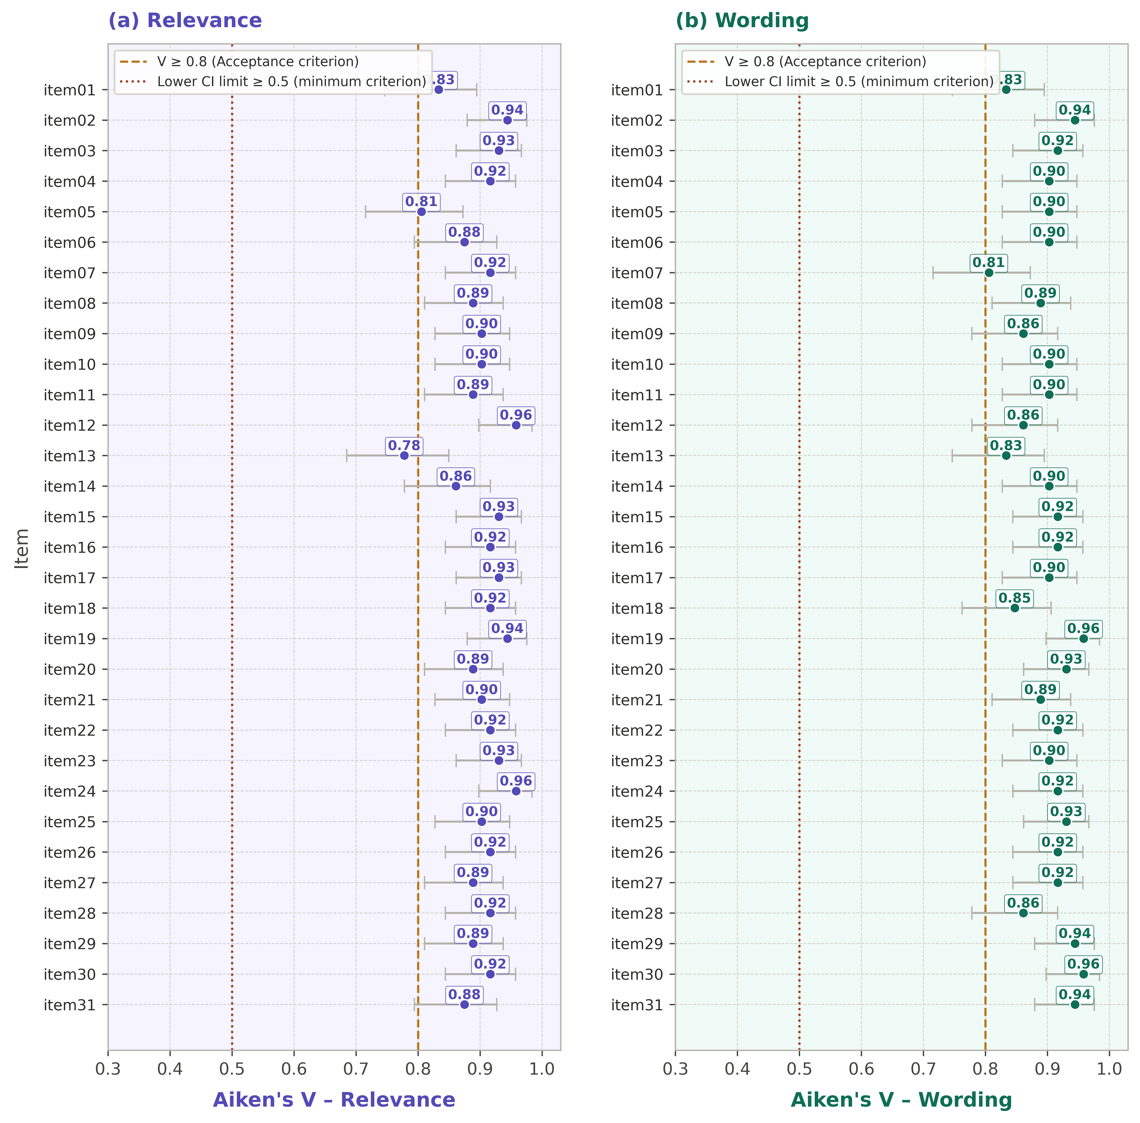
Note. Dashed line marks the acceptance criterion (V ≥ .80); dotted line marks the minimum lower-bound criterion (≥ .50). Error bars represent 95% confidence intervals.

