Technical Design Document
Event Ticket Reservation Prototype — TicketReservation

Architecture, technical decisions, best practices, UML design
and unit tests (xUnit)

Technical assessment — CBTW
August 23, 2026

1. Introduction
This document describes the technical design of the TicketReservation prototype: a minimal application for reserving event tickets, based on an already-known event code and user code (no registration or authentication involved). The system consists of a .NET 8 backend API and a React + TypeScript test client.
The document covers the architecture used, the technical decisions made during development, the best practices applied, the code organization, scalability and maintainability considerations, the UML design of the solution, and the unit test project created with xUnit.

1.1 Functional scope
- List the available events along with their capacity (total capacity and available seats).
- Reserve tickets by providing an event code, a user code, and a quantity.
- Business rules: a reservation cannot exceed the available capacity; a given user cannot have more than one reservation for the same event; the number of tickets per reservation is configurable per request.

1.2 Technology stack
Component | Technology
Backend | .NET 8 · ASP.NET Core Minimal APIs
Persistence | Entity Framework Core 8 · SQL Server · Migrations
API documentation | Swagger / Swashbuckle (OpenAPI)
Frontend | React 19 + TypeScript · Vite
Unit testing | xUnit · Moq · FluentAssertions

2. Architecture used
The backend is organized following Clean Architecture principles (a layered architecture with an inward dependency rule): the domain core depends on nothing, the application layer depends only on the domain, and the outer layers (infrastructure and API) depend on application and domain through interfaces — never the other way around. This translates into four independent projects inside the backend/TicketReservation.slnx solution:
Project | Responsibility | Depends on
TicketReservation.Domain | Business entities and exceptions. This is the core: it references no other project. | —
TicketReservation.Application | Use cases (services), repository contracts (interfaces), and input/output DTOs. | Domain
TicketReservation.Infrastructure | EF Core persistence implementation: DbContext, migrations, repositories, Unit of Work, data seeding. | Application, Domain
TicketReservation.Api | Minimal API: HTTP endpoints, error-handling middleware, CORS, Swagger, and dependency composition (Program.cs). | Application, Infrastructure, Domain

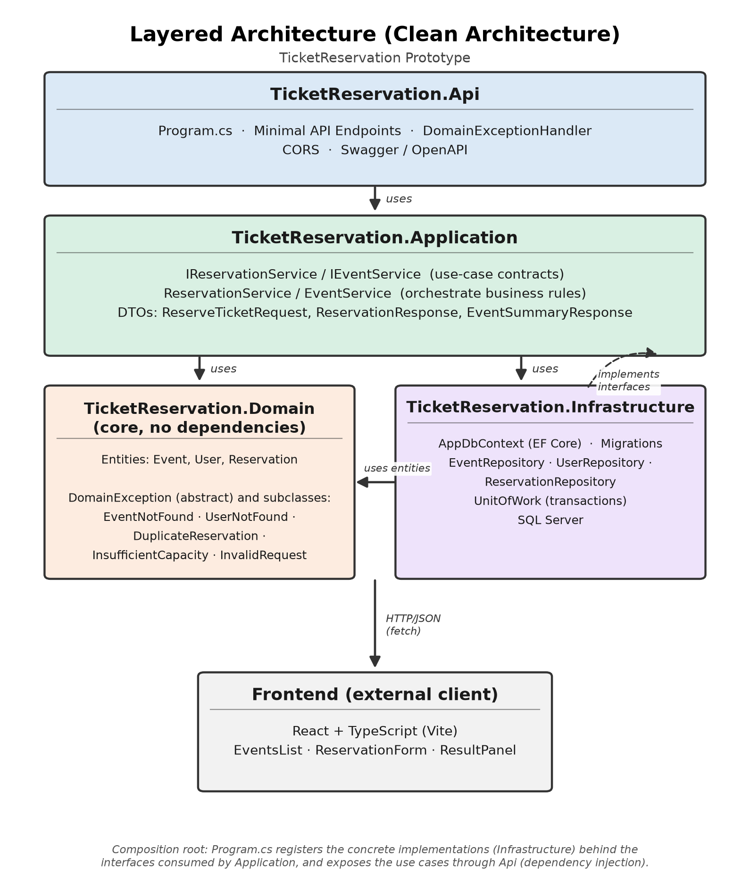
Figure 1. Layered architecture of the TicketReservation prototype.

2.1 Request flow
An HTTP request enters through TicketReservation.Api (a Minimal API endpoint), which delegates to the corresponding use case in TicketReservation.Application through an interface (IReservationService / IEventService). The use case orchestrates the business logic and uses the repository interfaces (IEventRepository, IUserRepository, IReservationRepository) and IUnitOfWork, whose actual implementations live in TicketReservation.Infrastructure and access SQL Server via EF Core. The API never knows about these concrete implementations: it only knows the interfaces, which are resolved at runtime through dependency injection configured in Program.cs.

2.2 Frontend
The frontend (React + TypeScript + Vite) is a decoupled test client that consumes the API exclusively over HTTP/JSON (fetch), sharing no code or types with the backend. It consists of three presentation components (EventsList, ReservationForm, ResultPanel) and a client module (reservationClient.ts) that centralizes the API's HTTP calls and error handling.

3. Technical decisions made during development

3.1 Minimal APIs instead of Controllers
Minimal APIs were chosen (MapGroup / MapGet / MapPost in EventEndpoints.cs and ReservationEndpoints.cs) over MVC controllers. For a service with two resources and two operations, this approach reduces boilerplate (no route attributes, no controller classes) while still keeping per-resource grouping (WithTags) and explicit OpenAPI metadata (Produces / ProducesProblem) per endpoint.

3.2 Repository + Unit of Work pattern
The application layer depends on repository interfaces (IEventRepository, IUserRepository, IReservationRepository) and IUnitOfWork instead of depending directly on EF Core or on AppDbContext. This isolates the business logic from persistence details and allows the infrastructure to be replaced (or the application to be tested with test doubles) without touching ReservationService or EventService.

3.3 Capacity control via a conditional atomic update
The most sensitive point of the domain is preventing ticket overselling under concurrent reservations. Instead of reading AvailableSeats, subtracting in memory, and then saving (which would be vulnerable to race conditions), EventRepository.TryReserveSeatsAsync executes a single SQL-conditioned UPDATE statement using EF Core 8's ExecuteUpdateAsync:
UPDATE Events
SET AvailableSeats = AvailableSeats - @quantity
WHERE Id = @eventId AND AvailableSeats >= @quantity
If the number of affected rows is 0, it means there was not enough capacity at that instant (with no need for explicit locks or retries), and the service throws InsufficientCapacityException. This decision avoids both overselling and the cost of a pessimistic row lock.

3.4 Explicit transaction wrapping the full reservation operation
IUnitOfWork.ExecuteInTransactionAsync wraps the duplicate check (ExistsAsync), the capacity deduction (TryReserveSeatsAsync), and the reservation insert (AddAsync + SaveChangesAsync) in a single database transaction, with automatic rollback on any exception. This guarantees that a reservation is created atomically: either all steps complete, or none of them are persisted.

3.5 Domain exception hierarchy + centralized handler
Each violated business rule is modeled as a concrete exception that inherits from the abstract DomainException class (which exposes an associated HTTP StatusCode): EventNotFoundException (404), UserNotFoundException (404), DuplicateReservationException (409), InsufficientCapacityException (409), and InvalidReservationRequestException (400). A single DomainExceptionHandler (an ASP.NET Core IExceptionHandler) intercepts any DomainException and translates it into a ProblemDetails response with the correct status code, avoiding repeated try/catch blocks in the endpoints.

3.6 DTOs (records) as the API contract
ReserveTicketRequest, ReservationResponse, and EventSummaryResponse are read-only records defined in the application layer. They decouple the HTTP contract from the domain model: EF Core entities (Event, User, Reservation) are never serialized directly to the client, which prevents leaking persistence details and allows the data model to evolve without breaking the public contract.

3.7 EF Core migrations with automatic seeding on startup
Program.cs applies pending migrations (Database.MigrateAsync) and seeds sample data (DbSeeder.SeedAsync) on every API startup. For an evaluation prototype, this removes manual setup steps: the evaluator only needs to run dotnet run to get a database ready with sample events and users.

3.8 Environment-configurable CORS
Allowed origins are read from configuration (Cors:AllowedOrigins in appsettings.json) instead of being hardcoded in Program.cs, with http://localhost:5173 (Vite's default port) as the fallback value if nothing is configured.

4. Best practices implemented
- Separation of concerns. Single responsibility principle: each class has one reason to change (ReservationService orchestrates the reservation; EventRepository only persists events; DomainExceptionHandler only translates errors).
- Dependency inversion. The application layer depends on abstractions (IEventRepository, IUnitOfWork, etc.), not on concrete EF Core implementations; these are injected from Infrastructure.
- Per-layer dependency injection. Each project exposes its own DependencyInjection class (AddApplication, AddInfrastructure) invoked from Program.cs, avoiding a monolithic service registration.
- Consistent asynchronous programming. All I/O operations (repositories, services, endpoints) are async end-to-end and propagate a CancellationToken, allowing in-flight requests to be cancelled.
- Nullable reference types. Nullable reference types are enabled (<Nullable>enable</Nullable>) in all four projects, catching potential unhandled null references at compile time.
- Early validation (guard clauses). ReservationService validates empty codes and non-positive quantities before touching the database, avoiding unnecessary queries for clearly invalid input.
- Optimized read-only queries. Read-only queries (GetByCodeAsync, ListAsync, ExistsAsync) use AsNoTracking(), avoiding the cost of EF Core's change tracker when it is not needed.
- Invariants enforced at the database level. Unique indexes on Code (Event, User) and on the (EventId, UserId) pair in Reservation, plus a check constraint AvailableSeats >= 0. The database enforces business invariants as a last line of defense, even in the face of application-layer bugs or concurrent access.
- Explicit domain exceptions. Business errors modeled as typed exceptions (the DomainException hierarchy) instead of magic error codes or ambiguous return values.
- Unit test coverage. 21 unit tests over the application layer with mocked dependencies (Moq), isolating the business logic from the real database.

5. Code structure and component organization
Repository directory structure:
backend/
TicketReservation.slnx
src/
TicketReservation.Domain/
Entities/ Event, User, Reservation
Exceptions/ DomainException and subclasses
TicketReservation.Application/
Dtos/ ReserveTicketRequest, ReservationResponse, EventSummaryResponse
Interfaces/ IEventRepository, IUserRepository, IReservationRepository,
IUnitOfWork, IEventService, IReservationService
Services/ EventService, ReservationService
DependencyInjection.cs
TicketReservation.Infrastructure/
Persistence/
AppDbContext.cs
Configurations/ EventConfiguration, UserConfiguration, ReservationConfiguration
Migrations/ InitialCreate
Repositories/ EventRepository, UserRepository, ReservationRepository
Seed/ DbSeeder
UnitOfWork.cs
DependencyInjection.cs
TicketReservation.Api/
Endpoints/ EventEndpoints, ReservationEndpoints
Middleware/ DomainExceptionHandler
Program.cs
tests/
TicketReservation.Application.Tests/
Services/ ReservationServiceTests, EventServiceTests
Domain/ DomainExceptionsTests
frontend/
src/
api/ reservationClient.ts (typed HTTP client)
components/ EventsList, ReservationForm, ResultPanel
App.tsx

5.1 Organization criteria
- Each backend project corresponds to an architectural layer; within each one, folders group by artifact type (Entities, Interfaces, Services, Repositories), which is consistent with the prototype's current size (few use cases).
- File names map 1:1 to the type they contain (ReservationService.cs → the ReservationService class), making the code easy to navigate.
- The test project mirrors Application's folder structure (Services/, Domain/), so each test suite sits next to the concept it validates.
- The frontend separates data access (api/) from presentation (components/), allowing the way the API is consumed to change without touching the visual components.

6. Scalability and maintainability of the solution

6.1 Elements that support scalability and maintainability
- Concurrency without in-memory state. Capacity control via a conditioned UPDATE (section 3.3) scales correctly across multiple API instances operating on the same database, without relying on in-process, in-memory locks — which would be a real problem if seat counting were managed in memory.
- Swappable infrastructure without touching the domain. Thanks to dependency inversion, TicketReservation.Infrastructure can be replaced (for example, switching from SQL Server to PostgreSQL, or introducing a cache) without changing a single line of TicketReservation.Application or TicketReservation.Api.
- Extensibility of use cases. New use cases (for example, cancelling a reservation or querying a user's history) are added by creating a new service method and its corresponding endpoint, without restructuring existing code.
- Testability. Because everything depends on interfaces, each use case can be unit-tested with test doubles (as done in TicketReservation.Application.Tests), which keeps development velocity up as the system grows.
- Horizontal scaling of the Api. The Api is a stateless process (it keeps no in-memory session); multiple instances behind a load balancer can serve traffic concurrently with no additional coordination.

6.2 Current limitations and possible evolutions
Being a scoped prototype, there are deliberate simplifications worth calling out when evolving toward production:
Current limitation | Suggested evolution
There is no authentication or authorization; the user is identified by a free-text code. | Introduce authentication (e.g., JWT / OAuth2) and associate the reservation with the authenticated user.
GET /api/events does not paginate or filter results. | Add pagination, filters by date/venue, and configurable sorting.
The reservation transaction runs against a single relational database; under extreme concurrency, the conditioned UPDATE remains consistent, but every instance competes for the same row. | If volume justifies it, partition by event or introduce a reservation queue with asynchronous processing and deferred confirmation.
There is no API versioning or contract strategy toward the frontend beyond the current DTOs. | Version the API (e.g., /api/v1) before introducing breaking changes.
Data seeding and migrations run automatically on API startup, which is convenient for a prototype but not desirable in production. | Move migration execution to an explicit deployment step (e.g., a CI/CD pipeline).
There is no observability (structured logging, metrics, traces). | Add structured logging and metrics (e.g., OpenTelemetry) to monitor reservations and errors in production.

7. UML design of the solution
This section presents the solution design through UML class diagrams (domain model and application layer) and a sequence diagram describing the full flow of creating a reservation.

7.1 Domain model
Event, User, and Reservation are the three entities of the domain core. They keep no navigation properties between each other (there are no navigable foreign keys in the EF Core model): Reservation relates to Event and User only by Id, and any query that needs both sides resolves the relationship by querying the corresponding repository. The five business exceptions inherit from the abstract DomainException class, which centralizes the HTTP status code associated with each one.
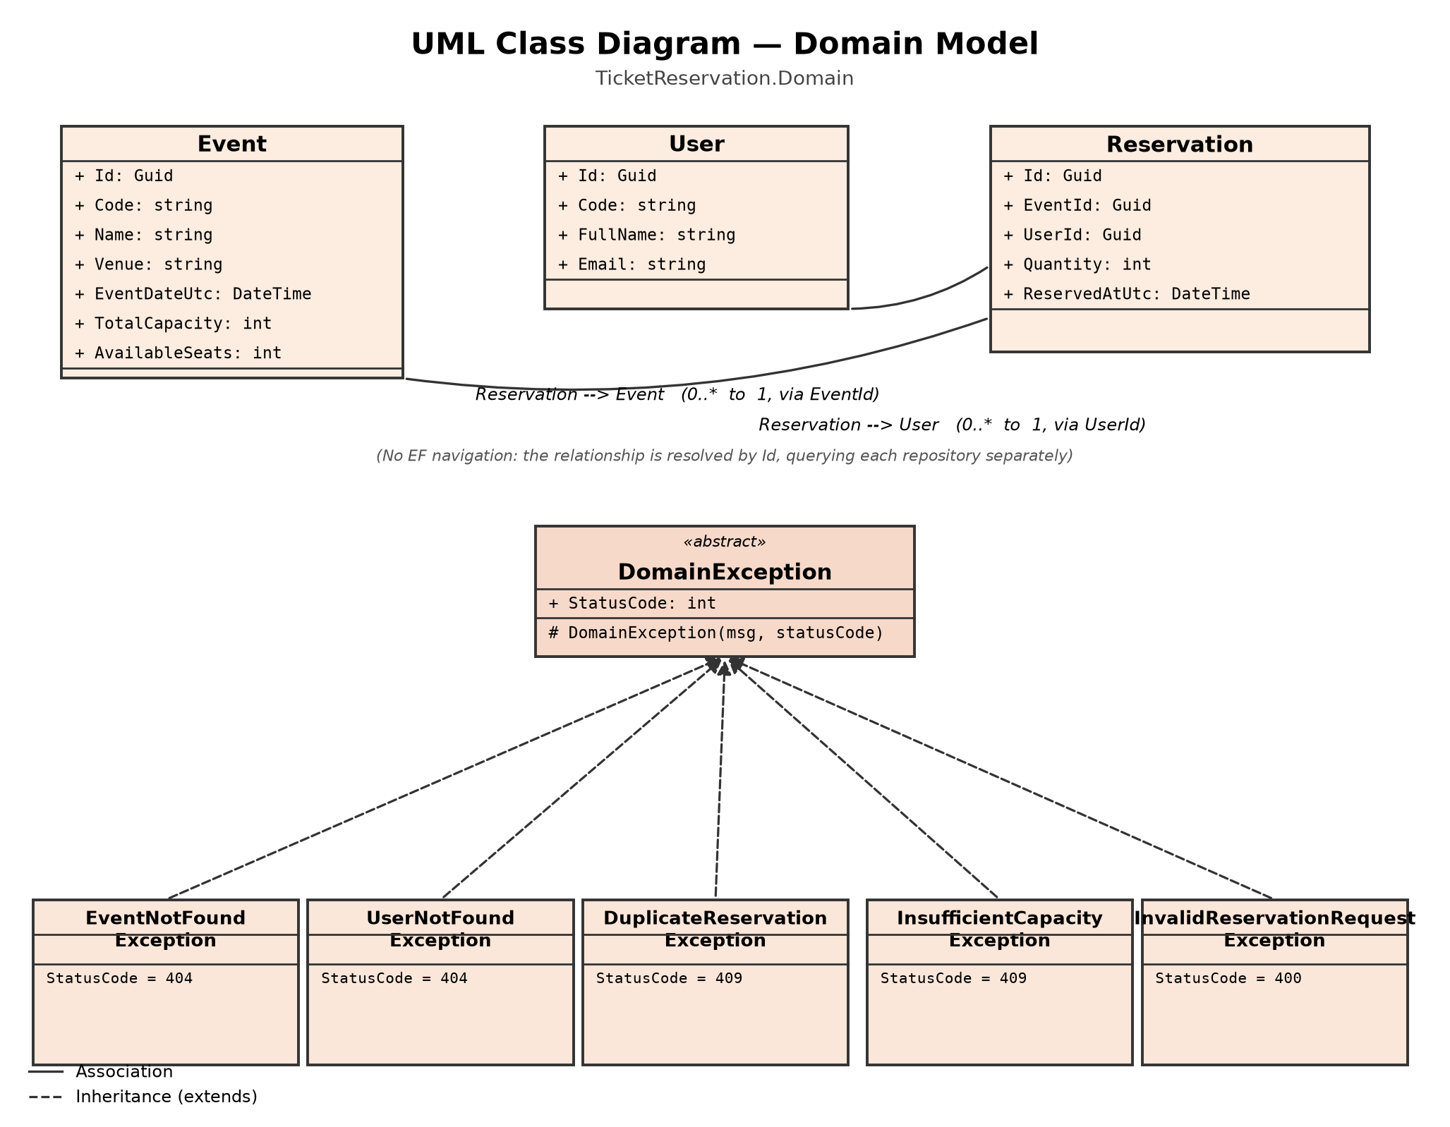
Figure 2. UML class diagram of the domain model (TicketReservation.Domain).

7.2 Application layer
ReservationService and EventService implement, respectively, IReservationService and IEventService. Both depend solely on the repository interfaces and on IUnitOfWork — never on AppDbContext or on any Entity Framework type — which keeps the application layer free of infrastructure details. The DTOs (ReserveTicketRequest, ReservationResponse, EventSummaryResponse) are the only kind of data that crosses the boundary toward the Api.
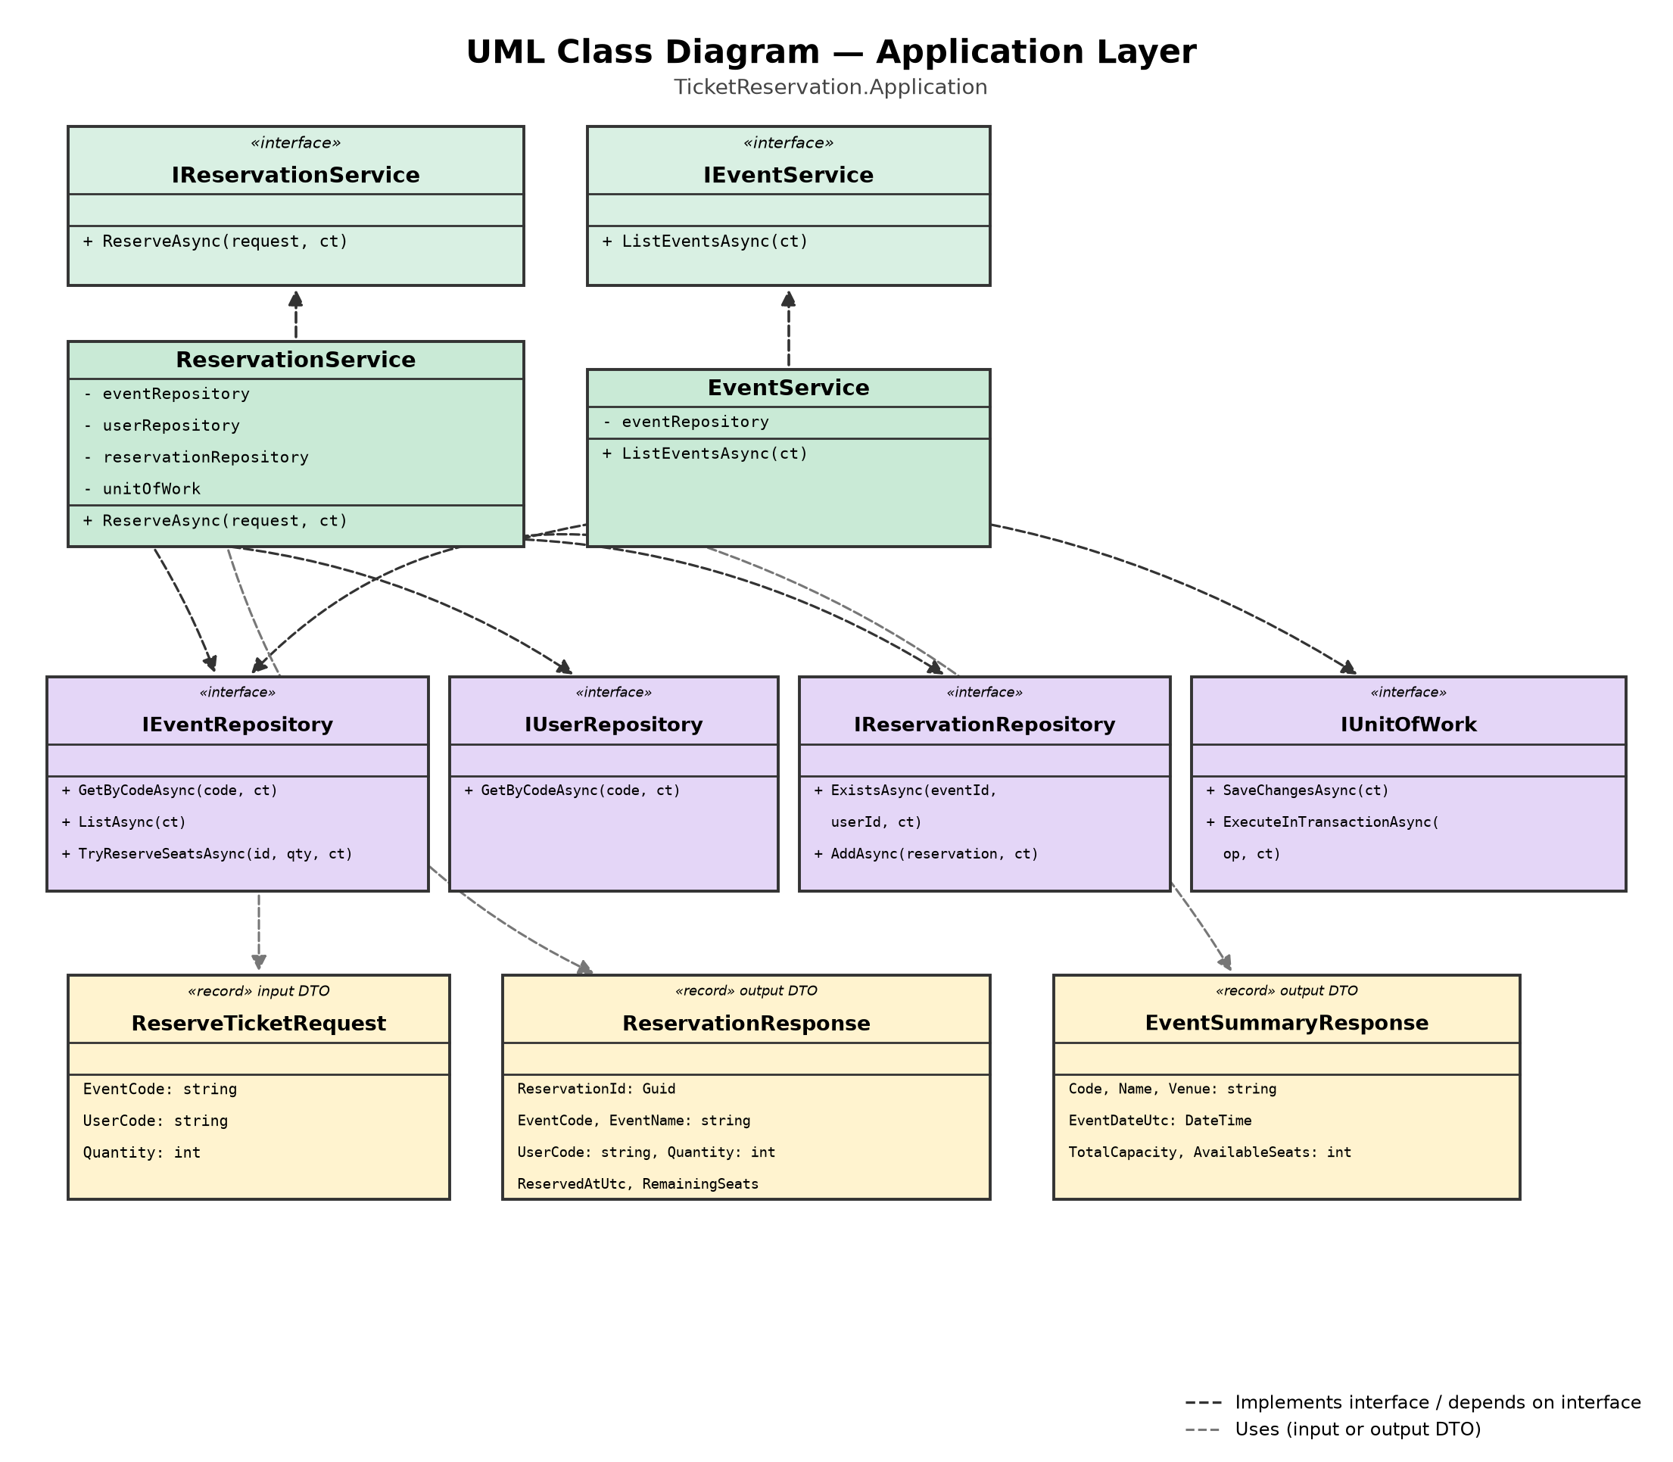
Figure 3. UML class diagram of the application layer (TicketReservation.Application).

7.3 Sequence diagram — Create a reservation
The following diagram shows the full sequence of POST /api/reservations, including the early exit points for each violated business rule (input validation, non-existent event or user, duplicate reservation, and insufficient capacity), and the transaction that wraps the duplicate check, the capacity deduction, and the persistence of the reservation.
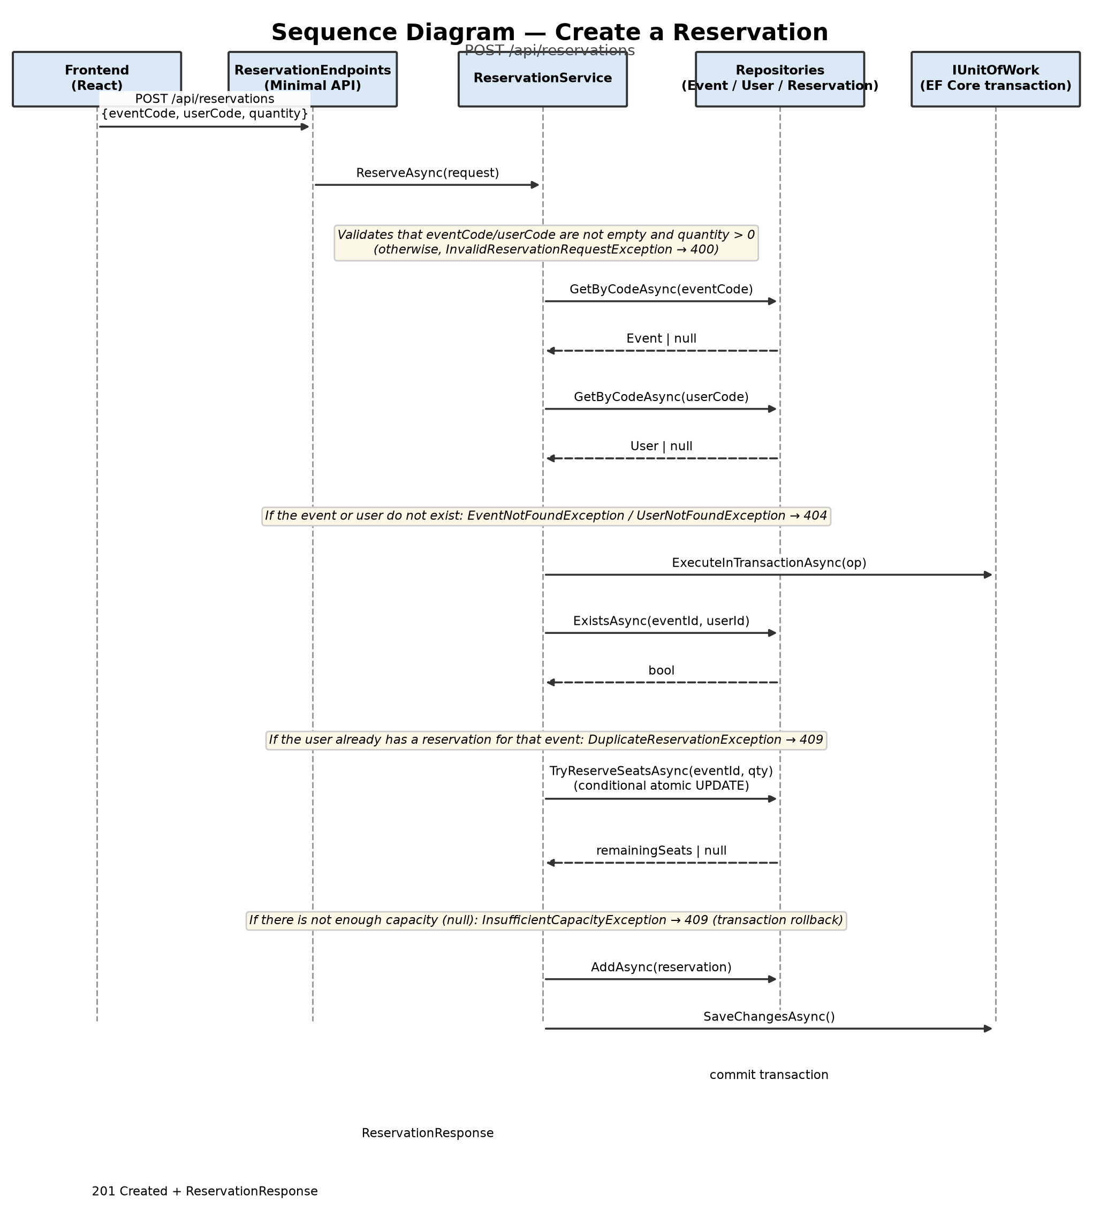
Figure 4. Sequence diagram of the “Create a reservation” use case.

8. Unit test project (xUnit)
The backend/tests/TicketReservation.Application.Tests project was created and added to the TicketReservation.slnx solution, with unit tests over the application layer (ReservationService, EventService) and over the domain exception hierarchy.

8.1 Tools used
Package | Use in the project
xUnit | Test framework ([Fact] and [Theory] attributes).
Moq | Creates test doubles (mocks) for IEventRepository, IUserRepository, IReservationRepository, and IUnitOfWork, isolating the service under test from the real database.
FluentAssertions | Expressive assertions (Should().Be(...), Should().ThrowAsync<...>(), etc.) that improve the readability of tests and of failure messages.

The project references TicketReservation.Application and TicketReservation.Domain, and is run with:
dotnet test backend/tests/TicketReservation.Application.Tests

8.2 Implemented tests
ReservationServiceTests.cs — tests for the main use case (ReserveAsync):
Test | What it validates
ReserveAsync_WithMissingCodes_ThrowsInvalidReservationRequestException | Throws InvalidReservationRequestException when the event or user code is empty, blank, or missing (Theory with 6 combinations), without ever querying the repositories.
ReserveAsync_WithNonPositiveQuantity_ThrowsInvalidReservationRequestException | Throws InvalidReservationRequestException when the requested quantity is 0 or negative.
ReserveAsync_WithUnknownEventCode_ThrowsEventNotFoundException | Throws EventNotFoundException when the event code does not exist, without querying the user.
ReserveAsync_WithUnknownUserCode_ThrowsUserNotFoundException | Throws UserNotFoundException when the user code does not exist, without checking for duplicates.
ReserveAsync_WhenUserAlreadyReservedEvent_ThrowsDuplicateReservationException | Throws DuplicateReservationException when the user already has a reservation for that event, without attempting to deduct capacity.
ReserveAsync_WhenNotEnoughSeatsAvailable_ThrowsInsufficientCapacityException | Throws InsufficientCapacityException when TryReserveSeatsAsync returns null (no capacity), and verifies that the reservation is not added and SaveChangesAsync is not called.
ReserveAsync_WithValidRequest_CreatesReservationAndReturnsResponse | With valid data, creates the reservation, persists it (AddAsync + SaveChangesAsync), and returns a ReservationResponse with the correct data (event, user, quantity, remaining capacity).
ReserveAsync_WithValidRequest_ExecutesBusinessLogicWithinTransaction | Verifies that all reservation logic runs inside IUnitOfWork.ExecuteInTransactionAsync.

EventServiceTests.cs — tests for listing events (ListEventsAsync):
Test | What it validates
ListEventsAsync_WithNoEvents_ReturnsEmptyList | Returns an empty list when the repository has no events.
ListEventsAsync_WithEvents_ReturnsMappedSummariesPreservingRepositoryOrder | Correctly maps each Event to an EventSummaryResponse (code, name, venue, date, total and available capacity) while preserving the order returned by the repository.

DomainExceptionsTests.cs — tests for the domain exception hierarchy:
Test | What it validates
EventNotFoundException_SetsStatusCode404AndMessageWithEventCode | StatusCode = 404 and the message includes the event code.
UserNotFoundException_SetsStatusCode404AndMessageWithUserCode | StatusCode = 404 and the message includes the user code.
DuplicateReservationException_SetsStatusCode409AndMessageWithBothCodes | StatusCode = 409 and the message includes both the event and the user.
InsufficientCapacityException_SetsStatusCode409AndMessageWithRequestedAndAvailableSeats | StatusCode = 409 and the message includes the requested and available quantities.
InvalidReservationRequestException_SetsStatusCode400AndGivenMessage | StatusCode = 400 and the message is exactly the one provided.

8.3 Execution result
All 21 tests were run with dotnet test on .NET 8, with the following result:
Passed! - Failed: 0, Passed: 21, Skipped: 0, Total: 21, Duration: 403 ms
TicketReservation.Application.Tests.dll (net8.0)
In addition, the complete solution (the four original projects plus the new test project) was verified to build with no warnings or errors via dotnet build TicketReservation.slnx.

