Gender Differences in STEM Career Selection in Colombian Higher Education: A Bayesian Analysis of Academic Performance Quintiles and Enrollment Probabilities

Ricardo Leon Gomez

Universidad de Antioquia

Author Note

Ricardo Leon Gomez, School of Education, Universidad de Antioquia, Medellin, Colombia. This research uses linked administrative data from the Instituto Colombiano para la Evaluacion de la Educacion (ICFES). Correspondence: ricardoleon.gomez@fulbrightmail.org

Abstract

This study examines whether gender differences in science, technology, engineering, and mathematics (STEM) career selection in Colombian higher education persist after controlling for high school academic performance in mathematics, natural sciences, and language. Using a linked dataset of 126,366 students who completed both the Saber 11 high school exit examination and the Saber Pro professional competency assessment in 2022, we estimated STEM enrollment probabilities through Bayesian logistic regression with weakly informative priors and a Laplace approximation. Academic performance was operationalized as within-cohort quintile rankings in each subject. The analyses revealed consistent gender differences across the full performance distribution: women showed lower predicted probabilities of STEM enrollment at every quintile for all three academic subjects, with posterior probabilities of 1.00 confirming the direction of the gap in every comparison. One-quintile offset contrasts, designed to test whether women need to demonstrate higher academic performance than men to achieve comparable STEM enrollment probabilities, produced negative differences in all but one comparison. The sole exception was mathematics at the highest quintile, where women performing at Q5 marginally surpassed men at Q4. For natural sciences, even women at the highest quintile remained below men at Q4. For language, substantial negative gaps persisted across all offset comparisons. These results indicate that academic performance differences do not account for observed gender differences in STEM career selection, and that non-academic factors including self-efficacy beliefs, occupational stereotypes, and structural barriers are implicated. Implications for educational equity policy are discussed.

Keywords: STEM career selection, gender gap, Bayesian logistic regression, high school performance, Colombia, Saber 11

Gender Differences in STEM Career Selection in Colombian Higher Education: A Bayesian Analysis of Academic Performance Quintiles and Enrollment Probabilities

The underrepresentation of women in science, technology, engineering, and mathematics (STEM) fields in higher education has attracted sustained research attention and policy concern across diverse national contexts (Cheryan et al., 2017; OECD, 2023; UNESCO, 2021). Although the magnitude of this gap varies by discipline and country, women remain underrepresented in many STEM programs globally, with particularly pronounced disparities in engineering, computing, and the physical sciences (Wang et al., 2013). In Latin America, including Colombia, similar patterns have been documented, with women constituting a minority of students in engineering and technology programs while being proportionally overrepresented in education and the social sciences (UNESCO, 2021). Understanding why these patterns persist is consequential for equity, economic productivity, and the diversification of scientific knowledge.
One influential class of explanations for gender differences in STEM career selection focuses on academic performance. If women systematically underperform relative to men in mathematics and natural sciences, lower rates of STEM enrollment might follow as a direct consequence of differential preparation. However, the empirical record challenges this explanation. Large-scale international assessments have consistently documented that gender differences in mathematics performance are small in magnitude and vary substantially across countries and institutional contexts (Hyde et al., 2008; Reilly et al., 2019). In Colombia, national standardized assessments have similarly shown small and context-dependent gender differences in academic outcomes (Botello-Penaloza & Rondon-Quintero, 2021). These findings suggest that differences in academic preparation are unlikely to fully account for observed gender gaps in STEM enrollment.
A theoretically grounded alternative proposes that women face a higher effective competence threshold for STEM entry than men. Research on cultural beliefs about intelligence and academic ability has shown that disciplines perceived as requiring innate talent tend to have fewer women, not because women lack the relevant abilities, but because cultural stereotypes associate raw intellectual talent primarily with men (Leslie et al., 2015). Under this account, women with equivalent or even superior academic preparation may be less likely than men to perceive themselves as suited for STEM careers, and consequently less likely to enroll in STEM programs. If this hypothesis holds empirically, one would expect that at any given level of academic performance, women would show lower STEM enrollment probabilities than men, and that women might need to achieve a higher performance level than men to reach comparable enrollment probabilities.
The expectancy-value model (Eccles, 2011; Wang et al., 2013) provides a theoretical framework connecting these mechanisms to career choice. Career selection, according to this model, is shaped by individuals' subjective expectancy of success in a domain and the value they attach to different occupational paths. Research has consistently found that, relative to men with comparable mathematical preparation, women tend to report lower mathematics self-efficacy and assign lower subjective value to STEM occupations (Pajares, 2005). These attitudinal differences translate into divergent career choices even when objective academic preparation is equivalent (Good et al., 2012; Stoet & Geary, 2018). From this perspective, examining whether gender differences in STEM enrollment persist after controlling for performance is central to understanding the relative contributions of academic preparation and non-academic factors.
The present study addresses this question using a large nationally representative dataset linking Colombian high school standardized test performance to field of study in higher education. Academic preparation is operationalized as within-cohort quintile rankings in three Saber 11 subtests: mathematics, natural sciences, and language/critical reading. This design supports two specific inferential goals. The first is to estimate whether, at the same performance quintile, women and men show different probabilities of selecting a STEM field. The second is to test an offset hypothesis: whether women at one performance quintile above men show higher, equivalent, or lower STEM enrollment probabilities than those men, directly quantifying the degree to which women may require greater academic preparation to achieve comparable STEM participation rates. These questions are addressed using Bayesian logistic regression, which provides direct probability statements about the parameters of interest and supports transparent characterization of uncertainty without reliance on conventional null hypothesis significance testing (Gelman et al., 2013; Kruschke, 2015; McElreath, 2020).

Method

Data and Sample

Data were drawn from a linked administrative dataset that combines Saber 11 high school exit examination records with Saber Pro 2022 enrollment and field-of-study information. The Saber 11 is a standardized national examination administered by the Colombian Institute for the Evaluation of Education (ICFES) at the end of secondary education, assessing performance across multiple academic domains including mathematics, natural sciences, and critical reading. The Saber Pro is a standardized competency assessment administered to students enrolled in accredited higher education programs in Colombia. Linking these two databases allows for examination of the relationship between high school academic preparation and subsequent field of study within a common cohort framework.
The analytic sample consisted of 126,366 students with valid records in both databases, including non-missing gender, a classifiable higher education program, and non-missing performance information on all three academic domains. Of these, 49,745 were men (39.4%) and 76,621 were women (60.6%). The larger proportion of women in the sample reflects higher rates of higher education enrollment and Saber Pro participation among women in Colombia. Students were drawn from multiple Saber 11 cohorts spanning 2010 to 2018, with more recent cohorts contributing the majority of linked observations.

Measures

Outcome Variable

The outcome variable, STEM enrollment, was a binary indicator coded 1 if the student's higher education program was classified as STEM and 0 otherwise. Programs were classified as STEM when their field of knowledge in the National Higher Education Information System (SNIES) corresponded to: engineering, architecture, urbanism, and related fields; mathematics and natural sciences; agronomy, veterinary sciences, and related fields; or health sciences. All other program areas were classified as non-STEM. This classification captures the broadest conventional definition of STEM in the Colombian higher education context.

Performance Quintiles

Academic performance in three domains was operationalized as within-cohort quintile rankings. Mathematics performance was based on scores from the Saber 11 mathematics subtest; natural sciences performance was based on the natural sciences subtest; and language performance was based on the critical reading subtest. Quintiles were constructed separately for each Saber 11 cohort to ensure that performance ranks are comparable within each test administration, accounting for secular changes in score distributions across cohorts. Quintile 1 (Q1) represents the lowest-performing fifth of students within a cohort and quintile 5 (Q5) represents the highest-performing fifth.

Control Variables

Individual socioeconomic level (NSE, from the Spanish nivel socioeconomico) was included as a categorical covariate to account for socioeconomic differences in STEM access and selection. The Saber 11 cohort was also included as a categorical covariate to capture secular trends in STEM enrollment rates and changes in the Saber Pro analytic cohort across the study period.

Analytical Strategy

STEM enrollment probabilities were estimated using Bayesian logistic regression. The model specified STEM enrollment as a function of gender (men as reference), mathematics quintile, natural sciences quintile, language quintile, socioeconomic level, and Saber 11 cohort. Gender-by-performance interactions were included for all three academic domains to allow the relationship between performance and STEM enrollment to differ by gender. The model was estimated using a Laplace approximation to the posterior distribution, obtaining the posterior mode via BFGS optimization initialized from maximum likelihood estimates, and drawing posterior samples from a multivariate normal approximation centered at the mode with covariance equal to the negative inverse Hessian. A total of 8,000 posterior draws were used for all summaries.
Weakly informative normal priors were specified: Normal(0, 2.5) for the intercept, Normal(0, 1.5) for all main effects, and Normal(0, 1.0) for gender-by-performance interaction terms. These priors are regularizing rather than strongly informative, providing modest shrinkage toward zero while remaining compatible with a wide range of plausible effect sizes on the log-odds scale.
Posterior predicted probabilities of STEM enrollment were computed for each combination of gender and performance quintile, with socioeconomic level and Saber 11 cohort held at their modal values. Gender differences were summarized as posterior distributions of the probability difference (women minus men) at the same performance quintile. The primary inferential quantity for same-quintile comparisons was the posterior probability that women's STEM enrollment probability was lower than men's. A 1-percentage-point region of practical equivalence (ROPE) was used to assess whether observed differences were negligibly small in practical terms.
To test the hypothesis that women require higher academic performance than men to achieve equivalent STEM enrollment probabilities, one-quintile offset contrasts were computed, comparing the predicted STEM enrollment probability of women at quintile k+1 to that of men at quintile k, for k = 1, 2, 3, 4. A negative offset contrast indicates that women performing one quintile above men still show a lower STEM enrollment probability than those men. Descriptive analyses were first conducted using beta-binomial posteriors for each gender-by-quintile cell, providing an unadjusted characterization of enrollment patterns prior to regression adjustment.

Results

Sample Characteristics

The analytic sample comprised 126,366 students, of whom 49,745 (39.4%) were men and 76,621 (60.6%) were women. The overall STEM enrollment rate was 40.8%. Men enrolled in STEM programs at a rate of 50.7%, compared to 34.4% among women, a difference of approximately 16.3 percentage points. The distribution of students across higher education program areas is shown in Table 1. Sample characteristics by gender and performance quintile are presented in Table 2. Performance quintile distributions showed notable gender differences in mathematics and natural sciences, with women more concentrated in lower quintiles and men more concentrated in higher quintiles. Language performance distributions were more similar between genders.

Table 1
Program Area Distribution in the Saber Pro 2022 Analytic Sample

Field of Knowledge | STEM | n
Engineering, architecture, and urbanism | Yes | 41,303
Mathematics and natural sciences | Yes | 3,363
Agronomy and veterinary sciences | Yes | 2,582
Health sciences | Yes | 16,929
Economics and administration | No | 41,629
Social sciences and humanities | No | 36,796
Education | No | 12,515
Fine arts | No | 4,628
Note. STEM classification was based on the SNIES field of knowledge. Rows with missing area information (n = 903) were excluded from the analytic sample.

Table 2
Sample Characteristics by Gender and Performance Quintile

Variable | Men (n = 49,745) | Women (n = 76,621)
STEM enrollment rate | 50.7% | 34.4%
Mathematics quintile
Q1 (lowest) | 1,777 (3.6%) | 4,929 (6.4%)
Q2 | 3,867 (7.8%) | 9,853 (12.9%)
Q3 | 7,270 (14.6%) | 15,627 (20.4%)
Q4 | 12,534 (25.2%) | 21,478 (28.0%)
Q5 (highest) | 24,297 (48.8%) | 24,734 (32.3%)
Natural sciences quintile
Q1 (lowest) | 2,303 (4.6%) | 5,028 (6.6%)
Q2 | 4,073 (8.2%) | 9,102 (11.9%)
Q3 | 7,312 (14.7%) | 15,198 (19.8%)
Q4 | 11,938 (24.0%) | 20,878 (27.3%)
Q5 (highest) | 24,119 (48.5%) | 26,415 (34.5%)
Language quintile
Q1 (lowest) | 2,632 (5.3%) | 4,210 (5.5%)
Q2 | 5,816 (11.7%) | 9,587 (12.5%)
Q3 | 8,349 (16.8%) | 13,641 (17.8%)
Q4 | 13,049 (26.2%) | 21,182 (27.6%)
Q5 (highest) | 19,899 (40.0%) | 28,001 (36.6%)
Note. Quintile distributions are constructed within each Saber 11 cohort. Percentages are computed within each gender group.

Observed STEM Enrollment Rates by Performance Quintile

STEM enrollment rates increased monotonically with mathematics and natural sciences quintile for both genders. Among men, observed STEM rates ranged from 29.0% at mathematics Q1 to 60.9% at mathematics Q5; among women, from 19.6% at Q1 to 47.6% at Q5. A similar gradient was observed for natural sciences, with men's rates ranging from 30.7% to 60.2% and women's from 19.4% to 46.4%. The relationship between language performance and STEM enrollment was negative for both genders: students with higher language quintile scores showed lower STEM enrollment rates, consistent with language proficiency being associated with selection into non-STEM fields. Figure 1 presents observed STEM rates by gender and performance quintile.
At every quintile and for every academic subject, women's observed STEM enrollment rates were lower than men's. Beta-binomial posterior analyses confirmed that the posterior probability of women's STEM rate being lower than men's was 1.00 at every subject-quintile combination, with no comparison falling within the 1-percentage-point practical equivalence region.

Figure 1
Observed STEM Selection Rates by Saber 11 Performance Quintile and Gender
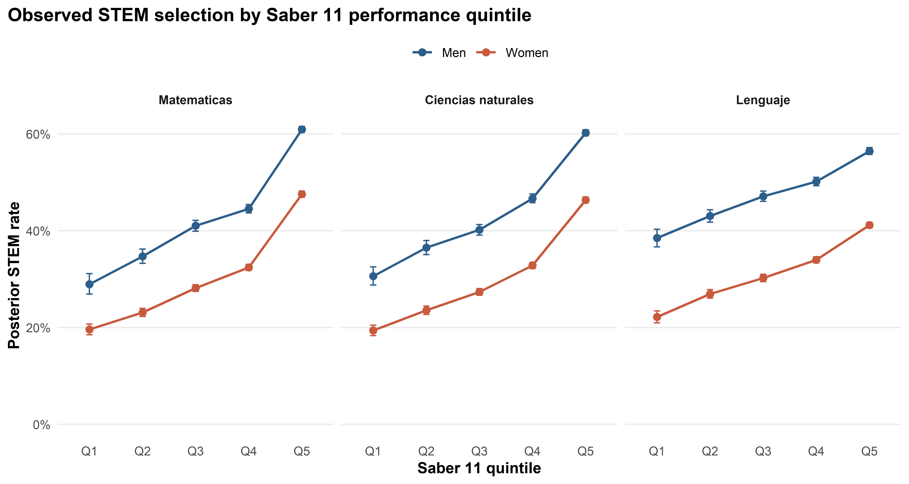
Note. Points represent posterior medians of within-cell beta-binomial models; error bars represent 95% credible intervals. The y-axis shows the posterior STEM enrollment rate. Q1 is the lowest performance quintile and Q5 is the highest. Mathematics (left), natural sciences (center), and language (right) are shown in separate panels. The negative slope for language indicates that higher language performance is associated with lower STEM enrollment rates for both genders.

Bayesian Logistic Regression Estimates

Table 3 presents selected posterior estimates from the Bayesian logistic regression. The main effect of gender (women relative to men) was negative with a posterior median of -0.554 and a 95% credible interval of [-0.715, -0.393], indicating that after controlling for all three performance domains, socioeconomic level, and cohort, women had substantially lower log-odds of STEM enrollment than men.
Mathematics and natural sciences quintiles showed positive and monotonically increasing associations with STEM enrollment. For mathematics, log-odds increased from Q2 through Q5 relative to Q1 (medians: 0.244, 0.472, 0.574, and 1.131). For natural sciences the pattern was similar (medians: 0.201, 0.322, 0.504, and 0.918). Credible intervals excluded zero for all quintile effects in both subjects.
Language/critical reading quintiles showed a negative association with STEM enrollment: higher quintile rankings were associated with lower log-odds of STEM enrollment (medians: -0.073, -0.184, -0.357, and -0.453 for Q2 through Q5), with credible intervals excluding zero for Q3, Q4, and Q5.
Gender-by-performance interactions differed across academic domains. Gender interactions with mathematics quintile were negative (medians: -0.098 to -0.153), though credible intervals included zero for all individual terms. Gender interactions with natural sciences quintile were near zero with wide credible intervals, indicating approximately parallel performance-STEM relationships for men and women in this domain. Gender interactions with language quintile were positive, with credible intervals excluding zero for Q3, Q4, and Q5 (medians: 0.172, 0.245, and 0.229), indicating that women's STEM enrollment probability declined less steeply with higher language performance than men's.

Table 3
Bayesian Logistic Regression Posterior Estimates: Selected Parameters

Parameter | Median | SD | 95% CI LL | 95% CI UL | Prior SD
Intercept | -0.858 | 0.104 | -1.062 | -0.654 | 2.5
Gender (Women) | -0.554 | 0.082 | -0.715 | -0.393 | 1.5
Mathematics quintile (ref. = Q1)
Q2 | 0.244 | 0.064 | 0.119 | 0.370 | 1.5
Q3 | 0.472 | 0.062 | 0.351 | 0.594 | 1.5
Q4 | 0.574 | 0.063 | 0.451 | 0.697 | 1.5
Q5 | 1.131 | 0.065 | 1.005 | 1.258 | 1.5
Natural sciences quintile (ref. = Q1)
Q2 | 0.201 | 0.058 | 0.088 | 0.314 | 1.5
Q3 | 0.322 | 0.056 | 0.213 | 0.431 | 1.5
Q4 | 0.504 | 0.056 | 0.394 | 0.615 | 1.5
Q5 | 0.918 | 0.059 | 0.803 | 1.033 | 1.5
Language quintile (ref. = Q1)
Q2 | -0.073 | 0.051 | -0.173 | 0.026 | 1.5
Q3 | -0.184 | 0.051 | -0.284 | -0.085 | 1.5
Q4 | -0.357 | 0.051 | -0.458 | -0.257 | 1.5
Q5 | -0.453 | 0.053 | -0.557 | -0.350 | 1.5
Gender x Language interactions (ref. = Q1)
Women x Q2 | 0.114 | 0.068 | -0.020 | 0.247 | 1.0
Women x Q3 | 0.172 | 0.068 | 0.039 | 0.305 | 1.0
Women x Q4 | 0.245 | 0.068 | 0.111 | 0.379 | 1.0
Women x Q5 | 0.229 | 0.071 | 0.091 | 0.368 | 1.0
Note. Estimates are posterior medians from Bayesian logistic regression with Laplace approximation (8,000 posterior draws; seed = 20260616). CI = credible interval; LL = lower limit; UL = upper limit; SD = posterior standard deviation; Prior SD = standard deviation of the normal prior. Gender-by-mathematics and gender-by-natural sciences interactions, socioeconomic level, and Saber 11 cohort effects are not shown; full results are available from the corresponding author.

Predicted Probabilities of STEM Enrollment

Figure 2 presents the model-adjusted predicted probabilities of STEM enrollment by gender and performance quintile for each academic domain, with socioeconomic level and Saber 11 cohort fixed at their modal values. Across all three subjects and all performance quintiles, women's predicted STEM enrollment probabilities were lower than men's.
For mathematics, predicted probabilities for men ranged from 23.9% at Q1 (95% CI: 21.6%, 26.3%) to 49.3% at Q5 (95% CI: 47.4%, 51.4%), while women's ranged from 18.2% at Q1 (95% CI: 16.8%, 19.7%) to 37.2% at Q5 (95% CI: 35.7%, 38.8%). For natural sciences, men's probabilities ranged from 26.8% at Q1 to 47.8% at Q5, and women's from 17.9% to 35.5%. For language, predicted probabilities decreased with higher quintile for both genders: men's ranged from 37.7% at Q1 to 27.8% at Q5, and women's from 24.1% at Q1 to 20.2% at Q5. Detailed predicted probabilities with 95% credible intervals are presented in Table 4.

Figure 2
Bayesian Predicted Probability of STEM Enrollment by Gender and Performance Quintile
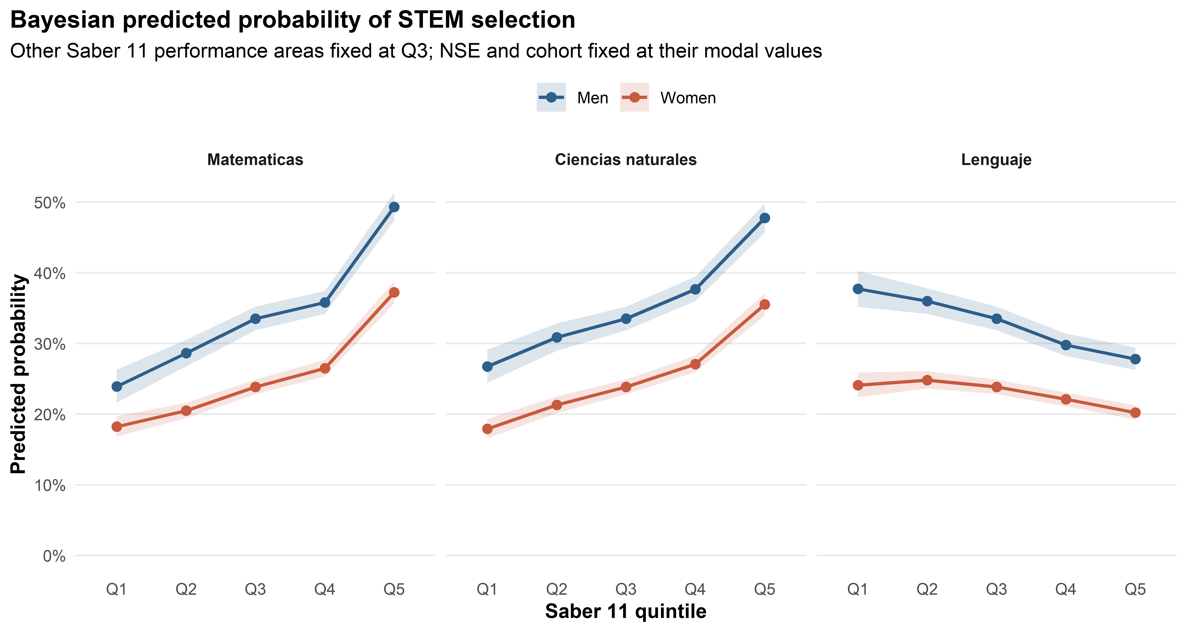
Note. Points represent posterior medians of predicted STEM enrollment probabilities; shaded ribbons represent 95% credible intervals. Predictions are computed with other performance areas fixed at Q3 and with socioeconomic level and Saber 11 cohort fixed at modal values. Mathematics (left), natural sciences (center), and language (right) are shown in separate panels.

Table 4
Bayesian Predicted STEM Enrollment Probabilities (%) by Gender and Performance Quintile

Subject | Gender | Q1 | Q2 | Q3 | Q4 | Q5
Mathematics | Men | 23.9 [21.6, 26.3] | 28.6 [26.8, 30.5] | 33.5 [31.9, 35.2] | 35.8 [34.2, 37.5] | 49.3 [47.4, 51.4]
 | Women | 18.2 [16.8, 19.7] | 20.5 [19.4, 21.6] | 23.9 [22.8, 24.9] | 26.5 [25.4, 27.7] | 37.2 [35.7, 38.8]
Natural Sciences | Men | 26.8 [24.5, 29.1] | 30.9 [29.0, 32.9] | 33.5 [31.9, 35.2] | 37.7 [36.0, 39.5] | 47.8 [45.7, 49.8]
 | Women | 17.9 [16.6, 19.3] | 21.3 [20.2, 22.5] | 23.9 [22.8, 24.9] | 27.1 [26.0, 28.3] | 35.5 [34.0, 37.1]
Language | Men | 37.7 [35.2, 40.2] | 36.0 [34.2, 37.9] | 33.5 [31.9, 35.2] | 29.8 [28.2, 31.4] | 27.8 [26.3, 29.5]
 | Women | 24.1 [22.4, 25.9] | 24.8 [23.7, 26.1] | 23.9 [22.8, 24.9] | 22.1 [21.1, 23.1] | 20.2 [19.2, 21.3]
Note. Values are posterior median predicted probabilities (%) with 95% credible intervals in brackets. Predictions are computed with other performance areas held at Q3 and covariates at modal values.

Gender Contrasts at the Same Performance Quintile

The posterior distribution of the gender difference in predicted STEM enrollment probability (women minus men) was computed for each subject and quintile. As shown in Figure 3 and Table 5, these differences were consistently negative across all 15 subject-quintile combinations.
For mathematics, the gender gap in predicted STEM probability ranged from -5.7 percentage points (pp) at Q1 (95% CI: -8.4, -3.1) to -12.1 pp at Q5 (95% CI: -14.5, -9.7). For natural sciences, the gap ranged from -8.8 pp at Q1 (95% CI: -11.5, -6.2) to -12.2 pp at Q5 (95% CI: -14.7, -9.8). For language, gaps ranged from -7.6 pp at Q5 (95% CI: -9.5, -5.8) to -13.6 pp at Q1 (95% CI: -16.6, -10.6). The posterior probability that women's STEM enrollment probability was lower than men's was 1.00 for all 15 combinations (Table 5), and no comparison fell within the 1-pp practical equivalence region.

Figure 3
Posterior Gender Difference in STEM Enrollment Probability at the Same Performance Quintile
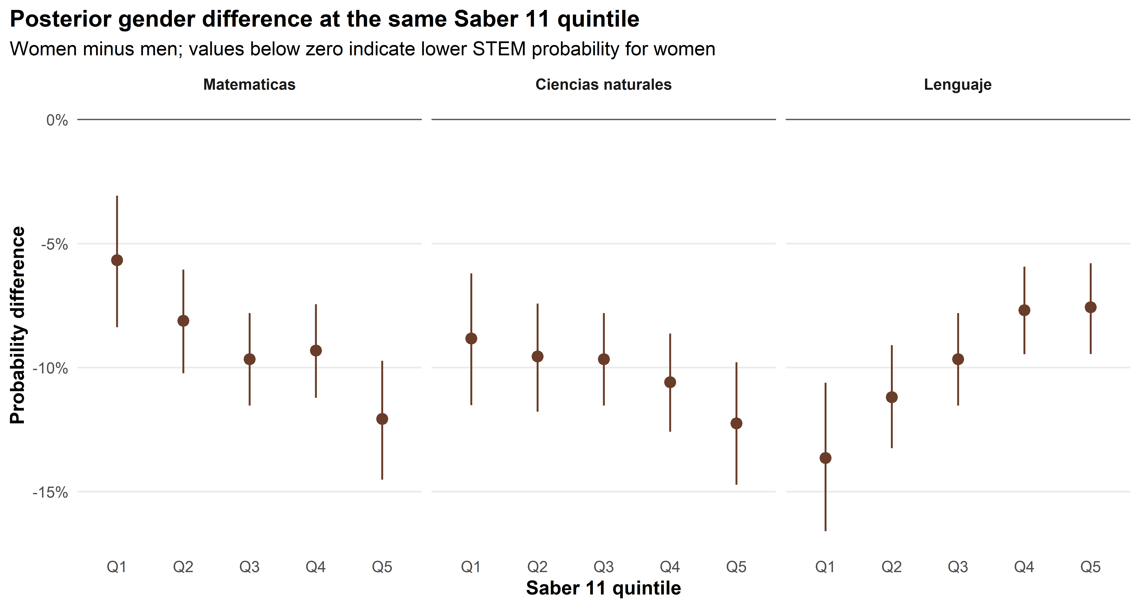
Note. Points represent posterior medians of the gender difference in predicted STEM probability (women minus men) at each quintile; vertical lines represent 95% credible intervals. Values below zero indicate lower STEM enrollment probability for women relative to men at the same quintile. The horizontal reference line at zero marks the point of equality. Mathematics (left), natural sciences (center), and language (right) are shown in separate panels.

Table 5
Posterior Gender Differences in STEM Enrollment Probability at the Same Performance Quintile

Subject | Q | Difference (pp) | 95% CI LL | 95% CI UL | Pr(Women < Men)
Mathematics | Q1 | -5.7 | -8.4 | -3.1 | 1.000
 | Q2 | -8.1 | -10.2 | -6.1 | 1.000
 | Q3 | -9.7 | -11.5 | -7.8 | 1.000
 | Q4 | -9.3 | -11.2 | -7.4 | 1.000
 | Q5 | -12.1 | -14.5 | -9.7 | 1.000
Natural Sciences | Q1 | -8.8 | -11.5 | -6.2 | 1.000
 | Q2 | -9.5 | -11.8 | -7.4 | 1.000
 | Q3 | -9.7 | -11.5 | -7.8 | 1.000
 | Q4 | -10.6 | -12.6 | -8.6 | 1.000
 | Q5 | -12.2 | -14.7 | -9.8 | 1.000
Language | Q1 | -13.6 | -16.6 | -10.6 | 1.000
 | Q2 | -11.2 | -13.2 | -9.1 | 1.000
 | Q3 | -9.7 | -11.5 | -7.8 | 1.000
 | Q4 | -7.7 | -9.5 | -5.9 | 1.000
 | Q5 | -7.6 | -9.5 | -5.8 | 1.000
Note. Difference = women minus men in predicted STEM probability at the same quintile, in percentage points (pp). CI = credible interval; LL = lower limit; UL = upper limit. Pr(Women < Men) = posterior probability that women's STEM enrollment probability is lower than men's at the same quintile. All comparisons yielded Pr = 1.00; none fell within the 1-pp region of practical equivalence.

One-Quintile Offset Comparisons

Table 6 and Figure 4 present the one-quintile offset contrasts, comparing the predicted STEM enrollment probability of women at quintile k+1 to men at quintile k. These contrasts directly operationalize the hypothesis that women must demonstrate higher academic performance than men to achieve equivalent STEM enrollment probabilities.
For mathematics, three of the four offset contrasts were negative: women at Q2 relative to men at Q1 yielded a difference of -3.4 pp (95% CI: -6.0, -0.9; Pr(Women > Men) = 0.003); women at Q3 relative to men at Q2, -4.8 pp (95% CI: -6.8, -2.7; Pr = 0.000); and women at Q4 relative to men at Q3, -7.0 pp (95% CI: -8.9, -5.1; Pr = 0.000). The fourth comparison, women at Q5 versus men at Q4, was the sole positive contrast across all subjects and quintile pairs: +1.4 pp (95% CI: -0.7, +3.6; Pr(Women > Men) = 0.903). This indicates that only at the highest mathematics performance quintile do women's predicted STEM enrollment probabilities exceed those of men one quintile below them.
For natural sciences, all four offset contrasts were negative. Even when women were one quintile above men in science performance, they showed lower STEM enrollment probabilities in three of four comparisons with high posterior certainty, and in the fourth comparison (Women Q5 vs. Men Q4: -2.2 pp, 95% CI: -4.4, 0.1) remained negative with 97.2% posterior probability.
For language, all four offset contrasts were negative and larger in magnitude than those for mathematics or natural sciences. Contrasts ranged from -9.6 pp for Women Q5 versus Men Q4 (95% CI: -11.4, -7.8; Pr(Women > Men) = 0.000) to -12.9 pp for Women Q2 versus Men Q1. These larger magnitudes reflect the inverse relationship between language performance and STEM enrollment combined with the baseline gender gap in STEM selection.

Table 6
One-Quintile Offset Contrasts: Women at Quintile k+1 versus Men at Quintile k

Subject | Comparison | Diff. (pp) | 95% CI LL | 95% CI UL | Pr(Women > Men)
Mathematics | Women Q2 vs. Men Q1 | -3.4 | -6.0 | -0.9 | 0.003
 | Women Q3 vs. Men Q2 | -4.8 | -6.8 | -2.7 | 0.000
 | Women Q4 vs. Men Q3 | -7.0 | -8.9 | -5.1 | 0.000
 | Women Q5 vs. Men Q4 | +1.4 | -0.7 | +3.6 | 0.903
Natural Sciences | Women Q2 vs. Men Q1 | -5.4 | -8.0 | -2.9 | 0.000
 | Women Q3 vs. Men Q2 | -7.0 | -9.1 | -4.9 | 0.000
 | Women Q4 vs. Men Q3 | -6.4 | -8.3 | -4.5 | 0.000
 | Women Q5 vs. Men Q4 | -2.2 | -4.4 | 0.1 | 0.028
Language | Women Q2 vs. Men Q1 | -12.9 | -15.5 | -10.2 | 0.000
 | Women Q3 vs. Men Q2 | -12.2 | -14.1 | -10.1 | 0.000
 | Women Q4 vs. Men Q3 | -11.4 | -13.3 | -9.6 | 0.000
 | Women Q5 vs. Men Q4 | -9.6 | -11.4 | -7.8 | 0.000
Note. Difference = predicted STEM enrollment probability for women at quintile k+1 minus men at quintile k, in percentage points (pp). CI = credible interval; LL = lower limit; UL = upper limit. Pr(Women > Men) = posterior probability that women's STEM probability exceeds men's in the offset comparison. The only positive contrast is Women Q5 vs. Men Q4 in mathematics.

Figure 4
One-Quintile Offset Contrasts: Women at Performance Quintile k+1 versus Men at Quintile k
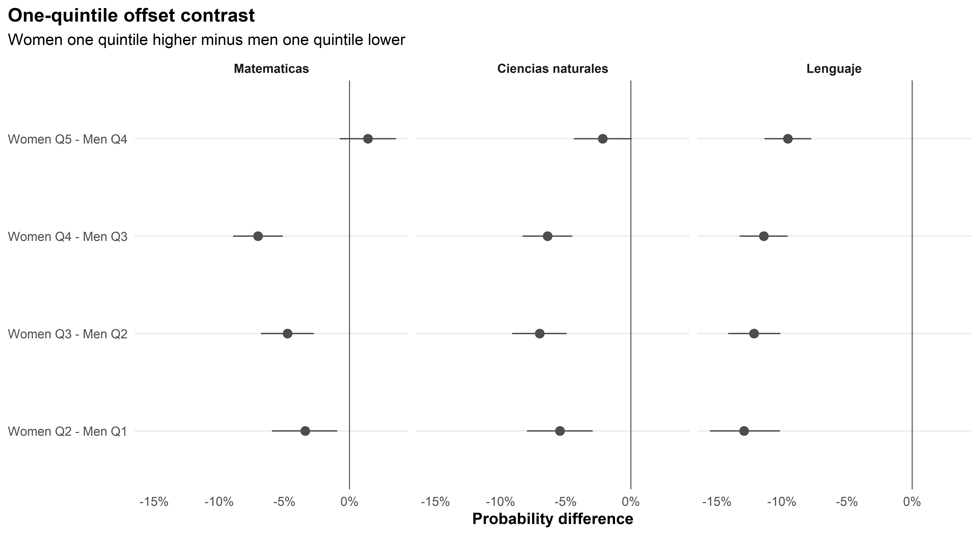
Note. Points represent posterior medians of the difference in predicted STEM probability (women at quintile k+1 minus men at quintile k); vertical lines represent 95% credible intervals. The horizontal reference line at zero marks the point of equality. Values below zero indicate that women performing one quintile above men still show a lower STEM enrollment probability. Mathematics (left), natural sciences (center), and language (right) are shown in separate panels.

Discussion

The results of this study address a central question in the literature on gender and STEM career selection: do women and men with equivalent high school academic performance choose STEM fields in higher education at similar rates? The answer, based on a nationally representative sample of 126,366 Colombian higher education students linked to their Saber 11 performance records, is that women showed consistently lower predicted STEM enrollment probabilities than men across the full performance distribution and across all three academic domains examined. This finding held after adjustment for socioeconomic level and Saber 11 cohort, and was not confined to any particular performance level. The posterior probability that women's STEM enrollment was lower than men's was 1.00 at every subject-quintile combination, with no comparison approaching practical equivalence.
The offset contrast analyses further refined this picture by directly quantifying whether women require higher academic performance than men to reach comparable STEM enrollment probabilities. In the majority of comparisons, women at one performance quintile above men still showed lower or equivalent STEM enrollment probabilities. The sole exception was the highest mathematics quintile comparison, where women at Q5 marginally exceeded men at Q4 in predicted STEM probability. For natural sciences, women at Q5 remained below men at Q4 with 97.2% posterior certainty. For language, women at every quintile above men remained substantially below men's predicted STEM probability, with the gap exceeding 9 percentage points even in the most favorable offset comparison. These results support the hypothesis that gender differences in STEM enrollment are not reducible to academic performance differences and that women face a higher effective threshold for STEM career selection than men across most of the performance distribution.
These findings are broadly consistent with theoretical arguments emphasizing the role of non-academic factors in STEM career selection. The expectancy-value model (Eccles, 2011) posits that career choices depend on subjective expectancy of success and the perceived value of different occupational paths. Research has consistently documented that women, relative to men with comparable academic preparation, report lower mathematics self-efficacy and assign lower value to STEM occupations (Pajares, 2005). The persistence of the gender gap across the full performance distribution in the present data is consistent with this account: the gap is not confined to lower performance levels but extends to the highest achievers, suggesting that it operates through mechanisms other than academic preparation. The brilliance-required hypothesis (Leslie et al., 2015) offers a complementary interpretation: when fields are perceived as demanding exceptional innate talent, cultural stereotypes associating intellectual brilliance with men may selectively discourage women from entering, independent of actual academic capability.
The negative association between language performance and STEM enrollment, and the finding that this association was weaker for women than for men, merits separate consideration. Among men, high language proficiency appears to exert a stronger pull toward non-STEM fields, perhaps reflecting a pattern in which men with high verbal skills are redirected toward humanities and social sciences. For women, this channeling effect was attenuated, with positive gender-by-language interactions that were credible for Q3 through Q5. One interpretation is that the occupational profile of high-language-ability individuals differs between genders, or that high-language-ability women retain broader occupational aspirations that are not captured by the simplified STEM/non-STEM distinction. This interaction warrants further investigation in studies that can examine field-of-study choices at a more granular level.
Several limitations should be acknowledged. First, the analytic sample is restricted to students who entered higher education and completed the Saber Pro assessment, which does not represent all Saber 11 graduates. If transitions into higher education differ systematically by gender and performance level, the findings characterize STEM selection among those already enrolled in higher education rather than among all secondary graduates. Second, the analysis draws on administrative records and does not include direct measures of self-efficacy, STEM identity, family expectations, or peer influences that theories of career choice identify as proximate determinants of field selection. The observed gender differences net of academic performance are consistent with such factors but cannot be causally attributed to specific mechanisms on the basis of these data. Third, the Laplace approximation to the posterior may underestimate uncertainty for interaction terms with limited data, and sensitivity analyses using full Markov chain Monte Carlo methods would provide additional assurance about posterior summaries. Fourth, the broad STEM classification used here masks potentially important heterogeneity across sub-disciplines, with gender differences likely varying considerably between engineering, health sciences, and mathematics programs.
The findings have practical implications for educational equity policy in Colombia and Latin America more broadly. The persistence of gender differences in STEM enrollment net of academic performance suggests that strategies aimed solely at improving women's preparation in mathematics and science are unlikely to close the STEM gender gap. Complementary interventions addressing self-efficacy beliefs, challenging stereotypes about who belongs in STEM, providing access to role models, and creating inclusive STEM learning environments are likely necessary (Cheryan et al., 2017). Programs that identify and support high-performing women in mathematics and science may be particularly valuable, given the finding that the gender gap narrows substantially at the highest performance level in mathematics. Institutional policies that reduce structural barriers to STEM entry and persistence, including mentoring programs and targeted outreach to women with strong academic profiles in STEM-relevant subjects, may also contribute to more equitable enrollment patterns.

Conclusion

This study used Bayesian logistic regression to examine gender differences in STEM career selection in Colombian higher education, with high school academic performance operationalized as within-cohort quintile rankings in mathematics, natural sciences, and language. The data revealed consistent and sizable gender differences in STEM enrollment probabilities across the full performance distribution, with women showing lower predicted STEM probabilities than men at every quintile and for every academic subject examined. One-quintile offset contrast analyses demonstrated that women achieving one performance quintile above men still showed lower STEM enrollment probabilities in all but one subject-quintile comparison. These results indicate that academic performance differences do not account for observed gender differences in STEM career selection in Colombia, and that non-academic factors shape the gender gap in STEM enrollment. Future research should examine the specific mechanisms through which these differences arise, including self-efficacy beliefs, occupational stereotypes, social influences, and institutional structures that may differentially shape STEM participation. The present findings underscore that equitable STEM participation requires attention to factors well beyond academic preparation.

References

Botello-Penaloza, H. A., & Rondon-Quintero, J. A. (2021). Gender and academic performance in standardized tests in Colombia. Lecturas de Economia, 94, 127-158. https://doi.org/10.17533/udea.le.n94a338

Cheryan, S., Ziegler, S. A., Montoya, A. K., & Jiang, L. (2017). Why are some STEM fields more gender balanced than others? Psychological Bulletin, 143(1), 1-35. https://doi.org/10.1037/bul0000052

Cvencek, D., Meltzoff, A. N., & Greenwald, A. G. (2011). Math-gender stereotypes in elementary school children. Child Development, 82(3), 766-779. https://doi.org/10.1111/j.1467-8624.2010.01529.x

Dekhtyar, S., Weber, D., Helgertz, J., & Herlitz, A. (2018). Sex differences in academic strengths contribute to gender segregation in education and occupation: A longitudinal examination of 167,776 individuals. Intelligence, 67, 84-92. https://doi.org/10.1016/j.intell.2017.11.007

Eccles, J. S. (2011). Gendered educational and occupational choices: Applying the Eccles et al. expectancy-value model. Journal of Social Issues, 67(3), 644-663. https://doi.org/10.1111/j.1540-4560.2011.01712.x

Gelman, A., Carlin, J. B., Stern, H. S., Dunson, D. B., Vehtari, A., & Rubin, D. B. (2013). Bayesian data analysis (3rd ed.). CRC Press.

Good, C., Rattan, A., & Dweck, C. S. (2012). Why do women opt out? Sense of belonging and women's representation in mathematics. Journal of Personality and Social Psychology, 102(4), 700-717. https://doi.org/10.1037/a0026659

Hyde, J. S., Lindberg, S. M., Linn, M. C., Ellis, A. B., & Williams, C. C. (2008). Gender similarities characterize math performance. Science, 321(5888), 494-495. https://doi.org/10.1126/science.1160364

Kruschke, J. K. (2015). Doing Bayesian data analysis: A tutorial with R, JAGS, and Stan (2nd ed.). Academic Press.

Leslie, S.-J., Cimpian, A., Meyer, M., & Freeland, E. (2015). Expectations of brilliance underlie gender distributions across academic disciplines. Science, 347(6219), 262-265. https://doi.org/10.1126/science.1261375

Mann, A., & DiPrete, T. A. (2013). Trends in gender segregation in the choice of science and engineering majors. Social Science Research, 42(6), 1519-1541. https://doi.org/10.1016/j.ssresearch.2013.07.002

McElreath, R. (2020). Statistical rethinking: A Bayesian course with examples in R and Stan (2nd ed.). CRC Press.

OECD. (2023). Education at a glance 2023. OECD Publishing. https://doi.org/10.1787/e13bef63-en

Pajares, F. (2005). Gender differences in mathematics self-efficacy beliefs. In A. M. Gallagher & J. C. Kaufman (Eds.), Gender differences in mathematics (pp. 294-315). Cambridge University Press.

Reilly, D., Neumann, D. L., & Andrews, G. (2019). Gender differences in reading and writing achievement: Evidence from the National Assessment of Educational Progress (NAEP). American Psychologist, 74(4), 445-458. https://doi.org/10.1037/amp0000356

Stoet, G., & Geary, D. C. (2018). The gender-equality paradox in science, technology, engineering, and mathematics education. Psychological Science, 29(4), 581-593. https://doi.org/10.1177/0956797617741719

UNESCO. (2021). Women in science. UNESCO Institute for Statistics. https://doi.org/10.15220/978-92-9189-247-7

Wang, M.-T., Eccles, J. S., & Kenny, S. (2013). Not lack of ability but more choice: Individual and gender differences in choice of careers in science, technology, engineering, and mathematics. Psychological Science, 24(5), 770-775. https://doi.org/10.1177/0956797612458937

