PCSPF
TECHNICAL VALIDATION REPORT
Port-Corridor SME Performance Framework
Operations Toolkit v1.1 | Microsoft Excel | U.S. market conventions
Deterministic logic • Ledger reconciliation • Evidence limits • Field-readiness controls

Illustrative performance interface — actual workbook preview
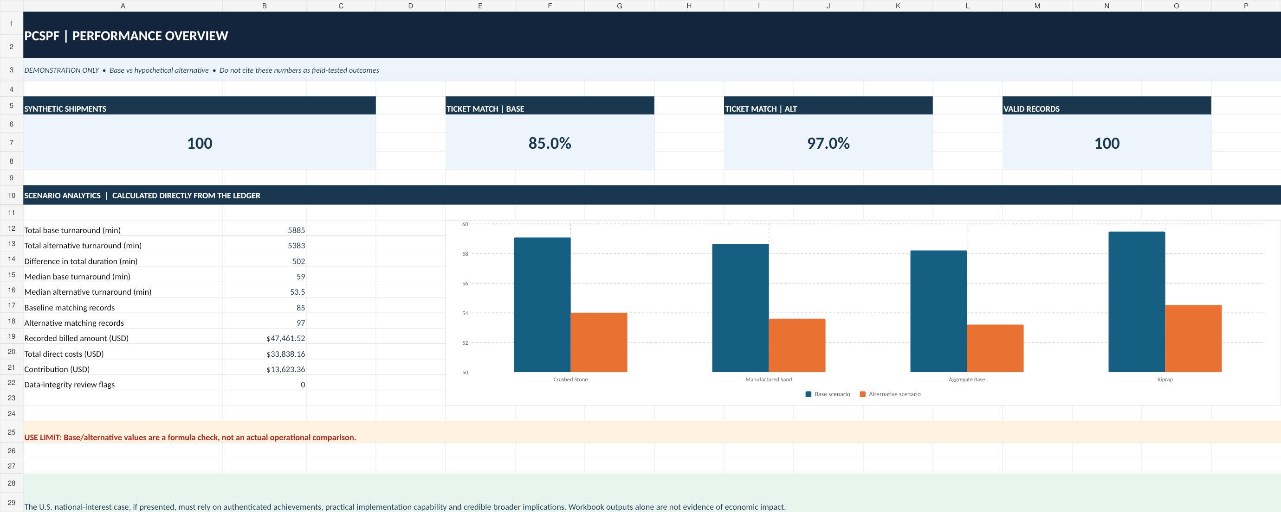
VERIFICATION SCOPE / NO EXTERNAL ATTESTATION
The conclusions address the supplied, unchanged 100-record synthetic workbook and selected spreadsheet controls. This is an internal analytical verification, not an independent expert opinion, a real U.S. pilot, a financial audit, or a certification of economic impact.

Release date: November 9, 2026 | Project owner: Ricardo Lopes Wiest
Companion files: PCSPF_v1_1_US_Operations_Toolkit_QA_Corrected.xlsx; PCSPF_v1_0_User_and_Implementation_Guide_EN.docx

01 Executive verification conclusion
OUTCOME • PASS, BOUNDED TO THE ORIGINAL SYNTHETIC SAMPLE
All 13 built-in reference checks report PASS on the unmodified workbook. An independent recomputation of the prescribed sample and of the main ledger rollups confirms those reference values. This conclusion does not extend to production reliability, real-world business results or national-scale use.

Disposition | Finding | Interpretation
PASS | 13 of 13 workbook QA reference checks | Original 100-record deterministic data only.
PASS | Independent computational reproduction | Shipment counts, constructed times, ticket matches, cost totals and product summaries.
PASS | Internal arithmetic reconciliation | Billing = recorded direct costs + calculated contribution, within monetary rounding.
LIMITED | Direct source-data guardrails | Selected negative numeric values raised row-level CHECK; comprehensive robustness is not established.
PASS (INTERNAL) | Dynamic QA propagation following adverse edits | Four controlled edits triggered expected row-level and dependent QA/dashboard changes; separately confirmed after .xlsx reimport. Native Excel and external verification are still pending.
NOT TESTED | Field effectiveness / independent adoption | No real company data, operating trial, independent technical opinion, or U.S. adopter.

Verified reference values
Measure | Result | Meaning
Synthetic shipments | 100 | Four commodities; 25 each.
Ticket reference matches | 85 base / 97 alternative | Constructed scenarios, not a recorded field change.
Turnaround totals | 5,885 / 5,383 minutes | 502-minute programmed difference; not savings.
Turnaround medians | 59.0 / 53.5 minutes | Medians not additive.
Billed amount / direct costs | US$ 47,461.52 / US$ 33,838.16 | Amounts are fictional.
Direct contribution | US$ 13,623.36 | Not profit, EBITDA, or cash generation.

02 Review object, artifacts and provenance
The review concerns the corrected v1.1 workbook issued November 9, 2026. The review used its actual formulas and calculated values, the QA TESTS sheet, independent reconstruction of the 100 synthetic transactions, and controlled adverse-input mutation tests. No third-party company supplied operational data or results.
Property | Verified record
Primary artifact | PCSPF_v1_1_US_Operations_Toolkit_QA_Corrected.xlsx
Analytical coverage | 100 synthetic loads; 12 synthetic equipment-period records.
Reference as-of date | November 9, 2026; CONTROL!B7.
Workbook worksheets | 12 named worksheets, including TRANSACTIONS, EQUIPMENT LOG, DASHBOARD and QA TESTS.
Transaction input / output | TRANSACTIONS!A7:V206 / W7:AL206; rows 7–106 populated.
Equipment input / output | EQUIPMENT LOG!A7:K46 / L7:R46; rows 7–18 populated.
Baseline specification | Professional Plan, Chapters 4, 15, 16 and 22–23.
Review purpose | Demonstrate selected arithmetic and control behavior; identify limitations for external review.

File identity and reproducibility
SHA-256 (workbook byte-for-byte reference):
687790b8141c21f635585bcf2278055ab9ae4a8d17bd8689616d0e04d23c7caf
The checksum binds this report to the corrected v1.1 workbook release, not to later edited copies. Any change to the file requires a new checksum, revision record and fresh QA results.
AUDIT AUTHORSHIP AND ASSURANCE
This document records an internal technical assessment. It is not signed by an independent U.S. expert, a certified public accountant, an engineering specialist or a law firm. Any third-party reviewer must conduct and document their own tests.

03 Methodology and test boundaries

Review procedure
Step | Procedure | Evidence
1 | Import supplied .xlsx; inspect source input ranges and formula-driven summary cells. | Workbook read-back.
2 | Read 13 fixed expected values and statuses from QA TESTS!A7:D19. | Reference acceptance matrix.
3 | Recompute synthetic durations and invoice-reference matches independently from the specified arithmetic recipe. | 100-record Python verification.
4 | Independently sum billing, direct costs, contribution and commodity groupings from ledger inputs. | Cross-tab reconciliation.
5 | Inspect receivable classifications and independent equipment-ledger count. | A/R and fleet controls.
6 | Apply four negative/adverse changes in a temporary in-memory copy; inspect both row-level and dependent dashboard/QA values, then restore original data and verify clean result. | Mutation audit: duplicate ID; invoice-ticket mismatch; negative quantity; negative equipment fuel.

Acceptance criteria
- The unchanged sample must return all 13 programmed expected values; each formula result must display PASS.
- Independent recomputation must agree with sample definitions and summary amounts to practical rounding precision.
- No field effects, adoption or financial savings may be inferred from a constructed alternative scenario.
- Any failed, untested or non-reproduced feature must be reported explicitly rather than presumed operational.
CRITICAL DISTINCTION
A successful computational smoke test demonstrates that a specific sample is internally coherent. It does not establish that the same workbook safely handles messy client data or that a control intervention improves a real company.

04 Reference acceptance matrix: 13 checks
Check | Observed | Expected | Result
Sample shipment count | 100 | 100 | PASS
Baseline matched tickets | 85 | 85 | PASS
Alternative matched tickets | 97 | 97 | PASS
Base duration sum, min | 5,885 | 5,885 | PASS
Alternative duration sum, min | 5,383 | 5,383 | PASS
Median base turnaround, min | 59 | 59 | PASS
Median alternative turnaround, min | 53.5 | 53.5 | PASS
Total base/alternative difference, min | 502 | 502 | PASS
Duplicate shipment IDs | 0 | 0 | PASS
Transaction integrity exceptions | 0 | 0 | PASS
Equipment integrity exceptions | 0 | 0 | PASS
Total loads across products | 100 | 100 | PASS
Accounts receivable count | 100 | 100 | PASS

ACCEPTANCE DECISION
13 / 13 checks passed for the fixed synthetic reference. Acceptance tests verify arithmetic and selected invariants only. The expected-value table must be redesigned before loading real-company data.

Trace locations
Reference checks: QA TESTS!A7:E19; aggregate gate: QA TESTS!A22:D22. The source cohort occupies TRANSACTIONS rows 7–106 and EQUIPMENT LOG rows 7–18. Check names and results reproduce the worksheet, not an externally certified test report.

05 Deterministic reproduction and data logic
The Professional Plan specifies integer IDs SYN-001 through SYN-100 with deterministic arithmetic. For i = 1..100, the synthetic baseline duration is 40 + 4 × (i mod 9) + (i mod 7); the alternative is baseline − ((7i) mod 11). Baseline matching holds when i mod 13 is neither 0 nor 1; alternative matching holds when i mod 31 is not 0.
Independent computation | Reference result | Verification
Sample indices | 1–100 | 100 unique source IDs.
Matching invoice/ticket references | 85 vs. 97 | Derived from exact reference logic.
Summed scenario minutes | 5,885 vs. 5,383 | Summation of all 100 durations.
Medians | 59.0 vs. 53.5 minutes | Computed on complete distributions.
Programmed difference | 502 minutes | 5,885 − 5,383.
Unresolved core input errors in sample | 0 | No displayed CHECK in populated synthetic rows.

Selected workbook formulas
Target field | Core rule / restriction
TRANSACTIONS W/X | 1 if the source load-ticket identifier exactly matches the scenario invoice reference; else 0.
TRANSACTIONS Y/Z | Rounded minutes = (departure timestamp − arrival timestamp) × 1,440.
TRANSACTIONS AL | Base duration − alternative duration, computed per row.
DASHBOARD B12:B18 | Sums, medians and match counts read from calculated transaction rows.
TRANSACTIONS AK | Selected missingness, nonnegative amount, positive-hour and timestamp-order rules.

INTERPRETATION GUARDRAIL
The alternative dataset was generated to differ from baseline. The 502-minute difference and the 12-point match-rate increase are not experimentally measured improvements and may not be represented as business savings.

06 Dispatch analytics
All four commodity groups contain 25 synthetic loads. The chart reproduces the baseline and alternative average turnaround from DISPATCH ANALYSIS!A7:H12. It illustrates summary logic and is not a field performance comparison.
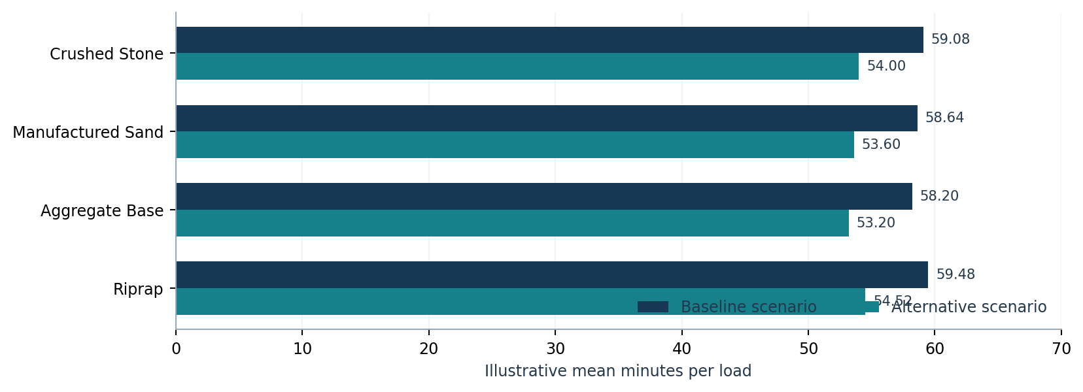
Product | Base total | Alt total | Constructed delta
Crushed Stone | 1,477 min | 1,350 min | 127 min
Manufactured Sand | 1,466 min | 1,340 min | 126 min
Aggregate Base | 1,455 min | 1,330 min | 125 min
Riprap | 1,487 min | 1,363 min | 124 min
ALL | 5,885 min | 5,383 min | 502 min

The arithmetic average is 58.85 minutes per baseline load and 53.83 minutes per alternative load. The median comparisons (59.0 and 53.5) are separate distribution measures. Neither method establishes causation without actual source transactions and defensible comparisons.

07 Financial ledger reconciliation
The workbook records fictional billed amounts and three types of direct cost. Independent recomputation of the 100 inputs yields the same financial totals as DASHBOARD and COST MODEL.
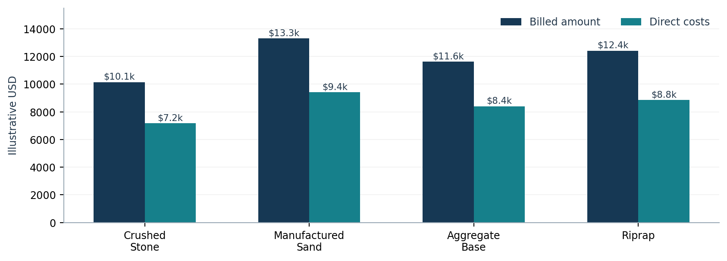
Cost bridge | Illustrative USD
Billed amount | $47,461.52
Material cost | $28,023.36
Freight cost | $5,002.30
Other direct cost | $812.50
Total direct cost | $33,838.16
Calculated direct contribution | $13,623.36
Contribution / billed amount | 28.70%

ACCOUNTING CLASSIFICATION
Direct contribution excludes corporate overhead, depreciation, income taxes, interest, financing costs and fixed-cost allocations. Fuel/equipment records are not automatically allocated to direct costs. Do not label these results as net income, EBITDA, cash flow, verified savings or GAAP financial statements.

08 Receivables and equipment calculations
The receivables ledger classifies all 100 synthetic invoices as of the fixed CONTROL!B7 date. The classification, amount totals and paid-invoice lag were inspected against the workbook.
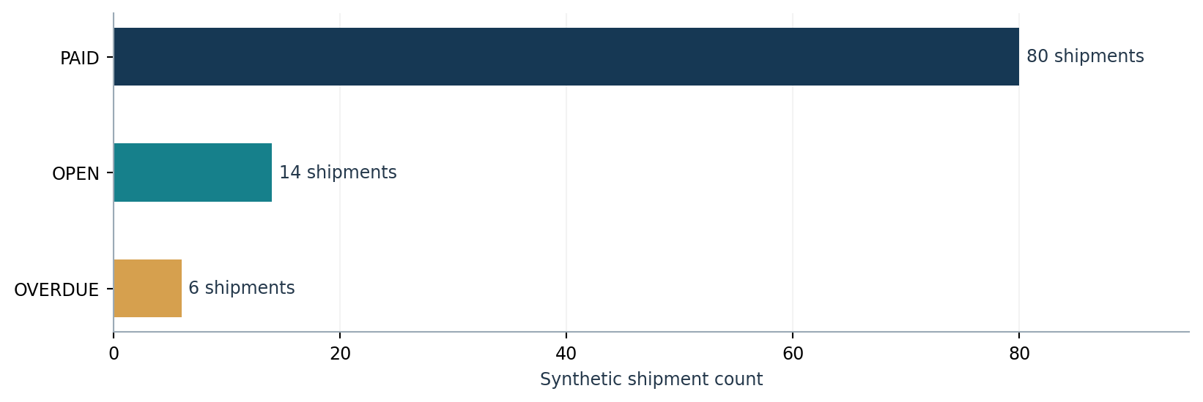
Status | Shipments | Illustrative billed amount
PAID | 80 | $37,718.24
OPEN | 14 | $6,705.41
OVERDUE | 6 | $3,037.87
ALL | 100 | $47,461.52

The mean time to collect for paid invoices is 15.675 days. This is not Days Sales Outstanding (DSO). Unpaid receivables total $9,743.28, based on the demonstration as-of date. An updated review date changes the classification context.

Equipment ledger
A separate set of 12 synthetic equipment-period records uses productive/idle hours, liters consumed, reported tonnage and fuel rate. Calculations include utilization, fuel intensity and sample fuel cost. Its numbers are not reconciled to TRANSACTIONS fuel inputs. It is incorrect to aggregate or combine them as a single cost pool.

09 Integrity, sensitivity and recalculation findings
The unchanged synthetic input sample contains zero duplicate shipment IDs, zero transaction CHECK flags and zero equipment CHECK flags. These outcomes are directly reflected in QA TESTS; they do not prove that all anomalous inputs would be detected.
Limited test in a temporary copy | Observed behavior | Disposition
Negative shipment quantity in TRANSACTIONS row 7 | Row-level data integrity changed to CHECK; aggregate exception count became 1 and QA status FAIL. | PASS (INTERNAL)
Negative equipment fuel in EQUIPMENT LOG row 7 | Equipment QA changed to CHECK; aggregate equipment exception count became 1 and QA status FAIL. | PASS (INTERNAL)
Duplicate shipment ID in row 8 | Both affected rows flagged DUPLICATE; QA duplicate count rose from 0 to 2; overall QA changed PASS → FAIL. | PASS (INTERNAL)
Modified baseline invoice-reference match | Changing matched invoice reference on row 8 lowered matching count 85 → 84 and dashboard match rate 85% → 84%; test status changed to FAIL. | PASS (INTERNAL)

CORRECTIVE TEST RESULT — INTERNAL PASS
The original duplicate-ID summary used a COUNTIF array operation inside SUMPRODUCT that did not respond to controlled data edits in the workbook evaluation environment. Version 1.1 uses a transparent row-level uniqueness formula in TRANSACTIONS column AM and counts flagged rows in QA TESTS. Controlled tests of duplicate IDs, mismatched ticket reference, negative shipment quantity and negative equipment fuel now propagated to the expected quality-control outputs. The corrected .xlsx was reimported and the duplicate case retested successfully. These internal tests do not replace a full native Microsoft Excel regression or external review.

Additional checks not covered by the 13 reference tests
- Ticket and invoice uniqueness across different shipments, not only duplicate shipment IDs.
- Authorization to issue invoices, invoice-value matching to accounting records and evidence of receipt.
- Invalid dates, timezone changes, exceptional service conditions and cross-ledger fuel allocation.
- Formula coverage after inserting, deleting or sorting rows; recovery after file corruption or accidental input over formula cells.

10 Known limitations and risk register
Risk | Why it matters | Required control
Synthetic evidence | Fabricated numbers have no business-effect inference. | State synthetic at every public use.
Alternative scenario | Constructed improvements are not observed pre/post. | Replace with controlled field study.
Reference-specific QA | Hardcoded expected values fit one original cohort. | Build adaptable unit tests for live data.
Limited input constraints | A PASS cannot prove completeness, identity or source authenticity. | Introduce independent source audit and anomaly tests.
Unlinked equipment costs | Potential omission/double counting if misused. | Source-based equipment allocation policy.
Limited row coverage | Formula blocks end at transaction row 206 and equipment row 46. | Capacity regression before scaling.
Static as-of date | Receivable classification becomes stale over time. | Controlled date update and freeze.
No access-control guarantee | Excel is a file, not a governed database. | Protect source records and access rights.
No independent assessment | Present report is internally produced. | Third-party review and signed findings.

Immediate risk decision
RELEASE CLASSIFICATION
Suitable for demonstration, training, formula inspection and discussion with potential reviewers. Not suitable for live production data, audit assurance, investment decisions, claimed operational savings or substantiation of U.S. national importance without additional independent evidence.

11 Proposed real-company validation protocol
This is a prospective protocol consistent with the Professional Plan; it has not yet been conducted. Actual data collection requires written permission, confidentiality controls and, where the work occurs in the United States, appropriate immigration and professional authorization.
Gate | Minimum evidence | Acceptance decision
G1 Authorized access | Signed scope, data controller, purpose, confidentiality and permitted retention. | No source access without authorization.
G2 Baseline mapping | Preserved ticket, billing, dispatch and equipment source extracts; defined units. | Reject unexplained field gaps.
G3 Pretest baseline | At least 8 weeks of usable baseline where feasible (§16.1). | Document exceptions and mix changes.
G4 Controlled action | Named business process owner, approved change date, safety review. | No unapproved changes.
G5 Follow-up | At least 8 weeks under comparable definitions where feasible. | Do not imply causation without defensible design.
G6 External verification | Independent professional reproduces measures; records adverse findings. | Report null results and limitations.

Minimum output package for a defensible pilot
- Source-to-field mapping, dated data dictionary, chain-of-custody record and permission letter.
- Versioned Excel file, read-only source extracts, frozen metric definitions and automated test records.
- Baseline/post-period reconciliation, sample-size disclosure, source completeness, confounder log and unfavorable outcomes.
- Reviewer's dated technical observations, reproducibility notes, qualifications and authorized release permission.

12 Relevance to EB-2 NIW evidence
A project-specific technical artifact may substantiate preparation and capability to execute a defined proposed endeavor. The report should be used for that narrow claim and accompanied by the actual workbook, version documentation and independently verifiable record of authorship.
Potential proposition | Support furnished by v1.1 | Still missing
A working calculation framework exists | Yes — selected numerical and formula functions demonstrated. | Broader reliability/field suitability.
The applicant is positioned to develop it | Partly — artifact and documented technical specification. | Attribution, permitted work samples, firsthand corroboration.
U.S. small firms need practical controls | Not established by sample outputs. | Separate authentic federal/sector sources and user research.
The framework has national importance | No — a technical demonstration is insufficient. | Genuine wider implications and independent relevance.
U.S. companies have used the method | No — there is no pilot or customer. | Actual authorized use, reports and independent adoption.

USE IN AN IMMIGRATION RECORD
Do not present this internal report as government approval, a neutral expert opinion, evidence of U.S. deployment or independent validation. Any future reviewer must be free to disagree, document defects and give an authentic first-hand technical assessment.

Recommended evidence sequence
1. Preserve the corrected v1.1 workbook and checksum. 2. Complete native Microsoft Excel recalculation and wider adverse-input regression tests. 3. Document authorship and version history. 4. Obtain competent independent technical review. 5. Pursue authorized industry feedback and, if possible, a properly scoped field pilot.

Appendix A Reproduction record and review sign-off

Core reconstruction recipe
For i = 1..100: base_minutes = 40 + 4 × (i mod 9) + (i mod 7); alternative_minutes = base_minutes − ((7 × i) mod 11); baseline matched when i mod 13 ∉ {0,1}; alternative matched when i mod 31 ≠ 0. Summaries must reproduce 85/97 matches; 5,885/5,383 minutes; medians 59/53.5; 502 artificial difference.

Verification mapping
Result | Workbook reference | Status
13 reference tests | QA TESTS!A7:E19; summary A22:D22 | Verified on unchanged file.
100 transaction records | TRANSACTIONS!A7:AL106 | Source and computed values inspected.
12 equipment records | EQUIPMENT LOG!A7:R18 | Input and direct QA status inspected.
Financial totals | DASHBOARD!B19:B21; COST MODEL!A7:K12 | Independent input recomputation matched.
Dispatch outcomes | DISPATCH ANALYSIS!A7:H12 | Scenario arithmetic matched.
Receivables | RECEIVABLES!A7:D16 | Counts and amounts reconciled.

Independent external review — not completed
Reviewer name / credentials: __________________________________________________________
Organization / contact: _____________________________________________________________
Verification environment and software build: _____________________________________________
Workbook SHA-256 verified: [ ] Yes [ ] No
Adverse-input tests independently completed: [ ] Yes [ ] No
Reviewer findings attached: [ ] Yes [ ] No
Signature / date: ____________________________________________________________________
FINAL TECHNICAL DISPOSITION
Internal sample validation complete with explicit limitations; external technical certification, live operational validation and field-level effect remain unperformed.

Source specification: Ricardo Lopes Wiest, Professional Plan and Integrated Evidence Dossier, PCSPF, November 2026, §§4, 15, 16, 22–23. Companion User & Implementation Guide v1.0. This report adds no independent government or market-performance claim.

