**Principles of Robot Autonomy I**

**Problem Set 1**

**Introduction**

For the first Homework we get three problems related with nonholonomic wheeled robots and constraints that refers to the rolling without slipping condition for the robot wheels. The first problem consists in write a set of linear equations given the polynomials and basis functions of the flat outputs. The second problem is related to closed loop control applied to pose stabilization given the control laws. The third problem is an extension from the second where is applied the trajectory tracking technique. The extra problem covers the advanced control methods.

**Problem 1: Trajectory Generation via Differential Flatness**

(i) Using a polynomial basis expansion for ($x\left(t\right),y\left(t\right)$) of the form

$x\left(t\right)=\sum_{i=1}^{n}{x_{i}ψ_{i}\left(t\right)}$, $y\left(t\right)=\sum_{i=1}^{n}{y_{i}ψ_{i}\left(t\right)}$

And the basis function of the form $ψ_{1}\left(t\right)=1,ψ_{2}\left(t\right)=t,ψ_{3}\left(t\right)=t^{2},ψ_{4}\left(t\right)=t^{3}$. Using the flatness output $z=α\left(x\right)$ and the differentiate $\overset{˙}{z}=β\left(x\right)$ we have the set of equations in the coefficients $x_{i},y_{i}$ for $i=1,…,4$, bellow:

$x\left(t\right)=x_{1}+x_{2}t+x_{3}t^{2}+x_{4}t^{3}$

$\overset{˙}{x}\left(t\right)=x_{2}+2x_{3}t+3x_{4}t^{2}$

$y\left(t\right)=y_{1}+y_{2}t+y_{3}t^{2}+y_{4}t^{3}$

$\overset{˙}{y}\left(t\right)=y_{2}+2y_{3}t+3y_{4}t^{2}$

Substituting the initial and final conditions, we get a linear system in the coefficients above:

$x\left(0\right)=0,y\left(0\right)=0,V\left(0\right)=0.5,θ\left(0\right)={−π}/2$

$x\left(t_{f}\right)=0,y\left(t_{f}\right)=0,V\left(t_{f}\right)=0.5,θ\left(t_{f}\right)={−π}/2$,

$wheret_{f}=15$.

For $\overset{˙}{x}\left(0\right),\overset{˙}{y}\left(0\right),\overset{˙}{x}\left(t_{f}\right)$ and $\overset{˙}{y}\left(t_{f}\right)$ we use the relation from kinematics $\overset{˙}{x}\left(t\right)=V\left(t\right)cos\left(θ\left(t\right)\right)$ and $\overset{˙}{y}\left(t\right)=V\left(t\right)sin\left(θ\left(t\right)\right)$, we get $\overset{˙}{x}\left(0\right)=0,\overset{˙}{y}\left(0\right)=−0.5,\overset{˙}{x}\left(t_{f}\right)=0,\overset{˙}{y}\left(t_{f}\right)=−0.5$.

$\left[\begin{matrix}1 & 0 \\ \begin{matrix}0 \\ 0 \\ \begin{matrix}0 \\ 1 \\ \begin{matrix}0 \\ 0 \\ 0\end{matrix}\end{matrix}\end{matrix} & \begin{matrix}1 \\ 0 \\ \begin{matrix}0 \\ 15 \\ \begin{matrix}1 \\ 0 \\ 0\end{matrix}\end{matrix}\end{matrix}\end{matrix}\begin{matrix}0 & 0 \\ \begin{matrix}0 \\ 0 \\ \begin{matrix}0 \\ 225 \\ \begin{matrix}30 \\ 0 \\ 0\end{matrix}\end{matrix}\end{matrix} & \begin{matrix}0 \\ 0 \\ \begin{matrix}0 \\ 3375 \\ \begin{matrix}675 \\ 0 \\ 0\end{matrix}\end{matrix}\end{matrix}\end{matrix}\begin{matrix}0 & 0 \\ \begin{matrix}0 \\ 1 \\ \begin{matrix}0 \\ 0 \\ \begin{matrix}0 \\ 1 \\ 0\end{matrix}\end{matrix}\end{matrix} & \begin{matrix}0 \\ 0 \\ \begin{matrix}1 \\ 0 \\ \begin{matrix}0 \\ 15 \\ 1\end{matrix}\end{matrix}\end{matrix}\end{matrix}\begin{matrix}0 & 0 \\ \begin{matrix}0 \\ 0 \\ \begin{matrix}0 \\ 0 \\ \begin{matrix}0 \\ 225 \\ 30\end{matrix}\end{matrix}\end{matrix} & \begin{matrix}0 \\ 0 \\ \begin{matrix}0 \\ 0 \\ \begin{matrix}0 \\ 3375 \\ 675\end{matrix}\end{matrix}\end{matrix}\end{matrix}\right]\left[\begin{matrix}x_{1} \\ \begin{matrix}x_{2} \\ \begin{matrix}x_{3} \\ x_{4} \\ \begin{matrix}y_{1} \\ y_{2} \\ \begin{matrix}y_{3} \\ y_{4}\end{matrix}\end{matrix}\end{matrix}\end{matrix}\end{matrix}\right]=\left[\begin{matrix}0 \\ \begin{matrix}0 \\ \begin{matrix}0 \\ −0.5 \\ \begin{matrix}5 \\ 0 \\ \begin{matrix}5 \\ −0.5\end{matrix}\end{matrix}\end{matrix}\end{matrix}\end{matrix}\right]$

(ii) If $V\left(t_{f}\right)=0$, we can generate a singularity, the matrix – *J* from kinematics - become not invertible (Singular matrix) at time $t_{f}$.

Differential Flatness results:

Figure 1 - Differential Flatness

System with disturbances:

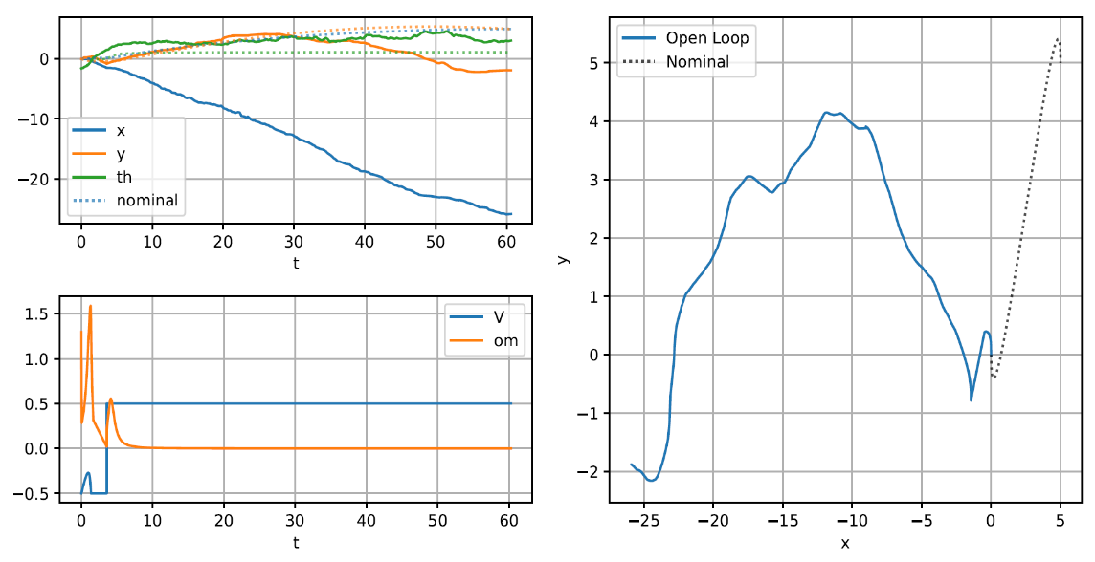

Figure 2 - Trajectory with (x(0),y(0)) = (0,0) and (x(tf),y(tf)) = (5,5)

**Problem 2: Pose Stabilization**

Plots (forward, reverse, and parallel):

Figure 3 - Foward

Figure 4 - Reverse

Figure 5 – Parallel: $k_{1}=0.02,k_{2}=0.8,k_{3}=0.3$.

**Problem 3: Trajectory Tracking**

(i) System of Equations for control inputs $\left(V,ω\right)$, given the system from kinematics:

$\left[\begin{matrix}\overset{¨}{x} \\ \overset{¨}{y}\end{matrix}\right]=\left[\begin{matrix}cosθ & −Vsinθ \\ sinθ & Vcosθ\end{matrix}\right]\left[\begin{matrix}a \\ ω\end{matrix}\right]≔\left[\begin{matrix}u_{1} \\ u_{2}\end{matrix}\right]$

$\left[\begin{matrix}\overset{¨}{x} \\ \overset{¨}{y}\end{matrix}\right]=J\left[\begin{matrix}a \\ ω\end{matrix}\right]≔\left[\begin{matrix}u_{1} \\ u_{2}\end{matrix}\right]$

To calculate inputs in terms of $\left(u | | 1,u_{2}\right),$

$\left[\begin{matrix}a \\ ω\end{matrix}\right]=J^{−1}\left[\begin{matrix}u_{1} \\ u_{2}\end{matrix}\right]$

Where

$u_{1}={\overset{¨}{x}}_{d}+k_{px}\left(x_{d}−x\right)+k_{dx}\left({\overset{˙}{x}}_{d}−\overset{˙}{x}\right)$

$u_{2}={\overset{¨}{y}}_{d}+k_{py}\left(y_{d}−y\right)+k_{dy}\left({\overset{˙}{y}}_{d}−\overset{˙}{y}\right)$

$\left(x,y\right)$ come from flatness equations and, $V=\int{a}dt$, in the software was used $V=V_{prev}+adt$ for each step of Velocity calculation.

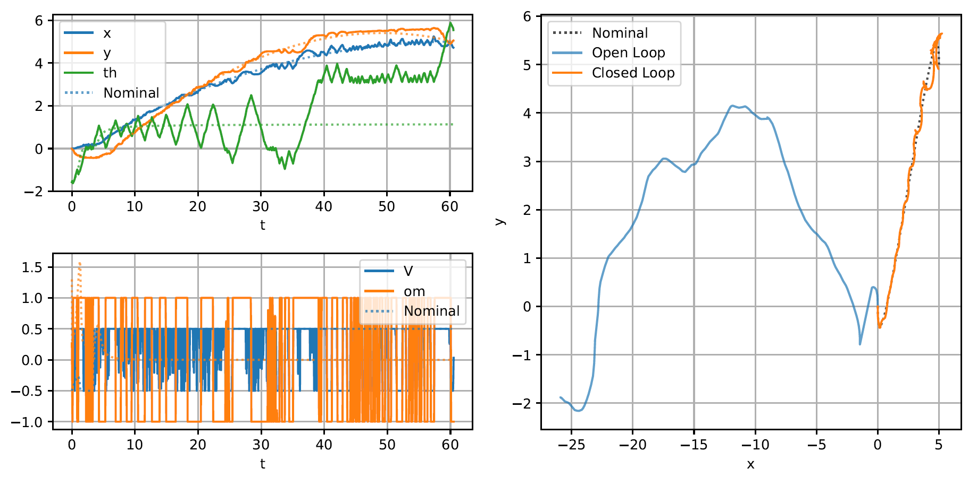

Figure 6 - Closed Loop: $k_{px}=400,k_{py}=400,k_{dx}=2,k_{dy}=2$.

**Extra Problem: Optimal Control and Trajectory Optimization**

(i)Hamiltonian:

Where

$g\left(x\left(t\right),u\left(t\right),t\right)=λ+V{\left(t\right)}^{2}+ω{\left(t\right)}^{2}$

And NOC’s