**Principles of Robot Autonomy I**

**Problem Set 1**

**Introduction**

For the first Homework we get three problems related with nonholonomic wheeled robots and constraints that refers to the rolling without slipping condition for the robot wheels. The first problem consists in write a set of linear equations given the polynomials and basis functions of the flat outputs. The second problem is related to closed loop control applied to pose stabilization given the control laws. The third problem is an extension from the second where is applied the trajectory tracking technique. The extra problem covers the advanced control methods.

**Problem 1: Trajectory Generation via Differential Flatness**

(i) Using a polynomial basis expansion for ($x\left(t\right),y\left(t\right)$) of the form

$x\left(t\right)=\sum_{i=1}^{n}{x_{i}ψ_{i}\left(t\right)}$, $y\left(t\right)=\sum_{i=1}^{n}{y_{i}ψ_{i}\left(t\right)}$

And the basis function of the form $ψ_{1}\left(t\right)=1, ψ_{2}\left(t\right)=t, ψ_{3}\left(t\right)=t^{2}, ψ_{4}\left(t\right)=t^{3}$. Using the flatness output $z= α\left(x\right)$ and the $\dot{z}=β\left(x\right)$ we have the set of equations in the coefficients $x_{i}, y_{i}$ for $i=1,…,4$, bellow:

$$x\left(t\right)= x_{1}+x_{2}t+ x_{3}t^{2}+ x_{4}t^{3}$$

$$\dot{x}\left(t\right)= x_{2}+2x_{3}t+3x_{4}t^{2}$$

$$y\left(t\right)= y_{1}+y_{2}t+ y_{3}t^{2}+ y_{4}t^{3}$$

$$\dot{y}\left(t\right)= y_{2}+2y_{3}t+3y_{4}t^{2}$$

Substituting the initial and final conditions, we get a linear system in the coefficients above:

$$x\left(0\right)=0, y\left(0\right)=0, V\left(0\right)=0.5, θ\left(0\right)= -π/2$$

$x\left(t_{f}\right)=0, y\left(t_{f}\right)=0, V\left(t_{f}\right)=0.5, θ\left(t_{f}\right)= -π/2$,

$where t_{f}=15$.

For $\dot{x}\left(0\right), \dot{y}\left(0\right), \dot{x}\left(t_{f}\right)$ and $\dot{y}(t_{f})$ we use the relation from kinematics $\dot{x}\left(t\right)=V(t)\cos{(θ\left(t\right))}$ and $\dot{y}\left(t\right)=V(t)\sin{(θ\left(t\right))}$, we get $\dot{x}\left(0\right)=0, \dot{y}\left(0\right)=-0.5, \dot{x}\left(t_{f}\right)=0, \dot{y}\left(t_{f}\right)= -0.5$.

$$\left[\begin{matrix}1 & 0 \\ \begin{matrix}0 \\ 0 \\ \begin{matrix}0 \\ 1 \\ \begin{matrix}0 \\ 0 \\ 0\end{matrix}\end{matrix}\end{matrix} & \begin{matrix}1 \\ 0 \\ \begin{matrix}0 \\ 15 \\ \begin{matrix}1 \\ 0 \\ 0\end{matrix}\end{matrix}\end{matrix}\end{matrix}\begin{matrix}0 & 0 \\ \begin{matrix}0 \\ 0 \\ \begin{matrix}0 \\ 225 \\ \begin{matrix}30 \\ 0 \\ 0\end{matrix}\end{matrix}\end{matrix} & \begin{matrix}0 \\ 0 \\ \begin{matrix}0 \\ 3375 \\ \begin{matrix}675 \\ 0 \\ 0\end{matrix}\end{matrix}\end{matrix}\end{matrix}\begin{matrix}0 & 0 \\ \begin{matrix}0 \\ 1 \\ \begin{matrix}0 \\ 0 \\ \begin{matrix}0 \\ 1 \\ 0\end{matrix}\end{matrix}\end{matrix} & \begin{matrix}0 \\ 0 \\ \begin{matrix}1 \\ 0 \\ \begin{matrix}0 \\ 15 \\ 1\end{matrix}\end{matrix}\end{matrix}\end{matrix}\begin{matrix}0 & 0 \\ \begin{matrix}0 \\ 0 \\ \begin{matrix}0 \\ 0 \\ \begin{matrix}0 \\ 225 \\ 30\end{matrix}\end{matrix}\end{matrix} & \begin{matrix}0 \\ 0 \\ \begin{matrix}0 \\ 0 \\ \begin{matrix}0 \\ 3375 \\ 675\end{matrix}\end{matrix}\end{matrix}\end{matrix}\right]\left[\begin{matrix}x_{1} \\ \begin{matrix}x_{2} \\ \begin{matrix}x_{3} \\ x_{4} \\ \begin{matrix}y_{1} \\ y_{2} \\ \begin{matrix}y_{3} \\ y_{4}\end{matrix}\end{matrix}\end{matrix}\end{matrix}\end{matrix}\right]=\left[\begin{matrix}0 \\ \begin{matrix}0 \\ \begin{matrix}0 \\ -0.5 \\ \begin{matrix}5 \\ 0 \\ \begin{matrix}5 \\ -0.5\end{matrix}\end{matrix}\end{matrix}\end{matrix}\end{matrix}\right]$$

(ii) If $V\left(t_{f}\right)=0$, we can generate a singularity, the matrix – *J* from kinematics - become not invertible (Singular matrix) at time $t_{f}$.

Differential Flatness results:

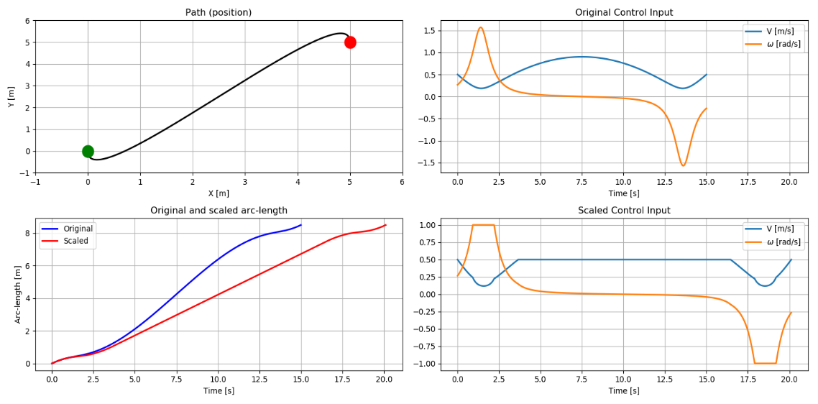

Figure 1 - Differential Flatness

System with disturbances:

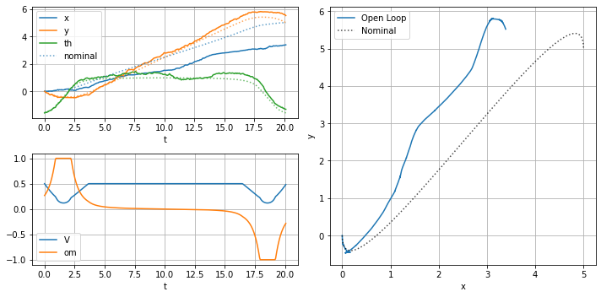

Figure 2 - Trajectory with (x(0),y(0)) = (0,0) and (x(tf),y(tf)) = (5,5)

**Problem 2: Pose Stabilization**

Plots (forward, reverse, and parallel), for $k_{1}=0.12, k_{2}=0.8, k_{1}=0.3$:

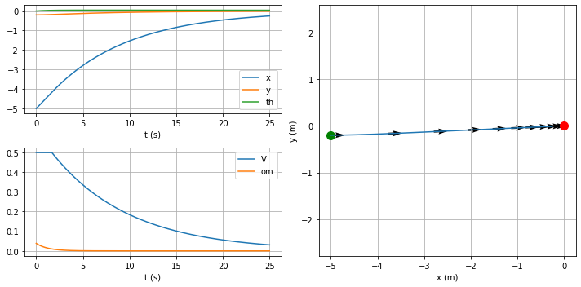

Figure 3 – Forward.

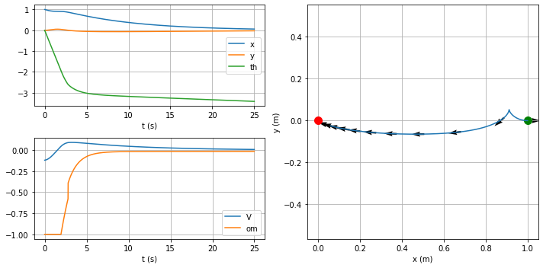

Figure 4 – Reverse.

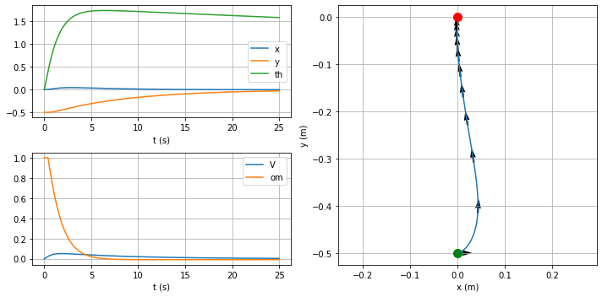

Figure 5 – Parallel.

**Problem 3: Trajectory Tracking**

(i) System of Equations for control inputs $(V,ω)$, given the system from kinematics:

$$\left[\begin{matrix}\ddot{x} \\ \ddot{y}\end{matrix}\right]=\left[\begin{matrix}\cos{θ} & -V\sin{θ} \\ \sin{θ} & V\cos{θ}\end{matrix}\right]\left[\begin{matrix}a \\ ω\end{matrix}\right]≔\left[\begin{matrix}u_{1} \\ u_{2}\end{matrix}\right]$$

$$\left[\begin{matrix}\ddot{x} \\ \ddot{y}\end{matrix}\right]=J\left[\begin{matrix}a \\ ω\end{matrix}\right]≔\left[\begin{matrix}u_{1} \\ u_{2}\end{matrix}\right]$$

To calculate inputs in terms of ${(u}_{1},u_{2}),$

$$\left[\begin{matrix}a \\ ω\end{matrix}\right]= J^{-1}\left[\begin{matrix}u_{1} \\ u_{2}\end{matrix}\right]$$

Where,

$$u_{1}={\ddot{x}}_{d}+k_{px}\left(x_{d}-x\right)+k_{dx}({\dot{x}}_{d}-\dot{x})$$

$$u_{2}={\ddot{y}}_{d}+k_{py}\left(y_{d}-y\right)+k_{dy}({\dot{y}}_{d}-\dot{y})$$

$(x,y)$ come from flatness equations and, $V= \int{a}dt$, in the software was used $V= V_{prev}+adt$ for each step of Velocity calculation.

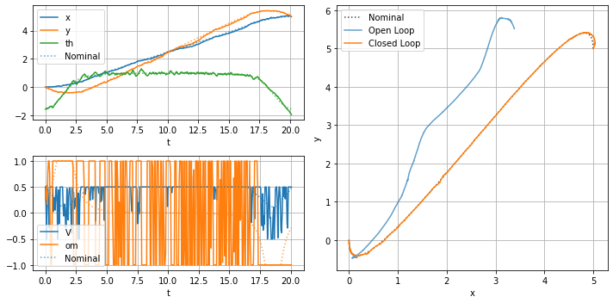

Figure 6 - Closed Loop: $k_{px}=400, k_{py}=400, k_{dx}=3.3, k_{dy}=5$.

**Extra Problem: Optimal Control and Trajectory Optimization**

(i) We want to minimize the cost function bellow:

$$J=h\left(x\left(t_{f}\right),t_{f}\right)+ \int_{t_{0}}^{t_{f}}{g\left(x\left(t\right),u\left(t\right),t\right)dt,}$$

The Hamiltonian:

$H\left(x\left(t\right),u\left(t\right),p\left(t\right),t\right) := g\left(x\left(t\right),u\left(t\right),t\right)+ p^{T}(t)α(x\left(t\right),u\left(t\right),t)$,

$\dot{x}(t)= α\left(x\left(t\right),u\left(t\right),t\right), x\left(t_{0}\right)= x_{0}$**.**

And the last initial condition,

${(\frac{∂h}{∂x}\left(x^{*}\left(t_{f}\right),t_{f}\right)- p^{*}(t_{f})))}^{T}δx_{f}+\left(H\left(x^{*}\left(t_{f}\right),u^{*}\left(t_{f}\right),p^{*}\left(t_{f}\right),t\right)+ \frac{∂h}{∂t}\left(x^{*}\left(t_{f}\right),t_{f}\right)\right)δt_{f}=0$.

The *Necessary Optimality Conditions* (NOC`s) are given by:

$${\dot{x}}^{*}\left(t\right)= \frac{∂H}{∂p}\left(x^{*}\left(t\right),u^{*}\left(t\right),p^{*}\left(t\right),t\right),$$

$${\dot{p}}^{*}\left(t\right)= -\frac{∂H}{∂x}\left(x^{*}\left(t\right),u^{*}\left(t\right),p^{*}\left(t\right),t\right),$$

$0= \frac{∂H}{∂u}\left(x^{*}\left(t\right),u^{*}\left(t\right),p^{*}\left(t\right),t\right)$,

For our case we need to derive the Hamiltonian and conditions for optimality and formulate as a 2P-BVP problem. The cost function is given by:

$$J= \int_{0}^{t_{f}}{λ+ {V(t)}^{2}+ {ω(t)}^{2}dt}$$

Initial conditions,

$$x\left(0\right)=0, y\left(0\right)=0, θ\left(0\right)= -π/2,$$

$$x\left(t_{f}\right)=5, y\left(t_{f}\right)=5, θ\left(t_{f}\right)= -π/2$$

This is a problem with free final time and a fixed final state. We can verify from cost unction that:

$h\left(x\left(t_{f}\right),t_{f}\right)=0$, $g\left(x\left(t\right),u\left(t\right),t\right)= λ+ {V\left(t\right)}^{2}+ {ω\left(t\right)}^{2},$

The state $x$ and $\dot{x}$:

$x=[x\left(t\right),y\left(t\right),θ(t)]$,

$\dot{x}=[\dot{x}\left(t\right),\dot{y}\left(t\right),ω(t)]$.

And the Hamiltonian:

$H= λ+ {V(t)}^{2}+ {ω(t)}^{2}+ p_{1}\left(t\right)\dot{x}\left(t\right)+ p_{2}\left(t\right)\dot{y}\left(t\right)+ p_{3}(t)ω$,

From kinematic model (Problem 1) and the Hamiltonian above, we have:

$H= λ+ {V(t)}^{2}+ {ω(t)}^{2}+ p_{1}\left(t\right)V\left(t\right)\cos{θ(t)}+ p_{2}\left(t\right)V\left(t\right)\sin{θ(t)}+ p_{3}(t)ω$.

From NOCs we get Differential Equations (ODEs),

$$\begin{matrix}{\dot{x}}^{*}\left(t\right)={∂H}/{∂p_{1}}=V^{*}(t)\cos{θ^{*}(t)} \\ {\dot{y}}^{*}\left(t\right)={∂H}/{∂p_{2}}=V^{*}(t)\sin{θ^{*}(t)} \\ \begin{matrix}{\dot{ω}}^{*}\left(t\right)={∂H}/{∂p_{3}}=ω^{*}(t) \\ {\dot{p}}_{1}^{*}\left(t\right)={-∂H}/{∂x}=0 \\ \begin{matrix}{\dot{p}}_{2}^{*}\left(t\right)={-∂H}/{∂y}=0 \\ {\dot{p}}_{3}^{*}\left(t\right)={∂H}/{∂θ}=p_{1}^{*}(t)V^{*}(t)\sin{θ^{*}\left(t\right)-p_{2}^{*}(t)V^{*}(t)\cos{θ^{*}(t)}} \\ \end{matrix}\end{matrix}\end{matrix}$$

Algebraic Equations,

$$\begin{matrix}0={∂H}/{∂V}=2V^{*}\left(t\right)+ p_{1}^{*}(t)\cos{θ^{*}\left(t\right)+ p_{2}^{*}(t)\sin{θ^{*}(t)}} \\ 0={∂H}/{∂ω}=2ω^{*}\left(t\right)+ p_{3}^{*}(t)\end{matrix}$$

Boundary conditions for the NOCs:

$x^{*}\left(0\right)=0, y^{*}\left(0\right)=0, θ^{*}\left(0\right)= -π/2$,

$x^{*}\left(t_{f}\right)=5, y^{*}\left(t_{f}\right)=5, θ^{*}\left(t_{f}\right)= -π/2$,

$$λ+ {V^{*}(t_{f})}^{2}+ {ω^{*}(t_{f})}^{2}+ {p_{1}}^{*}\left(t_{f}\right)\dot{x}\left(t_{f}\right)+ {p_{2}}^{*}\left(t_{f}\right)\dot{y}\left(t_{f}\right)+ {p_{3}}^{*}\left(t_{f}\right)ω=0$$

For this first part where $x ∈ R^{n} , u ∈ R^{m}$ we have $2n$ differential equations, $m$ algebraic equations and $2n+1$ boundary conditions because $t_{f}$ is not fixed, where $n=3$ and $m=2$.

Now we can make the changes to determine $t_{f}$:

1. Change the time derivate, $\frac{d(.)}{dτ}= t_{f}\frac{d(.)}{dt}$.
2. “Dummy” state r corresponding to $t_{f}$ with $\dot{r}=0$.
3. Replace $t_{f}$ with r in NOCs and BCs.

Following with the changes we get:

$${t_{f}d{(x}^{*}(t))}/{dt}={d{(x}^{*}(t))}/{dτ}=t_{f}V^{*}\left(t\right)\cos{θ^{*}\left(t\right)}$$

$${{t_{f}d(y}^{*}(t))}/{dt}={{d(y}^{*}(t))}/{dτ}={t_{f}V}^{*}\left(t\right)\sin{θ^{*}\left(t\right)}$$

$${{t_{f}d(ω}^{*}(t))}/{dt}={{d(ω}^{*}(t))}/{dτ}=t_{f}ω^{*}\left(t\right)$$

$${{t_{f}d(p}_{1}^{*}(t))}/{dt}={{-d(p}_{1}^{*}(t))}/{dτ}=0$$

$${{t_{f}d(p}_{2}^{*}(t))}/{dt}={-{d(p}_{2}^{*}(t))}/{dτ}=0$$

$${{t_{f}d(p}_{3}^{*}(t))}/{dt}={{d(p}_{3}^{*}(t))}/{dτ}={t_{f}p}_{1}^{*}(t)V^{*}(t)\sin{θ^{*}\left(t\right)-{t_{f}p}_{2}^{*}(t)V^{*}(t)\cos{θ^{*}(t)}}$$

Replace $t_{f}$ by the “Dummy” state **r:**

$${d{(x}^{*}(t))}/{dτ}=rV^{*}\left(t\right)\cos{θ^{*}\left(t\right)}$$

$${{d(y}^{*}(t))}/{dτ}={rV}^{*}\left(t\right)\sin{θ^{*}\left(t\right)}$$

$${{d(ω}^{*}(t))}/{dτ}= rω^{*}\left(t\right)$$

$${{d(p}_{1}^{*}(t))}/{dτ}=0$$

$${{d(p}_{2}^{*}(t))}/{dτ}=0$$

$${{d(p}_{3}^{*}(t))}/{dτ}={rp}_{1}^{*}\left(t\right)V^{*}\left(t\right)\sin{θ^{*}\left(t\right)-{rp}_{2}^{*}\left(t\right)V^{*}\left(t\right)\cos{θ^{*}\left(t\right)}}$$

And BCs:

$x^{*}\left(0\right)=0, y^{*}\left(0\right)=0, θ^{*}\left(0\right)= -π/2$,

$x^{*}\left(r\right)=5, y^{*}\left(r\right)=5, θ^{*}\left(r\right)= -π/2$,

$$λ+ {V^{*}(r)}^{2}+ {ω^{*}(r)}^{2}+ {p_{1}}^{*}\left(r\right)V^{*}(r)\cos{θ^{*}(r)}+ {p_{2}}^{*}\left(r\right)V^{*}\left(r\right)\sin{θ^{*}(r)}+ {p_{3}}^{*}\left(r\right)ω^{*}(r)=0$$

From Algebraic Equations we can find the $V(t)$ and $ω(t)$ as functions of **p** and substitute in Differential Equations:

$$V\left(t\right)=-\frac{1}{2}\left(p_{1}^{*}\cos{θ^{*}}+ p_{2}^{*}\sin{θ^{*}}\right)$$

$ω\left(t\right)=-\frac{p_{3}^{*}}{2}$

And finally, we can use the standard form:

$z=[x\left(t\right),y\left(t\right),θ\left(t\right),p_{1}\left(t\right),p_{2}\left(t\right),p_{3}\left(t\right), r]$**,**

$\dot{z}=[\dot{x}\left(t\right),\dot{y}\left(t\right),\dot{θ}\left(t\right),\dot{p_{1}\left(t\right)},\dot{p_{2}\left(t\right)},\dot{p_{3}\left(t\right)}, 0]$.

(iii) Result:

Figure 7 - Optimal Control

(iv) Explain the significance of using the largest feasible.

Writing the Integral in distributive form,

$$J= λ\int_{0}^{t_{f}}{dt}+ \int_{0}^{t_{f}}{{V(t)}^{2}dt}+ \int_{0}^{t_{f}}{{ω(t)}^{2}dt}$$

Then, as bigger the lambda constant factor, more robust will be the system to respect to “aggressive” control inputs.

(v) Optimal Control Simulation:

Figure 8 - Simulation