CS 237B: Principles of Robot Autonomy II  
Problem Set 02

Name: Ricardo Paschoeto  
SUID: rp304154

Problem 1: Form and Force Closure.

(i) Force closure can be seen as a “generalization” of form closure. Form closure considers only normal  
forces applied in the body contacts, but force closure considers friction-applied forces. Therefore force  
closure contains the span of form closure wrench Space. We can see this by the wrench basis for a  
point contact frictionless and with friction examples:

In the case of μ = 0, each contact can provide forces only along the normal direction, and force closure  
reduces to form closure.

(ii) To span the wrench linearly, we will need n contacts, but to get form closure, we need to span the  
space positively. Therefore, we will need n+1 contacts to apply a wrench to achieve the positive span  
(with the correct position and direction, verifying using a planar graph, e.g.) together with another set  
of wrenches. For 2D, , we need 4 contacts. For 3D, ,  
we need 7 contacts.

(iii) Form closure analysis:

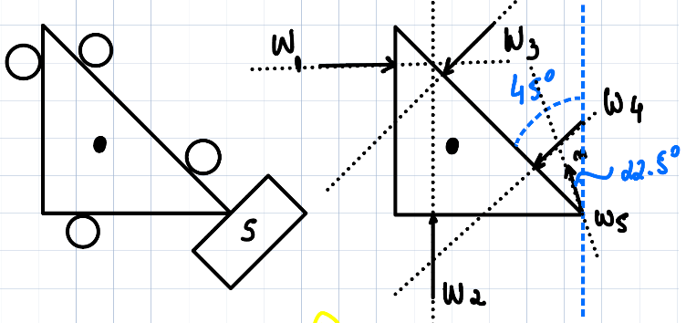

Figure 1 - Problem 1 Diagram.

For our analysis, we use a planar graph, evaluating the set of signals rotation. The (+) for counterclockwise and (-) for clockwise movement when one of the five forces is cut off.

* F1 out:

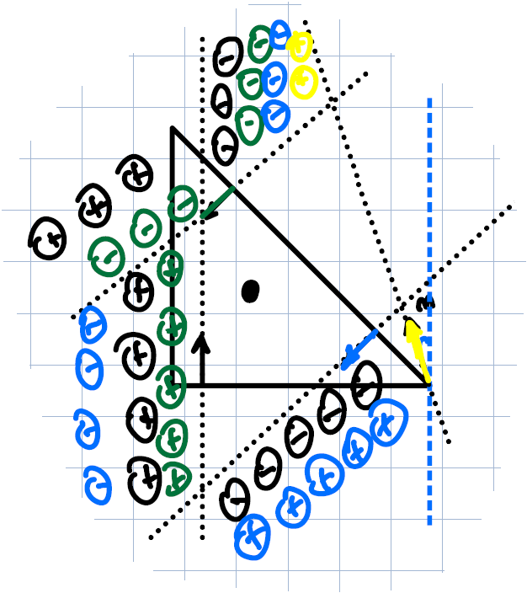

Figure 2 - F1 out.

We still have a mix of plus and minus signals in the regions, therefore, the object is in form closure yet for (2,3,4,5) finger subset.

* F2 out:

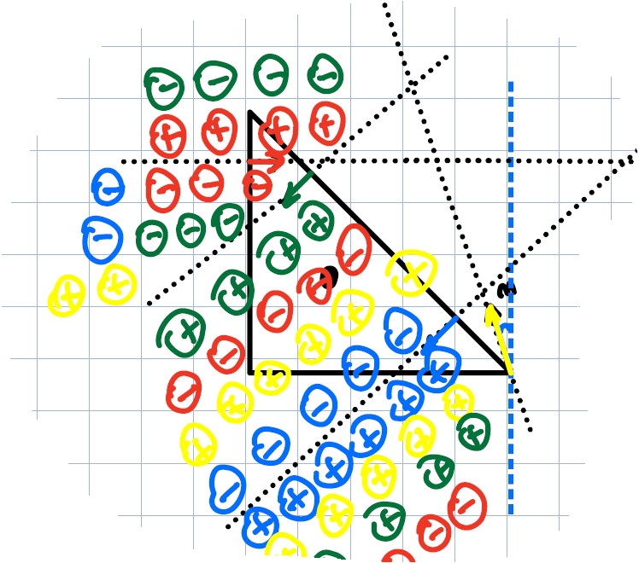

Figure 3 - F2 out.

We still have a mix of plus and minus signals in the regions, therefore, the object is in form closure yet for (1,3,4,5) finger subset.

* F3 out:

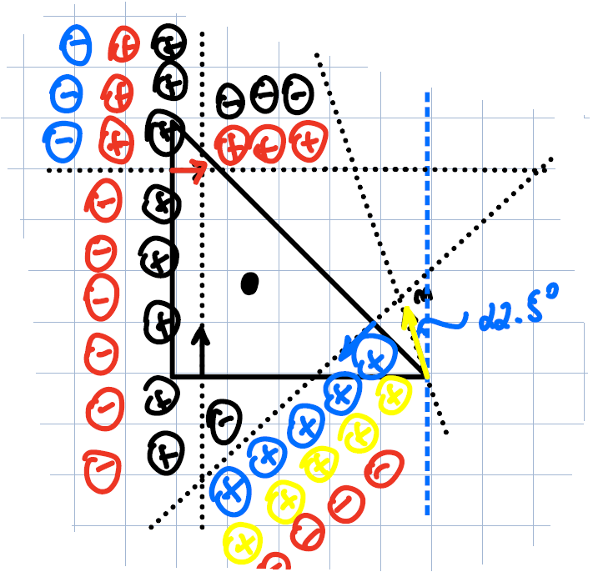

Figure 4 - F3 out.

We still have a mix of plus and minus signals in the regions, therefore, the object is in form closure yet for (1,2,4,5) finger subset.

* F4 out:

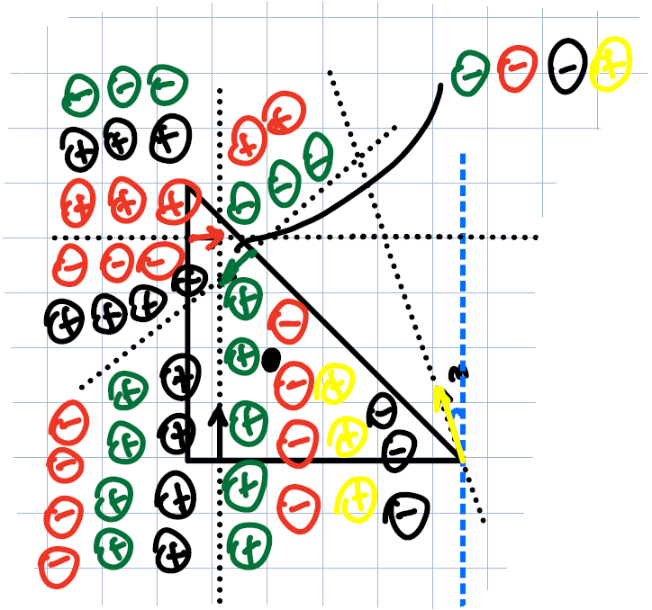

Figure 5 - F4 out.

We still have a mix of plus and minus signals in the regions, therefore, the object is in form closure yet for (1,2,3,5) finger subset.

* F5 out:

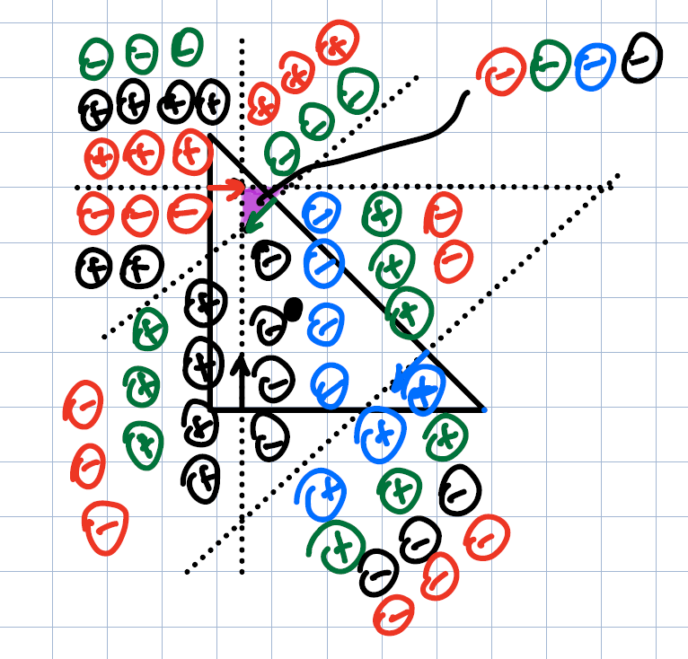

Figure 6 - F5 out.

We doesn’t have anymore a mix of plus and minus signals in the regions (purple’s region), therefore, the object is NOT in form closure yet for (1,2,3,4) finger subset.

(vi) Figure 2, analyzing the range of μ that the grasp yields force closure.

Therefore,

And finally,

For point contact coordinates,

So, we can calculate the wrenches,

The wrench matrix ,

,

The cross matrices (vector in 2D),

,

Follow to wrench evaluation,

And evaluation,

,

To force closure conditions,

(1) rank () = 3 ()

(2)

Now we have the set of equations above,

Substituting (I), (II) in (III),

And finally,

Now we have two ranges,

Or

,

Where c = 0.25 and h = 0.5,

Then the range will be the intersection of the intervals above,

The range of

Problem 2: Grasp Force Optimization.

(i) Rewriting equations (4) and (5) as :

Where

From eqs (4) and (5),

Then ,

So we can find the matrix and ,

Where,

(ii)Recast objective function in linear form:

Adding a scalar and constraint

For norm-2,

The quadratic cone constraint is:

Add for each side of equation,

,

S = ,

Then .

(iii) Define the variable x and the SOCP parameters:

= cpx variable (forces)

Defining matrix,

Comparing against ,

,

,

,

.

Where,

,

,

.

Problem 3: Learning Intuitive Physics.

(iv) Training process and validation loss:

Epoch 1/50

20/20 [==============================] - 30s 1s/step - loss: 4.0505 - val_loss: 3.8058

Epoch 2/50

20/20 [==============================] - 27s 1s/step - loss: 3.3181 - val_loss: 3.6125

Epoch 3/50

20/20 [==============================] - 27s 1s/step - loss: 3.0610 - val_loss: 3.0726

Epoch 4/50

20/20 [==============================] - 27s 1s/step - loss: 2.6611 - val_loss: 2.8966

Epoch 5/50

20/20 [==============================] - ETA: 0s - loss: 2.5681

Epoch 5: saving model to trained_models\cp-005.ckpt

20/20 [==============================] - 27s 1s/step - loss: 2.5681 - val_loss: 2.6103

Epoch 6/50

20/20 [==============================] - 27s 1s/step - loss: 2.2608 - val_loss: 2.4963

Epoch 7/50

20/20 [==============================] - 27s 1s/step - loss: 2.2841 - val_loss: 2.5573

Epoch 8/50

20/20 [==============================] - 26s 1s/step - loss: 2.0323 - val_loss: 2.6373

Epoch 9/50

20/20 [==============================] - 27s 1s/step - loss: 2.0425 - val_loss: 2.5348

Epoch 10/50

20/20 [==============================] - ETA: 0s - loss: 1.8394

Epoch 10: saving model to trained_models\cp-010.ckpt

20/20 [==============================] - 27s 1s/step - loss: 1.8394 - val_loss: 1.9893

Epoch 11/50

20/20 [==============================] - 28s 1s/step - loss: 1.7428 - val_loss: 1.8403

Epoch 12/50

20/20 [==============================] - 27s 1s/step - loss: 1.5211 - val_loss: 2.1723

Epoch 13/50

20/20 [==============================] - 27s 1s/step - loss: 1.1818 - val_loss: 1.9352

Epoch 14/50

20/20 [==============================] - 27s 1s/step - loss: 1.1059 - val_loss: 1.5510

Epoch 15/50

20/20 [==============================] - ETA: 0s - loss: 1.0637

Epoch 15: saving model to trained_models\cp-015.ckpt

20/20 [==============================] - 27s 1s/step - loss: 1.0637 - val_loss: 1.4948

Epoch 16/50

20/20 [==============================] - 28s 1s/step - loss: 1.1327 - val_loss: 1.4955

Epoch 17/50

20/20 [==============================] - 27s 1s/step - loss: 0.8156 - val_loss: 1.5534

Epoch 18/50

20/20 [==============================] - 27s 1s/step - loss: 0.8499 - val_loss: 1.5926

Epoch 19/50

20/20 [==============================] - 27s 1s/step - loss: 0.7901 - val_loss: 1.5731

Epoch 20/50

20/20 [==============================] - ETA: 0s - loss: 0.8002

Epoch 20: saving model to trained_models\cp-020.ckpt

20/20 [==============================] - 27s 1s/step - loss: 0.8002 - val_loss: 1.5145

Epoch 21/50

20/20 [==============================] - 28s 1s/step - loss: 0.6680 - val_loss: 1.4837

Epoch 22/50

20/20 [==============================] - 27s 1s/step - loss: 0.6988 - val_loss: 1.4841

Epoch 23/50

20/20 [==============================] - 27s 1s/step - loss: 0.6455 - val_loss: 1.5828

Epoch 24/50

20/20 [==============================] - 27s 1s/step - loss: 0.6497 - val_loss: 1.5140

Epoch 25/50

20/20 [==============================] - ETA: 0s - loss: 0.7100

Epoch 25: saving model to trained_models\cp-025.ckpt

20/20 [==============================] - 27s 1s/step - loss: 0.7100 - val_loss: 1.5965

Epoch 26/50

20/20 [==============================] - 27s 1s/step - loss: 0.6196 - val_loss: 1.6603

Epoch 27/50

20/20 [==============================] - 27s 1s/step - loss: 0.6649 - val_loss: 1.5413

Epoch 28/50

20/20 [==============================] - 27s 1s/step - loss: 0.4906 - val_loss: 1.5522

Epoch 29/50

20/20 [==============================] - 27s 1s/step - loss: 0.5763 - val_loss: 1.5928

Epoch 30/50

20/20 [==============================] - ETA: 0s - loss: 0.6149

Epoch 30: saving model to trained_models\cp-030.ckpt

20/20 [==============================] - 27s 1s/step - loss: 0.6149 - val_loss: 1.7886

Epoch 31/50

20/20 [==============================] - 27s 1s/step - loss: 0.5658 - val_loss: 1.6173

Epoch 32/50

20/20 [==============================] - 27s 1s/step - loss: 0.4916 - val_loss: 1.7010

Epoch 33/50

20/20 [==============================] - 27s 1s/step - loss: 0.4961 - val_loss: 1.6470

Epoch 34/50

20/20 [==============================] - 28s 1s/step - loss: 0.4196 - val_loss: 1.6009

Epoch 35/50

20/20 [==============================] - ETA: 0s - loss: 0.5412

Epoch 35: saving model to trained_models\cp-035.ckpt

20/20 [==============================] - 27s 1s/step - loss: 0.5412 - val_loss: 1.6499

Epoch 36/50

20/20 [==============================] - 28s 1s/step - loss: 0.4841 - val_loss: 1.7359

Epoch 37/50

20/20 [==============================] - 27s 1s/step - loss: 0.3702 - val_loss: 1.6199

Epoch 38/50

20/20 [==============================] - 27s 1s/step - loss: 0.3504 - val_loss: 1.6952

Epoch 39/50

20/20 [==============================] - 27s 1s/step - loss: 0.3648 - val_loss: 1.6278

Epoch 40/50

20/20 [==============================] - ETA: 0s - loss: 0.3348

Epoch 40: saving model to trained_models\cp-040.ckpt

20/20 [==============================] - 28s 1s/step - loss: 0.3348 - val_loss: 1.6665

Epoch 41/50

20/20 [==============================] - 28s 1s/step - loss: 0.2920 - val_loss: 1.7099

Epoch 42/50

20/20 [==============================] - 27s 1s/step - loss: 0.3284 - val_loss: 1.6609

Epoch 43/50

20/20 [==============================] - 27s 1s/step - loss: 0.3027 - val_loss: 1.6269

Epoch 44/50

20/20 [==============================] - 27s 1s/step - loss: 0.3266 - val_loss: 1.6766

Epoch 45/50

20/20 [==============================] - ETA: 0s - loss: 0.3482

Epoch 45: saving model to trained_models\cp-045.ckpt

20/20 [==============================] - 28s 1s/step - loss: 0.3482 - val_loss: 1.6149

Epoch 46/50

20/20 [==============================] - 27s 1s/step - loss: 0.3228 - val_loss: 1.5921

Epoch 47/50

20/20 [==============================] - 27s 1s/step - loss: 0.2787 - val_loss: 1.7064

Epoch 48/50

20/20 [==============================] - 27s 1s/step - loss: 0.3712 - val_loss: 1.6578

Epoch 49/50

20/20 [==============================] - 27s 1s/step - loss: 0.2809 - val_loss: 1.6985

Epoch 50/50

20/20 [==============================] - ETA: 0s - loss: 0.2353

Epoch 50: saving model to trained_models\cp-050.ckpt

20/20 [==============================] - 28s 1s/step - loss: 0.2353 - val_loss: 1.6849

(v) The predictions regarding to match with the dot product . The layer “mu” is a linear activation layer , therefore if the input is negative, output will be negative. To force a neural network to output positive we can choose another activation layer, e.g., relu layer.

(vii) Training process and validation loss:

Epoch 1/50

20/20 [==============================] - 31s 1s/step - loss: 4.2423 - val_loss: 3.8567

Epoch 2/50

20/20 [==============================] - 27s 1s/step - loss: 3.5132 - val_loss: 3.1686

Epoch 3/50

20/20 [==============================] - 26s 1s/step - loss: 2.6183 - val_loss: 2.8514

Epoch 4/50

20/20 [==============================] - 27s 1s/step - loss: 2.4851 - val_loss: 2.6457

Epoch 5/50

20/20 [==============================] - ETA: 0s - loss: 2.2200

Epoch 5: saving model to trained_models\cp-005.ckpt

20/20 [==============================] - 27s 1s/step - loss: 2.2200 - val_loss: 2.4810

Epoch 6/50

20/20 [==============================] - 26s 1s/step - loss: 2.0036 - val_loss: 2.3396

Epoch 7/50

20/20 [==============================] - 26s 1s/step - loss: 1.9779 - val_loss: 2.1912

Epoch 8/50

20/20 [==============================] - 26s 1s/step - loss: 1.7905 - val_loss: 2.1003

Epoch 9/50

20/20 [==============================] - 26s 1s/step - loss: 1.7011 - val_loss: 2.0022

Epoch 10/50

20/20 [==============================] - ETA: 0s - loss: 1.5673

Epoch 10: saving model to trained_models\cp-010.ckpt

20/20 [==============================] - 27s 1s/step - loss: 1.5673 - val_loss: 1.9958

Epoch 11/50

20/20 [==============================] - 26s 1s/step - loss: 1.6243 - val_loss: 1.9811

Epoch 12/50

20/20 [==============================] - 26s 1s/step - loss: 1.4359 - val_loss: 1.8939

Epoch 13/50

20/20 [==============================] - 26s 1s/step - loss: 1.4019 - val_loss: 1.8504

Epoch 14/50

20/20 [==============================] - 27s 1s/step - loss: 1.2848 - val_loss: 1.9392

Epoch 15/50

20/20 [==============================] - ETA: 0s - loss: 1.2996

Epoch 15: saving model to trained_models\cp-015.ckpt

20/20 [==============================] - 26s 1s/step - loss: 1.2996 - val_loss: 1.9315

Epoch 16/50

20/20 [==============================] - 27s 1s/step - loss: 1.3140 - val_loss: 1.8175

Epoch 17/50

20/20 [==============================] - 27s 1s/step - loss: 1.2689 - val_loss: 2.0742

Epoch 18/50

20/20 [==============================] - 26s 1s/step - loss: 1.1886 - val_loss: 1.8210

Epoch 19/50

20/20 [==============================] - 26s 1s/step - loss: 1.0716 - val_loss: 1.8269

Epoch 20/50

20/20 [==============================] - ETA: 0s - loss: 0.9990

Epoch 20: saving model to trained_models\cp-020.ckpt

20/20 [==============================] - 27s 1s/step - loss: 0.9990 - val_loss: 1.8673

Epoch 21/50

20/20 [==============================] - 27s 1s/step - loss: 0.9596 - val_loss: 1.7861

Epoch 22/50

20/20 [==============================] - 26s 1s/step - loss: 1.0476 - val_loss: 1.8379

Epoch 23/50

20/20 [==============================] - 26s 1s/step - loss: 1.0614 - val_loss: 1.8018

Epoch 24/50

20/20 [==============================] - 27s 1s/step - loss: 0.8589 - val_loss: 1.8408

Epoch 25/50

20/20 [==============================] - ETA: 0s - loss: 0.8532

Epoch 25: saving model to trained_models\cp-025.ckpt

20/20 [==============================] - 27s 1s/step - loss: 0.8532 - val_loss: 1.7444

Epoch 26/50

20/20 [==============================] - 27s 1s/step - loss: 0.9181 - val_loss: 1.7868

Epoch 27/50

20/20 [==============================] - 27s 1s/step - loss: 0.7933 - val_loss: 1.7866

Epoch 28/50

20/20 [==============================] - 28s 1s/step - loss: 0.7727 - val_loss: 1.7115

Epoch 29/50

20/20 [==============================] - 27s 1s/step - loss: 0.7569 - val_loss: 1.7945

Epoch 30/50

20/20 [==============================] - ETA: 0s - loss: 0.8045

Epoch 30: saving model to trained_models\cp-030.ckpt

20/20 [==============================] - 27s 1s/step - loss: 0.8045 - val_loss: 1.7753

Epoch 31/50

20/20 [==============================] - 27s 1s/step - loss: 0.7382 - val_loss: 1.7243

Epoch 32/50

20/20 [==============================] - 27s 1s/step - loss: 0.7455 - val_loss: 1.7294

Epoch 33/50

20/20 [==============================] - 27s 1s/step - loss: 0.6334 - val_loss: 1.7802

Epoch 34/50

20/20 [==============================] - 27s 1s/step - loss: 0.6674 - val_loss: 1.7661

Epoch 35/50

20/20 [==============================] - ETA: 0s - loss: 0.6692

Epoch 35: saving model to trained_models\cp-035.ckpt

20/20 [==============================] - 27s 1s/step - loss: 0.6692 - val_loss: 1.7676

Epoch 36/50

20/20 [==============================] - 27s 1s/step - loss: 0.7304 - val_loss: 1.7584

Epoch 37/50

20/20 [==============================] - 26s 1s/step - loss: 0.7439 - val_loss: 1.8898

Epoch 38/50

20/20 [==============================] - 26s 1s/step - loss: 0.6849 - val_loss: 1.7564

Epoch 39/50

20/20 [==============================] - 26s 1s/step - loss: 0.6676 - val_loss: 1.7560

Epoch 40/50

20/20 [==============================] - ETA: 0s - loss: 0.5661

Epoch 40: saving model to trained_models\cp-040.ckpt

20/20 [==============================] - 27s 1s/step - loss: 0.5661 - val_loss: 1.7778

Epoch 41/50

20/20 [==============================] - 27s 1s/step - loss: 0.5935 - val_loss: 1.7766

Epoch 42/50

20/20 [==============================] - 26s 1s/step - loss: 0.6199 - val_loss: 1.8339

Epoch 43/50

20/20 [==============================] - 27s 1s/step - loss: 0.5118 - val_loss: 1.7649

Epoch 44/50

20/20 [==============================] - 26s 1s/step - loss: 0.5923 - val_loss: 1.7639

Epoch 45/50

20/20 [==============================] - ETA: 0s - loss: 0.5089

Epoch 45: saving model to trained_models\cp-045.ckpt

20/20 [==============================] - 26s 1s/step - loss: 0.5089 - val_loss: 1.7589

Epoch 46/50

20/20 [==============================] - 27s 1s/step - loss: 0.4461 - val_loss: 1.7548

Epoch 47/50

20/20 [==============================] - 26s 1s/step - loss: 0.4824 - val_loss: 1.7880

Epoch 48/50

20/20 [==============================] - 26s 1s/step - loss: 0.4602 - val_loss: 1.8156

Epoch 49/50

20/20 [==============================] - 27s 1s/step - loss: 0.4771 - val_loss: 1.8053

Epoch 50/50

20/20 [==============================] - ETA: 0s - loss: 0.4774

Epoch 50: saving model to trained_models\cp-050.ckpt

20/20 [==============================] - 26s 1s/step - loss: 0.4774 - val_loss: 1.8546

Comparing against the physical network the baseline NN performs worst. The baseline used predictions from data to evaluate the acceleration, the physical network evaluate the acceleration analytically, prediction the friction coefficient using the network only, this argument could be used to explain the difference in performing and results.