**Engenharia de Software**

**2023/2024**

**Code Patterns**

Diogo Lemos, 56837

Code Patterns

1. Template Method

(src/net/sf/freecol/client/gui/action)

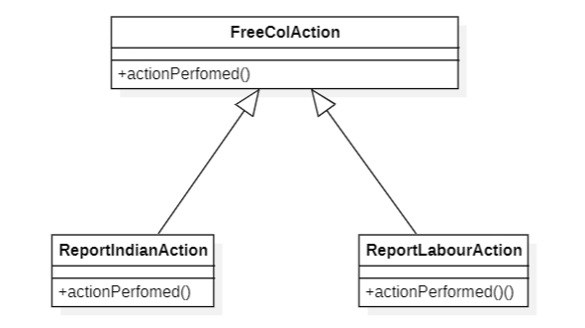 Figure 1. StarUML Diagram of the Template Method Pattern

* Both ReportIndianAction and ReportLabourAction share similar methods, for example, actionPerfomed(). FreeColAction is then used as a basis for both subclasses.

Code Patterns

1. Iterator Pattern

(src/net/sf/freecol/common/model/UnitIterator.java)

Figure . unitIterator

* The unitIterator class enables the possibility of iterating through the Unit objects without compromising their implementation.

Code Patterns

1. Singleton

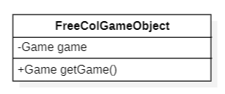 Figure . FreeColGameObject class's diagram

* FreeColGameObject’s class has only one instance of the attribute game, which is hidden from all other outside classes. The only way to access it is through the public method *getGame* found in the same class.