**Tubería Estructural**

**Usos y Aplicaciones:**

Tubería estructural o perfiles en geometría redonda, cuadrada o rectangular, son una alternativa industrial, diseñada para construir Sistemas Estructurales Metálicos de alta resistencia, de una manera práctica, rápida y sencilla.

Los perfiles se fabrican con acero laminado en caliente (H.R.) de bajo contenido de carbono, alta soldabilidad y ductilidad, según normas AISI/SAE 1015, JISG 3132, SPHT 4, ó cualquier otro acero equivalente.

**Dimensiones** Longitud: 6 metros

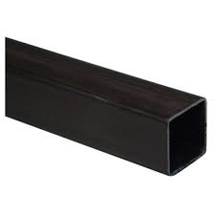

|  |  |  |  |  |  |  |  |
| --- | --- | --- | --- | --- | --- | --- | --- |
| TUBERIA ESTRUCTURAL CUADRADA | | | | | | | |
| CALIBRE | | | | | | | |
| DIM EN MM | 16 | 14 | 12 | 3MM | 4MM | 5MM | 6MM |
| 25X25 | X | X |  |  |  |  |  |
| 30X30 |  | X |  |  |  |  |  |
| 40X40 | X | X | X | X |  |  |  |
| 50X50 | X | X | X | X |  |  |  |
| 60X60 |  | X | X | X |  |  |  |
| 70X70 | X | X | X | X |  |  |  |
| 75X75 |  |  |  | X |  |  |  |
| 90X90 |  | X | X | X |  |  |  |
| 100X100 |  | X | X | X | X |  | X |
| 120X120 |  |  |  |  | X |  |  |
| 127X127 |  |  |  |  | X |  |  |
| 135X135 |  |  |  |  | X | X | X |
| 150X150 |  |  |  |  | X |  | X |
| 200X200 |  |  |  |  |  | X |  |

|  |  |  |  |  |  |  |  |
| --- | --- | --- | --- | --- | --- | --- | --- |
| TUBERIA ESTRUCTURAL RECTANGULAR | | | | | | | |
| DIM EN MM | 16 | 14 | 12 | 3MM | 4MM | 5MM | 6MM |
| 50,8X25,4 | X | X | X |  |  |  |  |
| 50X30 | X | X | X |  |  |  |  |
| 60X40 | X | X | X |  |  |  |  |
| 76X38 | X | X | X | X |  |  |  |
| 80X40 | X | X | X |  |  |  |  |
| 90X50 |  | X | X |  |  |  |  |
| 100X40 | X | X | X |  |  |  |  |
| 100X50 | X | X | X | X |  |  |  |
| 120X60 |  | X | X | X |  |  |  |
| 150X50 |  | X | X | X |  |  |  |
| 150X100 |  |  |  |  | X |  |  |
| 200X70 |  |  |  |  | X |  |  |
| 200X100 |  |  |  | X | X |  | X |
| 250X100 |  |  |  |  |  | X |  |
| 300X100 |  |  |  |  |  | X |  |

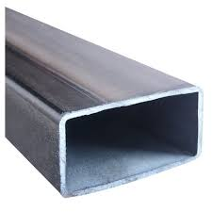

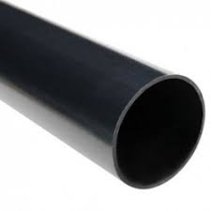

|  |  |  |  |  |
| --- | --- | --- | --- | --- |
| TUBO ESTRUCTURAL REDONDO | | | | |
| CALIBRE | | | | |
| DIM | 14 | 3MM | 5MM | 6MM |
| 1 1/2" | X | X |  |  |
| 3" | X |  |  |  |
| 6" |  |  |  | X |
| 8" |  |  | X |  |

**PROVEEDORES**

COLMENA tubería estructural.pdf

<TERNIUM.pdf>

[ACESCO ficha tecnica.pdf](ACESCO%20ficha%20tecnica.pdf)