**CODE DISCRIPTION**

1. **Classifier**

Read_Images_from_Folders

It makes list of all images in all folders of given DirBase(Directory) and returns the same.

Program

It returns the value of feature extraction which in this case in maximum difference in frame.

Extract features

It calls ‘program’ for each image and extract feature and save it in an array

train_svm_classifier

It will train a SVM, saved the trained and SVM model and report the classification performance

saves 20% of data for performance evaluation

features: array of input features

labels: array of labels associated with the input features

model_output_path: path for storing the trained svm model

OUTPUT

Best parameters set:

{'C': 10, 'kernel': 'linear'}

Confusion matrix:

Labels: Walking, jogging

[[7 3]

[4 7]]

Classification report:

precision recall f1-score support

Walking 0.64 0.70 0.67 10

jogging 0.70 0.64 0.67 11

avg / total 0.67 0.67 0.67 21

1. **Frame comparison**

We take two frames- last and current, so that we can calculate the different between them.

Store the current frame as last frame, and then read a new one, and find the difference.

OUTPUT

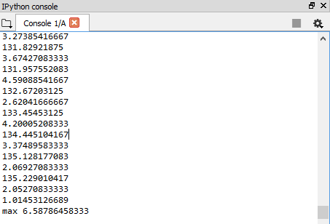

1. **Contour center**

Capture frame-by-frame

Get threshold

Find contour of threshold image and also the center of contour and draw each

OUTPUT

