Computer Science and Engineering Artificial Neural Networks & Deep Learning

A.A. 2021-2022

Homework 1

Image Classification

Group: I_tre_neuroni

Authors: Riccardo Campi, Matteo Bianchi, Leonardo Galeazzi

Version: v1.0

Professors: M. Matteucci, G. Boracchi, F. Lattari, E. Lomurno

Date: 28/11/2021

Summary

1. Introduction 3

2. Dataset 3

2.1 Class-imbalance problem 3

2.1.1 Under-sampling 4

2.2 Image data augmentation 4

2.2.1 Horizontal and vertical shift augmentation 4

2.2.2 Horizontal and vertical flip augmentation 4

2.2.3 Random rotation augmentation 4

2.2.4 Random zoom augmentation 4

2.3 Some useful observation 5

3 Training 5

3.1 Simple CNN 5

3.1.1 Accuracy 6

3.1.2 Categorical cross-entropy 6

3.1.3 Confusion matrix 6

3.2 VGG16 7

3.1 Inception ResNet V2 8

# Introduction

This is the first Homework of the Artificial Neural Networks and Deep Learning course.

In this homework the groups are required to classify images of leaves, which are divided into categories according to the species of the plant to which they belong. Being a classification problem, given an image, the goal is to predict the correct class label.

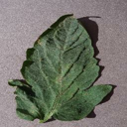 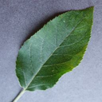

Figure 1: an example of leaf images

# Dataset

The dataset provided by the competition’s promoters is a folder containing 17 728 files, grouped into several categories. In particular, there are 14 different types of leaves with whom is possible to classify the images (Tomato, Orange, Soybean, Grape, Corn, Apple, Peach, Pepper, Potato, Strawberry, Cherry, Squash, Blueberry, Raspberry).

## Class-imbalance problem

Table : class-imbalance problem

As is shown in *Table 1: class-imbalance problem*, some classes contain much more images than the others. In particular, the sum of Tomato, Orange and Soybean represents more than half of the entire distribution.

This problem is known as class-imbalance. Due to this, the fitted model tends to be biased towards the majority class data, which leads to lower accuracy during the testing phase.

### Under-sampling

One of the most used techniques to bring the required balance in the data is called under-sampling. In particular, for this homework under-sampling was used to partially solve the problem by removing some files in larger classes.

## Image data augmentation

Image data augmentation is a technique that can be used to artificially expand the size of a training dataset by creating modified versions of images in the dataset.

Training models on more data can result in more skilful models, and the augmentation techniques can create variations of the images that can improve the ability of the fit models to generalize what they have learned to new images.

For this homework were used the 4 image data augmentation types. We decided to keep the basic augmentation settings given us in the lectures.

Figure : ImageDataGenerator object with augmentation techniques

The code showed in *Figure 2: ImageDataGenerator object with augmentation techniques* was used for all of the trained models.

### Horizontal and vertical shift augmentation

A shift to an image means moving all pixels of the image in one direction, such as horizontally or vertically, while keeping the image dimensions the same.

### Horizontal and vertical flip augmentation

An image flip means reversing the rows or columns of pixels in the case of a vertical or horizontal flip respectively.

### Random rotation augmentation

A rotation augmentation randomly rotates the image clockwise by a given number of degrees from 0 to 360.

### Random zoom augmentation

A zoom augmentation randomly zooms the image in and either adds new pixel values around the image or interpolates pixel values respectively.

## Some useful observation

Rotation and shift will leave areas of the frame with no pixel data, that were filled with black pixels. In fact, we left the default fill mode as the original images have a black background and the border, so other fill modes would have given us augmented images too different to the originals.

# 3 Training

In this chapter are listed all the training experiments we made.

All the model used early-stopping to avoid overfitting as much as possible. For all models it was kept a patience of 10 epochs and the best epoch was kept.

Except for the last one (InceptionResNetV2) we monitored for the early-stopping the validation loss which remained for all categorical cross-entropy.

## 3.1 Simple CNN

The first net we tried was designed as a simple convolutional neural net, that is, a convolutional part followed by a fully connected one. The dataset used for this first model was the original one, so all the images have been kept and no under-sampling was applied to solve the class-imbalance problem.

In particular, we used 5 convolutional layers (+ activation + pooling) followed by a flatten layer, a classification layer, and an output layer.

Figure : Simple CNN Summary

The metrics obtained by the fitted model on the validation set are:

Accuracy: 92.06% - Precision: 91.18% - Recall: 89.89% - F1: 90.16%

### 3.1.1 Accuracy

Table : Accuracy of the Simple CNN

### 3.1.2 Categorical cross-entropy

Table : Categorical cross-entropy of the Simple CNN

### 3.1.3 Confusion matrix

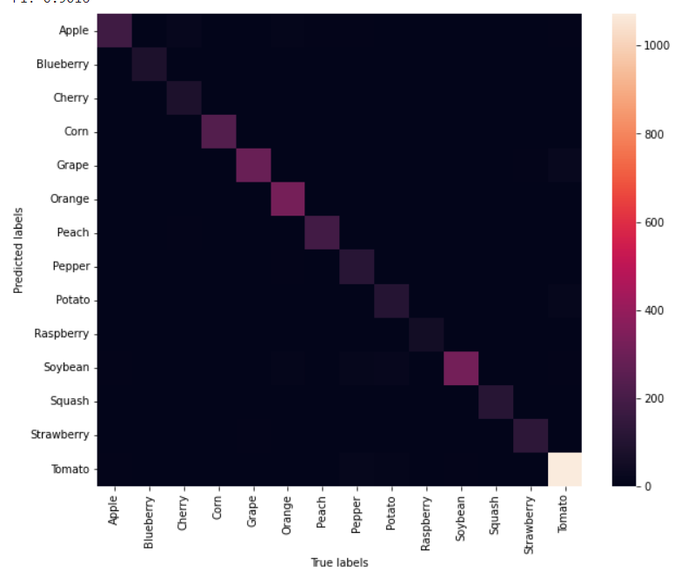

Figure : Confusion Matrix of Simple CNN

## 3.2 VGG16

Our second model is a VGG16 based CNN. We used VGG as supernet and fine-tuned the fully connected part to it. The intention was to use the already trained features of this supernet to help our model to be more precise in its generalization ability.

Figure : Transfer Learning and Fine-Tuning Summary

## 3.1 Inception ResNet V2

Table : Categorical cross-entropy of the InceptionResNetV2

Table : Accuracy of the InceptionResNetV2