Log Book

Parameters and their influence on the simulation speed

**TOLERANCE**

SCF.DM.Tolerance 5E-6

SCF.H.Tolerance 5E-5 eV

9 Steps

—---

SCF.DM.Tolerance 1E-4 # default value

SCF.H.Tolerance 1E-3 eV # default value

10 Steps

**Conclusion**:

Simulation time is not very different

**MIXER**

SCF.Mixer.History 7

SCF.Mixer.Weight 0.2500000000

10 Steps

—--

SCF.Mixer.History 20

SCF.Mixer.Weight 0.1500000000

15 Steps

**Conclusion**:

Simulation time is changed of 1.5 times

**LATTICE VECTOR**

LatticeConstant 1.0 Ang

%block LatticeVectors

7.000000 0.000000 0.000000

0.000000 7.000000 0.000000

0.000000 0.000000 7.000000

%endblock LatticeVectors

10 Steps, time per step = 0.466

—--

LatticeConstant 1.0 Ang

%block LatticeVectors

20.000000 0.000000 0.000000

0.000000 20.000000 0.000000

0.000000 0.000000 20.000000

%endblock LatticeVectors

10 Steps, time per step = 2.122

**Conclusion**:

Simulation time is changed of 5 times

**TEMPERATURE**

ElectronicTemperature 300 K

10 Steps, time per step = 0.466

—--

ElectronicTemperature 0.1 K

>300 steps

**Conclusion**:

Simulation time has changed a lot!!

# --------------

# OUTPUT OPTIONS

# --------------

**Conclusion**:

Simulation time does not change a lot.

**Molecular Dynamics**

MD.MaxCGDispl 0.2 Ang

MD.MaxCGDispl 0.02 Ang

**Conclusion**:

0.2 Ang is moving very much at the beginning, but then stabilizes. 0.02 Ang requires many more steps if you are not close to the stable position.

**CARBON DIMER**Run simulations with different interatomic distance (0.02 Bohr)

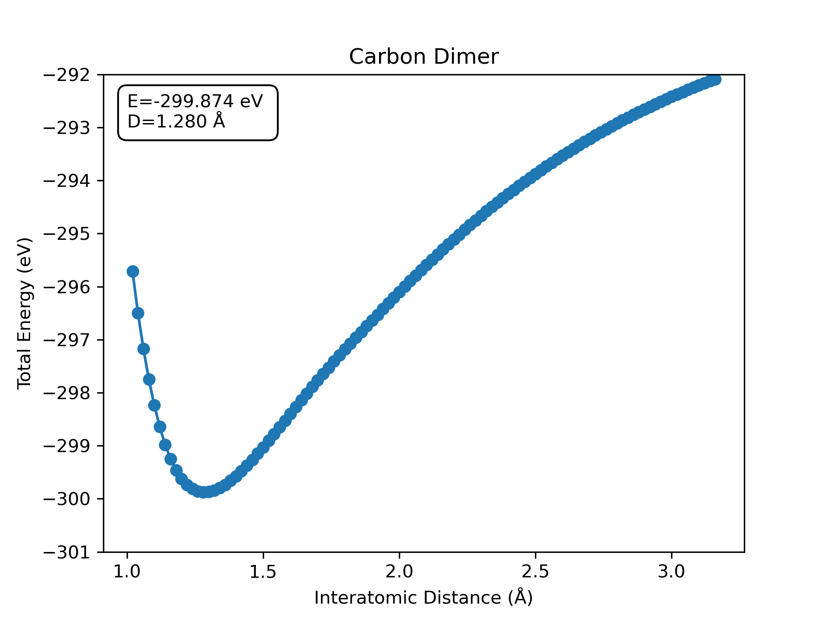

Molecular Dynamics  
Relaxation

Interatomic DIstance = 1.2907

Energy minimum = -299.871736

