Report Buffer TC 2024

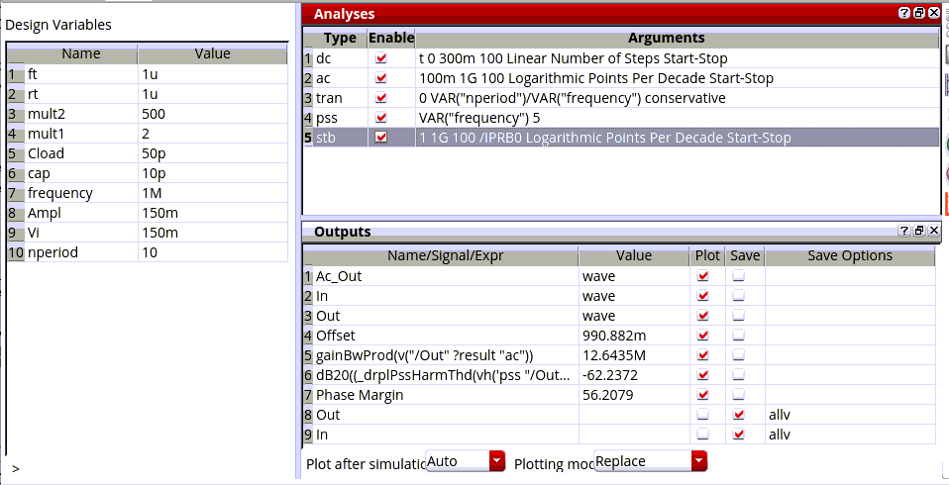Figure 1: Parameters and performance of the buffer.
