**POLITECNICO DI MILANO**



**Radar Imaging:**

**SAR Interferometry (InSAR)**

Riccardo REGGIANI

C.P. 10670577

1. **Description**

The purpose of this homework was to simulate a space borne radar and perform SAR interferometry. The geometry can be intended as one sensor moving and performing two different acquisitions or as two different satellites in different positions, I personally sticked to the last one while doing the homework, but the results and the computation would have been the same.

Talking more precisely about the geometry, there are two satellites at a distance of 693 Km from the ground and spaced between each other by an horizontal base line of 200 m.

1. **Mono-dimensional SAR data simulation**

As first thing I have defined the data of the problem, which are already defined in the sheet of the homework, apart from the depression angle ‘teta_d’ which was obtained from the geometry of the scenario.

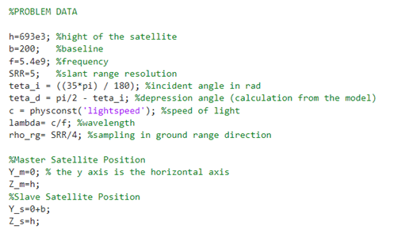

Having now the data the computation can be started, but first ground range, height and complex reflectivity of each target in the scenario must be defined. In order to do so the mountain is seen as a group of pixels each characterized by a coordinate, an height and a complex reflectivity.

I have calculated the middle point of the mountain, and defined the ground range axis, with a total length of 1 Km and shifted of *p* meters on the right.

The complex reflectivity coefficient was defined as a random vector. At this point I got everything I needed to plot the elevation profile (our mountain), I chose to define it as suggested on the homework sheet, so as a normal distribution.

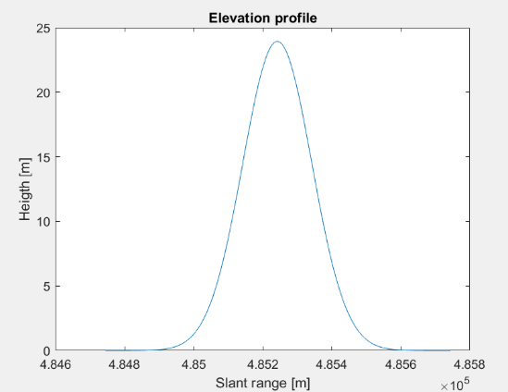

Subsequently I have defined the slant range axis.

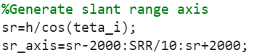

At this point, coding and using the formulas in the homework, I have been able to get the two mono-dimensional SAR images.

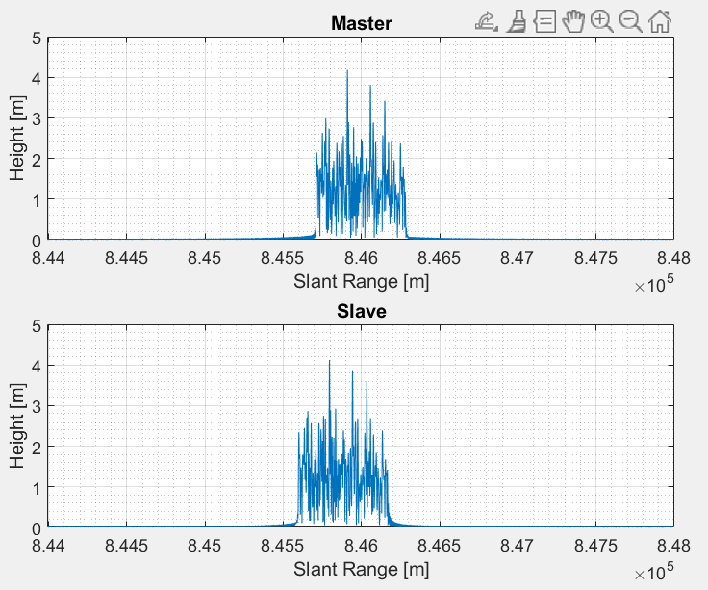

1. **Image coregistration**

As can be seen in the obtained acquisition the images are shifted, this has been caused by the used reference system. In fact the use of slant range coordinates remarks the fact that the sensors have different distances from the targets.

To fix this and obtain two aligned images, coregistration must be done. I have been able to perform it following step by step the procedure stated in the homework, as shown below.

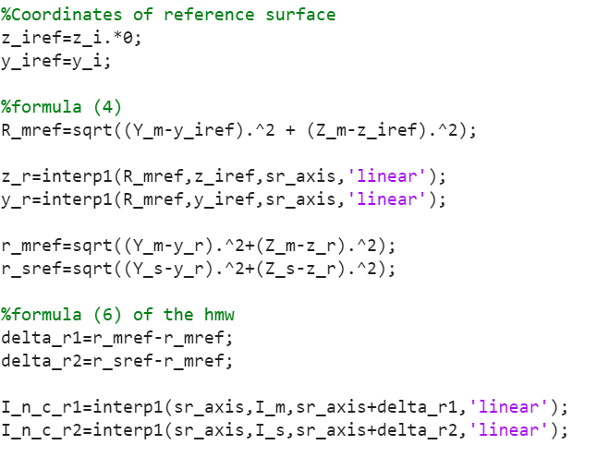

At this point I have plotted the absolute value of the two coregistered SAR images. And as shown below both the master (upper figure) and the slave (lower figure) are aligned, so I assumed coregistration has been executed properly.

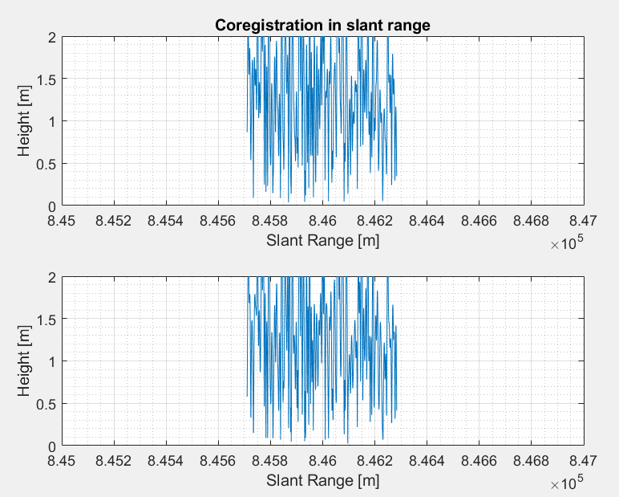

1. **The interferometric phase**

The interferogram has been implemented by complex multiplication of the two SAR images, and then I have plotted the interferometric phase as function of the range.

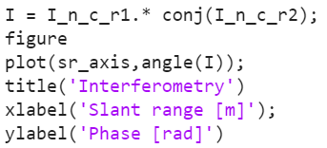

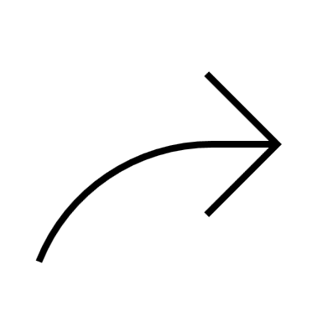

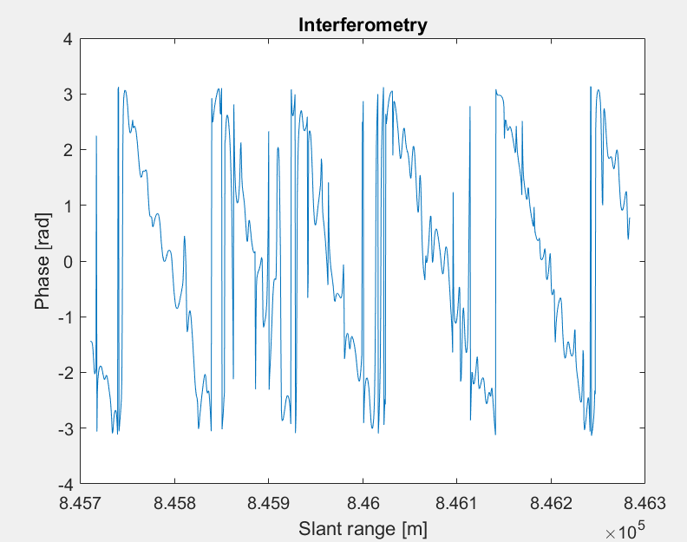

The interferometric fringes due to the presence of the reference surface are the vertical line in the plot, that should be removed in the following point, unfortunately I was not able to tackle the remaining points of the fourth exercise.