Priority: data quality and cross-region security

INGESTION:

The raw files received are likely in azure blob storage, so created a snowflake internal stage to mimic the scenario.

Used snowsql (snowflake’s cli tool) to upload files

Bronze tables are ingested as is to get better understanding of data

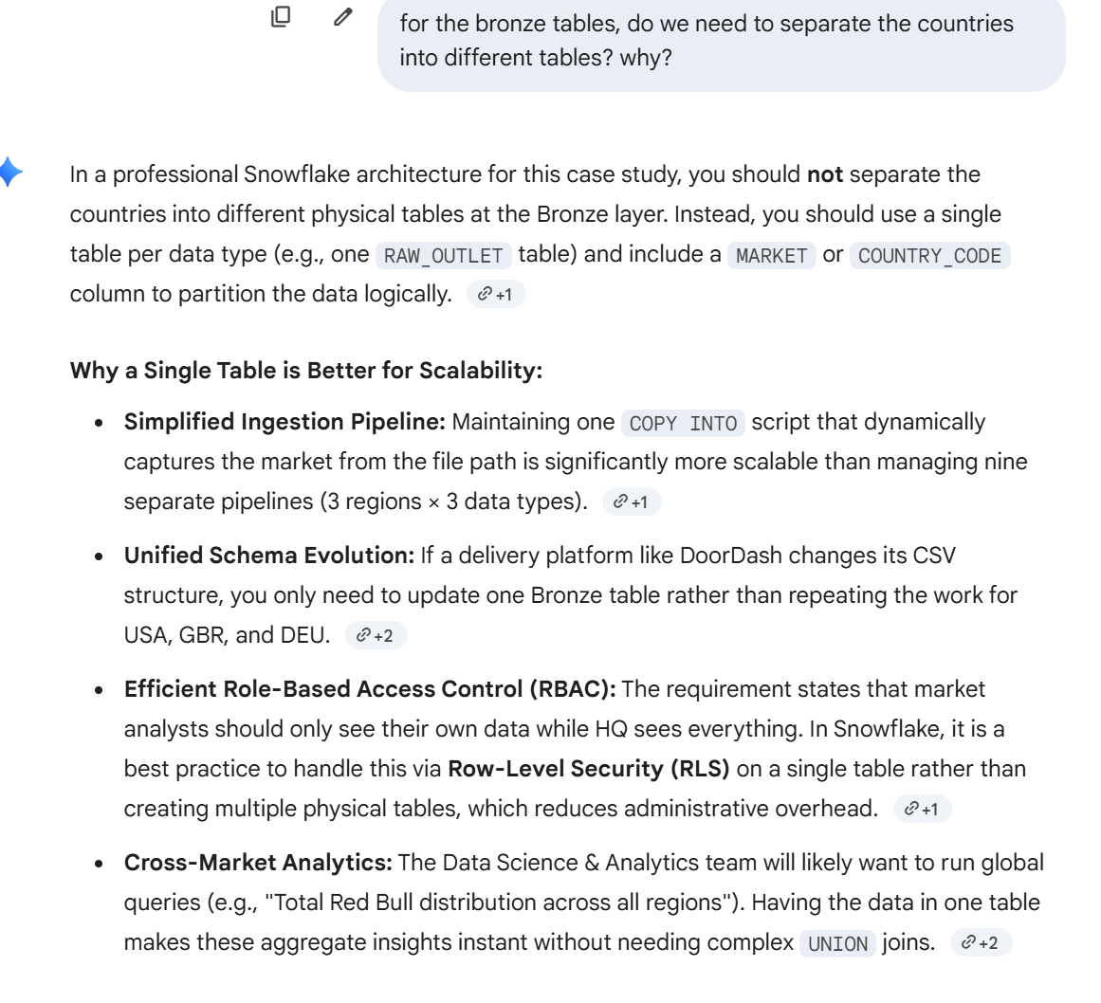

Use snowpipe(keeps it native) to move data from stage to bronze tables

When loading from stage to bronze table:
Method 1: Structured Raw (Multi-Column)
This method maps each $n variable ($1, $2, $3...) directly to a named column during the initial COPY INTO command.
- Pros:
  - Immediate Visibility: You can query the Bronze table and see your IDs, Market codes, and Scores in their own columns right away.
  - Simpler SQL: Downstream transformations are easier because the columns are already defined.
  - Native Typing: You can cast columns to specific types (Integer, Float) immediately if you trust the source.
- Cons:
  - Brittle: If the source file adds a new column in the middle or changes the order, your Snowpipe will likely fail or load data into the wrong columns.
  - Schema Rigidity: You must know exactly how many columns exist before you start the load.

Method 2: Single-Column Blob (Pattern 2)
This method uses FIELD_DELIMITER = NONE to load the entire line into one VARIANT or STRING column.
- Pros:
  - Maximum Resilience: This is "Future-Proof." If the file format changes (new columns, different delimiters), the ingestion never breaks. You just adjust your "Silver" logic later.
  - Faster Ingestion: Snowflake can sometimes ingest single-column blobs faster because it doesn't have to perform character-level parsing/splitting during the load.
  - Complete Audit Trail: You have the exact, untouched raw string for every row, which is helpful if you ever need to debug a parsing error from months ago.
- Cons:
  - Complex Downstream: Every time you want to use the data, you have to use SPLIT_PART or PARSE_JSON logic, which can be computationally more expensive if not managed correctly.
  - No "Quick Peek": Looking at the Bronze table is messy because you're seeing long strings of tab-separated values.

The "Industry Standard" Verdict
For a 7.5 GB case study, Method 2 (Blob) is considered the more "Senior" architectural choice. It follows the ELT (Extract, Load, Transform) philosophy: get the data into the system as fast and safely as possible (Load), then worry about the structure once it's inside (Transform).
Using views - reads entire table:
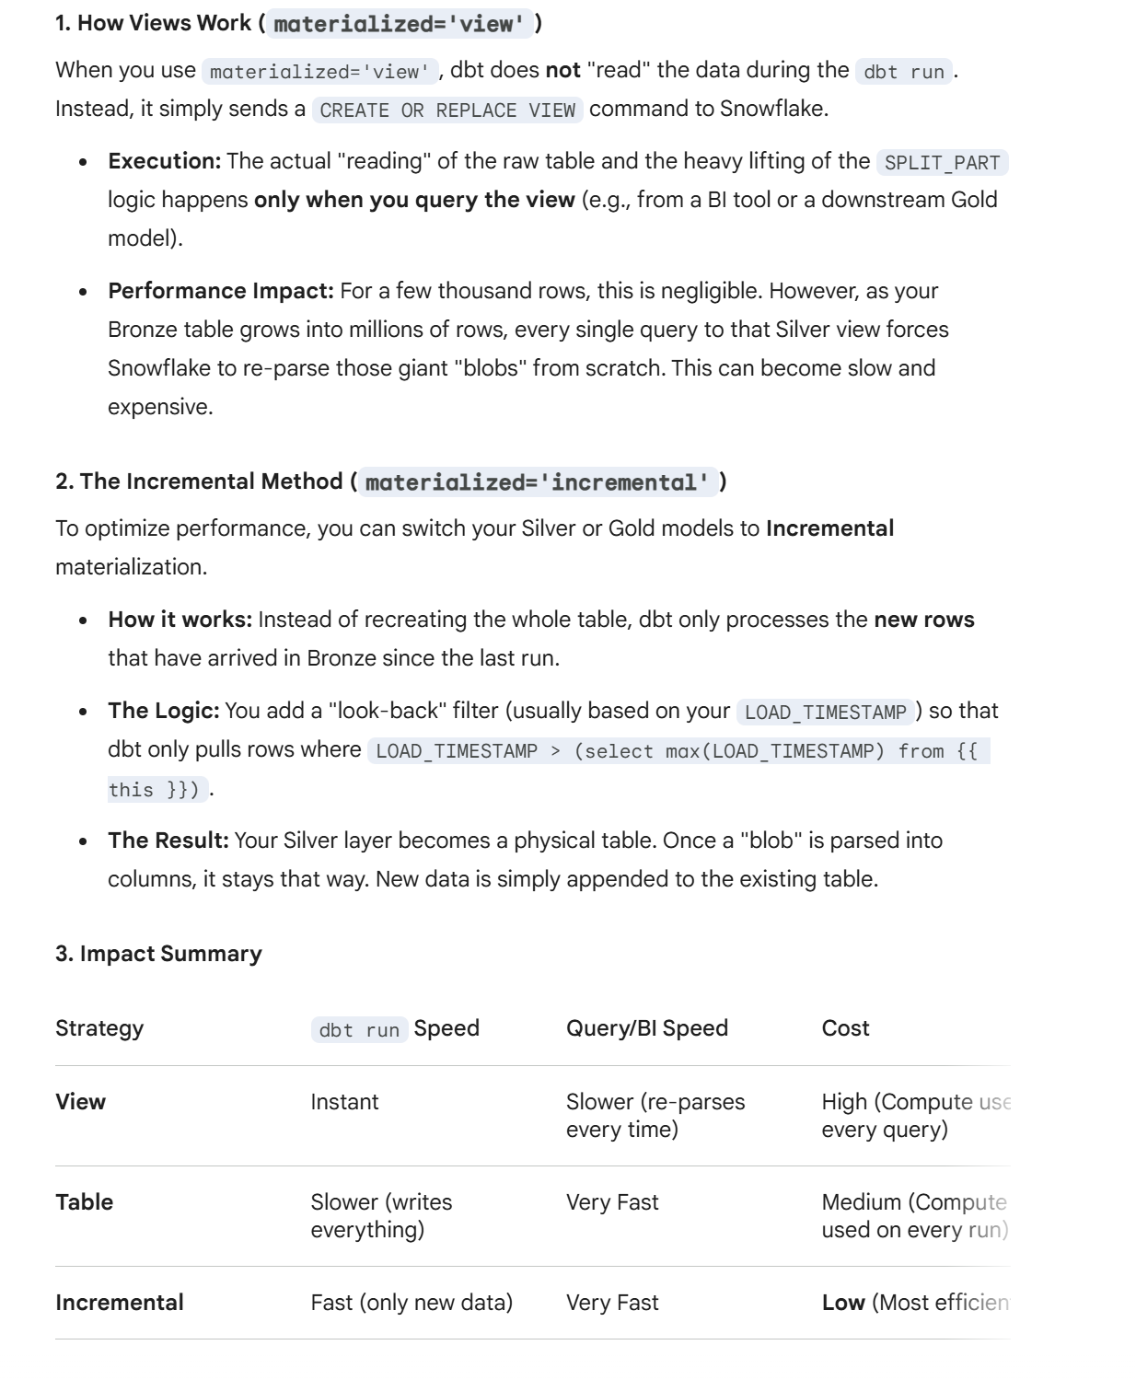

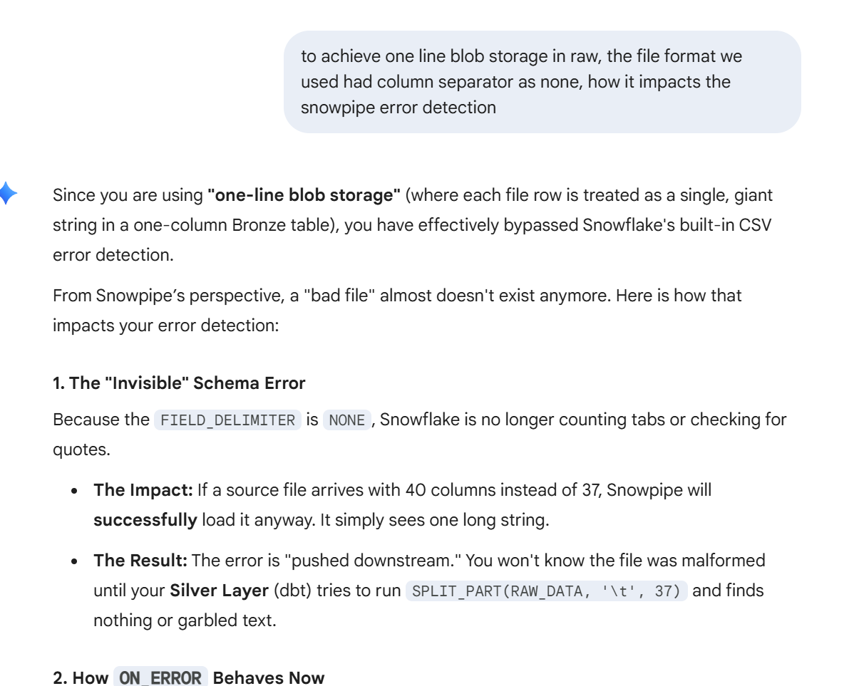
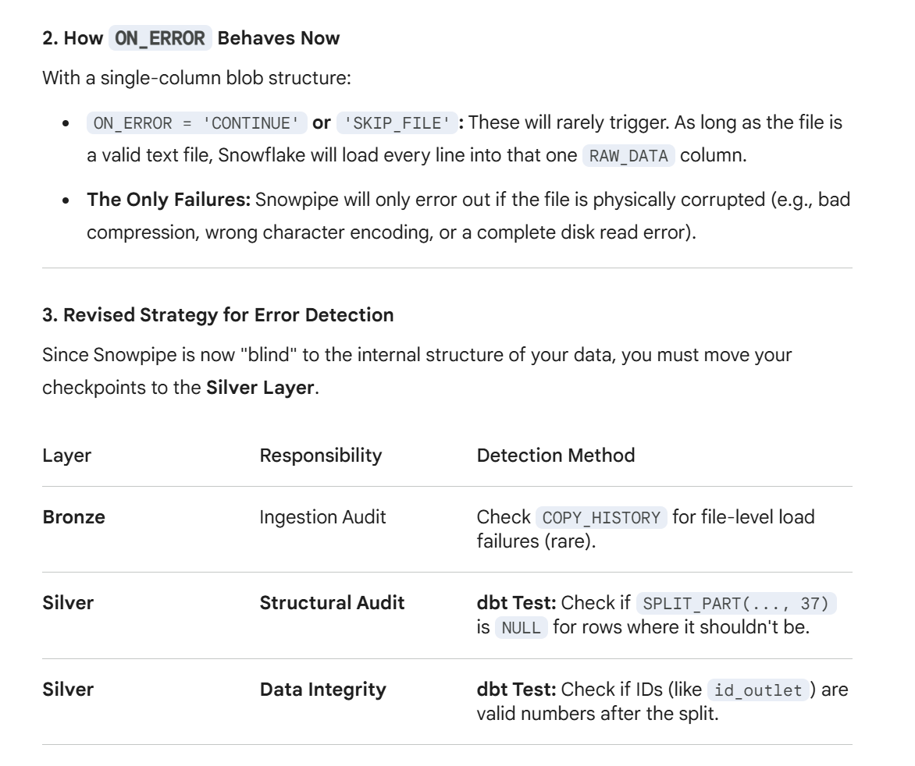
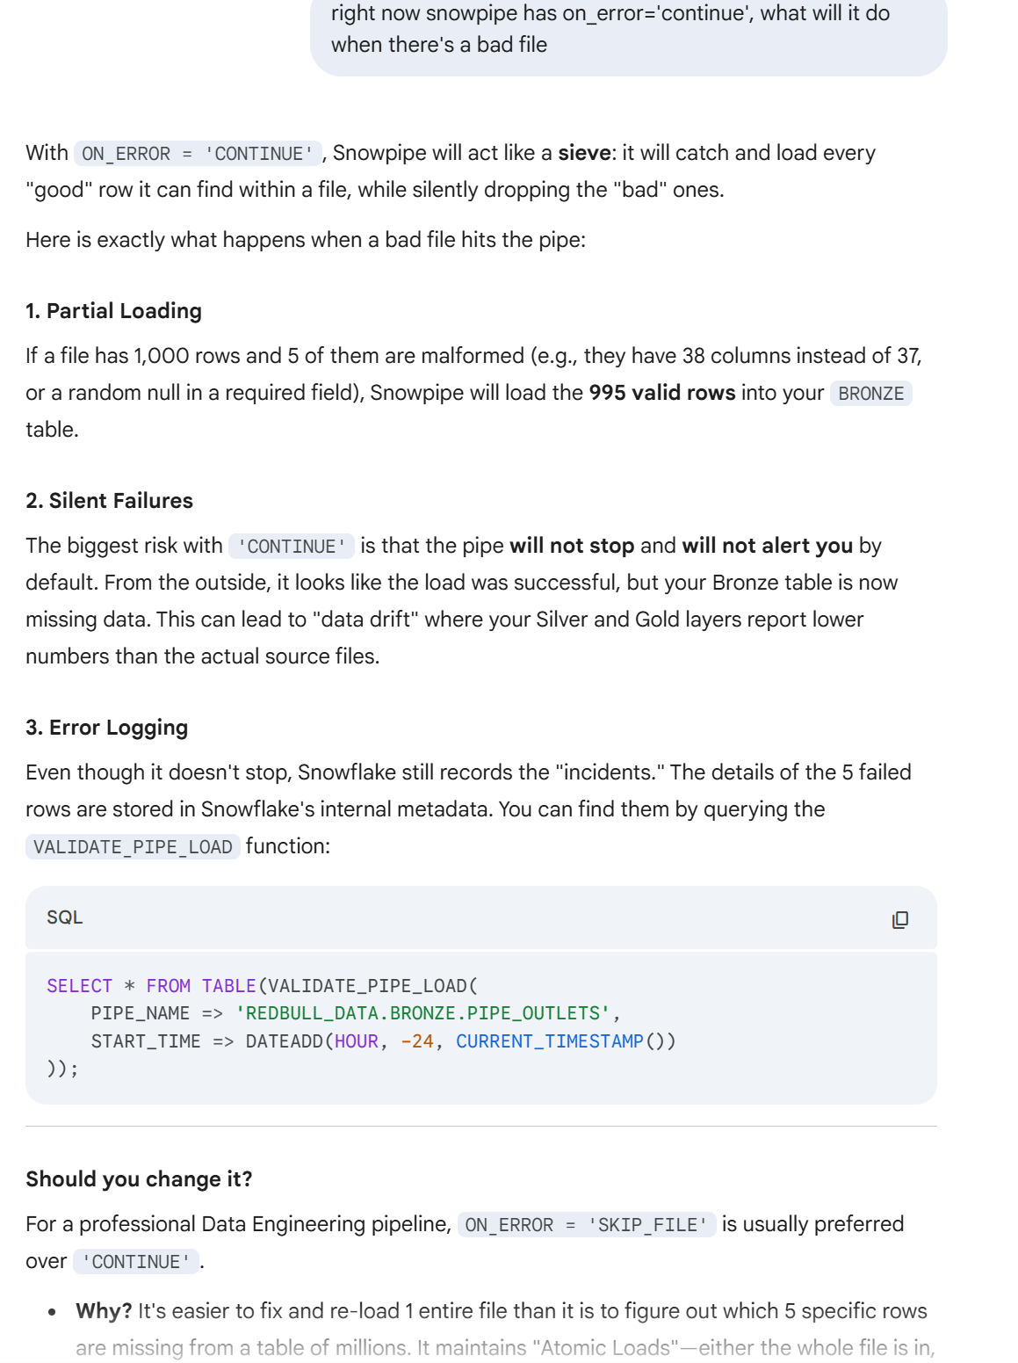

TRANSFORMATION:
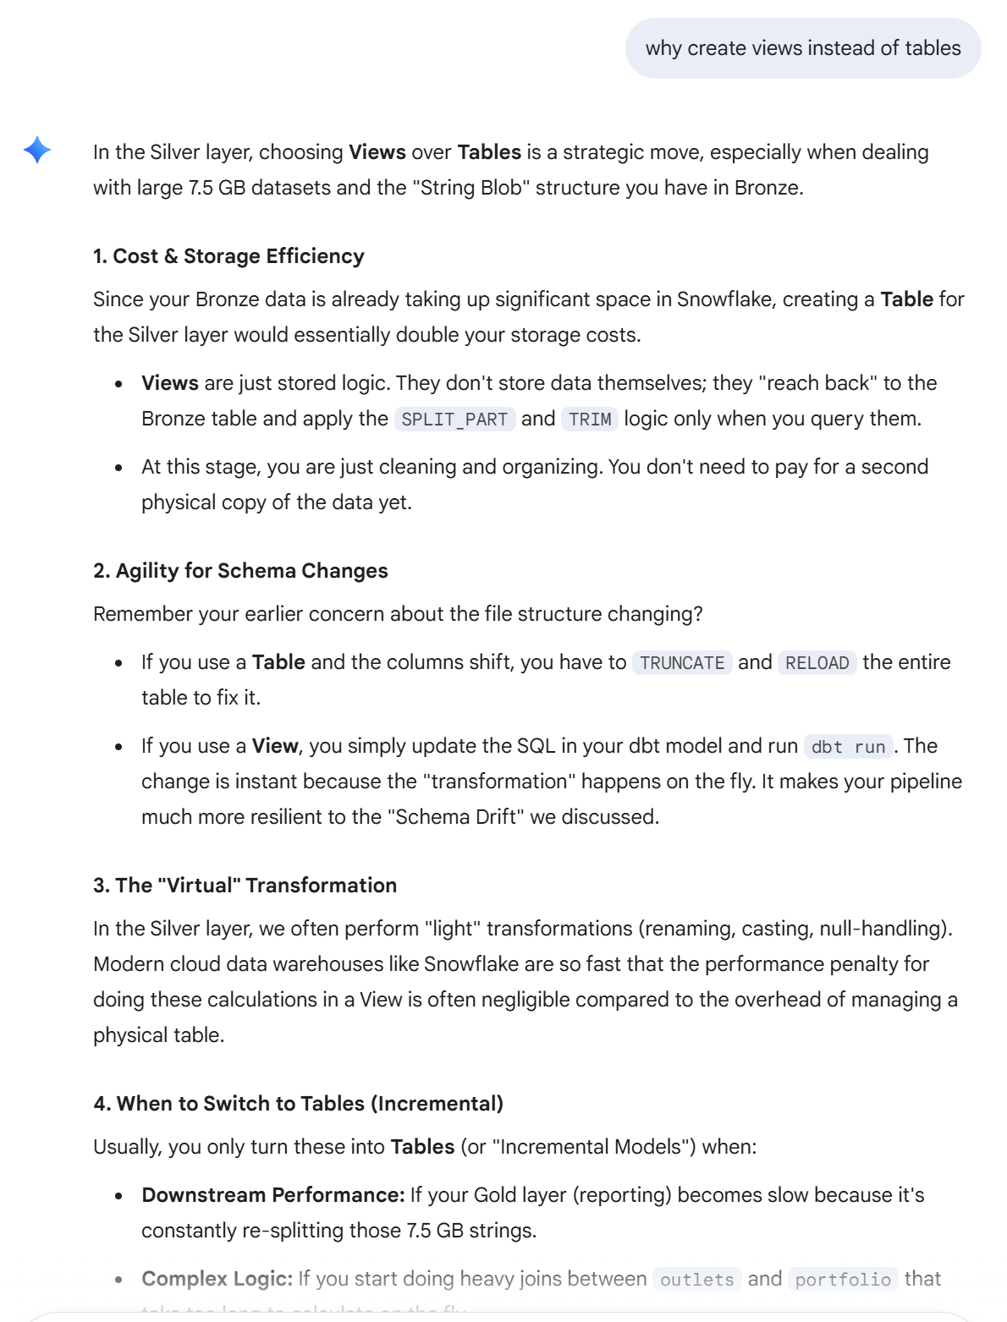

There are dbt tests implemented between transforming from bronze to silver. Would add data source freshness check in production but not here since our data is stale.

Right now some data transformation and data validation constraint are hardcoded/repeated, would implement macro to create central ‘source of truth’
Gold layer:
Dim-outlet table: right now is kind of duplicated, one shop might be on multiple delivery platforms, so there will be multiple rows for one shop with the primary difference being the platform column. However, when inspecting the data, i noticed that ext_id, and other info such as addr, business name can vary (very similar, but minor differences) more importantly the ext_id, so keeping them all here.

It seems that id_drink points to a specific drink of a specific brand, while id_beverage points additionally to drink volume (ml)

