**Day 1 of #xxDaysOfHTML**: Started with the basics of HTML! Learned about the **Responsive Web Design**

A It is helpful to know the core web development skills when building a survey form, a tribute page, technical documentation page, a product landing page, and a personal portfolio webpage. You learn what form creation and validation are, how to structure content so it can easily be read, and how to create layouts that are responsive. Among them there are **HTML, CSS**, user-oriented approach, and accessibility. You also work to create interesting content, structure technical information, and bring attention to personal products. Through the course of these projects, you gain an appreciation for how responsive design actually works, the principles of UX, and best practices in information architecture, paving the way for actual web development works.

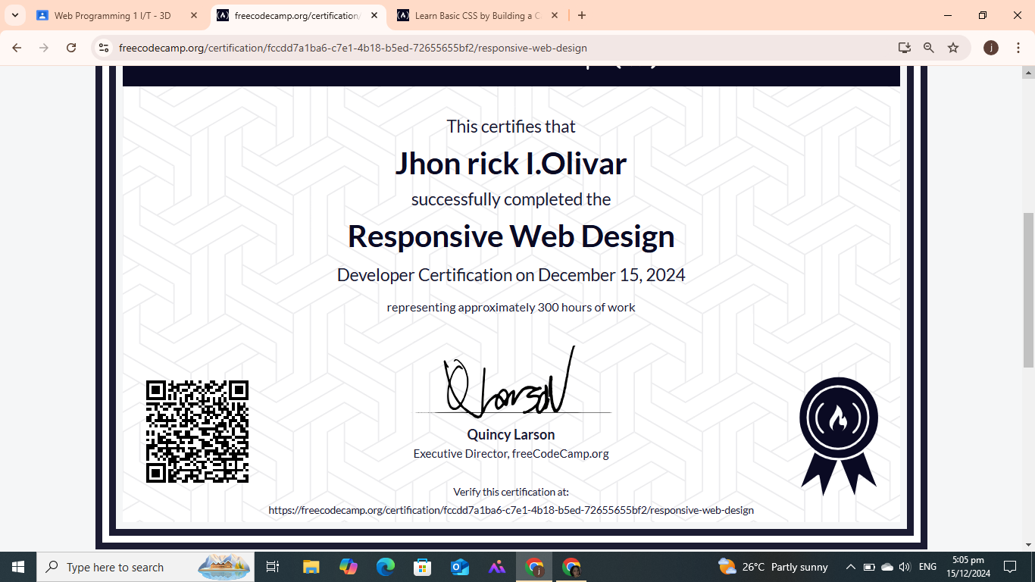

**Day 2 of #xxDaysOfJavaScript**: Took my first step into the world of JavaScript! Learned about the **JavaScript Algorithms and Data Structures (Beta)**

Constructing applications such as the Palindrome Checker, Roman Numeral Converter, Telephone Number Validator, Cash Register and the Pokemon Search App enhances your JavaScript. You find out how to use strings, use regex to check for inputs, work with basic arithmetic functions and money and be able to get and display data using APIs. These projects explain concepts like loops, functions, conditions, problem-solving alongside handling real-life problems and enhance the skills of coding language

