**PROJECT SPECIFICATION FORM**

UNIVERSITY OF WOLVERHAMPTON

SCHOOL OF ENGINEERING

**6MA017 / 6ET011 (40 credits) Individual Project**

**PROJECT SPECIFICATION (Please complete this form electronically, then print and sign)**

Riccardo Geraci

1. Name of Student ..................................................................

r.geraci@wlv.ac.uk

***e-mail address*** *..................................................................*

01902 753409

Telephone (home) .................................................................

07432219900

(work) ..................................................................

Fax ..................................................................

Niki Zakeri

Name of University Supervisor..................................................................

Credit Rating of Project 40

Nominal Duration 400

Academic Session 2019/2020

2. Title of Project:

Stratospheric Data Collection Via Telemetry Using High-Altitude Weather Balloon

3. Objectives

* Design of the balloon payload and means of returning to Earth (i.e parachute)
* Choosing materials which can withhold the effects of atmospheric conditions
* Design of the onboard telemetry hardware
* Designing a means of tracking the balloon via GPS that transmits coordinates to a computer
* Design of onboard sensor units which may include air pressure, temperature, and altitude
* Designing a live camera feed system using TVL-600 camera system
* Calculating the payload total mass to ensure the balloon is within lift capabilities
* Calculation of expected burst altitude, ascent time, landing location, descent time with effects of the parachute
* Identification of a suitable weather balloon that can withstand the load
* Research of the regulations regarding weather balloon launches

4. Proposed Programme of Work (include a detailed work plan, typically a Gantt Chart):

**Design**

Research will be undertaken to determine a suitable design for the payload section of the weather balloon. This may include creating cradles or cut-outs for cameras and mounting for telemetry electronics. A method of attaching the payload and parachute to the balloon will also need to be established.

**Materials**

Due to the sub-zero temperatures of high altitudes, and weight limitation of balloons, a material will need to be determined of which will protect and carry the payload electronics and which has properties that will satisfy weight, insulation, impact absorption effects, and floatation in the event it lands in water.

**Telemetry**

Telemetry hardware will be designed to transmit the measured values from the onboard sensors back to a ground computer to show live atmospheric readings. This will require research into transmitting and receiving hardware and a system to display this information periodically.

**GPS**

The balloon will be tracked via GPS to show its live position. This is necessary to be able to find the payload after it returns to Earth. This could be an average of 3 hours of driving to reach the landing location. A system will need to be established so that it will be able to transmit the latitude and longitude coordinates for tracing via mapping software, which will also allow observation of the drift from the launch site to the landing location.

**Sensors**

The commercial purpose of using weather balloons is to gather data for forecasting the weather by meteorologists. Therefore, up to three different sensing technologies will be integrated into the payload to measure air pressure, air temperature, and altitude. These sensors will be made into modules, or probes and then connected to a microcontroller before being transmitted to a ground computer via telemetry.

**Cameras**

One or two video cameras with internal memory will be mounted in the payload to provide high definition aerial videos/photos of the Earth. These will either be GoPro action cameras or inexpensive Chinese action cameras with the latter more likely in case the payload is not retrieved due being stolen, destroyed, or from landing in an inaccessible location such as on top of a government building or a fenced-off private property. Though permission to retrieve the payload will be made as much as possible. An analogue video feed system will be designed to allow broadcasting of a live video to show the current location of the balloon. Though the maximum distance of this will likely less than the distance to the stratospheric and will not provide a receivable video signal. Though, further research will confirm this.

**Calculations**

Calculations will be made to determine whether the payload’s total mass is within the lifting range of the balloon, the expected time of ascent of the balloon before bursting due to low air pressure along with the burst altitude. The drift of the balloon will be predicted by using weather forecasting, so the location of the landing can be expected somewhere preserving, and not somewhere such as the Atlantic Ocean, or a prison, etc. The time of the descent with the slowing effects of the parachute will be calculated to determine the expected time of landing. These calculations will then be compared with the actual data to show the accuracy of the predictions.

**Weather Balloon**

Balloons designed for this purpose come in various sizes and have various burst altitudes. The larger capacity balloons tend to have higher maximum altitudes that the smaller ones. But this comes at a much-increased cost. The material the balloon is manufactured from will also play a role in which is selected. The distributor *Kaymont* lists professional bodies that use their Japanese-made Totex weather balloons including the U.S space program, national weather service, and military. Research will be done to determine which balloon size and balloon material will be chosen to take the payload to near space.

**Regulations**

Since there are many regulations that must be respected when launching weather balloons, research will be done to determine what will be required before launching the balloon. Previous research efforts have concluded things such as 28-day prior permission, air traffic control notification on the day of launching, and a map showing the launch site will need submitting to the CAA before the launch can take place.

**Project Schedule**

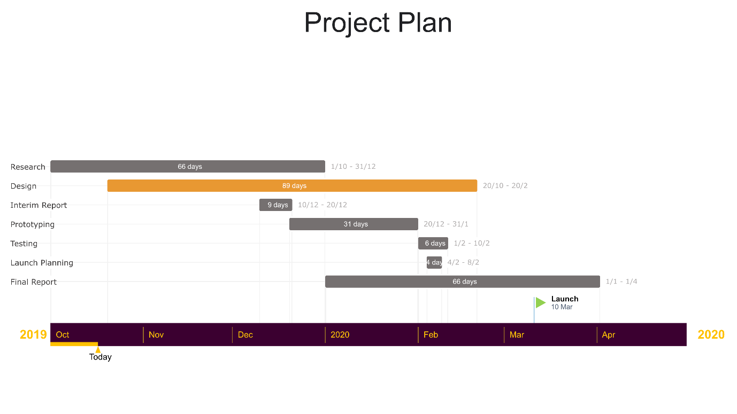

I confirm that this project proposal can be completed in the time available.

Signed..........................…………. (University Supervisor) Date .....................

Signed……………………............. (Student) Date ......................

Accepted ………………............... (Project Module Leader) Date ......................

**DISSERTATION AND PROJECT WORK, ETHICS AND SAFETY APPROVAL FORM**



Faculty of Science and Engineering

**UNDERGRADUATE AND POSTGRADUATE TAUGHT DISSERTATION AND PROJECT WORK, ETHICS APPROVAL**

|  |  |  |  |
| --- | --- | --- | --- |
| Section 1 | | | |
| Student Name: | Riccardo Geraci | Academic Year: | 2019/2020 |
| Student Number: | 1615626 | Contact telephone number: | 07432219900 |
| Course: | Electronics and Telecommunications | Email address: | r.geraci@wlv.ac.uk |
| Supervisor’s Name: | Niki Zakeri | | |
| Project Title: | Stratospheric Data Collection Via Telemetry Using High-Altitude Weather Balloon | | |
| Section 2 | | | |
| **Aim and Objectives:**   * Design of the balloon payload and means of returning to Earth (i.e parachute) * Choosing materials which can withhold the effects of atmospheric conditions * Design of the onboard telemetry hardware * Designing a means of tracking the balloon via GPS that transmits coordinates to a computer * Design of onboard sensor units which may include air pressure, temperature, and altitude * Designing a live camera feed system using TVL-600 camera system * Calculating the payload total mass to ensure the balloon is within lift capabilities * Calculation of expected burst altitude, ascent time, landing location, descent time with effects of the parachute * Identification of a suitable weather balloon that can withstand the load * Research of the regulations regarding weather balloon launches | | | |
| **Brief Explanation and Justification of Methodology:**  To achieve the objective of the project will require extensive research into many factors such as regulations, hardware, programming, PCB fabrication, sensors, microcontrollers, materials, etc. The aim of this project is to broadcast data from the stratosphere via onboard telemetry during the weather balloon’s ascent and descent. The type of data collected may include altitude, temperature, air pressure, and will require GPS for tracking of the balloon and mounted camera(s) for videos/images to use in the final report. This may also include the transmission of a TVL-600 analogue camera for live viewing of the balloon during the initial launch. Calculations will be made to ensure the payload is within the lifting capabilities of the balloon, along with research of the expected burst time, burst altitude, landing location and time of retrieval of the balloon. The onboard telemetry will also likely include custom fabricated PCBs for the various onboard sensors. | | | |

|  |  |  |  |
| --- | --- | --- | --- |
| **Section 3** | | | |
| **Please tick (✓) aspects relevant to your investigation and detail overleaf:** |  | **If ticked, respond Yes/No to the following, give details in Section 4:** | |
| **Ethics:** | | |  |
| Production of videos / audiotapes, etc | **✓** | Has permission of participants been obtained? (see note 2) | No |
| Working with minors |  | Are consents/assents and CRB approval in place? (see note 1) |  |
| Working with vulnerable groups within the community (e.g. the disabled, the sick, pensioners) |  | Has permission of participants been obtained? (see note 2) |  |
| Observation of human subjects |  | Has permission of participants been obtained? (see note 2) |  |
| Telephone contact with other individuals or organisations |  | Has permission of participants been obtained? (see note 2) |  |
| Interviews |  | Has supervisor approval been obtained?  (see note 4) |  |
| Questionnaires |  | Has supervisor approval been obtained?  (see note 4) |  |
| Confidential information |  | Are measures in place to ensure continued confidentiality? (see note 5) |  |
| **General:** | | |  |
| Is any of your work likely to bring the University of Wolverhampton into disrepute on ethical, safety or legal grounds? |  | Are measures in place to prevent this from happening? |  |
| Are measures in place to ensure confidential disposal of data? |  |  |  |
|  |  |  |  |
| **Section 4.**  Give further details justifying issues from Section 3. **NOTE**, even if there are no ticks in the above boxes **confirm, in this box,** that you have read the above and that **none** of the categories apply to your project.  Video/photos will be taken via the onboard cameras, but no permissions are required as the footage will be of the Earth and sky. | | | |

Notes:

1. If you intend to work with minors, you will need to obtain a parental consent form, a child assent form, and to engage in the Criminal Record Bureau (CRB)* process and complete the self-declaration form. If you have not received your CRB check prior to testing you need to refer in your method to the individual who has been CRB checked who will be present when you are completing your data collection.

2. Participants have been fully informed of the risks and benefits of the procedures and of their right to refuse participation or withdraw from the research at any time.

1. The confidentiality and anonymity of all participants in the work specified must be maintained during collection, analysis, dissemination and subsequent storage, and disposal, in line with the Data Protection Act (1998).
2. Final versions of questionnaires and interview questions to be submitted to the supervisor for confirmation of ‘*fitness for purpose*’ BEFORE any data is collected.
3. Has a risk assessment been completed, and can you comply with it? (Append documents).

##### Research Ethics – Project Categorisation

# CATEGORY 0 & CATEGORY A

Category 0 projects are non-hazardous, do not employ participants and use only existing material publicly and legally available in the UK and overseas. They do not meet the criteria for Category A or B.

*Category A projects usually involve the participation of people, rather than secondary data sources such as published memoirs etc. but are not deemed hazardous to the physical or psychological welfare of the participant or the investigator. They do not employ vulnerable individuals, in the context of the specific research, or investigate issues likely to give grounds for offence. If a project appears to be a borderline case of category B it should be deemed to be category B in the first instance. A school ethics committee may subsequently determine it to be category A and set precedent for future usage. Category A projects may be carried out by undergraduates and students, with appropriate training, on other courses below degree level but a first degree in an appropriate subject, or other relevant professional recognition, is a minimum requirement for carrying out category B projects.

# CATEGORY B projects involve any of the following

*Any research involving covert procedures.

**\***The use of any procedure that may be considered likely to be physically or psychologically harmful unless the procedure is widely used in practice and potential hazards have been minimized. For example, blood sampling and collection of other bodily fluids may be category A procedures provided there is strict adherence to established safety protocols and appropriate supervision.

**\***Research that may be offensive, for example, research into pornography, drug abuse etc. Also, research that is contentious in the sense that it may bring the university into disrepute. For example, investigations into some racial differences will need to be shown to be ethically defensible.

**\***Research that requires access to, or creates, data about individuals of a highly confidential nature.

**\***Research involving participants who, within the context of the study to be undertaken, are considered to be vulnerable. Projects with vulnerable individuals may be designated category A if it is clear that the vulnerability of the individual is likely to be unaffected by participation in the study.

**\***Research that requires the administration of substances (legal or otherwise).

**\***Research that requires the approval of another ethics committee, for example, an LREC, will usually be designated category B. Similarly, research requiring data collection abroad, especially if the supervisor remains in the UK, will usually require scrutiny by a school ethics committee.

**Student Declaration:**

I confirm that the information I have provided is complete and accurate and that in the case where any concerns arise which require ethical approval, or over which doubt exists, then work will be halted immediately, and clarification sought from an Ethics Committee representative.

Signed:

Date:

**Supervisor Declaration:**

I am satisfied that the planned research procedures as discussed with me and as outlined in the attached proposal are appropriate for consideration by the Ethics and Safety Committee.

Signed:

Date

|  |  |  |  |
| --- | --- | --- | --- |
| Decision of Safety and Ethics Committee | | | |
|  | ✓ | Signature  (Chair of Ethics and Safety Committee) | Date |
| Approved |  |  |  |
| Approved with comments |  |  |  |
| Approved with conditions |  |  |  |
| Deferred |  |  |  |
| Comments: | | | |
|  | | | |

**RISK ASSESSMENT FORM**

Mechatronics Lab

Telford

Location …………………………………………………. Environment/Activity/Equipment …………..…………………………………Sheet 1 of 1

**Hazard Identification Reference**

|  |  |  |  |  |  |  |  |  |  |  |  |  |
| --- | --- | --- | --- | --- | --- | --- | --- | --- | --- | --- | --- | --- |
| (a) Confined Spaces | (b) Falls from Height | (c) Striking by mobile platform | (d) Trip or Slip | (e) Collapse | (f) Manual Handling | (g) Electrical | (h) Hazardous Substances | (i) Radiation | (j) Noise & Vibration | (k) Fire | (l) Explosion | (m) Others |

**Severity (S) Likelihood (L) Risk Factor (R) S x L= R**

|  |  |  |
| --- | --- | --- |
| 1 Negligible - all in a day's work | 1 Improbable | <4 Risk may need to be controlled LOW |
| 2 Minor - minor injury with short term effect | 2 Remote - unlikely | 4-6 Risk must be controlled MEDIUM |
| 3 Severe - major injury/disability (reportable) | 3 Possible - may or could well occur | 7-9 Hazard must be controlled HIGH |
| 4 Extreme – fatal | 4 Probable - expected to occur, several times | >9 Hazard must be avoided VERY HIGH |

|  |  |  |  |  |  |  |  |  |  |  |  |  |  |  |  |  |
| --- | --- | --- | --- | --- | --- | --- | --- | --- | --- | --- | --- | --- | --- | --- | --- | --- |
| **Hazard Ref.** | **Hazard Description** | **People at risk** | | | **Initial Assessment** | | | **Control Measures** | | | **Residual**  **Risk** | | | **Action/Comments** | | |
|  |  |  |  |  | **S** | **L** | **R** |  |  |  | **S** | **L** | **R** |  |  |  |
| D | Trailing cables | Everybody in the Lab | | | 2 | 2 | 4 | Ensure there are no cables suspended across walkways or left lying on the floor | | | 1 | 1 | 1 | Since cables are kept away from walking areas, there is no chance of tripping on any | | |
| M | Eye Strain | Those working on computers | | | 2 | 3 | 6 | Ensure regular breaks are taken to minimise eye strain and focus on faraway objects periodically | | | 1 | 1 | 1 | Regular breaks will allow eyes to focus on various distances preventing eye strain | | |
| M | Soldering Burns | Those working with soldering equipment | | | 2 | 4 | 8 | Ensure careful attention is kept when handling high-temperature soldering equipment | | | 2 | 3 | 6 | While the risk still remains, the acknowledgement of greater attention required will lessen the overall risk | | |
| G | Electric Shock | Those working with electrical equipment | | | 3/4 | 3 | 8 | Ensure high voltage equipment is not tampered with while it is energised, such as power outlets | | | 3 | 2 | 6 | Acknowledgement of the potentially fatal effects of tampering with mains electricity will lower the likelihood | | |
| M | Cuts from Tools | Those working with tools | | | 2 | 3 | 6 | Ensure to cut away from the body and be careful when handling sharp tools | | | 2 | 2 | 6 | Using tools correctly will reduce the likelihood of injuries | | |

18/10/19

Riccardo Geraci

Completed by…………………………………………Date………………

Copies to ……………..…………………………………………………….

Reviewed by ……………………………………………………………….

Review Date (s) ……………………………………………………………