Invasive_wrack_manuscript_code

Ric DeSantiago

12/15/2021

#libraries

library(knitr)  
library(tidyverse)

## ── Attaching packages ─────────────────────────────────────── tidyverse 1.3.0 ──

## ✓ ggplot2 3.3.3 ✓ purrr 0.3.4  
## ✓ tibble 3.0.6 ✓ dplyr 1.0.4  
## ✓ tidyr 1.1.2 ✓ stringr 1.4.0  
## ✓ readr 1.4.0 ✓ forcats 0.5.1

## ── Conflicts ────────────────────────────────────────── tidyverse_conflicts() ──  
## x dplyr::filter() masks stats::filter()  
## x dplyr::lag() masks stats::lag()

library(tidyr)  
library(ggplot2)  
library(ggfortify)  
library(lme4)

## Loading required package: Matrix

##   
## Attaching package: 'Matrix'

## The following objects are masked from 'package:tidyr':  
##   
## expand, pack, unpack

library(car)

## Loading required package: carData

## Registered S3 methods overwritten by 'car':  
## method from  
## influence.merMod lme4  
## cooks.distance.influence.merMod lme4  
## dfbeta.influence.merMod lme4  
## dfbetas.influence.merMod lme4

##   
## Attaching package: 'car'

## The following object is masked from 'package:dplyr':  
##   
## recode

## The following object is masked from 'package:purrr':  
##   
## some

library(nlme)

##   
## Attaching package: 'nlme'

## The following object is masked from 'package:lme4':  
##   
## lmList

## The following object is masked from 'package:dplyr':  
##   
## collapse

library(ggpubr)  
library(multcompView)  
library(boot)

##   
## Attaching package: 'boot'

## The following object is masked from 'package:car':  
##   
## logit

library(Hotelling)

## Loading required package: corpcor

library(mvnTest)

## Loading required package: mvtnorm

library(vegan)

## Loading required package: permute

## Loading required package: lattice

##   
## Attaching package: 'lattice'

## The following object is masked from 'package:boot':  
##   
## melanoma

## This is vegan 2.5-7

library(factoextra)

## Welcome! Want to learn more? See two factoextra-related books at https://goo.gl/ve3WBa

library(FactoMineR)  
library(agricolae)

## Registered S3 methods overwritten by 'klaR':  
## method from   
## predict.rda vegan  
## print.rda vegan  
## plot.rda vegan

##   
## Attaching package: 'agricolae'

## The following object is masked from 'package:factoextra':  
##   
## hcut

library(glmm)

## Loading required package: trust

## Loading required package: parallel

## Loading required package: doParallel

## Loading required package: foreach

##   
## Attaching package: 'foreach'

## The following objects are masked from 'package:purrr':  
##   
## accumulate, when

## Loading required package: iterators

library(HH)

## Loading required package: grid

## Loading required package: latticeExtra

##   
## Attaching package: 'latticeExtra'

## The following object is masked from 'package:ggplot2':  
##   
## layer

## Loading required package: multcomp

## Loading required package: survival

##   
## Attaching package: 'survival'

## The following object is masked from 'package:boot':  
##   
## aml

## Loading required package: TH.data

## Loading required package: MASS

##   
## Attaching package: 'MASS'

## The following object is masked from 'package:dplyr':  
##   
## select

##   
## Attaching package: 'TH.data'

## The following object is masked from 'package:MASS':  
##   
## geyser

## Loading required package: gridExtra

##   
## Attaching package: 'gridExtra'

## The following object is masked from 'package:dplyr':  
##   
## combine

##   
## Attaching package: 'HH'

## The following object is masked from 'package:boot':  
##   
## logit

## The following objects are masked from 'package:car':  
##   
## logit, vif

## The following object is masked from 'package:purrr':  
##   
## transpose

library(ggpubr)  
library(rstatix)

##   
## Attaching package: 'rstatix'

## The following object is masked from 'package:MASS':  
##   
## select

## The following object is masked from 'package:stats':  
##   
## filter

#hi

#Choice Assays

#import and name data  
LabAssayWholeTissue <-read.csv("LabAssaysWholeTissue.csv",header=T)  
View(LabAssayWholeTissue)  
  
#ensure factors are correctly read  
is.numeric(LabAssayWholeTissue$algae_Wd)

## [1] TRUE

is.factor(LabAssayWholeTissue$algae_spp.)

## [1] FALSE

AllSpeciesWholeTissue<-ggplot(LabAssayWholeTissue, aes(x=grazer_spp., y=algae_Wd, fill= algae_spp.)) + geom_boxplot() + theme_bw() + xlab("Algae Species") + ylab("Total Consumed (g)") + ggtitle("Live algae choice assay") + theme(plot.title =element_text(hjust = 0.5))  
AllSpeciesWholeTissue

## Warning: Removed 117 rows containing non-finite values (stat_boxplot).

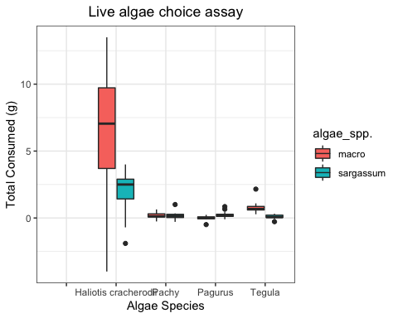

##Tegula

#read and rename file  
WholeTissueAssay <- read.csv("LabAssaysWholeTissue.csv",header=T)  
View(WholeTissueAssay)  
  
#subset the tegula rows  
tegula<-subset(LabAssayWholeTissue, grazer_spp.== "Tegula")  
view(tegula)  
  
#since controls were solely used for correction of autogenic growth, we can further subset to only look at the experimental treatments  
tegulachoice <- subset(tegula, trt == "exp")  
view(tegulachoice)  
  
#visualize data  
  
#look at the data in boxplots to visualize the spread around the median  
ggplot(tegulachoice, aes(x=algae_spp., y=algae_Wd)) + geom_boxplot()

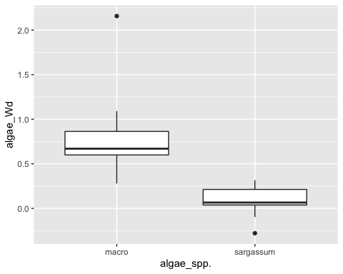

#there seems to be an outlier in each treatment that may be pulling distributions, however, we are leaving outliers in as they are biological real.  
  
#separate the histogram by species of algae to visually determine if the distributions of differences (f-i, adjusted for autogenic growth) look normal  
#sargassum  
tegulachoicesarg<-subset(tegulachoice, algae_spp. == "sargassum")  
ggplot(tegulachoicesarg, aes(x=algae_Wd)) + geom_histogram(binwidth=0.1)

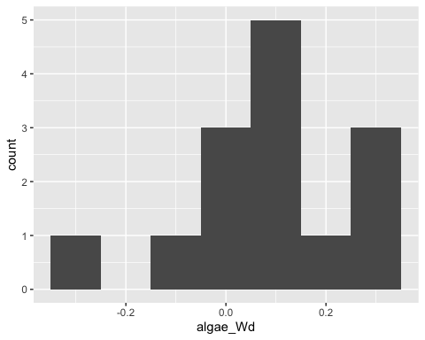

mean(tegula$algae_Wd[tegula$algae_spp.== 'sargassum'],na.rm = T)

## [1] 0.09127857

sd(tegula$algae_Wd[tegula$algae_spp.== 'sargassum'],na.rm = T)

## [1] 0.1622792

#macrocystis  
tegulachoicemacro<-subset(tegulachoice, algae_spp. == "macro")  
ggplot(tegulachoicemacro, aes(x=algae_Wd)) + geom_histogram(binwidth=0.1)

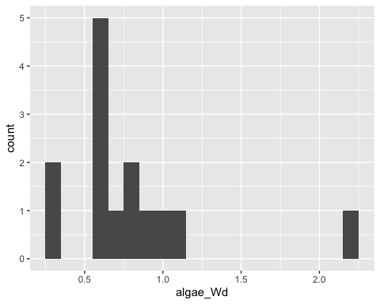

mean(tegula$algae_Wd[tegula$algae_spp.== 'macro'],na.rm = T)

## [1] 0.7892286

sd(tegula$algae_Wd[tegula$algae_spp.== 'macro'],na.rm = T)

## [1] 0.4574772

#Ds of weight in S. horneri tend to be right leaning while M. pyrifera samples tend to be left learning  
#test for normality  
par(mfrow=c(2,2))  
qqnorm(tegulachoicemacro$algae_Wd)  
qqline(tegulachoicemacro$algae_Wd)  
qqnorm(tegulachoicesarg$algae_Wd)  
qqline(tegulachoicesarg$algae_Wd)  
# when graphing the sample quantities versues theoretical, we can see that the data tend to center around the fitted line. We can proceed.  
  
##however, our data are not independent since they are a choice between two options of algae within each replicate  
### To address the question "Do grazers show a preference between S. horneri or M. pyrifera?" we will use consumption as a proxy for choice. Thus, we can use a paired T test to see if there is a difference in "total consumed" between S. horneri and M. pyrifera.  
####Paired t-tests are essentially one-sample t-tests, but you are comparing a distribution of DIFFERENCES to a theoretical one rather than a distribution of sample statistics. The original data are not used, rather the mean, variance, and standard deviation are based on the DIFFERENCES. Thus, we don't need equal variances, only normal distribution of means and equal sample size.   
  
####make the data in "wide form" to create column to display differences#####  
#create a dataframe with just important columns  
tegdiffs <- na.omit(tegulachoice[, -c(1:8, 10:12, 14:22)])  
view(tegdiffs)  
#subset S.horneri only  
tegdiffs2<-subset(tegdiffs, algae_spp. == "sargassum")  
view(tegdiffs2)  
#subset M. pyrifera only  
tegdiffs3<-subset(tegdiffs, algae_spp. == "macro")  
view(tegdiffs3)  
#Bind the two datasets in "wide form"  
tegdiffs4<- bind_cols(tegdiffs2,tegdiffs3)

## New names:  
## * algae_spp. -> algae_spp....1  
## * algae_Wd -> algae_Wd...2  
## * algae_spp. -> algae_spp....3  
## * algae_Wd -> algae_Wd...4

view(tegdiffs4)  
#create new column with the differences by subtracting S. horneri consumed from M. pyrifera consumed  
tegdiffs5<- mutate(tegdiffs4, diffs = algae_Wd...4 - algae_Wd...2)   
view(tegdiffs5)  
  
#check for normality of the differences  
ggplot(tegdiffs5, aes(x=diffs)) + geom_histogram(binwidth=0.1)  
qqnorm(tegdiffs5$diffs)  
qqline(tegdiffs5$diffs)  
#there seems to be an outlier, however, the data look normally distributed around the theoretical line. We can proceed to a paired T test

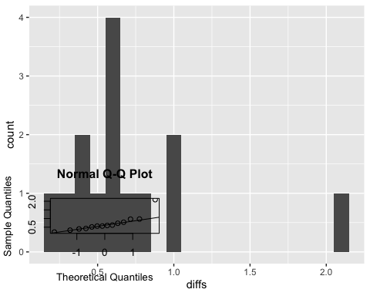

###Analysis

#we will conduct a paired-T test.  
  
## H0: There is no difference in total consumed between S. horneri and M. pyrifera (i.e. there is no choice between algae).  
## HA: There is a difference in total consumed between S. horneri and M. pyrifera (i.e. there is a choice between algae).  
  
#T test  
t.test(tegulachoice$algae_Wd~tegulachoice$algae_spp., mu=0, alt="two.sided", paired=T,conf.level=0.95)

##   
## Paired t-test  
##   
## data: tegulachoice$algae_Wd by tegulachoice$algae_spp.  
## t = 5.7152, df = 13, p-value = 7.111e-05  
## alternative hypothesis: true difference in means is not equal to 0  
## 95 percent confidence interval:  
## 0.4341199 0.9617801  
## sample estimates:  
## mean of the differences   
## 0.69795

## we reject the null hypothesis (t = 5.7152, df = 13, p-value = 7.111e-05), there was a choice made between algae  
  
  
#make boxplot   
ggplot(tegula, aes(x=algae_spp., y=algae_Wd, fill= algae_spp.))+ geom_boxplot() + theme_bw() + guides() + xlab("Algae Species") + ylab(" Consumtion (g)") + ggtitle("M. pyrifera vs. S. horneri whole tissue consumption by T. funebralis") + theme(plot.title =element_text(hjust = 0.5))

## Warning: Removed 28 rows containing non-finite values (stat_boxplot).

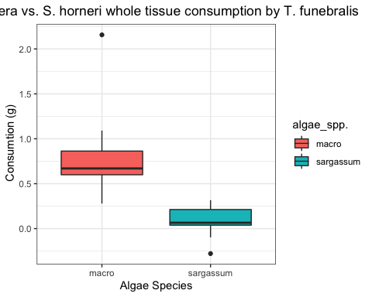

#When given a choice between S. horneri and M. pyrifera, Tegula preferred M. pyrifera.  
  
##this will be repeated for all other grazers.

##Pachy

#subset the P. crassipes rows  
pachy<-subset(LabAssayWholeTissue, grazer_spp.== "Pachy")  
view(pachy)  
  
#since controls were solely used for correction of autogenic growth, we can further subset to only look at the experimental treatments  
pachychoice <- subset(pachy, trt == "exp")  
view(pachychoice)  
  
#visualize data  
  
#look at the data in boxplots to visualize the spread around the median  
ggplot(pachychoice, aes(x=algae_spp., y=algae_Wd)) + geom_boxplot()

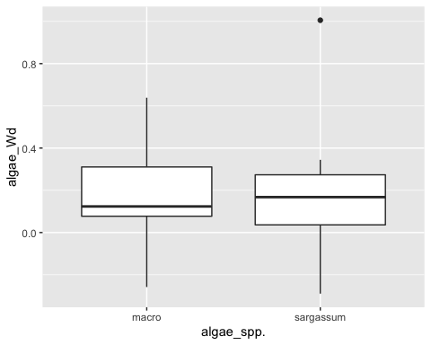

#there seems to be an outlier in the S. horneri treatment that may be pulling the distribution  
  
#check for normality  
ggplot(pachychoice, aes(x=algae_Wd)) + geom_histogram(binwidth=0.1)

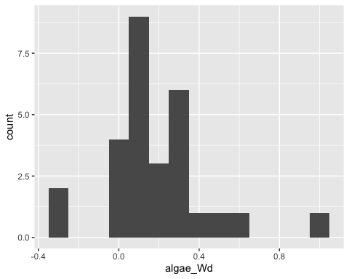

qqnorm(pachychoice$algae_Wd)  
qqline(pachychoice$algae_Wd)

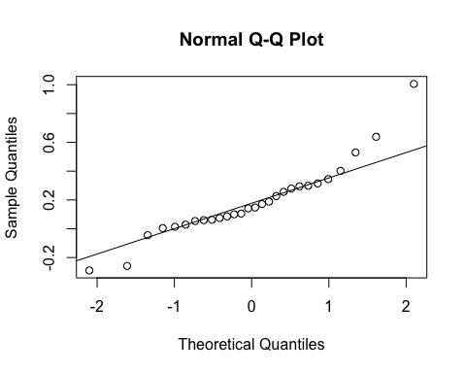

#there seems to be an outlier, however, the data look normally distributed around the theoretical line  
  
#we will conduct a paired-T test.

###Analysis

## H0: There is no difference in total consumed between S. horneri and M. pyrifera (i.e. there is no choice between algae).  
## HA: There is a difference in total consumed between S. horneri and M. pyrifera (i.e. there is a choice between algae).  
  
  
#T test  
t.test(pachychoice$algae_Wd~pachychoice$algae_spp., mu=0, alt="two.sided", paired=T,conf.level=0.95)

##   
## Paired t-test  
##   
## data: pachychoice$algae_Wd by pachychoice$algae_spp.  
## t = 0.073928, df = 13, p-value = 0.9422  
## alternative hypothesis: true difference in means is not equal to 0  
## 95 percent confidence interval:  
## -0.2179178 0.2333607  
## sample estimates:  
## mean of the differences   
## 0.007721429

## we fail reject the null hypothesis (t = 0.073928, df = 13, p-value = 0.9422), there was no choice made between algae  
  
  
#make boxplot   
ggplot(pachy, aes(x=algae_spp., y=algae_Wd, fill= algae_spp.))+ geom_boxplot() + theme_bw() + guides() + xlab("Algae Species") + ylab(" Consumtion (g)") + ggtitle("M. pyrifera vs. S. horneri whole tissue consumption by P. crassipes ") + theme(plot.title =element_text(hjust = 0.5))

## Warning: Removed 28 rows containing non-finite values (stat_boxplot).

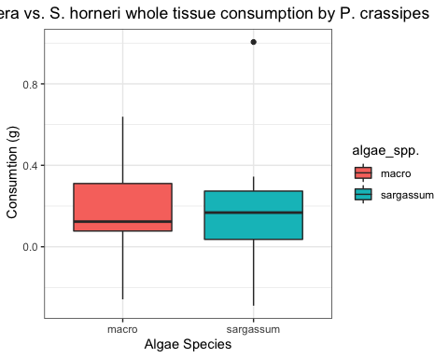

#When given a choice between S. horneri and M. pyrifera, P. Crassipes showed no preference.

##Pagurus

#subset the P. samuelis rows  
pagurus<-subset(LabAssayWholeTissue, grazer_spp.== "Pagurus")  
view(pagurus)  
  
#since controls were solely used for correction of autogenic growth, we can further subset to only look at the experimental treatments  
paguruschoice <- subset(pagurus, trt == "exp")  
view(paguruschoice)  
  
#visualize data  
  
#look at the data in boxplots to visualize the spread around the median  
ggplot(paguruschoice, aes(x=algae_spp., y=algae_Wd)) + geom_boxplot()

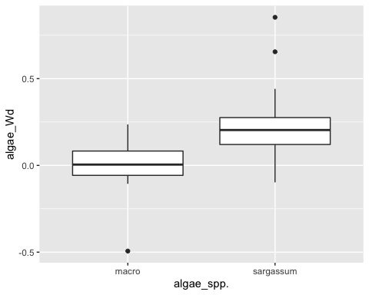

#check for normality  
ggplot(paguruschoice, aes(x=algae_Wd)) + geom_histogram(binwidth=0.1)

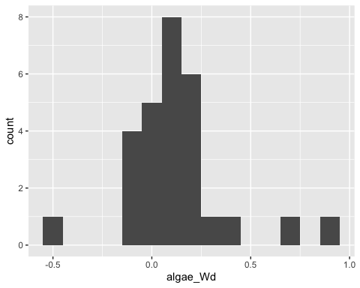

qqnorm(paguruschoice$algae_Wd)  
qqline(paguruschoice$algae_Wd)

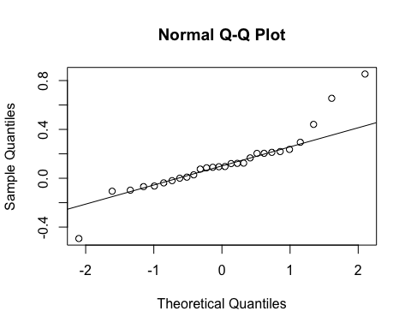

#there seems to be an outlier on both ends, however, the data look normally distributed around the theoretical line  
  
#we will conduct a paired-T test.  
## H0: There is no difference in total consumed between S. horneri and M. pyrifera (i.e. there is no choice between algae).  
## HA: There is a difference in total consumed between S. horneri and M. pyrifera (i.e. there is a choice between algae).  
  
#T test  
t.test(paguruschoice$algae_Wd~paguruschoice$algae_spp., paired= TRUE)

##   
## Paired t-test  
##   
## data: paguruschoice$algae_Wd by paguruschoice$algae_spp.  
## t = -3.7593, df = 13, p-value = 0.002385  
## alternative hypothesis: true difference in means is not equal to 0  
## 95 percent confidence interval:  
## -0.4080334 -0.1102095  
## sample estimates:  
## mean of the differences   
## -0.2591214

## we reject the null hypothesis (t = -3.7593, df = 13, p-value = 0.002385), there was a choice made between algae  
  
  
#make boxplot   
ggplot(pagurus, aes(x=algae_spp., y=algae_Wd, fill= algae_spp.))+ geom_boxplot() + theme_bw() + guides() + xlab("Algae Species") + ylab(" Consumtion (g)") + ggtitle("M. pyrifera vs. S. horneri whole tissue consumption by P. samuelis ") + theme(plot.title =element_text(hjust = 0.5))

## Warning: Removed 28 rows containing non-finite values (stat_boxplot).

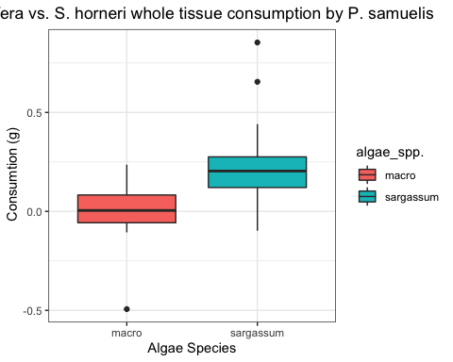

#When given a choice between S. horneri and M. pyrifera, P. samuelis showed a preference for sargassum .

##Abalone September 2019

#subset the A. cracherodii rows  
abalone<-subset(LabAssayWholeTissue, grazer_spp.== "Haliotis cracherodii")  
view(abalone)  
  
#since controls were solely used for correction of autogenic growth, we can further subset to only look at the experimental treatments  
abalonechoice <- subset(abalone, trt == "Experimental")  
view(abalonechoice)  
  
#visualize data  
  
#look at the data in boxplots to visualize the spread around the median  
ggplot(abalonechoice, aes(x=algae_spp., y=algae_Wd)) + geom_boxplot()

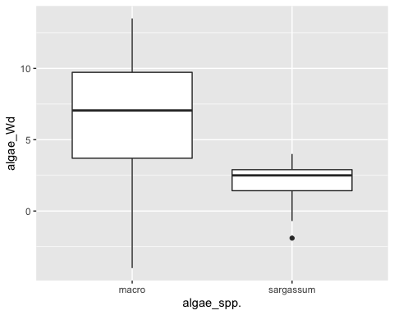

#check for normality  
ggplot(abalonechoice, aes(x=algae_Wd)) + geom_histogram(binwidth=0.5)

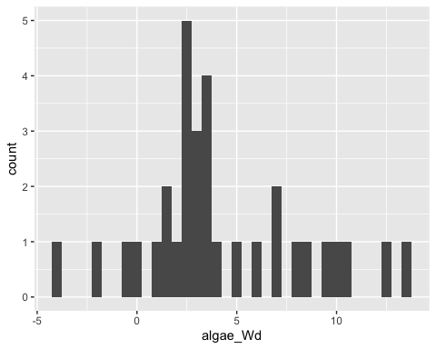

qqnorm(abalonechoice$algae_Wd)  
qqline(abalonechoice$algae_Wd)

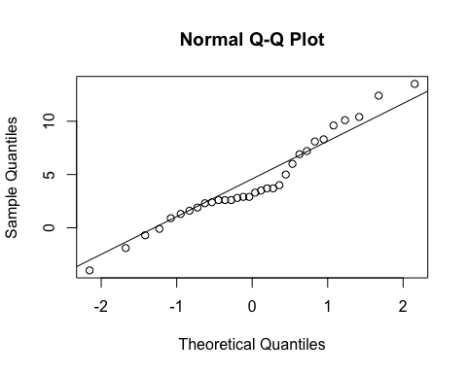

#the data seem normal  
  
#we will conduct a paired-T test.

###Analysis

## H0: There is no difference in total consumed between S. horneri and M. pyrifera (i.e. there is no choice between algae).  
## HA: There is a difference in total consumed between S. horneri and M. pyrifera (i.e. there is a choice between algae).  
  
  
#T test  
t.test(abalonechoice$algae_Wd~abalonechoice$algae_spp., mu=0, alt="two.sided", paired=T,conf.level=0.95)

##   
## Paired t-test  
##   
## data: abalonechoice$algae_Wd by abalonechoice$algae_spp.  
## t = 4.5053, df = 15, p-value = 0.0004189  
## alternative hypothesis: true difference in means is not equal to 0  
## 95 percent confidence interval:  
## 2.430333 6.794667  
## sample estimates:  
## mean of the differences   
## 4.6125

## we reject the null hypothesis (4.5053, df = 15, p-value = 0.0004189), there was a choice made between algae  
  
  
#make boxplot   
ggplot(abalonechoice, aes(x=algae_spp., y=algae_Wd, fill= algae_spp.))+ geom_boxplot() + theme_bw() + guides() + xlab("Algae Species") + ylab(" Consumtion (g)") + ggtitle("M. pyrifera vs. S. horneri whole tissue consumption by H. cracherodii ") + theme(plot.title =element_text(hjust = 0.5))

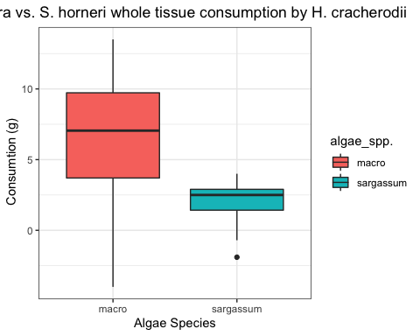

#When given a choice between S. horneri and M. pyrifera, H. cracherodii showed a preference for M. pyriferae.

#Performance Assays March-April 2020

#load data  
performance<-read.csv("PerformanceAssays2020.csv", header=TRUE)  
view(performance)  
na.omit(performance)

## [1] grazer_spp. box_label   
## [3] animal_label diet   
## [5] shell_length_i shell_length_w2   
## [7] shell_length_w3 shell_length_f   
## [9] imageJ_Li imageJ_Lf   
## [11] shell_width_i imageJ_Wf   
## [13] imageJ_Ai imageJ_Af   
## [15] wetmass_i wetmass_2   
## [17] wetmass_3 wetmass_f   
## [19] wetmass_total_Wd buoyant_Wi   
## [21] buoyant_W2 buoyant_W3   
## [23] buoyant_Wf righting_time_1   
## [25] righting_time_2 righting_attempts_final   
## [27] terminal_wet_tissue_mass terminal_gonad_wet_mass   
## [29] terminal_nongonad_wet_mass terminal_shell_wet_mass   
## [31] tissue_sampled terminal_dry_tissue_mass   
## [33] terminal_gonad_dry_mass terminal_nongonad_dry_mass  
## [35] terminal_shell_dry_mass terminal_total_dry_mass   
## [37] est_total_dry_mass_i est_tissue_dry_mass_i   
## [39] est_non_gonad_dry_mass_i est_gonad_dry_mass_i   
## [41] est_shell_dry_mass_i Water_Temp   
## [43] treatment Water_Temp.1   
## <0 rows> (or 0-length row.names)

is.numeric(performance$wetmass_total_Wd)

## [1] TRUE

performance$wetmass_total_Wd<-as.numeric(performance$wetmass_total_Wd)  
is.factor(performance$treatment)

## [1] FALSE

performance$treatment<-as.factor(performance$treatment)  
  
  
#create new column to look at dry weight difference (Wf-Wi) as a proportion of initial weight (Wd/Wi *100) to visualize weight differences from begining to end using estimated starting weights (see section "estimated intial masses")  
performance<-mutate(performance, dry_mass_percent_change = ((terminal_total_dry_mass - est_total_dry_mass_i)/ est_total_dry_mass_i)* 100)  
view(performance)  
  
ggplot(performance, aes(y=dry_mass_percent_change, x=diet)) + geom_boxplot()

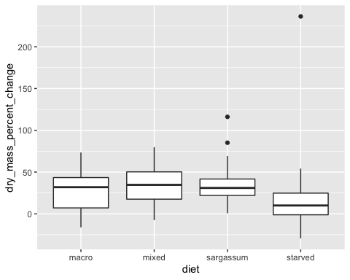

##Red Abalone ###Exploring Data

#subset data for abalone  
redabaloneperformance<-subset(performance, grazer_spp.== "red abalone")  
view(redabaloneperformance)  
  
#visualize data  
ggplot(redabaloneperformance, aes(y=terminal_dry_tissue_mass, x=diet)) + geom_boxplot()

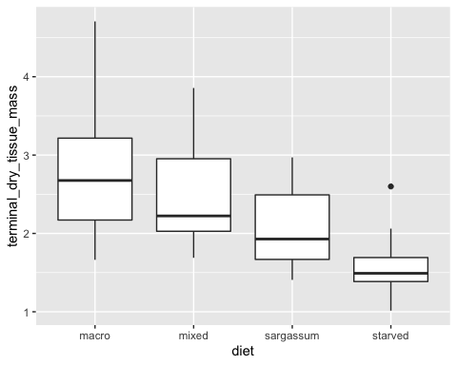

#histogram  
ggplot(redabaloneperformance, aes(x=terminal_dry_tissue_mass)) + geom_histogram(binwidth=0.1)

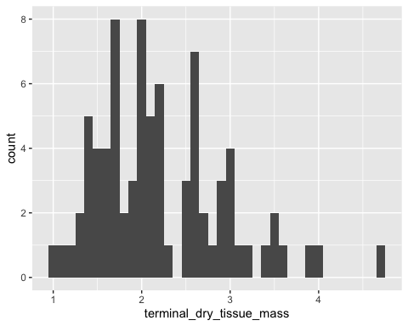

#the data look fairly normal when combined, the histogram shows the distribution tailes to the left having some numbers in the negative, this is likely due to the starved treatment.  
##we will conduct ANOVA or GLMM if assumptions are met. Starved treatment is used as a control and to detect if any food treatment is worse than starvation (e.g., toxic and harmful algae), thus, starved treatments will not be used unless a food treatment causes more mass loss than starved.   
  
#explore the data   
  
#make boxplot for initial wet mass  
ggplot(redabaloneperformance, aes(x=diet, y=wetmass_i , fill= diet)) + geom_boxplot() + theme_bw() + xlab("Diet") + ylab("H. rufescens Wet Mass (g)") + ggtitle("H. rufescens initial wet mass") + theme(plot.title =element_text(hjust = 0.5))

## Warning: Removed 1 rows containing non-finite values (stat_boxplot).

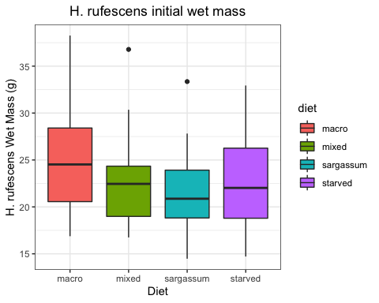

#make boxplot of final wet mass  
ggplot(redabaloneperformance, aes(x=diet, y=wetmass_f , fill= diet)) + geom_boxplot() + theme_bw() + xlab("Diet") + ylab("H. rufescens Wet Mass (g)") + ggtitle("H. rufescens final wet mass by diet") + theme(plot.title =element_text(hjust = 0.5))

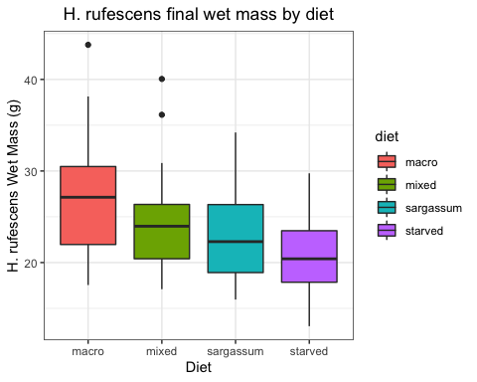

#make boxplot for mass difference  
ggplot(redabaloneperformance, aes(x=diet, y=wetmass_total_Wd , fill= diet)) + geom_boxplot() + theme_bw() + xlab("Diet") + ylab("H. rufescens change in wet Mass (g)") + ggtitle("H. rufescens mass change by diet") + theme(plot.title =element_text(hjust = 0.5))

## Warning: Removed 1 rows containing non-finite values (stat_boxplot).

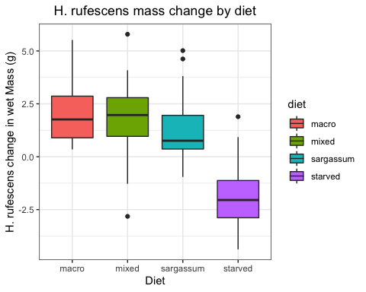

#aside from the variabilty in weights due to water, starved treatment has a mean below zero while others are above   
  
#look at DRY mass based on tissue type  
  
#make boxplot of final dry mass  
ggplot(redabaloneperformance, aes(x=diet, y=terminal_dry_tissue_mass , fill= diet)) + geom_boxplot() + theme_bw() + xlab("Diet") + ylab("H. rufescens Dry Mass (g)") + ggtitle("H. rufescens final wet dry by diet") + theme(plot.title =element_text(hjust = 0.5))

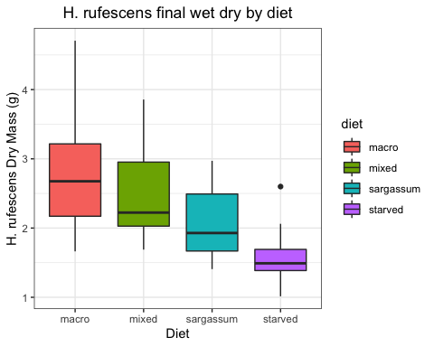

#make boxplot of final gonad/gill/digestive dry mass by diet  
ggplot(redabaloneperformance, aes(x=diet, y=terminal_gonad_dry_mass, fill= diet)) + geom_boxplot() + theme_bw() + xlab("Diet") + ylab("Gonad Dry Mass (g)") + ggtitle("H. rufescens final gonad/gill/GI mass by diet") + theme(plot.title =element_text(hjust = 0.5))

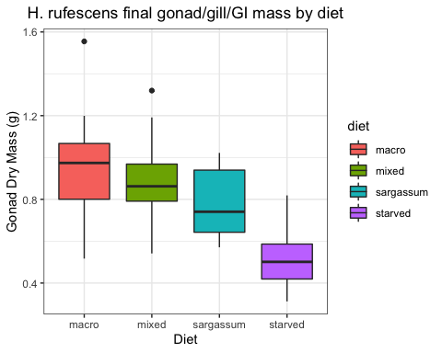

#make boxplot of final foot dry mass by diet  
ggplot(redabaloneperformance, aes(x=diet, y=terminal_nongonad_dry_mass, fill= diet)) + geom_boxplot() + theme_bw() + xlab("Diet") + ylab("Tissue Dry Mass (g)") + ggtitle("H. rufescens final non-gonad dry mass by diet") + theme(plot.title =element_text(hjust = 0.5))

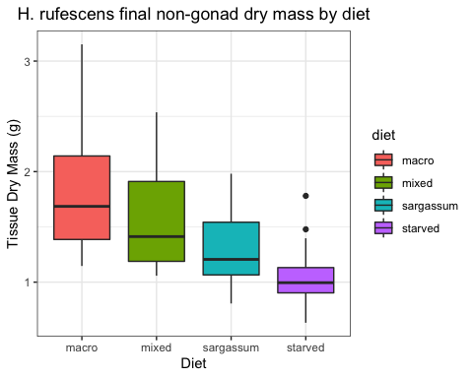

#make boxplot of final shell dry mass by diet  
ggplot(redabaloneperformance, aes(x=diet, y=terminal_shell_dry_mass , fill= diet)) + geom_boxplot() + theme_bw() + xlab("Diet") + ylab("Shell Dry Mass (g)") + ggtitle("H. rufescens final shell dry mass by diet") + theme(plot.title =element_text(hjust = 0.5))

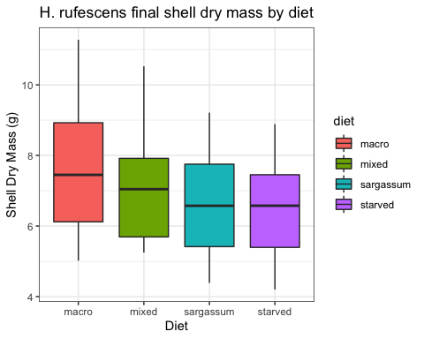

###Estimating Initial Masses

#test if there is a significant difference in initial wet masses using a simple anova  
initialmassabs<-aov(redabaloneperformance$wetmass_i ~ redabaloneperformance$diet)  
summary(initialmassabs)

## Df Sum Sq Mean Sq F value Pr(>F)  
## redabaloneperformance$diet 3 118.5 39.49 1.433 0.24  
## Residuals 75 2067.4 27.57   
## 1 observation deleted due to missingness

#we fail to reject the null hypothesis (p = 0.24), the treatments are not different  
  
##To reduce variability due to water weight, we estimated initial DRY masses through regression analysis using shell lengths to predict dry weight using a sub-sample of the population before the experiment  
  
#read and rename file  
regressions <- read.csv("regressiondata.csv",header=T)  
View(regressions)  
  
#subset abalone  
regressionsub<-subset(regressions, Species == "Ab")  
  
#explore data  
mean(regressionsub$Dissected_total_dry_weight)

## [1] 8.929149

sd(regressionsub$Dissected_total_dry_weight)

## [1] 2.050368

hist(regressionsub$Dissected_total_dry_weight)

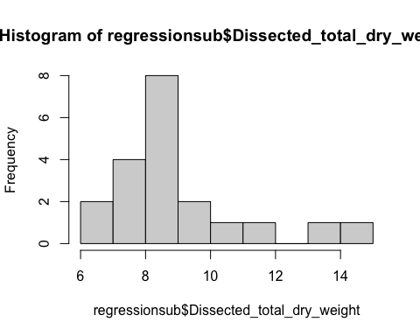

mean(regressionsub$Shell_L)

## [1] 55.912

sd(regressionsub$Shell_L)

## [1] 3.468157

hist(regressionsub$Shell_L)

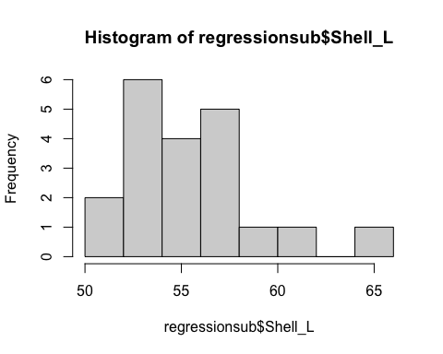

#simple scatterplot and pearson correlation  
plot(regressionsub$Dissected_total_dry_weight, regressionsub$Shell_L, data = regressionsub, main = "scatterplot")

## Warning in plot.window(...): "data" is not a graphical parameter

## Warning in plot.xy(xy, type, ...): "data" is not a graphical parameter

## Warning in axis(side = side, at = at, labels = labels, ...): "data" is not a  
## graphical parameter  
  
## Warning in axis(side = side, at = at, labels = labels, ...): "data" is not a  
## graphical parameter

## Warning in box(...): "data" is not a graphical parameter

## Warning in title(...): "data" is not a graphical parameter

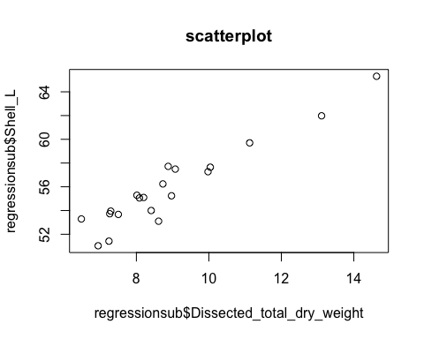

cor(regressionsub$Dissected_total_dry_weight, regressionsub$Shell_L)

## [1] 0.9483042

#Abalone models   
  
#model 1  
#regression to predict total dry mass from shell length  
mod<-lm(Dissected_total_dry_weight ~ Shell_L, data = regressionsub)  
summary(mod)

##   
## Call:  
## lm(formula = Dissected_total_dry_weight ~ Shell_L, data = regressionsub)  
##   
## Residuals:  
## Min 1Q Median 3Q Max   
## -1.06488 -0.46440 -0.04882 0.46014 1.25996   
##   
## Coefficients:  
## Estimate Std. Error t value Pr(>|t|)   
## (Intercept) -22.41711 2.47714 -9.05 4.06e-08 ***  
## Shell_L 0.56064 0.04422 12.68 2.07e-10 ***  
## ---  
## Signif. codes: 0 '***' 0.001 '**' 0.01 '*' 0.05 '.' 0.1 ' ' 1  
##   
## Residual standard error: 0.6685 on 18 degrees of freedom  
## Multiple R-squared: 0.8993, Adjusted R-squared: 0.8937   
## F-statistic: 160.7 on 1 and 18 DF, p-value: 2.075e-10

attributes(mod)

## $names  
## [1] "coefficients" "residuals" "effects" "rank"   
## [5] "fitted.values" "assign" "qr" "df.residual"   
## [9] "xlevels" "call" "terms" "model"   
##   
## $class  
## [1] "lm"

#add the line  
abregplot<- plot(regressionsub$Shell_L, regressionsub$Dissected_total_dry_weight, main = "regression",  
 xlab = "Shell Length", ylab = "Total Dry Tissue",  
 pch = 19, frame = FALSE) +  
abline(lm(regressionsub$Dissected_total_dry_weight ~ regressionsub$Shell_L))

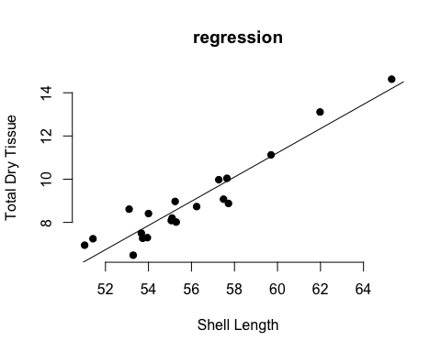

#Model 1: Total sum of dry tissue Formula y= 0.56064x -22.41711  
  
  
#model 2  
#regression to predict foot dry tissue mass from shell length  
mod2<-lm(Dissected_nongonad_dry_weight ~ Shell_L, data = regressionsub)  
summary(mod2)

##   
## Call:  
## lm(formula = Dissected_nongonad_dry_weight ~ Shell_L, data = regressionsub)  
##   
## Residuals:  
## Min 1Q Median 3Q Max   
## -0.314520 -0.102659 0.002746 0.094626 0.301432   
##   
## Coefficients:  
## Estimate Std. Error t value Pr(>|t|)   
## (Intercept) -4.64417 0.61197 -7.589 5.15e-07 ***  
## Shell_L 0.10928 0.01093 10.002 8.90e-09 ***  
## ---  
## Signif. codes: 0 '***' 0.001 '**' 0.01 '*' 0.05 '.' 0.1 ' ' 1  
##   
## Residual standard error: 0.1652 on 18 degrees of freedom  
## Multiple R-squared: 0.8475, Adjusted R-squared: 0.839   
## F-statistic: 100 on 1 and 18 DF, p-value: 8.898e-09

attributes(mod2)

## $names  
## [1] "coefficients" "residuals" "effects" "rank"   
## [5] "fitted.values" "assign" "qr" "df.residual"   
## [9] "xlevels" "call" "terms" "model"   
##   
## $class  
## [1] "lm"

#add the line  
abregplot2<- plot(regressionsub$Shell_L, regressionsub$Dissected_nongonad_dry_weight, main = "regression",  
 xlab = "Shell Length", ylab = "Foot Dry Tissue",  
 pch = 19, frame = FALSE) +  
abline(lm(regressionsub$Dissected_nongonad_dry_weight ~ regressionsub$Shell_L))

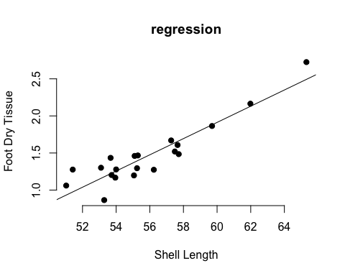

#Model 2: Foot dry tissue Formal y= 0.10928x - 4.64417  
  
  
#Model3  
  
#regression to predict gill/gut/gonad tissue mass from shell length  
mod3<-lm(Dissected_gonad_dry_weight ~ Shell_L, data = regressionsub)  
summary(mod3)

##   
## Call:  
## lm(formula = Dissected_gonad_dry_weight ~ Shell_L, data = regressionsub)  
##   
## Residuals:  
## Min 1Q Median 3Q Max   
## -0.20258 -0.04972 0.02770 0.06261 0.14643   
##   
## Coefficients:  
## Estimate Std. Error t value Pr(>|t|)   
## (Intercept) -1.990739 0.357292 -5.572 2.74e-05 ***  
## Shell_L 0.049014 0.006379 7.684 4.33e-07 ***  
## ---  
## Signif. codes: 0 '***' 0.001 '**' 0.01 '*' 0.05 '.' 0.1 ' ' 1  
##   
## Residual standard error: 0.09643 on 18 degrees of freedom  
## Multiple R-squared: 0.7664, Adjusted R-squared: 0.7534   
## F-statistic: 59.05 on 1 and 18 DF, p-value: 4.329e-07

attributes(mod3)

## $names  
## [1] "coefficients" "residuals" "effects" "rank"   
## [5] "fitted.values" "assign" "qr" "df.residual"   
## [9] "xlevels" "call" "terms" "model"   
##   
## $class  
## [1] "lm"

#add the line  
abregplot3<- plot(regressionsub$Shell_L, regressionsub$Dissected_gonad_dry_weight, main = "regression",  
 xlab = "Shell Length", ylab = "Gill/gut/gonad complex Dry Tissue",  
 pch = 19, frame = FALSE) +  
abline(lm(regressionsub$Dissected_gonad_dry_weight ~ regressionsub$Shell_L))

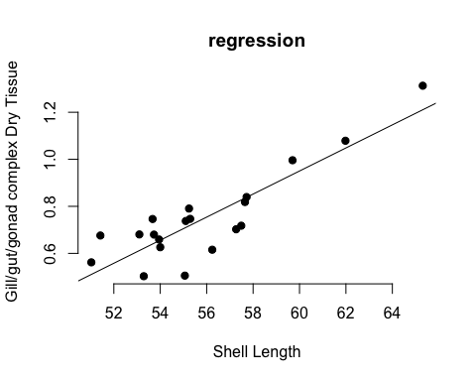

#Model 3: gill/gut/gonad complex dry tissue Formula y= 0.049014x -1.990739  
  
#model 4  
  
#regression to predict soft tissue mass from shell length  
mod4<-lm(Dissected_tissue_dry_weight ~ Shell_L, data = regressionsub)  
summary(mod4)

##   
## Call:  
## lm(formula = Dissected_tissue_dry_weight ~ Shell_L, data = regressionsub)  
##   
## Residuals:  
## Min 1Q Median 3Q Max   
## -0.43285 -0.10316 0.00203 0.12838 0.44786   
##   
## Coefficients:  
## Estimate Std. Error t value Pr(>|t|)   
## (Intercept) -6.63491 0.91230 -7.273 9.26e-07 ***  
## Shell_L 0.15829 0.01629 9.719 1.38e-08 ***  
## ---  
## Signif. codes: 0 '***' 0.001 '**' 0.01 '*' 0.05 '.' 0.1 ' ' 1  
##   
## Residual standard error: 0.2462 on 18 degrees of freedom  
## Multiple R-squared: 0.8399, Adjusted R-squared: 0.831   
## F-statistic: 94.46 on 1 and 18 DF, p-value: 1.382e-08

attributes(mod4)

## $names  
## [1] "coefficients" "residuals" "effects" "rank"   
## [5] "fitted.values" "assign" "qr" "df.residual"   
## [9] "xlevels" "call" "terms" "model"   
##   
## $class  
## [1] "lm"

#add the line  
abregplot4<- plot(regressionsub$Shell_L, regressionsub$Dissected_tissue_dry_weight, main = "regression",  
 xlab = "Shell Length", ylab = "Total soft tissue",  
 pch = 19, frame = FALSE) +  
abline(lm(regressionsub$Dissected_tissue_dry_weight ~ regressionsub$Shell_L))

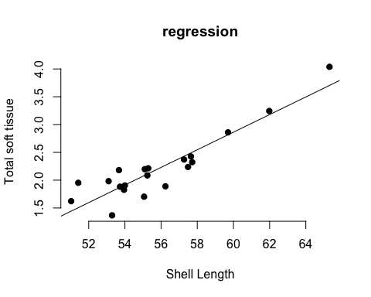

#Model 4: total soft dry tissue Formula y= 0.15829x -6.63491  
  
#model 5  
#regression to predict shell mass from shell length  
mod5<-lm(Dissected_shell_dry_weight ~ Shell_L, data = regressionsub)  
summary(mod5)

##   
## Call:  
## lm(formula = Dissected_shell_dry_weight ~ Shell_L, data = regressionsub)  
##   
## Residuals:  
## Min 1Q Median 3Q Max   
## -0.88719 -0.46582 0.01956 0.39858 1.04863   
##   
## Coefficients:  
## Estimate Std. Error t value Pr(>|t|)   
## (Intercept) -15.78220 2.01945 -7.815 3.41e-07 ***  
## Shell_L 0.40234 0.03605 11.160 1.61e-09 ***  
## ---  
## Signif. codes: 0 '***' 0.001 '**' 0.01 '*' 0.05 '.' 0.1 ' ' 1  
##   
## Residual standard error: 0.545 on 18 degrees of freedom  
## Multiple R-squared: 0.8737, Adjusted R-squared: 0.8667   
## F-statistic: 124.5 on 1 and 18 DF, p-value: 1.609e-09

attributes(mod5)

## $names  
## [1] "coefficients" "residuals" "effects" "rank"   
## [5] "fitted.values" "assign" "qr" "df.residual"   
## [9] "xlevels" "call" "terms" "model"   
##   
## $class  
## [1] "lm"

#add the line  
abregplot5<- plot(regressionsub$Shell_L, regressionsub$Dissected_shell_dry_weight, main = "regression",  
 xlab = "Shell Length", ylab = "Total soft tissue",  
 pch = 19, frame = FALSE) +  
abline(lm(regressionsub$Dissected_shell_dry_weight ~ regressionsub$Shell_L))

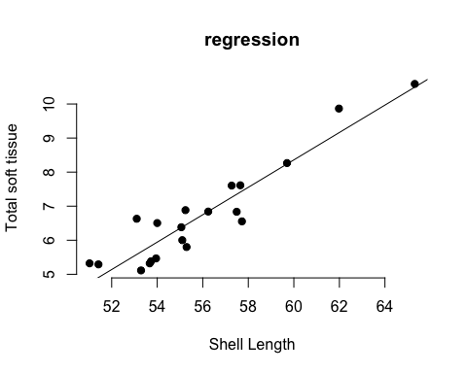

#Model 5: shell dry mass Formula y= 0.40234x -15.78220  
  
#graph estimated total dry mass  
ggplot(redabaloneperformance, aes(x=diet, y=est_total_dry_mass_i , fill= diet)) + geom_boxplot() + theme_bw() + xlab("Diet") + ylab("Dry Mass (g)") + ggtitle("H. rufescens initial dry mass") + theme(plot.title =element_text(hjust = 0.5))

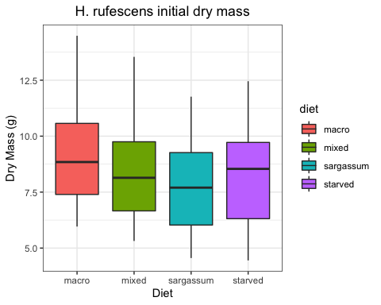

###Abalone Analysis

#remove starved treatment  
abmodels<-subset(redabaloneperformance, !diet== "starved")  
view(abmodels)  
  
#look at the data without starved treatment  
#histogram  
ggplot(abmodels, aes(x=terminal_total_dry_mass)) + geom_histogram(binwidth=01)

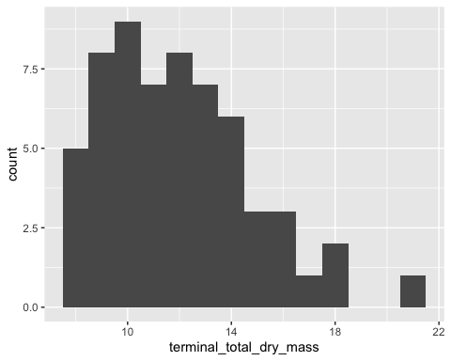

#when combined, the terminal dry masses show a left leaning distribution  
   
#before proceeding check that there is no correlation between estimated initial dry weights and proportional change  
reg<- plot(abmodels$est_total_dry_mass_i,abmodels$dry_mass_percent_change, frame = FALSE) +  
abline(lm(abmodels$dry_mass_percent_change ~ abmodels$est_total_dry_mass_i))

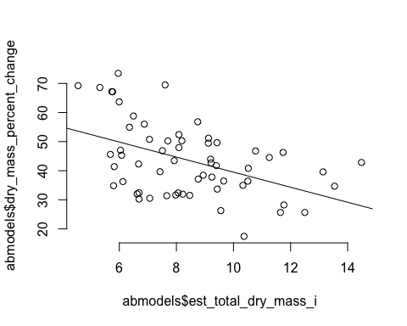

#there seems to be a slight correlation between initial dry mass and percent change. Bigger individuals change less. Thus we will use initial weight estimates as a covariate to look at the effect of diet on size. By doing this, we account for initial weights but lose one degree of freedom  
  
abmodel <- lm(terminal_total_dry_mass ~ diet * est_total_dry_mass_i , data = abmodels)  
# Create a QQ plot of residuals  
par(mfrow = c(2, 2))  
plot(abmodel)

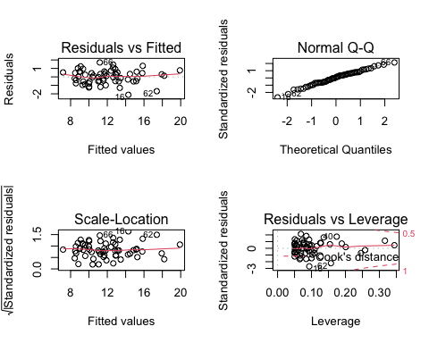

#the data look fairly normal  
  
#testing normality with a Shapiro-Wilk test  
shapiro_test(residuals(abmodel))

## # A tibble: 1 x 3  
## variable statistic p.value  
## <chr> <dbl> <dbl>  
## 1 residuals(abmodel) 0.991 0.942

#SW test fails to reject the Ho(p=0.594), the residuals are normally distributed  
  
bartlett.test(terminal_total_dry_mass ~ diet, data=abmodels)

##   
## Bartlett test of homogeneity of variances  
##   
## data: terminal_total_dry_mass by diet  
## Bartlett's K-squared = 1.8641, df = 2, p-value = 0.3937

#Bartlett test fails to reject the null Ho (p-value =0.3937), thus we accept the hypothesis that our variances are equal  
  
  
#Assumptions for ANCOVA are met, we can now run the analysis to answer the question:  
  
#ANCOVA  
#first we test if there is an interaction between the initial weights and the diets  
int<-ggplot(abmodels, aes(y=terminal_total_dry_mass , x= est_total_dry_mass_i))   
   
int + geom_jitter(aes(col=diet)) + geom_smooth(aes(col=diet), method="lm", se=F)

## `geom_smooth()` using formula 'y ~ x'

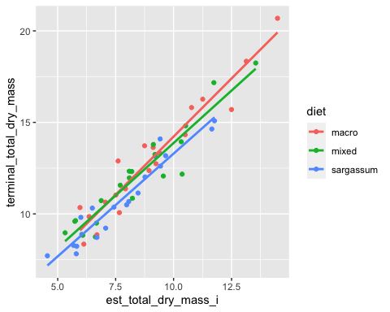

#it looks like there could be an interaction when plotting, lets see if its significant  
  
abmodel <- lm(terminal_total_dry_mass ~ est_total_dry_mass_i * diet , data = abmodels)  
anova(abmodel)

## Analysis of Variance Table  
##   
## Response: terminal_total_dry_mass  
## Df Sum Sq Mean Sq F value Pr(>F)   
## est_total_dry_mass_i 1 434.69 434.69 635.9078 < 2e-16 ***  
## diet 2 5.03 2.52 3.6811 0.03172 *   
## est_total_dry_mass_i:diet 2 1.21 0.61 0.8868 0.41787   
## Residuals 54 36.91 0.68   
## ---  
## Signif. codes: 0 '***' 0.001 '**' 0.01 '*' 0.05 '.' 0.1 ' ' 1

#The interaction between the dependent variable and factor are not signficant(p=0.4179), we can test for significant effect of the factor without the interaction to ask the question "Does diet impact abalone weight?"  
  
## H0: There is no relationship between diet and abalone weights  
## HA: There is a relationship between diet and abalone weights  
abmodel2 <- aov(terminal_total_dry_mass ~ est_total_dry_mass_i + diet , data = abmodels)  
summary(abmodel2)

## Df Sum Sq Mean Sq F value Pr(>F)   
## est_total_dry_mass_i 1 434.7 434.7 638.488 <2e-16 ***  
## diet 2 5.0 2.5 3.696 0.0311 *   
## Residuals 56 38.1 0.7   
## ---  
## Signif. codes: 0 '***' 0.001 '**' 0.01 '*' 0.05 '.' 0.1 ' ' 1

#We reject the H0 and embrace HA, Diet impacts abalone weights (p=0.0311)  
  
#check residuals  
par(mfrow = c(2,2))  
plot(abmodel2)

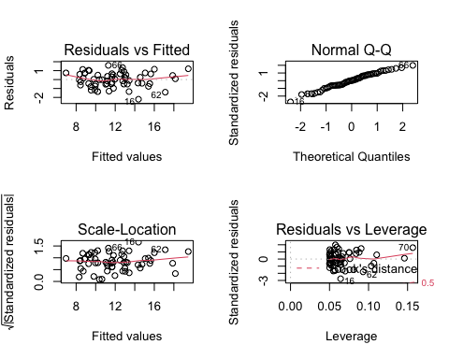

#conduct Tukeys post hoc test to see how the treatments differ  
redab.aov.HSD1 <- HSD.test(abmodel2 , trt = 'diet')   
print(redab.aov.HSD1)

## $statistics  
## MSerror Df Mean CV MSD  
## 0.6808037 56 11.95416 6.902269 0.6281866  
##   
## $parameters  
## test name.t ntr StudentizedRange alpha  
## Tukey diet 3 3.404809 0.05  
##   
## $means  
## terminal_total_dry_mass std r Min Max Q25 Q50  
## macro 13.01614 3.189707 20 8.3464 20.6889 10.563750 12.81260  
## mixed 12.02375 2.644882 20 8.7461 18.2394 9.626150 12.01655  
## sargassum 10.82259 2.332362 20 7.7091 15.0865 8.841075 10.43505  
## Q75  
## macro 14.67300  
## mixed 13.37960  
## sargassum 12.74407  
##   
## $comparison  
## NULL  
##   
## $groups  
## terminal_total_dry_mass groups  
## macro 13.01614 a  
## mixed 12.02375 b  
## sargassum 10.82259 c  
##   
## attr(,"class")  
## [1] "group"

plot(redab.aov.HSD1)  
#all treatments differ from each other

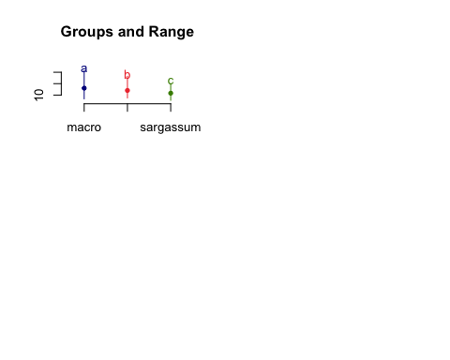

## Tegula

###Exploring Data

#subset data for tegula  
tegulaperformance<-subset(performance, grazer_spp.== "tegula")  
  
#histogram  
ggplot(tegulaperformance, aes(x=terminal_dry_tissue_mass)) + geom_histogram()

## `stat_bin()` using `bins = 30`. Pick better value with `binwidth`.

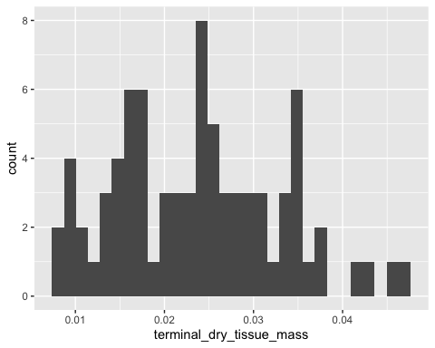

#the data look fairly normal when combined  
  
##we will conduct ANOVA or GLMM if assumptions are met. Starved treatment is used as a control and to detect if any food treatment is worse than starvation (e.g., toxic and harmful algae), thus, starved treatments will not be used unless a food treatment causes more mass loss than starved.   
  
#explore the data   
  
#make boxplot for initial wet mass  
ggplot(tegulaperformance, aes(x=diet, y=wetmass_i , fill= diet)) + geom_boxplot() + theme_bw() + xlab("Diet") + ylab("T. funebralis Wet Mass (g)") + ggtitle("T. funebralis initial wet mass") + theme(plot.title =element_text(hjust = 0.5))

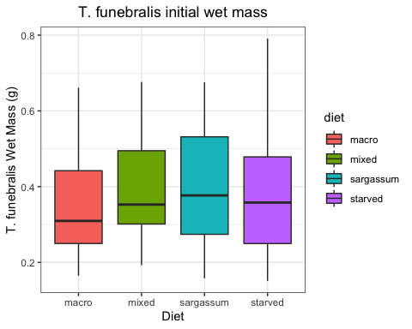

#make boxplot of final wet mass  
ggplot(tegulaperformance, aes(x=diet, y=wetmass_f , fill= diet)) + geom_boxplot() + theme_bw() + xlab("Diet") + ylab("T. funebralis Wet Mass (g)") + ggtitle("T. funebralisfinal wet mass by diet") + theme(plot.title =element_text(hjust = 0.5))

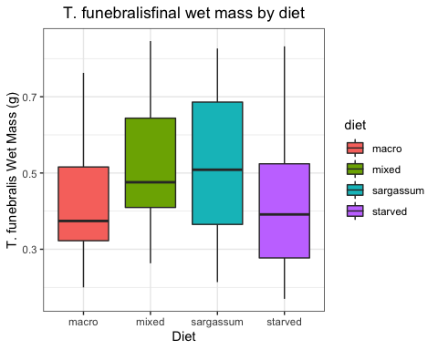

#make boxplot for mass difference  
ggplot(tegulaperformance, aes(x=diet, y=wetmass_total_Wd , fill= diet)) + geom_boxplot() + theme_bw() + xlab("Diet") + ylab("T. funebralis change in wet Mass (g)") + ggtitle("T. funebralis mass change by diet") + theme(plot.title =element_text(hjust = 0.5))

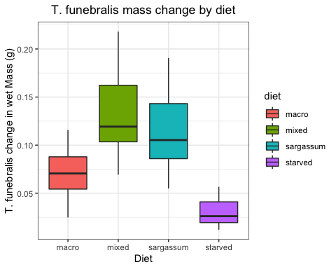

#aside from the variabilty in weights due to water, starved treatment has a mean below zero while others are above   
  
  
#look at DRY mass based on tissue type  
  
#make boxplot of final dry mass  
ggplot(tegulaperformance, aes(x=diet, y=terminal_dry_tissue_mass , fill= diet)) + geom_boxplot() + theme_bw() + xlab("Diet") + ylab("T. funebralis Dry Mass (g)") + ggtitle("T. funebralis final dry tissue by diet") + theme(plot.title =element_text(hjust = 0.5))

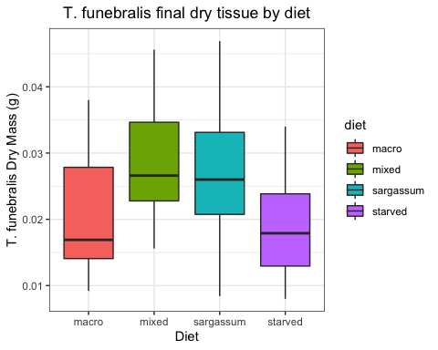

#make boxplot of final shell dry mass by diet  
ggplot(tegulaperformance, aes(x=diet, y=terminal_shell_dry_mass , fill= diet)) + geom_boxplot() + theme_bw() + xlab("Diet") + ylab("Shell Dry Mass (g)") + ggtitle("T. funebralis shell dry mass by diet") + theme(plot.title =element_text(hjust = 0.5))

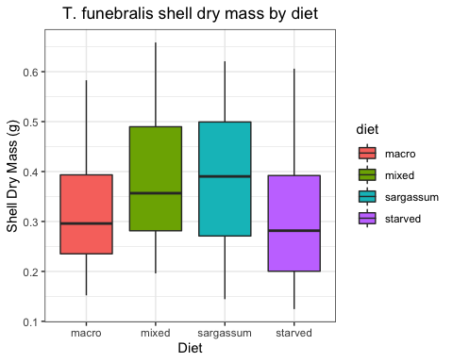

###Estimating Initial Masses

#test if there is a significant difference in initial wet masses using a simple anova  
initialmassteg<-aov(tegulaperformance$wetmass_i ~ tegulaperformance$diet)  
summary(initialmassteg)

## Df Sum Sq Mean Sq F value Pr(>F)  
## tegulaperformance$diet 3 0.0339 0.01131 0.494 0.687  
## Residuals 76 1.7401 0.02290

#we fail to reject the null hypothesis (p = 0.687), the treatments are not different  
  
##To reduce variance due to water weight, we estimated initial DRY masses through regression analysis using shell lengths to predict dry weight using a sub-sample of the population before the experiment  
  
#read and rename file  
regressions <- read.csv("regressiondata.csv",header=T)  
View(regressions)  
  
#subset abalone  
tegregressions<-subset(regressions, Species == "Teg")  
view(tegregressions)  
  
#explore data  
mean(tegregressions$Dissected_total_dry_weight)

## [1] 0.35452

sd(tegregressions$Dissected_total_dry_weight)

## [1] 0.1656278

hist(tegregressions$Dissected_total_dry_weight)

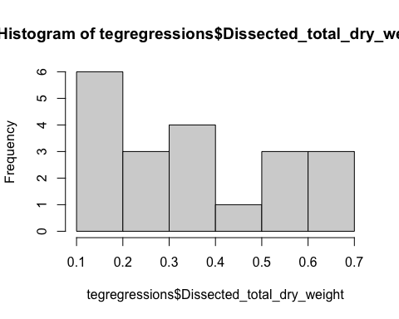

mean(tegregressions$Real_L)

## [1] 7.8055

sd(tegregressions$Real_L)

## [1] 1.278303

hist(tegregressions$Real_L)

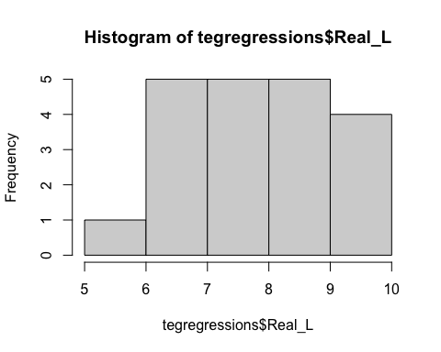

#simple scatterplot and pearson correlation  
plot(tegregressions$Dissected_total_dry_weight, tegregressions$Real_L, data = tegregressions, main = "scatterplot")

## Warning in plot.window(...): "data" is not a graphical parameter

## Warning in plot.xy(xy, type, ...): "data" is not a graphical parameter

## Warning in axis(side = side, at = at, labels = labels, ...): "data" is not a  
## graphical parameter  
  
## Warning in axis(side = side, at = at, labels = labels, ...): "data" is not a  
## graphical parameter

## Warning in box(...): "data" is not a graphical parameter

## Warning in title(...): "data" is not a graphical parameter

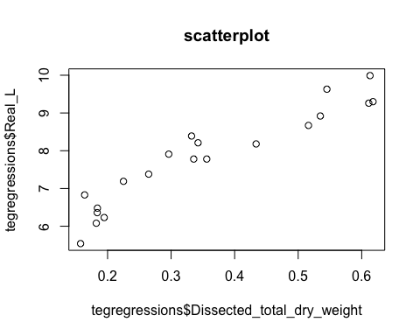

cor(tegregressions$Dissected_total_dry_weight, tegregressions$Real_L)

## [1] 0.9442978

#Tegula Model  
  
#Teg Model 1 total dry tissue  
tegmod1<-lm(Dissected_total_dry_weight ~ Real_L, data = tegregressions)  
summary(tegmod1)

##   
## Call:  
## lm(formula = Dissected_total_dry_weight ~ Real_L, data = tegregressions)  
##   
## Residuals:  
## Min 1Q Median 3Q Max   
## -0.093834 -0.041873 -0.001822 0.040103 0.080426   
##   
## Coefficients:  
## Estimate Std. Error t value Pr(>|t|)   
## (Intercept) -0.60049 0.07944 -7.559 5.44e-07 ***  
## Real_L 0.12235 0.01005 12.174 4.00e-10 ***  
## ---  
## Signif. codes: 0 '***' 0.001 '**' 0.01 '*' 0.05 '.' 0.1 ' ' 1  
##   
## Residual standard error: 0.056 on 18 degrees of freedom  
## Multiple R-squared: 0.8917, Adjusted R-squared: 0.8857   
## F-statistic: 148.2 on 1 and 18 DF, p-value: 4.002e-10

attributes(tegmod1)

## $names  
## [1] "coefficients" "residuals" "effects" "rank"   
## [5] "fitted.values" "assign" "qr" "df.residual"   
## [9] "xlevels" "call" "terms" "model"   
##   
## $class  
## [1] "lm"

#add the line  
tegplot1<- plot(tegregressions$Real_L, tegregressions$Dissected_total_dry_weight, main = "regression",  
 xlab = "Shell Length", ylab = "Tegula Whole Tissue",  
 pch = 19, frame = FALSE) +  
abline(lm(tegregressions$Dissected_total_dry_weight ~ tegregressions$Real_L))

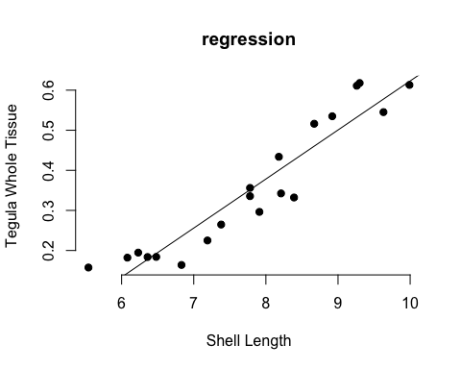

#Teg Model 1: total dry tissue Y= 0.12235x -0.60049  
  
#Teg Model 2 soft dry tissue  
tegmod2<-lm(Dissected_tissue_dry_weight ~ Real_L, data = tegregressions)  
summary(tegmod2)

##   
## Call:  
## lm(formula = Dissected_tissue_dry_weight ~ Real_L, data = tegregressions)  
##   
## Residuals:  
## Min 1Q Median 3Q Max   
## -0.008802 -0.004530 -0.001723 0.001910 0.018854   
##   
## Coefficients:  
## Estimate Std. Error t value Pr(>|t|)   
## (Intercept) -0.014478 0.010322 -1.403 0.17777   
## Real_L 0.004463 0.001306 3.417 0.00307 **  
## ---  
## Signif. codes: 0 '***' 0.001 '**' 0.01 '*' 0.05 '.' 0.1 ' ' 1  
##   
## Residual standard error: 0.007277 on 18 degrees of freedom  
## Multiple R-squared: 0.3935, Adjusted R-squared: 0.3598   
## F-statistic: 11.68 on 1 and 18 DF, p-value: 0.003072

attributes(tegmod2)

## $names  
## [1] "coefficients" "residuals" "effects" "rank"   
## [5] "fitted.values" "assign" "qr" "df.residual"   
## [9] "xlevels" "call" "terms" "model"   
##   
## $class  
## [1] "lm"

#add the line  
tegplot2<- plot(tegregressions$Real_L, tegregressions$Dissected_tissue_dry_weight, main = "regression",  
 xlab = "Shell Length", ylab = "Tegula Soft Tissue",  
 pch = 19, frame = FALSE) +  
abline(lm(tegregressions$Dissected_tissue_dry_weight ~ tegregressions$Real_L))

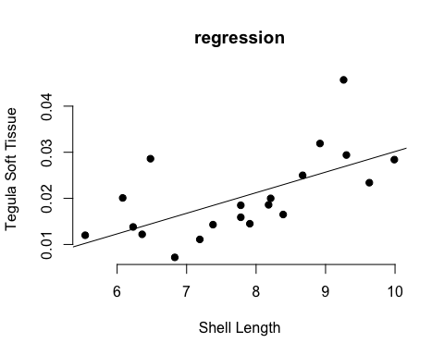

tegplot2

## integer(0)

#Model 2: soft tissue dry tissue Y= 0.004463x -0.014478  
  
#Model 3 dry shell  
tegmod3<-lm(Dissected_shell_dry_weight ~ Real_L, data = tegregressions)  
summary(tegmod3)

##   
## Call:  
## lm(formula = Dissected_shell_dry_weight ~ Real_L, data = tegregressions)  
##   
## Residuals:  
## Min 1Q Median 3Q Max   
## -0.087371 -0.037129 -0.000276 0.037026 0.078412   
##   
## Coefficients:  
## Estimate Std. Error t value Pr(>|t|)   
## (Intercept) -0.586016 0.073141 -8.012 2.40e-07 ***  
## Real_L 0.117889 0.009253 12.740 1.91e-10 ***  
## ---  
## Signif. codes: 0 '***' 0.001 '**' 0.01 '*' 0.05 '.' 0.1 ' ' 1  
##   
## Residual standard error: 0.05156 on 18 degrees of freedom  
## Multiple R-squared: 0.9002, Adjusted R-squared: 0.8946   
## F-statistic: 162.3 on 1 and 18 DF, p-value: 1.914e-10

attributes(tegmod3)

## $names  
## [1] "coefficients" "residuals" "effects" "rank"   
## [5] "fitted.values" "assign" "qr" "df.residual"   
## [9] "xlevels" "call" "terms" "model"   
##   
## $class  
## [1] "lm"

#add the line  
tegplot3<- plot(tegregressions$Real_L, tegregressions$Dissected_shell_dry_weight, main = "regression",  
 xlab = "Shell Length", ylab = "Tegula Shell ",  
 pch = 19, frame = FALSE) +  
abline(lm(tegregressions$Dissected_shell_dry_weight ~ tegregressions$Real_L))

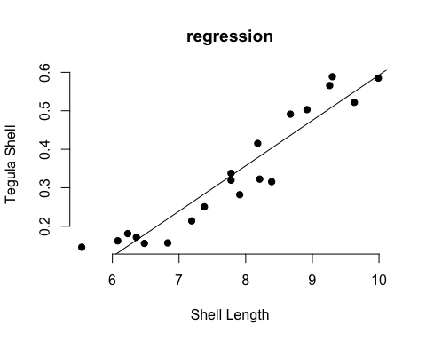

#Teg Model 3: total dry tissue Y= 0.117889x -0.586016  
  
#graph estimated total dry mass  
ggplot(tegulaperformance, aes(x=diet, y=est_total_dry_mass_i , fill= diet)) + geom_boxplot() + theme_bw() + xlab("Diet") + ylab("Dry Mass (g)") + ggtitle("T.funebralis initial dry mass") + theme(plot.title =element_text(hjust = 0.5))

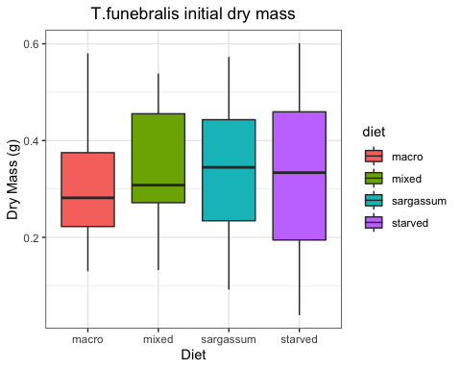

###Tegula Analysis

#remove starved treatment  
tegmodels<-subset(tegulaperformance, !diet== "starved")  
view(tegmodels)  
  
#look at the data without starved treatment  
#histogram  
ggplot(tegmodels, aes(x=terminal_total_dry_mass)) + geom_histogram(binwidth=0.01)

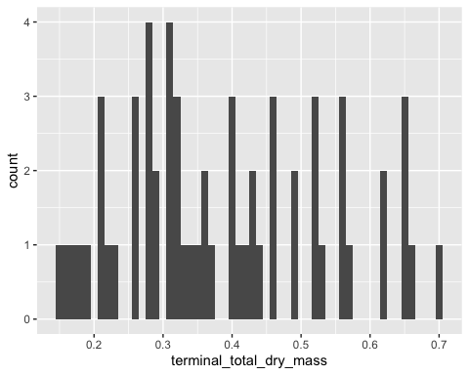

#when combined, the terminal dry masses show a left leaning distribution  
   
  
# Build the linear model to test normality of residuals  
# The model will look at   
Tegmodel <- lm(terminal_total_dry_mass ~ diet + est_total_dry_mass_i , data = tegmodels)  
# Create a QQ plot of residuals  
ggqqplot(residuals(Tegmodel))

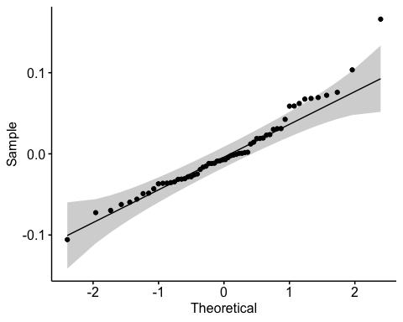

#the data look normal but deviate toward the right end of the QQ plot. May need to address outliers  
  
par(mfrow = c(2, 2))  
plot(Tegmodel)

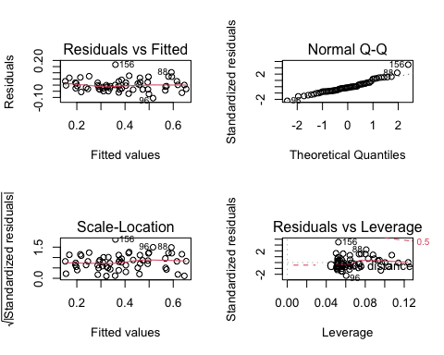

#the data look fairly normal  
  
#Since the data are not normal, we can't use a Bartlette test for equal variance, instead we will use a Levene Test  
bartlett.test(terminal_total_dry_mass ~ diet , data=tegmodels)

##   
## Bartlett test of homogeneity of variances  
##   
## data: terminal_total_dry_mass by diet  
## Bartlett's K-squared = 0.41249, df = 2, p-value = 0.8136

#Bartlet test fails to reject the null Ho (p-value =0.8136), thus we accept the hypothesis that our variances are equal  
  
  
#Assumptions for ANCOVA are met, we can now run the analysis to answer the question:  
  
#ANCOVA  
#first we test if there is an interaction between the initial weights and the diets  
int2<-ggplot(tegmodels, aes(y=terminal_total_dry_mass , x= est_total_dry_mass_i))   
   
int2 + geom_jitter(aes(col=diet)) + geom_smooth(aes(col=diet), method="lm", se=F)

## `geom_smooth()` using formula 'y ~ x'

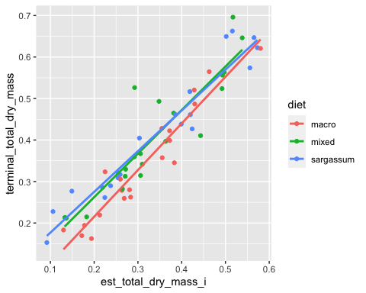

tegmodel <- lm(terminal_total_dry_mass ~ est_total_dry_mass_i * diet , data = tegmodels)  
anova(tegmodel)

## Analysis of Variance Table  
##   
## Response: terminal_total_dry_mass  
## Df Sum Sq Mean Sq F value Pr(>F)   
## est_total_dry_mass_i 1 1.11025 1.11025 460.3476 < 2e-16 ***  
## diet 2 0.02195 0.01097 4.5501 0.01492 *   
## est_total_dry_mass_i:diet 2 0.00327 0.00164 0.6781 0.51184   
## Residuals 54 0.13024 0.00241   
## ---  
## Signif. codes: 0 '***' 0.001 '**' 0.01 '*' 0.05 '.' 0.1 ' ' 1

#There is no interaction between the dependent variable and factor (p=0.5118), we can test for significant effect of the factor without the interaction to ask the question "Does diet impact tegula weight?"  
  
## H0: There is no relationship between diet and tegula weights  
## HA: There is a relationship between diet and tegula weights  
tegmodel2 <- aov(terminal_total_dry_mass ~ est_total_dry_mass_i + diet , data = tegmodels)  
summary(tegmodel2)

## Df Sum Sq Mean Sq F value Pr(>F)   
## est_total_dry_mass_i 1 1.1103 1.1103 465.701 <2e-16 ***  
## diet 2 0.0219 0.0110 4.603 0.0141 *   
## Residuals 56 0.1335 0.0024   
## ---  
## Signif. codes: 0 '***' 0.001 '**' 0.01 '*' 0.05 '.' 0.1 ' ' 1

#We reject the H0 and embrace HA, Diet impacts tegula weights (p=0.0141)  
  
#check residuals  
par(mfrow = c(2,2))  
plot(tegmodel2)



#conduct Tukeys post hoc test to see how the treatments differ  
redab.aov.HSD1 <- HSD.test(tegmodel2 , trt = 'diet')   
print(redab.aov.HSD1)

## $statistics  
## MSerror Df Mean CV MSD  
## 0.002384048 56 0.3885667 12.56585 0.03717365  
##   
## $parameters  
## test name.t ntr StudentizedRange alpha  
## Tukey diet 3 3.404809 0.05  
##   
## $means  
## terminal_total_dry_mass std r Min Max Q25 Q50  
## macro 0.339135 0.1346245 20 0.1623 0.6208 0.249325 0.3144  
## mixed 0.411245 0.1424852 20 0.2121 0.6960 0.313975 0.3819  
## sargassum 0.415320 0.1559601 20 0.1528 0.6625 0.288700 0.4157  
## Q75  
## macro 0.423850  
## mixed 0.524550  
## sargassum 0.531175  
##   
## $comparison  
## NULL  
##   
## $groups  
## terminal_total_dry_mass groups  
## sargassum 0.415320 a  
## mixed 0.411245 a  
## macro 0.339135 b  
##   
## attr(,"class")  
## [1] "group"

plot(redab.aov.HSD1)  
#all treatments differ from each other

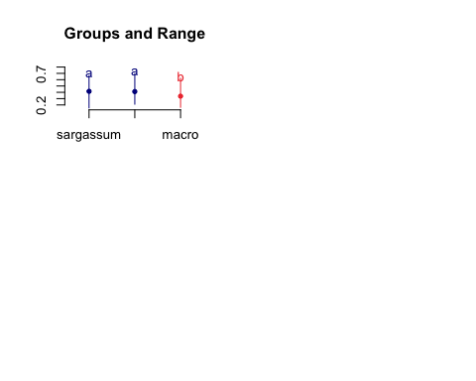

##Righting times

performance<-read.csv("PerformanceAssays2020.csv", header=TRUE)  
view(performance)  
na.omit(performance)

## [1] grazer_spp. box_label   
## [3] animal_label diet   
## [5] shell_length_i shell_length_w2   
## [7] shell_length_w3 shell_length_f   
## [9] imageJ_Li imageJ_Lf   
## [11] shell_width_i imageJ_Wf   
## [13] imageJ_Ai imageJ_Af   
## [15] wetmass_i wetmass_2   
## [17] wetmass_3 wetmass_f   
## [19] wetmass_total_Wd buoyant_Wi   
## [21] buoyant_W2 buoyant_W3   
## [23] buoyant_Wf righting_time_1   
## [25] righting_time_2 righting_attempts_final   
## [27] terminal_wet_tissue_mass terminal_gonad_wet_mass   
## [29] terminal_nongonad_wet_mass terminal_shell_wet_mass   
## [31] tissue_sampled terminal_dry_tissue_mass   
## [33] terminal_gonad_dry_mass terminal_nongonad_dry_mass  
## [35] terminal_shell_dry_mass terminal_total_dry_mass   
## [37] est_total_dry_mass_i est_tissue_dry_mass_i   
## [39] est_non_gonad_dry_mass_i est_gonad_dry_mass_i   
## [41] est_shell_dry_mass_i Water_Temp   
## [43] treatment Water_Temp.1   
## <0 rows> (or 0-length row.names)

#subset the abalone   
abperf<-subset(performance, grazer_spp.== "red abalone")  
  
#wrangle data to show attempt 1 and attempt 2 side by side for each treatment  
gathered_obs<-gather(abperf, key="righting", value="time", 24:25)  
view(gathered_obs)  
na.omit(gathered_obs)

## [1] grazer_spp. box_label   
## [3] animal_label diet   
## [5] shell_length_i shell_length_w2   
## [7] shell_length_w3 shell_length_f   
## [9] imageJ_Li imageJ_Lf   
## [11] shell_width_i imageJ_Wf   
## [13] imageJ_Ai imageJ_Af   
## [15] wetmass_i wetmass_2   
## [17] wetmass_3 wetmass_f   
## [19] wetmass_total_Wd buoyant_Wi   
## [21] buoyant_W2 buoyant_W3   
## [23] buoyant_Wf righting_attempts_final   
## [25] terminal_wet_tissue_mass terminal_gonad_wet_mass   
## [27] terminal_nongonad_wet_mass terminal_shell_wet_mass   
## [29] tissue_sampled terminal_dry_tissue_mass   
## [31] terminal_gonad_dry_mass terminal_nongonad_dry_mass  
## [33] terminal_shell_dry_mass terminal_total_dry_mass   
## [35] est_total_dry_mass_i est_tissue_dry_mass_i   
## [37] est_non_gonad_dry_mass_i est_gonad_dry_mass_i   
## [39] est_shell_dry_mass_i Water_Temp   
## [41] treatment Water_Temp.1   
## [43] righting time   
## <0 rows> (or 0-length row.names)

is.factor(gathered_obs$righting)

## [1] FALSE

gathered_obs$righting<-as.factor(gathered_obs$righting)  
  
#make bargraph  
ggplot(gathered_obs, aes(x=diet, y=time, fill= righting)) + xlab("") + ylab("Time (sec)") + ggtitle("Righting Time Before and After Diet Treatment") + theme(axis.text=element_text(size=12)) + geom_bar(stat="identity",position=position_dodge()) + theme_minimal() +   
 scale_x_discrete(limits = c("starved", "macro", "mixed", "sargassum"), labels=c("starved" = "Starved", "macro" = "M. pyrifera","mixed" = "Mixed","sargassum" = "S. horneri")) +  
 geom_vline(xintercept=c(1.5),linetype="dotted") +  
 scale_fill_manual("", values = c("righting_time_1" = "#1260AB", "righting_time_2" = "#009BFF"), labels=c("righting_time_1" = "Initial", "righting_time_2" = "Final"))

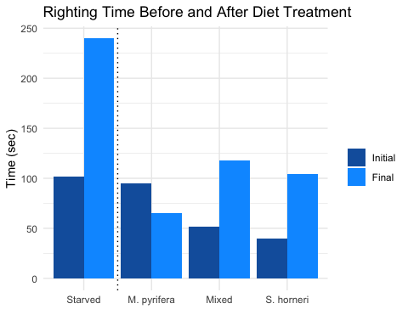

#Overall, initial righting time was higher for starved treatment individuals followed by M. pyrifera, Mixed and S. horneri  
##Final righting time increased for starved individuals, mixed, and S. horneri but decreased for M. pyrifera.

#Wrack Dependent Community Assay

community<-read.csv("Comm grazer exp.csv", header = T)  
view(community )

##Exploring Data

#####visualize Data######  
#lets look at TOTAL consumption to see how that differs between treatments  
ggplot(community, aes(x= Wrack_treatment , y= Total_Algae_Consumed)) + theme_bw() + geom_boxplot() + ggtitle("Total Algae Consumed") + ylab("Total Consumption(g)") + xlab("Wrack treatment") + theme(plot.title =element_text(hjust = 0.5))

## Warning: Removed 200 rows containing non-finite values (stat_boxplot).

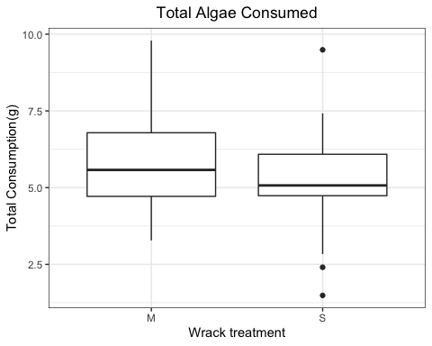

#Overall, the combined consumption of native benthic seaweeds + wrack appears to be lower in the S. horneri treatment  
  
#lets look at how NATIVE BENTHIC SEAWEED consumption differs between treatments  
ggplot(community, aes(x= Wrack_treatment , y= Total_Benthic_Algae_Consumed )) + theme_bw() + geom_boxplot() + ggtitle("Total Native Benthic Seaweed Consumed by Wrack Treatment") + ylab("Total Consumption(g)") + xlab("Wrack treatment") + theme(plot.title =element_text(hjust = 0.5))

## Warning: Removed 200 rows containing non-finite values (stat_boxplot).

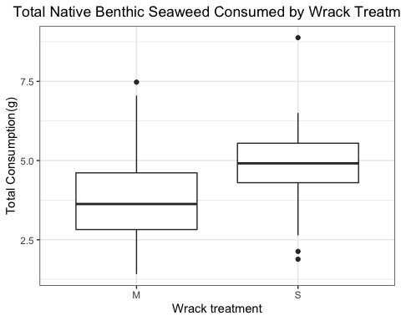

#The total biomass of native benthic seaweeds consumed appears to be higher in S. horneri treatment. Suggesting that consumption may have shifted onto NBS when S. horneri was introduced.  
  
#Now lets look at how consumption of just the WRACK species differs by Treatment  
ggplot(community, aes(x= Wrack_treatment , y= Total_Wrack_Algae_Consumed )) + theme_bw() + geom_boxplot() + ggtitle("Total Wrack Consumed by Wrack Treatment") + ylab("Total Consumption(g)") + xlab("Wrack treatment") + theme(plot.title =element_text(hjust = 0.5))

## Warning: Removed 200 rows containing non-finite values (stat_boxplot).

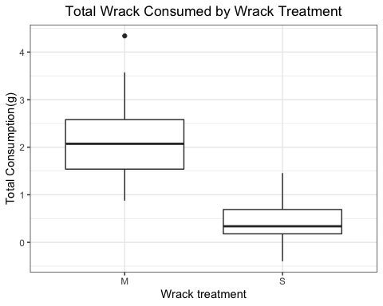

#consumption of S. horneri appears to be much lower than consumption of M. pyrifera   
  
#############lets check the normality of consumption of NBS Data##############  
ggplot(community, aes(x=Total_Benthic_Algae_Consumed)) + geom_histogram(binwidth=0.5)

## Warning: Removed 200 rows containing non-finite values (stat_bin).

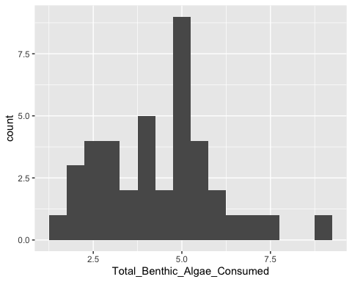

#for S.horneri treatment  
commSH<- subset(community, Wrack_treatment == "S")  
view(commSH)  
ggplot(commSH, aes(x=Total_Benthic_Algae_Consumed)) + geom_histogram(binwidth=0.5)

## Warning: Removed 100 rows containing non-finite values (stat_bin).

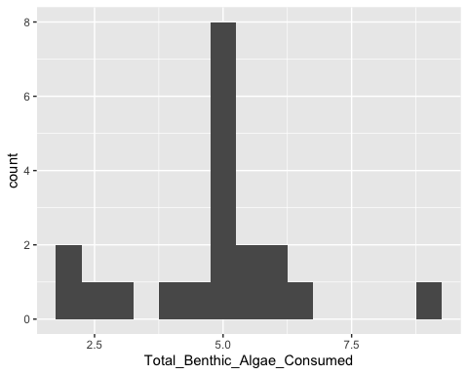

#difficult to visualize normally with low replication   
qqnorm(commSH$Total_Benthic_Algae_Consumed)  
qqline(commSH$Total_Benthic_Algae_Consumed)

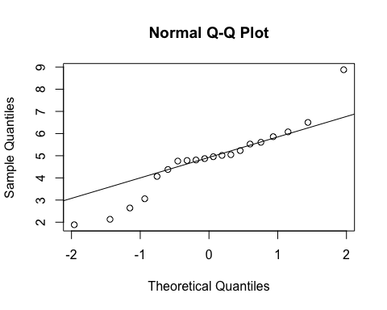

#The data tend to deviate away from the theoretical line at both ends  
  
#lets conduct an SW test for normality  
shapiro_test(commSH$Total_Benthic_Algae_Consumed)

## # A tibble: 1 x 3  
## variable statistic p.value  
## <chr> <dbl> <dbl>  
## 1 commSH$Total_Benthic_Algae_Consumed 0.930 0.154

#SW test fails to reject the Ho(p=0.154), the data are normally distributed  
  
  
#for M. pyrifera treatment  
commMP<- subset(community, Wrack_treatment == "M")  
view(commMP)  
ggplot(commMP, aes(x=Total_Benthic_Algae_Consumed)) + geom_histogram(binwidth=0.1)

## Warning: Removed 100 rows containing non-finite values (stat_bin).

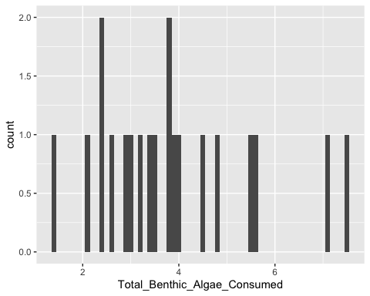

qqnorm(commMP$Total_Benthic_Algae_Consumed)  
qqline(commMP$Total_Benthic_Algae_Consumed)

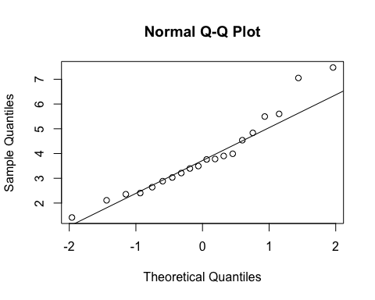

#the data tend to deviate away from the theoretical line at the top of the distribution.  
  
#lets conduct an SW test for normality  
shapiro_test(commMP$Total_Benthic_Algae_Consumed)

## # A tibble: 1 x 3  
## variable statistic p.value  
## <chr> <dbl> <dbl>  
## 1 commMP$Total_Benthic_Algae_Consumed 0.938 0.217

#SW test fails to reject the Ho(p=0.217), the data are normally distributed  
  
  
  
#############lets check the normality of consumption of WRACK TREATMENT CONSUMPTION Data##############  
  
#for S.horneri treatment  
SHwrack<- subset(community, Wrack_treatment == "S")  
view(SHwrack)  
ggplot(SHwrack, aes(x=Total_Wrack_Algae_Consumed)) + geom_histogram(binwidth=0.1)

## Warning: Removed 100 rows containing non-finite values (stat_bin).

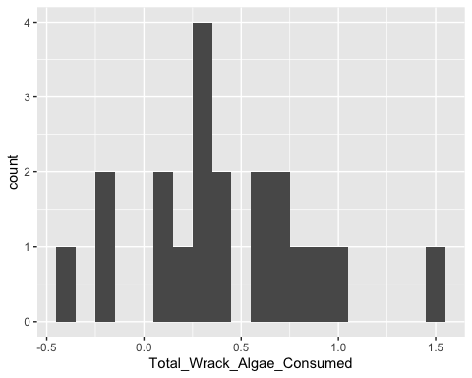

#the histogram shows a fairly normal ditribution  
qqnorm(SHwrack$Total_Wrack_Algae_Consumed)  
qqline(SHwrack$Total_Wrack_Algae_Consumed)

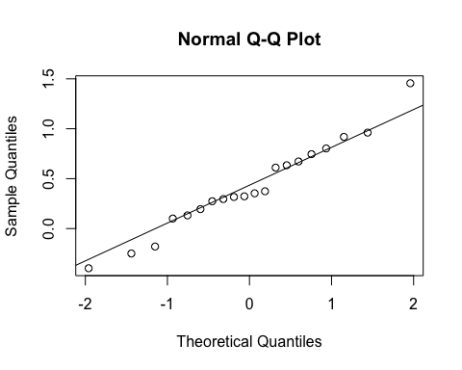

#The data are distributed around the theoretical line  
  
#lets conduct an SW test for normality  
shapiro_test(SHwrack$Total_Wrack_Algae_Consumed)

## # A tibble: 1 x 3  
## variable statistic p.value  
## <chr> <dbl> <dbl>  
## 1 SHwrack$Total_Wrack_Algae_Consumed 0.976 0.877

#SW test fails to reject the Ho(p=0.976), the data are normally distributed  
  
  
#for M. pyrifera treatment  
MPwrack<- subset(community, Wrack_treatment == "M")  
view(MPwrack)  
ggplot(MPwrack, aes(x=Total_Wrack_Algae_Consumed)) + geom_histogram(binwidth=0.1)

## Warning: Removed 100 rows containing non-finite values (stat_bin).

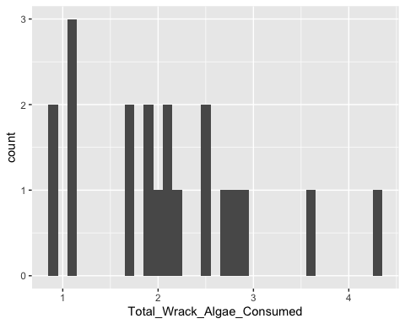

qqnorm(MPwrack$Total_Wrack_Algae_Consumed)  
qqline(MPwrack$Total_Wrack_Algae_Consumed)

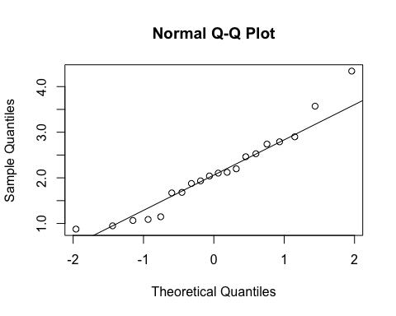

#the data tend show a bit of scatter but still tend to center around the theoretical line  
  
#lets conduct an SW test for normality  
shapiro_test(MPwrack$Total_Wrack_Algae_Consumed)

## # A tibble: 1 x 3  
## variable statistic p.value  
## <chr> <dbl> <dbl>  
## 1 MPwrack$Total_Wrack_Algae_Consumed 0.944 0.291

#SW test fails to reject the Ho(p=0.944), the data are normally distributed  
  
  
#########Test for equal Variances for a 2 Sample T Test########  
#We are clear to conduct T-tests  
  
#Native Benthic Seaweeds by Wrack Treatment  
bartlett.test(Total_Benthic_Algae_Consumed ~ Wrack_treatment, data=community)

##   
## Bartlett test of homogeneity of variances  
##   
## data: Total_Benthic_Algae_Consumed by Wrack_treatment  
## Bartlett's K-squared = 2.2726e-05, df = 1, p-value = 0.9962

#Bartlett test fails to reject the null Ho (p-value =0.9962), thus we accept the hypothesis that our variances are equal  
  
  
#Wrack Seaweeds by Wrack Treatment  
bartlett.test(Total_Wrack_Algae_Consumed ~ Wrack_treatment, data=community)

##   
## Bartlett test of homogeneity of variances  
##   
## data: Total_Wrack_Algae_Consumed by Wrack_treatment  
## Bartlett's K-squared = 8.3622, df = 1, p-value = 0.003831

#Bartlett test rejects the null Ho (p-value =0.003831), thus we accept the hypothesis that our variances are not equal.   
##We will Perform a Welch's T test for the unequal variences

##Wrack vs Native Benthic Seaweed Analyses

#lets see if consumption between the two wrack species differed using a T-test  
#H0: There is no difference in consumption between S. horneri and M. pyrifera  
#HA: There is a difference in consumption between S. horneri and M. pyrifera  
t.test(community$Total_Wrack_Algae_Consumed~community$Wrack_treatment, alt="two.sided", paired=F,conf.level=0.95)

##   
## Welch Two Sample t-test  
##   
## data: community$Total_Wrack_Algae_Consumed by community$Wrack_treatment  
## t = 7.5289, df = 27.87, p-value = 3.457e-08  
## alternative hypothesis: true difference in means is not equal to 0  
## 95 percent confidence interval:  
## 1.228142 2.146468  
## sample estimates:  
## mean in group M mean in group S   
## 2.104070 0.416765

## We reject the null hypothesis (p-value = 3.457e-08) and embrace the alternative, there is a difference in consumption between S. horneri and M. pyrifera  
  
#we want to know if lower palatability of S. horneri causes a shift of consumption onto Native Benthic Seaweeds (NBS)  
##(NBS= Algae_Spp. - M. pyrifera and S. horneri) consumption.##  
  
#look at an scatterplot  
scatter<-ggplot(community, aes(y=Algae_Wd , x= Algae_trt)) + geom_jitter(aes(col=Wrack_treatment)) + geom_smooth(aes(col=Algae_Spp.), method="lm", se=F)  
scatter

## `geom_smooth()` using formula 'y ~ x'

## Warning: Removed 80 rows containing non-finite values (stat_smooth).

## Warning: Removed 80 rows containing missing values (geom_point).

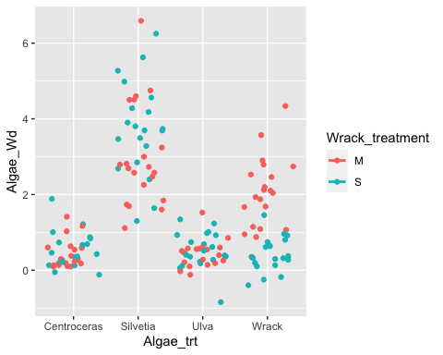

#In general, we see that consumption tends to be clustered equally for Ulva and Centroceras but there is a vertical shift in Silvetia consumption when going from M to S and the opposite for the wrack treatment  
  
#We can nest algae treatments within Wrack treatment to ask  
###########################"Does consumption of algae species differ within Wrack treatments?##################  
  
#H0: Consumption is the same between Algae Species.  
#HA: Consumption is not the same between Algae Species.  
#H1: Consumption is the same between Wrack Treatments.  
#H2: Consumption is not the same between Wrack Treatments.  
NestedNBSaov<-aov(Algae_Wd ~ Algae_Spp. + Wrack_treatment + Error(Wrack_treatment:Algae_Spp.), data =community)

## Warning in aov(Algae_Wd ~ Algae_Spp. + Wrack_treatment +  
## Error(Wrack_treatment:Algae_Spp.), : Error() model is singular

summary(NestedNBSaov)

##   
## Error: Wrack_treatment:Algae_Spp.  
## Df Sum Sq Mean Sq F value Pr(>F)   
## Algae_Spp. 4 253.93 63.48 44.124 0.0223 *  
## Wrack_treatment 1 2.92 2.92 2.029 0.2904   
## Residuals 2 2.88 1.44   
## ---  
## Signif. codes: 0 '***' 0.001 '**' 0.01 '*' 0.05 '.' 0.1 ' ' 1  
##   
## Error: Within  
## Df Sum Sq Mean Sq F value Pr(>F)  
## Residuals 152 97.26 0.6398

#we can quickly visualize that here  
#H0  
ggplot(community, aes(x = Wrack_treatment, y=Algae_Wd)) + geom_boxplot()

## Warning: Removed 80 rows containing non-finite values (stat_boxplot).

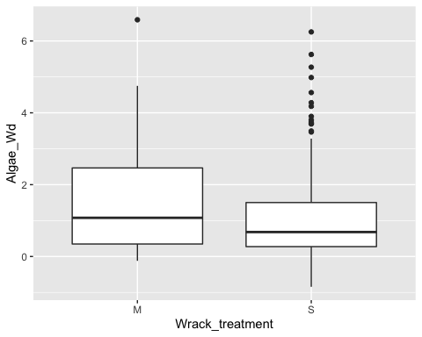

#H1  
ggplot(community, aes(x = Algae_trt, y=Algae_Wd)) + geom_boxplot()

## Warning: Removed 80 rows containing non-finite values (stat_boxplot).

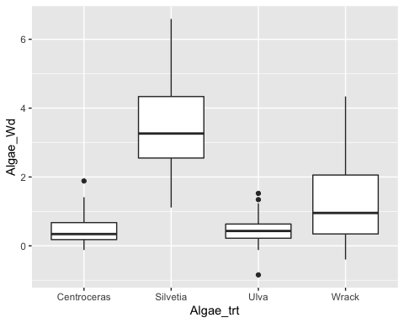

#although we nested Algae Species within Wrack treatment and accounted for the error, all we can say is that total consumption remains the same when Wrack species are different, but we know that consumption is NOT the same within species. Thus Grazers are eating the same amount but consumption may be shifting from one species to another.  
  
  
  
  
  
########################################note for my collaborators#############################  
###Alternately, If we want to understand how consumption changes by species, we can can change S. horneri and M. pyrifera to "wrack" and compare all Algae species across Wrack treatment (Eg, Ulva, Silvetia, Centroceras, and Wrack by M and S). We should expect to see a decrease in "wrack" and an increase in "silvetia." I personally think this is the better analysis that will show the same results in a simplified manner. I know we had previously talked about nesting the anova but i think this way is less messy.  
  
###So  
aov2<-lm(Algae_Wd ~ Wrack_treatment * Algae_trt, data =community)  
anova(aov2)

## Analysis of Variance Table  
##   
## Response: Algae_Wd  
## Df Sum Sq Mean Sq F value Pr(>F)   
## Wrack_treatment 1 1.412 1.412 2.2068 0.1395   
## Algae_trt 3 225.462 75.154 117.4557 < 2.2e-16 ***  
## Wrack_treatment:Algae_trt 3 32.854 10.951 17.1157 1.254e-09 ***  
## Residuals 152 97.257 0.640   
## ---  
## Signif. codes: 0 '***' 0.001 '**' 0.01 '*' 0.05 '.' 0.1 ' ' 1

summary(aov2)

##   
## Call:  
## lm(formula = Algae_Wd ~ Wrack_treatment * Algae_trt, data = community)  
##   
## Residuals:  
## Min 1Q Median 3Q Max   
## -2.4552 -0.3192 -0.0924 0.2708 3.5858   
##   
## Coefficients:  
## Estimate Std. Error t value Pr(>|t|)   
## (Intercept) 0.43617 0.17886 2.439 0.0159 *   
## Wrack_treatmentS 0.08789 0.25295 0.347 0.7287   
## Algae_trtSilvetia 2.56842 0.25295 10.154 < 2e-16 ***  
## Algae_trtUlva -0.00839 0.25295 -0.033 0.9736   
## Algae_trtWrack 1.66790 0.25295 6.594 6.67e-10 ***  
## Wrack_treatmentS:Algae_trtSilvetia 0.66198 0.35773 1.851 0.0662 .   
## Wrack_treatmentS:Algae_trtUlva 0.01012 0.35773 0.028 0.9775   
## Wrack_treatmentS:Algae_trtWrack -1.77520 0.35773 -4.962 1.85e-06 ***  
## ---  
## Signif. codes: 0 '***' 0.001 '**' 0.01 '*' 0.05 '.' 0.1 ' ' 1  
##   
## Residual standard error: 0.7999 on 152 degrees of freedom  
## (80 observations deleted due to missingness)  
## Multiple R-squared: 0.7276, Adjusted R-squared: 0.715   
## F-statistic: 57.99 on 7 and 152 DF, p-value: < 2.2e-16

#Here we see no difference when looking at consumption by wrack treatment   
#significant difference in algae treatment  
#significant interaction between algae treatment and wrack treatment....  
  
#the story here is that overall grazing does not differ between a "native wrack" vs "invasive wrack" treatments when we swap the wrack species because the grazing from S. horneri shifts to Silvetia... thats the story I am just not sure how to best show it. I can use some help!

#Figures for Manuscript

#choice  
LabAssayWholeTissue <- read.csv("LabAssaysWholeTissue.csv",header=T)  
View(LabAssayWholeTissue)  
choice <- LabAssayWholeTissue[1:232,]  
  
fig1<- ggplot(choice, aes(x=algae_spp., y= algae_Wd, fill = algae_spp.)) + geom_boxplot(show.legend = FALSE) + theme_bw() + xlab("") + ylab("Algae Mass Consumed (g)") + ggtitle("Food Choice Assay") + theme(axis.text=element_text(size=12),  
 axis.title=element_text(size=12),plot.title =element_text(hjust = 0.5)) +   
 facet_grid(grazer_spp. ~., scales = "free_y", labeller = as_labeller(c("Haliotis cracherodii" = "H. cracherodii", "Tegula" = "T. funebralis", "Pachy" = "P. crassipes", "Pagurus" = "P. samuelis")),)  
  
fig1

## Warning: Removed 116 rows containing non-finite values (stat_boxplot).

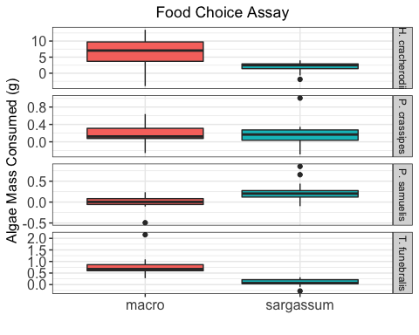

#performance  
#this figure only shows final dry mass of non-shell tissue for tegula and red abalone. All other tissue will be in the appendix  
  
fig2<- ggplot(performance, aes(x=diet, y= terminal_dry_tissue_mass, fill= diet)) +   
 geom_boxplot(show.legend = FALSE) + theme_bw() +   
 xlab("Diet") +   
 ylab("Dry Tissue Mass (g)") +   
 ggtitle("Herbivore Dry Tissue Mass by Diet") +   
 theme(axis.text=element_text(size=12),  
 axis.title=element_text(size=12), plot.title =element_text(hjust = 0.5)) +  
 facet_grid(grazer_spp. ~ ., scales = "free_y", labeller = as_labeller(c("red abalone" = "H. rufescence", "tegula" = "T. funebralis"))) +  
 scale_x_discrete(limits = c("starved", "macro", "mixed", "sargassum"), labels=c("starved" = "Starved", "macro" = "M. pyrifera",  
 "mixed" = "Mixed","sargassum" = "S. horneri")) +  
 geom_vline(xintercept=c(1.5),linetype="dotted") +  
 theme(axis.text.x = element_text(face="italic",   
 size=10))  
fig2

