CMP9135M Workshop 1: Introduction to MATLAB and Image Processing
Write your own code with comments so that you can refer to it later; it will help you to understand your work should you come to study it in future. Keep a copy of it on OneDrive or similar. Refer to the lecture notes or ask for help if you get stuck!

This workshop will cover the basics of MATLAB and image processing. You should be able to find MATLAB on the Windows Start menu of the lab machines. You are provided with a copy of Section 1.7 ‘The MATLAB Working Environment’ of the textbook ‘Digital Image Processing using MATLAB’, and a complete copy of Chapter 2 ‘Fundamentals’. This will serve as your MATLAB basic programming manual for the workshop, so read it carefully!

Note: you are welcome to use any programming language (e.g., Python) however the module makes fairly strong assumptions that you’ll be using either MATLAB for solving your assessments.

Task 1: Get to know the environment
Work through Section 1.7 of Digital Image Processing using MATLAB, and familiarise yourself with the environment.

Task 2: Reading, writing and displaying images
Download and unzip “standard_test_images.zip” from Blackboard. Work your way through Sections 2.1 to 2.4 of the textbook, trying out the basic MATLAB functions for loading, saving and displaying digital images on the test images you’ve downloaded.

Note: Over the course of the module, you may want to refer to this chapter as a guide. Try working through the rest of the chapter as part of your own independent studies.

Task 3: Indexing and iterating
As images are multi-dimensional arrays, it is important to understand how to access elements, rows, columns, and sub-arrays programmatically. To practice this, download the .m file from Blackboard called “images_as_arrays.m” and read through it carefully before attempting the following:

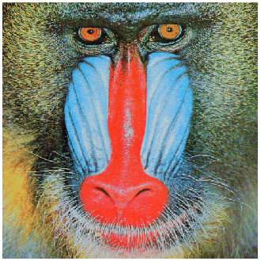
2 (a): Extract and display the green and blue channels of the image.
2 (b): Extract a whole row of pixels and display it as a line plot.
2 (c): Calculate the min and max values of the image pixels (for a single channel)

