Presentation Graphics

Introduction
A presentation is a series of slides that can be viewed on a computer, through the web or as a slide show. Microsoft PowerPoint is the most popular software used for this purpose.

A slide may contain:
- Text
- Images
- Video and sound clips
- Graphs, organisation charts

All of these can be formatted in the usual ways.

Open PowerPoint
Left click the Start button, then Programs then Microsoft Office choose PowerPoint

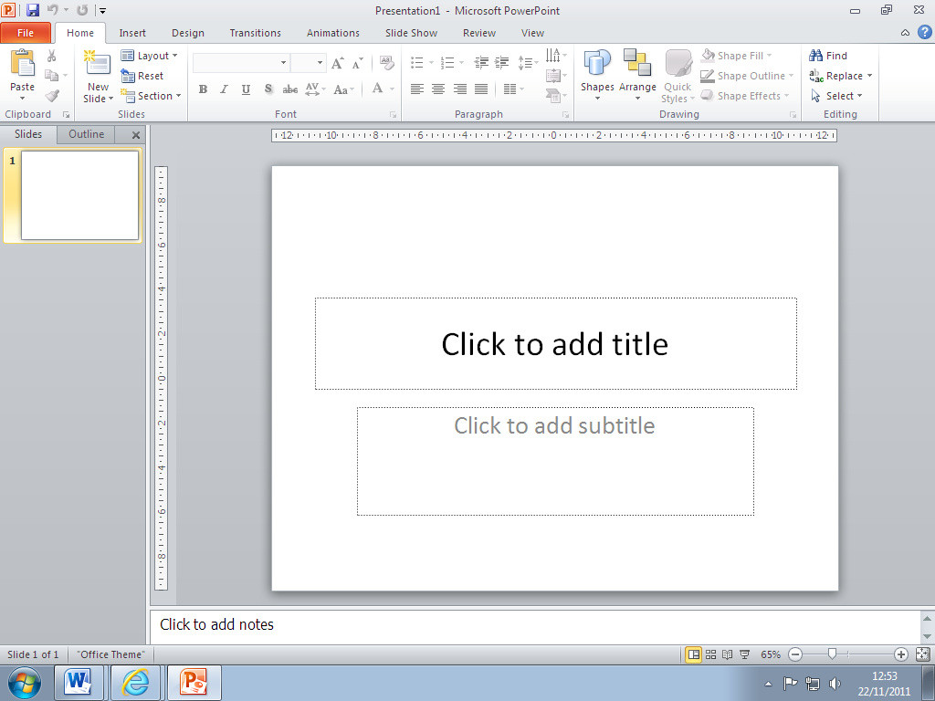

File button

Ribbon

Outline pane

Slide pane

Notes pane

View buttons

The Ribbon

Tabs

Groups

The ribbon is divided into Tabs. Tabs are task-oriented, so some tabs will only appear when certain tasks are performed, ie; the Chart Tools tab will only appear when a chart is active.

Each tab is further divided into Groups of related functions

Panes
The screen has three panes:
The Outline pane shows only the text on the slides. The text can be added to or edited and new slides can be added from here.
The Slides pane is where you build up and display the slides – normally on screen one at a time.
The Notes pane holds optional notes that can be printed to accompany the slides, usually used by the speaker or presenter.

Views
At the bottom right of the screen are the view buttons

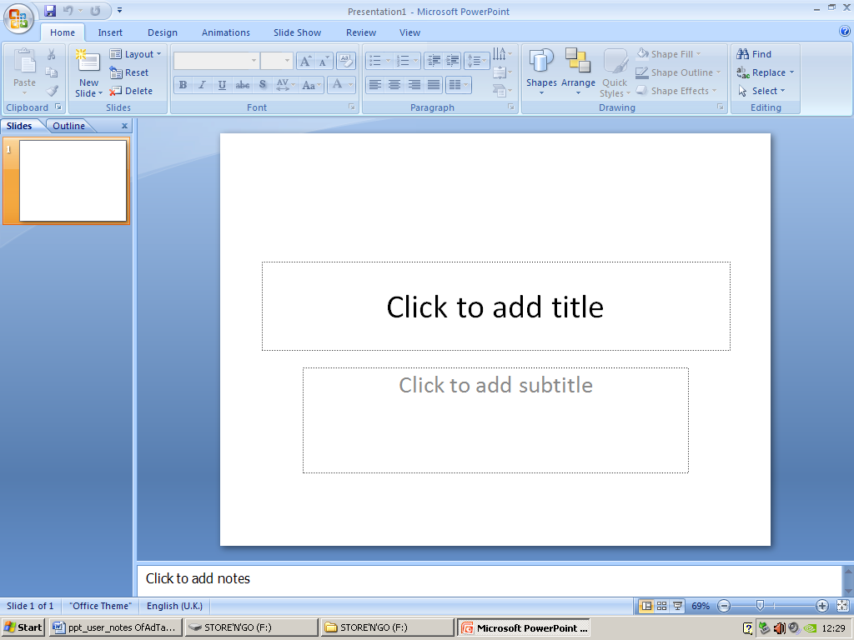

Normal view is best for creating the slides and working on them.
Slide Sorter view allows you to rearrange the order of slides.
Slide Show runs the presentation to the full screen slide after slide.

You can also change the zoom slider here to zoom in and out of your work

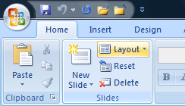
Creating Slides

The quickest way to create a slide is to use the automatic slide layouts provided.

On the Home tab, in the Slides group, click on
the Layout button.
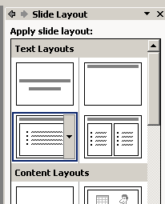
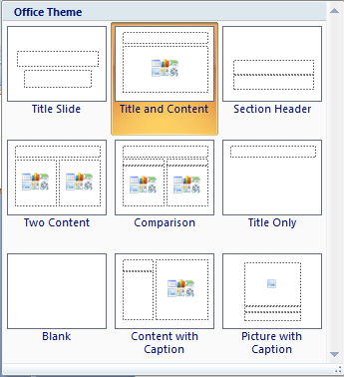
Content slides allow you to insert graphics, charts, tables etc, as well as bulleted text.

Choose a layout with a page wide heading, and page wide main frame by left clicking on the layout.

Using a preset layout helps maintain a consistent look to your presentation – all layouts can be modified and adapted once chosen.

Master Slide

The master slide sets the default design for all the slides in your presentation. The master slide is used to set up text styles, colour, layout and footers for the entire presentation. Any image that is added to the master slide appears on all the slides.

From the View tab, select Slide Master

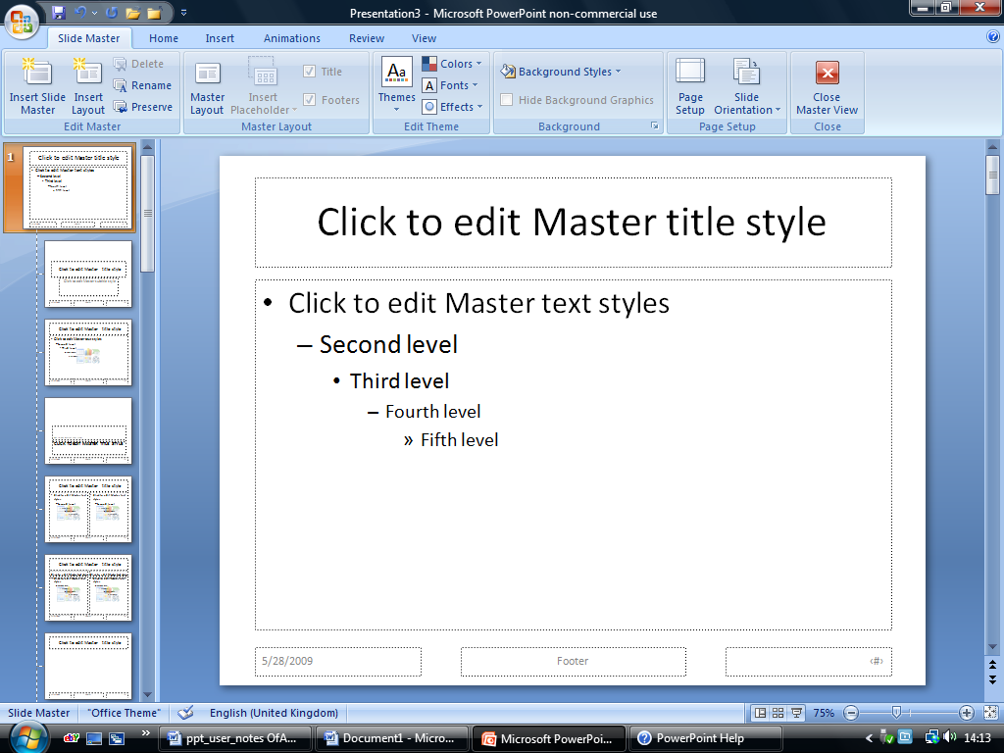

Colour Schemes

PowerPoint contains a selection of colour schemes for you to use.

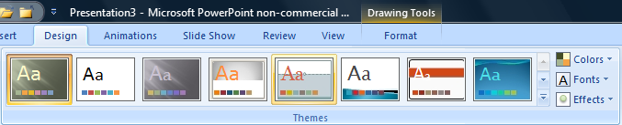

To view the colour schemes click on the Design tab. Hovering the mouse over each theme allows you to preview each effect before selecting the desired theme with a left click.

Right clicking on the theme allows you to select which slides to apply the theme to.

Each theme can then be customised by changing the colour scheme and the font using the buttons on the right of the group.

Change Background Colour
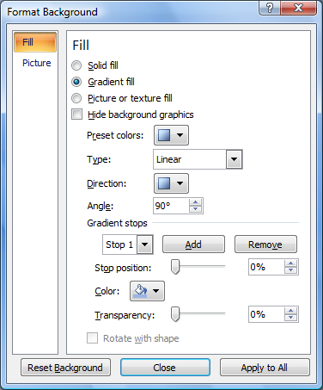
You can choose your own background colour by clicking the Background styles button on the Design tab. Roll your mouse over the different styles to view the effects.

Click on Format Background. From this dialogue box you can change the colour, add gradient effects, picture or textured backgrounds.

Experiment with the buttons and drop down boxes to explore the various effects.

Add an image

Pictures can be added from files, from ClipArt or from WordArt. An image added to the master page will be visible on all pages.

To add a picture click on Insert, then Clipart. The insert clipart pane opens on the right hand side of the screen. Type the name of a topic of your choice in the search for box. Then click Go. A choice of pictures will appear. Left click on a picture to select it. Position the picture on the right hand side of the main text box.

The insert tab can also be used to add pictures from file, charts, and tables. The shapes button allows you to draw simple lines and shapes. Movies and sound are also added from here using the buttons in the media clips group

Add a Footer

From the Master Slide, click the Insert tab, then either Date and Time or Slide Number.

The following dialogue box appears.

The date and slide number are automatically included once you have selected them.
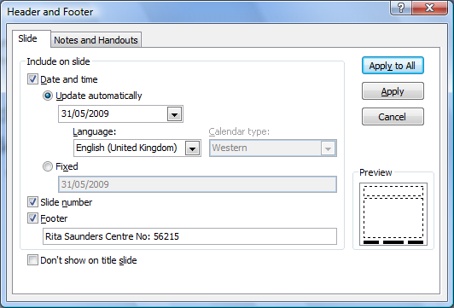
To ‘turn on’ the date, click on the update automatically radio button.

A range of styles are available and can be selected from the list.

To select Slide number click the radio button.

Text typed in the Footer box will appear in the centre text box of your slides.
Click the Print Preview button to check your selections.

Save the Master Slide
Click on the File button, choose Save As and save your file as Presentation 1

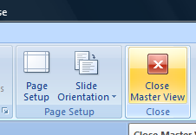
Close the Master View

Click on Slide Master tab. Click on the Close Master View button on the ribbon.

Enter Text
Enter text by clicking on the text box.
Click in the Title frame and type: THE REGENCY HOTEL

In the main frame type: Breakfast Menu this will appear at 1st level.
Press the enter key.
To enter text at the 2nd level, press the tab key or the indent button on the Home tab.

Type at 2nd level Cereal
Hot Buffet
Tea or Coffee

Add a new slide

Click New Slide on the Home tab, or press the Ctrl key + M

Add text
Add the following text to the 2nd slide.

THE REGENCY HOTEL |  | Title frame
Lunch Menu | 1st level | Main frame
Asparagus Soup | 2nd level | Main frame
Roast Beef with vegetables | 2nd level | Main frame
Apple Pie with cream | 2nd level | Main frame

Print your presentation
You are advised to spell-check your presentation before printing.

From the File button select Print.

In the print dialogue box you can choose WHICH slides you want to print:
Print All Slides, Print Current Slide or a Custom Range of Slides.
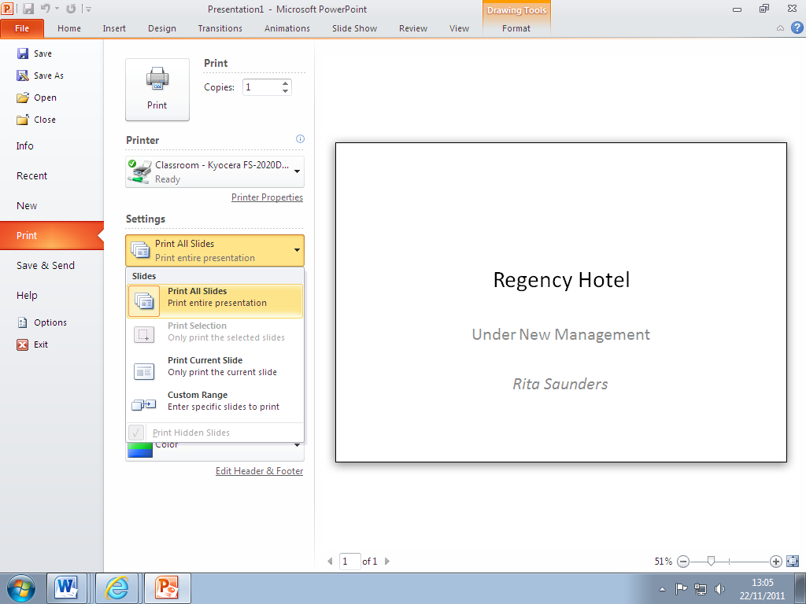

In the print dialogue box you can choose HOW slides should be printed:
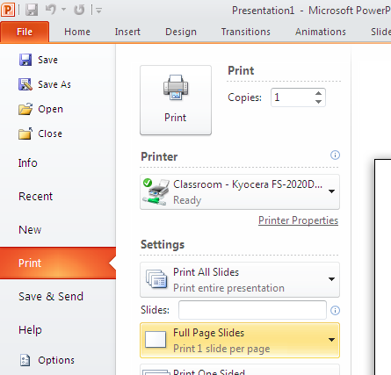

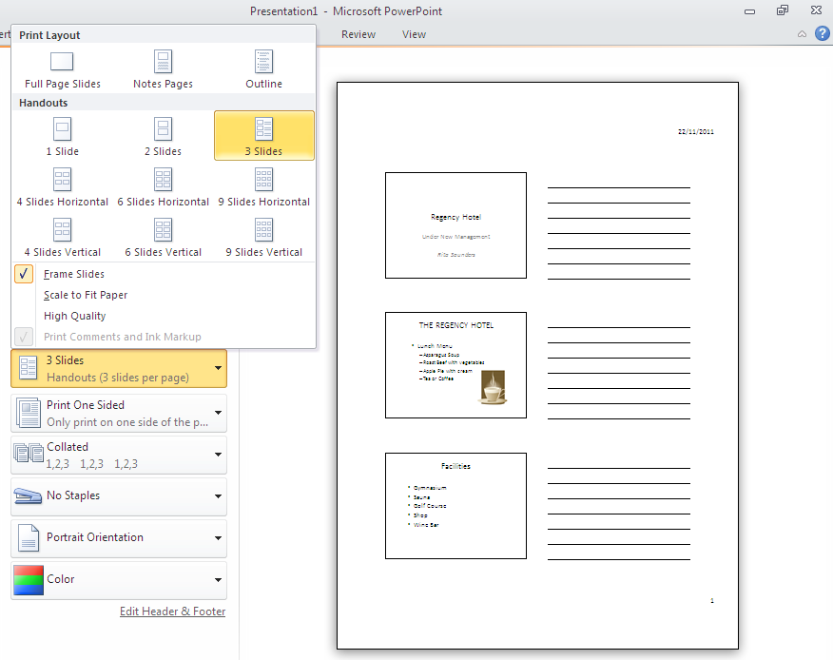

In the Settings list choose to print Full Page Slides, Notes Pages, Outline or Handouts

Save your presentation
From the File button, select Save As and save your file as Regency Hotel 1

View your presentation
From the Slide Show tab choose From Beginning or click the Slide Show view icon in the bottom of the window to view your slide show. Press Esc to end the slideshow.

Transition and Animations

Transitions allow you to control the way slides move on and off the screen during a slideshow.
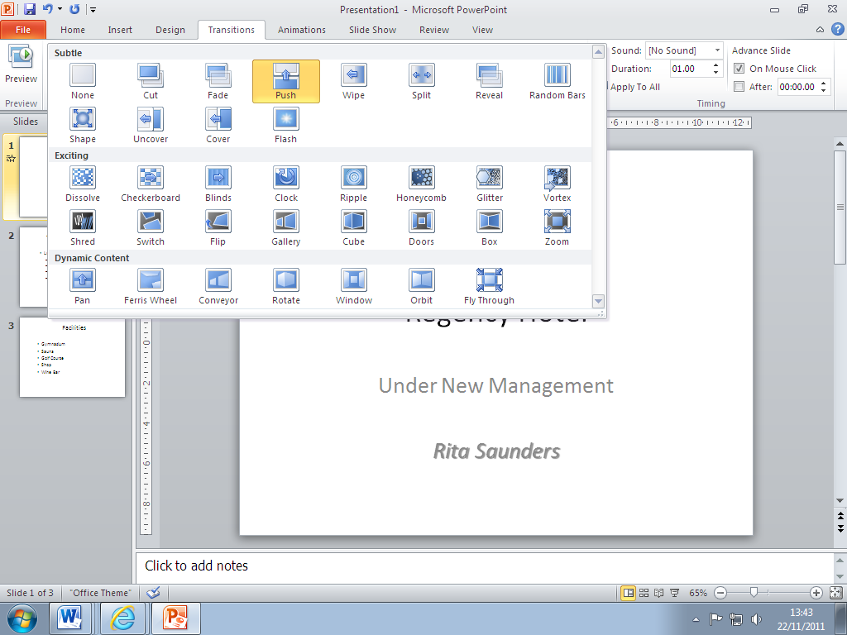

From the Transitions tab, click on one
of the choices of Transition to This Slide
to preview the effects.

Open up the full group to see more animations.

Click on the Apply to All button or choose a different transition for each individual slide.

Animations allow you to control the way text, images and objects appear on the slide during the slideshow.

Click on Animations tab, then click on an item on the slide which you want to animate. From the Animations tab choose an effect.
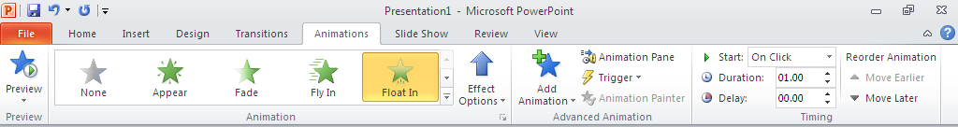

Click on Preview button to see the effect working.

Transitions and animations can be set to appear automatically or by clicking the mouse during the slide show.

Organization Charts in PowerPoint

Organization Charts are objects which can be inserted into a presentation. They are used to show the hierarchical structure of a company or range of services/products.

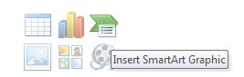
Organization Charts are chosen from the SmartArt Graphic icon on a Title and Content layout.

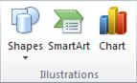

or on the Insert tab, in the Illustrations group, click SmartArt

From the SmartArt Graphic Gallery click on Hierarchy
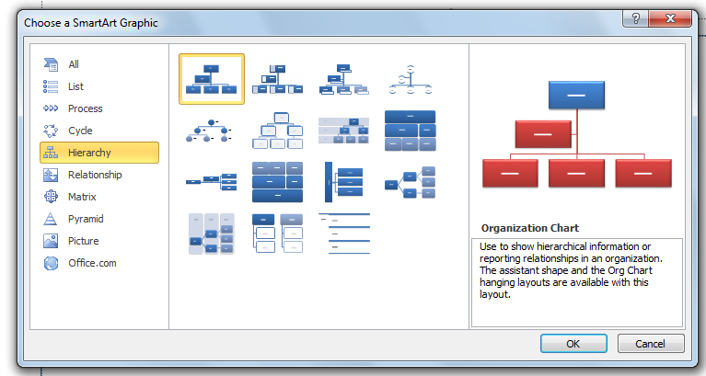

Choose the first style for a simple Organization Chart

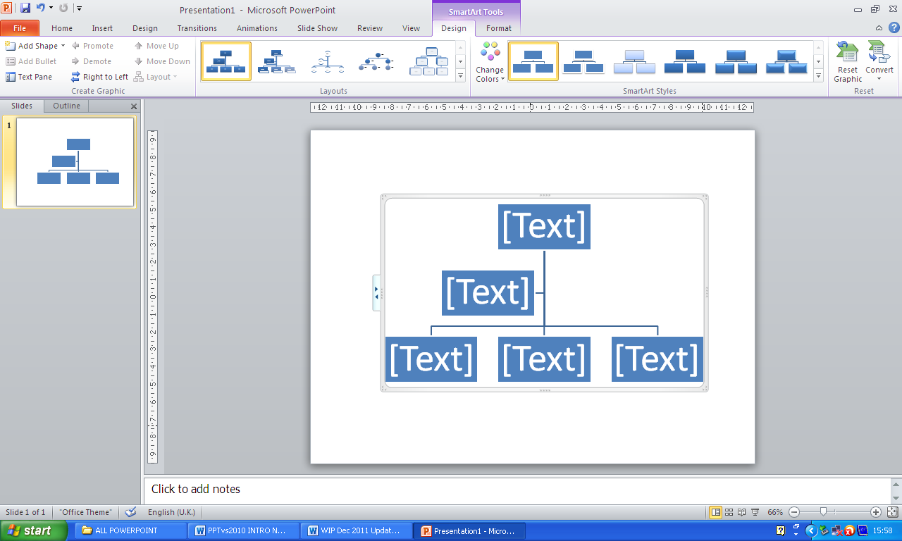

Click in a box in the Organization Chart, and then type your text – the text will change in size to fit the box on the chart.

Add a new box
Click the existing box that is located closest to where you want to add the new box.
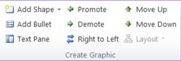
Under SmartArt Tools, on the Design tab, in the Create Graphic group, click the arrow next to Add Shape, and then choose where you want to add a shape.

- Co-workers (on the same level) – Add Shape After or Add Shape Before
- Managers (above current box) – Add Shape Above
- Subordinates (below current box) – Add Shape Below
- Assistants (between levels) – Add Assistant

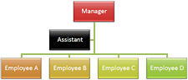
Change the hanging layout

- To centre all of the boxes below the selected box
click Standard.

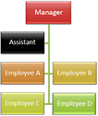
- To centre the selected box above the boxes below it
and arrange the boxes below it horizontally
with two boxes in each row
click Both.

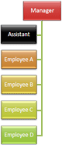
- To arrange the selected box to the right of the boxes
below it and left-align the boxes below it vertically
click Left Hanging.

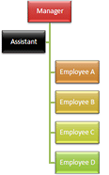

- To arrange the selected box to the left of the boxes
below it and right-align the boxes below it vertically
click Right Hanging.

Slide Transitions

Transitions are the way one slide moves to the next slide during an on-screen show.

- Change to Slide Sorter View
- Select the slide or slides you wish to change
- Click on the Transitions tab
- A gallery with choices of Transition is shown on the ribbon

As you select a Transition it will be Previewed on the slide
An icon appears under slides with Transitions
Click on the icon to
Preview the Transition
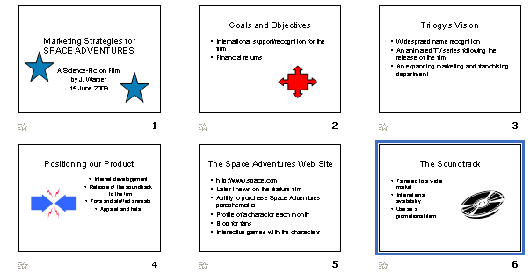

Transition Effect Options

Click on Effect Option to chose a direction, shape or style of transition depending on which transition you have chosen.
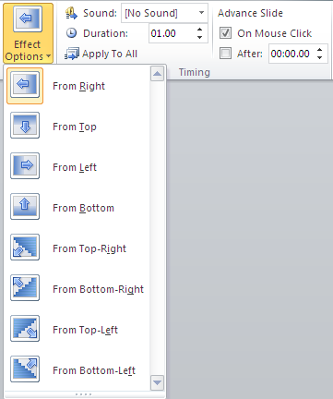
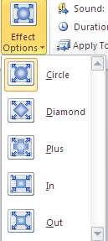
Then deselect the
On Mouse Click box
and add a timing in seconds.

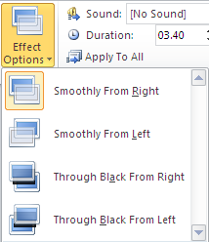

Be careful not to add too many different transitions as it can be very distracting and disorientating to watch a show where slides are flying in and out and appearing and disappearing on and off screen in a jumbled confusion. When the effects begin to detract from the content of the presentation, you have failed in reaching your audience with your message.
Tables in PowerPoint

Tables are chosen from the Table icon on a Title and Content layout.

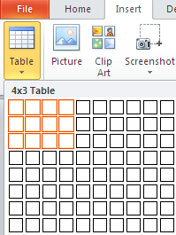
or on the Insert tab, in the Tables group, click Table and drag out rows and columns required from the grid

The Table Tools tab appears when a table is selected – with Design and Layout tabs

The Layout tab

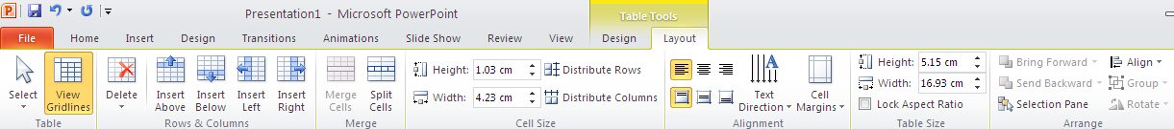

Text Alignment
Text within a table cell can be aligned left, right and centre and also top, bottom and middle. The text direction can also be rotated to horizontal, vertical, stacked.

The Design tab

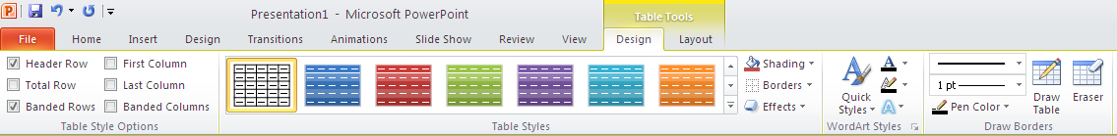

Borders and Shading
Rows and columns can be filled with a shading colour and the lines of the table can be changed in colour and weight and style. Change the weight and colour of the pen tool to draw on the table.

