Insert > [Illustrations ] > Shapes > Circle

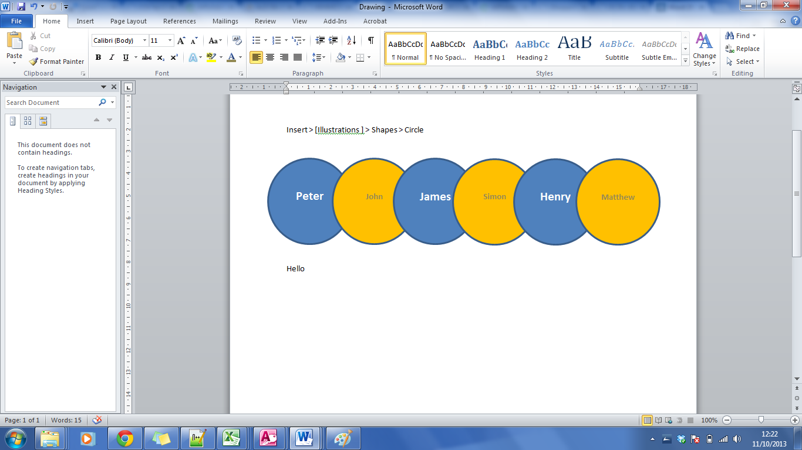

Exercise Rearrange the shapes as above