12 March 2026

Best practice guide: Python Project Structure

Introduction
This guide describes the recommended structure for Python projects developed within the Company. The objective is to ensure that projects are:
- Maintainable – code organisation remains clear as projects grow.
- Consistent – developers can quickly understand any internal repository.
- Reliable – tests run against the same code that will be deployed.
- Professional – aligned with widely accepted Python packaging practices.
The structure described here follows recommendations from the Python packaging community while remaining pragmatic for internal applications.

Standard Project Layout
All Python projects should follow the src layout:
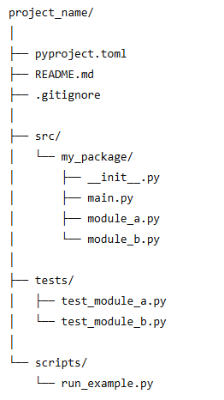

Directory Roles
Directory/File | Purpose
pyproject.toml | Project configuration and dependency management
src/ | All application or library source code
tests/ | Unit and integration tests
scripts/ | Optional helper scripts for development
README.md | Overview of the project

Use the src/ Layout
When Python executes code, it automatically places the current working directory (CWD) at the beginning of the import search path (sys.path).
If a project stores its package directly in the project root, such as:
project_root/
my_package/
Python may import this local directory instead of the installed version of the package in the virtual environment.
This situation is sometimes referred to as CWD shadowing. The local source directory “shadows” the installed package.
This can lead to subtle problems:
- Tests may run successfully using the local source files
- The installed package may behave differently
- Errors may only appear after installation or deployment
The src/ layout prevents this issue because the project root does not contain an importable package.
project_root/
src/my_package/
Python therefore imports the package from the virtual environment installation, ensuring tests exercise the code in the same way users or deployment systems will.

Relevance in Modern Workflows
Modern tooling (for example environments created automatically with dependency managers) typically installs the package into an isolated .venv environment.
In these workflows:
- The project is installed into the environment.
- Tests normally run against the installed package.
This reduces the practical risk of CWD shadowing.
However, the src layout still provides benefits:
- Consistent project structure across repositories.
- Clear separation between project configuration and source code.
- Alignment with modern Python packaging standards.
- Reduced risk of accidental import behaviour.
For these reasons, the src layout is the recommended default for all company Python projects.

Package Design Guidelines
Within the package directory:
src/my_package/
developers should follow the following practices.

Keep Modules Focused
Modules should represent a clear responsibility.
Example:
data_processing.py
simulation_engine.py
visualisation.py
Avoid large “utility” modules that collect unrelated functions.

Use __init__.py to define the package interface
The __init__.py file marks a directory as a Python package and can be used to provide a clean entry point to the package.
In many cases, a package contains several modules internally, but users of the package should not need to know the internal structure.
Example project structure:
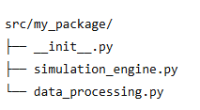
The package may contain a class defined in simulation_engine.py:
class SimulationModel:
...
To make this class easily accessible to users of the package, it can be imported in __init__.py:
from .simulation_engine import SimulationModel
This allows users to write:
from my_package import SimulationModel
instead of:
from my_package.simulation_engine import SimulationModel
This approach helps present a simple and stable interface to the package while allowing the internal module structure to evolve over time.
In many projects __init__.py may remain empty. It only needs to contain code when you want to expose selected objects at the package level.

Running Applications with the src Layout
Avoid Running Modules Directly from src
When using the src/ project layout, developers should not run modules directly from inside the src directory.
For example, avoid commands such as:
python src/my_package/main.py
Running a module in this way changes Python’s import behaviour and can cause imports within the package to fail.
This occurs because Python adds the directory containing the executed script to the import path (sys.path). When running a file inside src, the interpreter may not recognise the full package structure correctly.
Typical symptoms include errors such as:
ModuleNotFoundError
ImportError

Recommended Approaches

Run Modules Using -m
Applications should normally be executed using Python’s module mode:
python -m my_package.main
This ensures that Python runs the module as part of the package and resolves imports correctly.

Provide a main() entry point
Application modules should define a main() function:
def main():
print("Application starting")

if __name__ == "__main__":
main()
This allows the module to be run both as a script and as a package module.

Optional: Command Line Entry Points
For user-facing applications, projects may define command-line entry points in pyproject.toml. This allows the application to be run as a command after installation.
Example:
my_app = "my_package.main:main"
Users can then run:
my_app
This is the most user-friendly approach for packaged applications.

Summary
When using the src layout:
- Do not run modules directly from src.
- Run applications using python -m package.module.
- Provide a clear main() entry point.
Following this approach ensures imports behave consistently during development and deployment.

