Page Replacement Policy

Richelin Metellus

Build Instruction
- Download the source code.
  - Make sure to include the PageRequest folder if not already in the directory
- Run the code from a IDE
  - I used NetBeans
- Enter a digit for the Buffer size

Output requirement

Simulation for 3 frames of memory

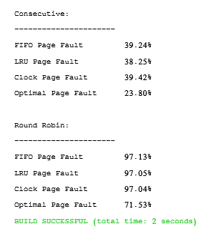

Simulation for 10 frames of memory

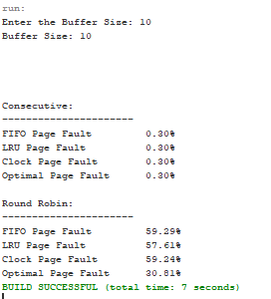

Simulation for 5 frames of memory

