
Richelin Metellus
Pipe And Fork: CSCI 474-p01

March 9, 2018
NDsu

 | Parent Read File(Child Process)
 | Small | Medium | Large
1 Process | 0.000544862 | 0.002830053 | 3.5778
2 Process | 0.000848933 | 0.0066722057 | 3.168288
4 Process | 0.001734096 | 0.005852693 | 3.1878

 | Child Reads File(Parent Sent offset)
 | Small | Medium | Large
1 Process | 0.000736175 | 0.067372301 | 66.482431182
2 Process | 0.000699683 | 0.041678290 | 34.67
4 Process | 0.000767948 | 0.019405808 | 18.269

Description: In this assignment we test 2 ways to get data to the child process to accomplish a task, i.e add all the number in the file.
- The first implementation of my program titled: ParentReadFileEXP read the file, assemble a chunk of those data block and repatriates these block to the child process to sum up and sent the result back via a pipe. This was time using the shared libray -lrt.
- The second implementation , the Parent Direct the child process where in the file to go. By calculating the right offset, each can open a copy of the file to process the data, and send their result to the parent. The parent then calculate each of the result to give the sum.

Discussion:
Multiprogramming enable individual programs to make use of memory and operating system resources as if programs were concurrent. Based on the result of the table, some times it seems the running time increase as the number of process increase. This may be due to time it takes to create a process. For example, when the program only uses one process then it took a mere 0.5 ms whereas it took 1.73 milliseconds with 4 processes when dealing with the small.txt file. One would expect the opposite but no. Same for the medium.txt, when the parent sends the offset and the children read the file, we have 0.0673 seconds for 1 process whereas we have 0.0194 for 4 processes. It takes time to create process and switch them, by giving us, the user the impression that one single program is doing all the job, with a few print statements one can which process are currently in execution. The real benefit of multiprogramming become more apparent as the size of the file increase, where it took half of the time to process the block given 2 processes depending on the implementation. The time seems to vary less when we have the Parent read the file and dispatch the appropriate block to the children.

Another important lesson learn in this exercise is how we can run into some synchronization issues. When the children were too busy reading and processing the block, the parent was already in a stage where it needed to read the information even when they were not ready. The program become suspended and was caught in a loop, so the way I get around that was to have each child to send their status to the parent once they are done with the job and once all of them were done, then the parent can go and read the pipe to grab the info and output the result.

Output for Small.txt Child Read File
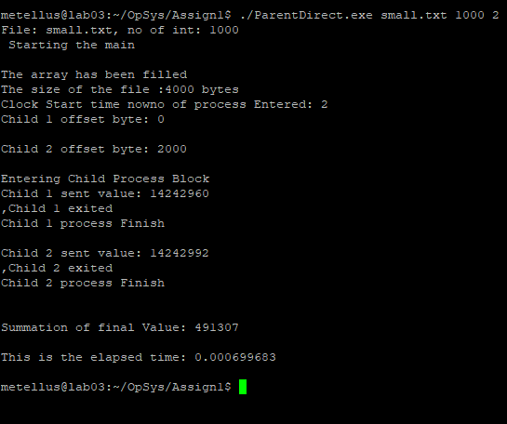
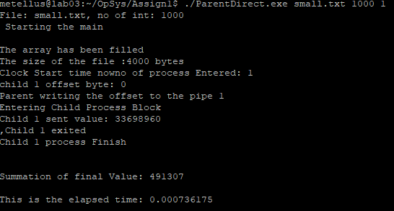
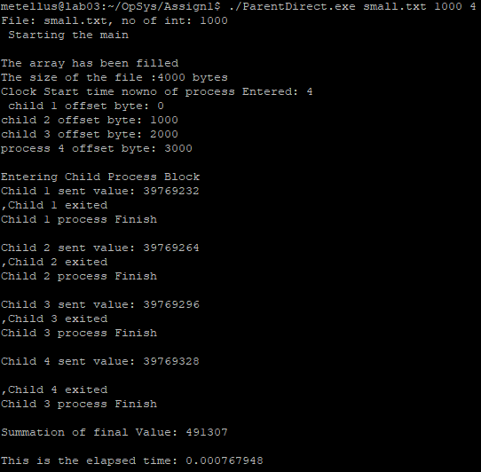

Output for Medium.txt Child Read File
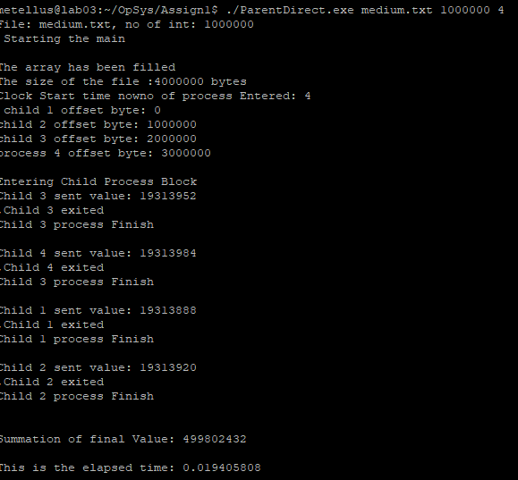
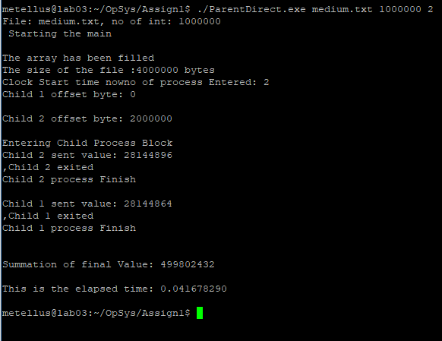
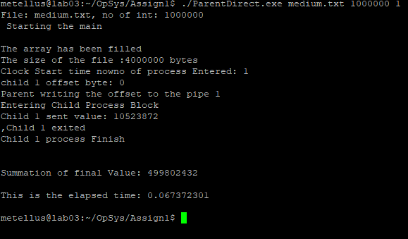

Output for Large.txt Child Read File
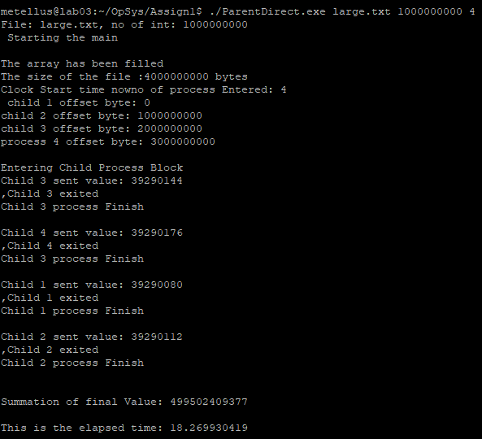
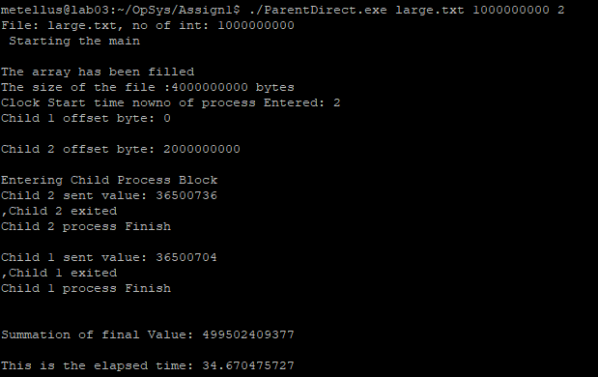
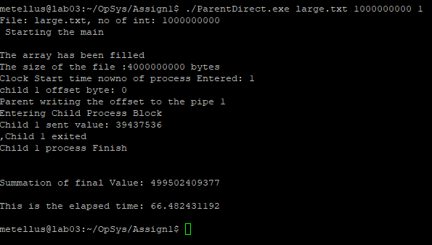

Parents read File small.txt sample

