[Type the company name]
Room Management
Case Study
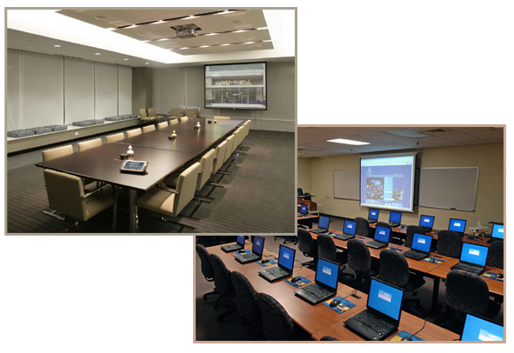

Contents
1. Introduction 3
Background 3
Overview 3
Current System 3
Acronyms and Abbreviations 3
2. Requirements 4
Create room: 4
Admin: 4
Book Room: 5
Booking Reports: 5
Email notifications [Optional]: 5
Look-and-Feel 5
Security 5

Introduction
Background
The purpose of this case study is to provide a real world application to Associate Software Trainees, which they can develop by going through all the stages of a Software Development Life Cycle (SDLC).

This is to achieve a reduced time to production of Trainees so that they are “project ready” by the time they are put onto projects.
Overview
The case study is for an application for L and D Department for LNT InfoTech. There are three stakeholders of this system: Admin, Users (LnD Staff) and BU staff. The application used by Admin and Users (LnD Staff) will be an intranet application.

Apart from developing the application, Trainees are also expected to analyze the requirements and apply OOAD principles to come up with a proper design. Trainees are expected to follow LNT InfoTech coding standards and adhere to best practices and coding principles. Trainees will also have to deploy their application so that it can be tested. For this purpose, they will have to create an installation pack, which will deploy their application, with minimal manual intervention.

Current System

Consider person A as the training department representative who manages the Excel sheet. Let person B be any person from training department who asks for the booking.
Person B has to personally visit person A to book the training room. Person A checks the Excel sheet for availability. If available, person A does the update in Excel sheet & confirms the booking status to B and an acknowledgment mail is send to B against the confirmation. If not available, no booking is considered and person B can adjust with other dates and timings. To book training rooms at a different location, person B has to personally contact the concerned person at that location to book the training room of that location. In case of discussion rooms, person B can book the room any time and no conditions are applied.

Apart from the core functionality, the AST must also take into consideration important issues like security, ease of use, familiar look-and-feel across the application, easy navigation and performance.

Acronyms and Abbreviations
LnD | Learning and Development
SDLC | Software Development Life Cycle
BU | Business Unit

Requirements
Create room:
Admin will have to login and on login verification admin will be allowed to create new room, when the new room is allocated to LnD for technical training, discussion or soft skill training. When room is created its seating capacity and if infrastructure exists then the no. of Machines also need to be added. The details like location, block, and city of training to be also added for room creation for the room type mentioned above. The room details can be updated, or deleted after corresponding room id is searched for and found in the system.

Create Room should record all this details
- Name of the Room
- Room Type
- Venue Details
  - City
  - Location
  - Block
  - Address
- Room Owner Details
  - Location Coordinator Name1 mail fired to this person this details should come from database
  - Email Id
  - Phone
- Facilities
  - Seating Capacity
  - Table Types(Round/Square tables)
  - No of Machines
  - White Board
  - Flip Chart
  - Screen
  - Projector
  - Network
  - Internet Connection
- Remark
- No of Participants
- Deletion of the Room can happen

Admin:
After logging in Admin can create, modify, delete user. Admin can also manage the rooms. Admin have got rights to confirm room cancellation. Admin can also have the booking done. While booking the room Admin will do the booking for “Open Programs” first after which the booking “BU Specific Programs” will be done either by Admin or Users. Admin will acknowledge the trainings confirmed to the respective users who have done the booking and the BU members. Admin will manage the bookings across the locations also.

User Table
- Name
- Emailid
- Phone
- Roles
The user Profile has to be maintained.
Book Room:
After logging in user can book the rooms after checking for availability of that room. Admin will first do the entry for the Open Programs only then the users of the system will be allowed to make entry for the BU Programs. The admin may choose the user and assign him/her rights for having the permissions given to specific users to have bookings and cancellations done in his/her absence. While booking rooms the booking status either “Confirmed” if the booking is confirmed. If the booking is cancelled then the status will change to “Cancelled”. By default the status will be “Available” and if the training is scheduled but not confirmed then status will be set to “Tentative”. While booking either of users will have to take care that the Open Programs is booked before any user could do booking for the BU Specific Program.

The bookings can be done by any users for current month and next month. The booking cannot be started for next month before 27th of the month. If there is any holiday on 27th then on next consecutive day the bookings will start for the next month. Bookings can be done online by users for any location.
On updating a booking Remark field should be there. No approval needed for cancellation of the booking.
When a booking is to be done for a specific day and if there is a clash at such moment user needs to show the details on whose name it has been booked already.

Booking Reports:
Report option
Booked history weekly, monthly
- Program type wise
- BU Type Wise
User wise or Admin Wise
Start - end date booked details should be showed
Super Admin will get which users location wise
Start - end date booked details should be showed
Email notifications [Optional]:

- System will send emails to respective users if the booking is “confirmed” or “cancelled”
- On creation of users, they will be notified through email with regards to their username, password and their rights.
Look-and-Feel
All pages must have the same look-and-feel with exactly the same header, footer and navigation panel on the left.

Users must be able to go to any screen with minimum mouse-clicks.
Security
The users have to have appropriate permission to do bookings for the available rooms. On basis of the permission given to users they will login the system to do a specific task.

