- Setup your machine with Git Configuration
- Integrate notepad++.exe to Git and make it a default editor
- Add a file to source code repository
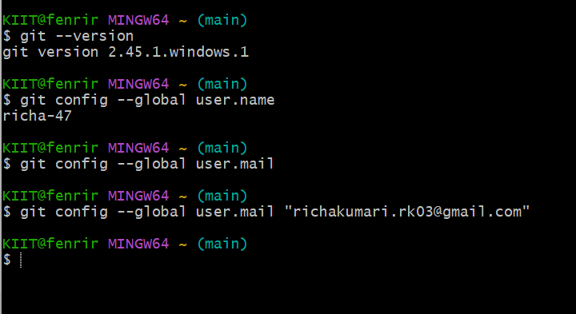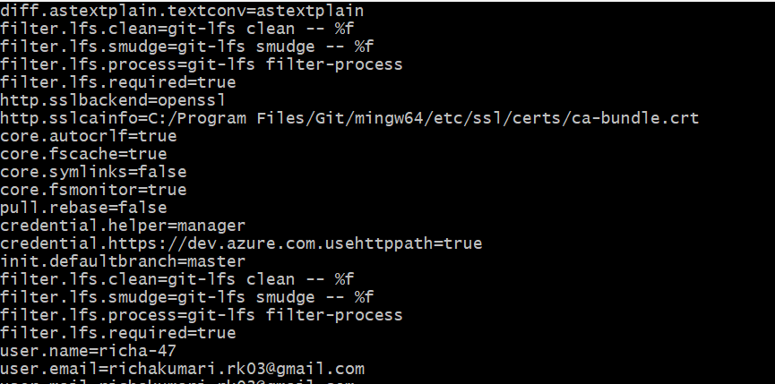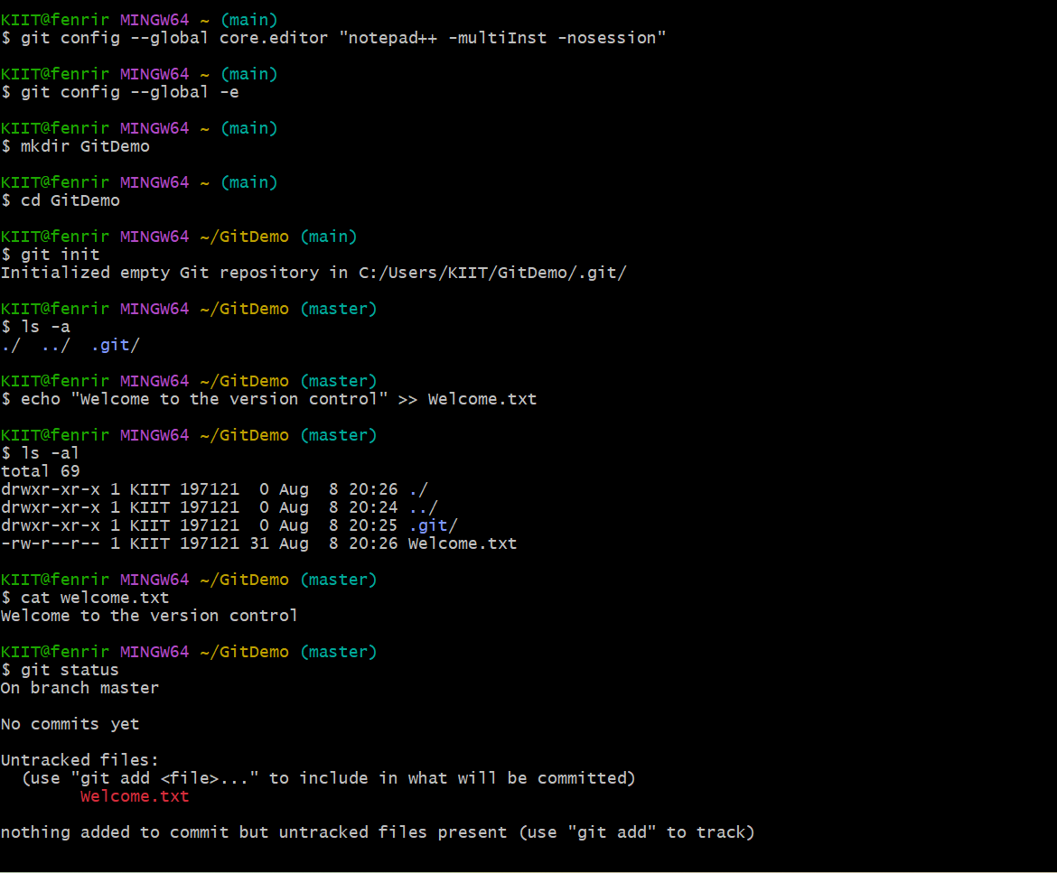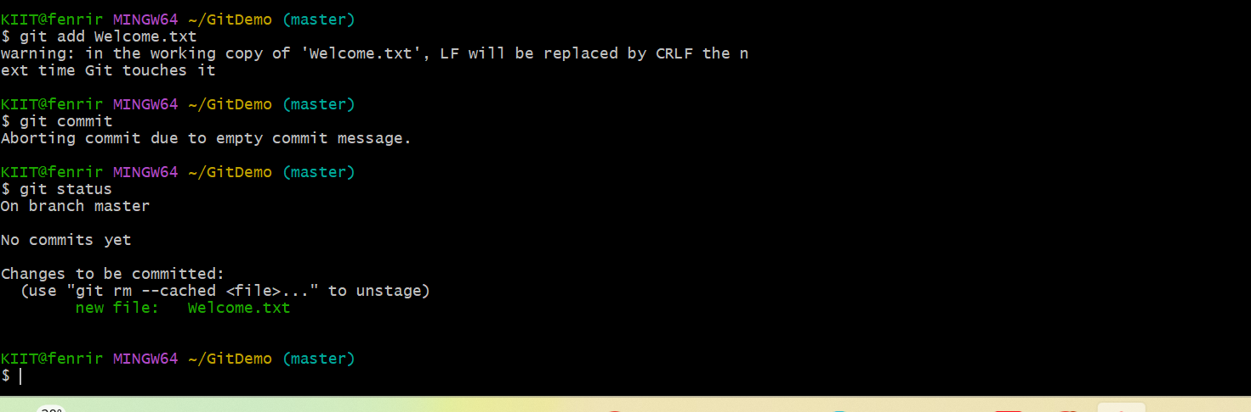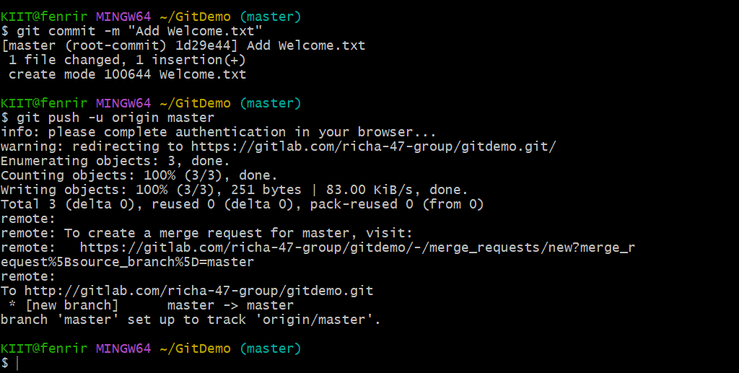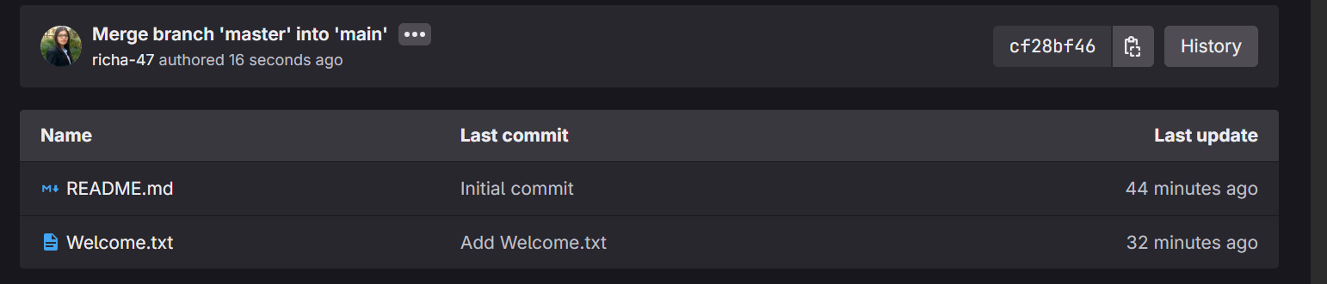

Create a “.log” file and a log folder in the working directory of Git. Update the .gitignore file in such a way that on committing, these files (.log extensions and log folders) are ignored.
Verify if the git status reflects the same about working directory, local repository and git repository.

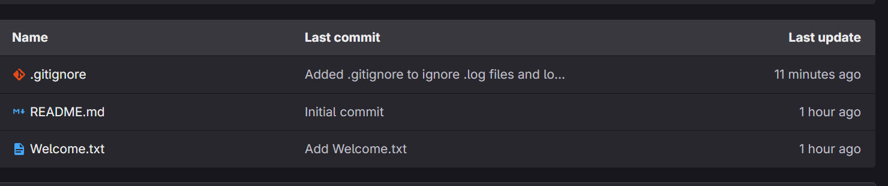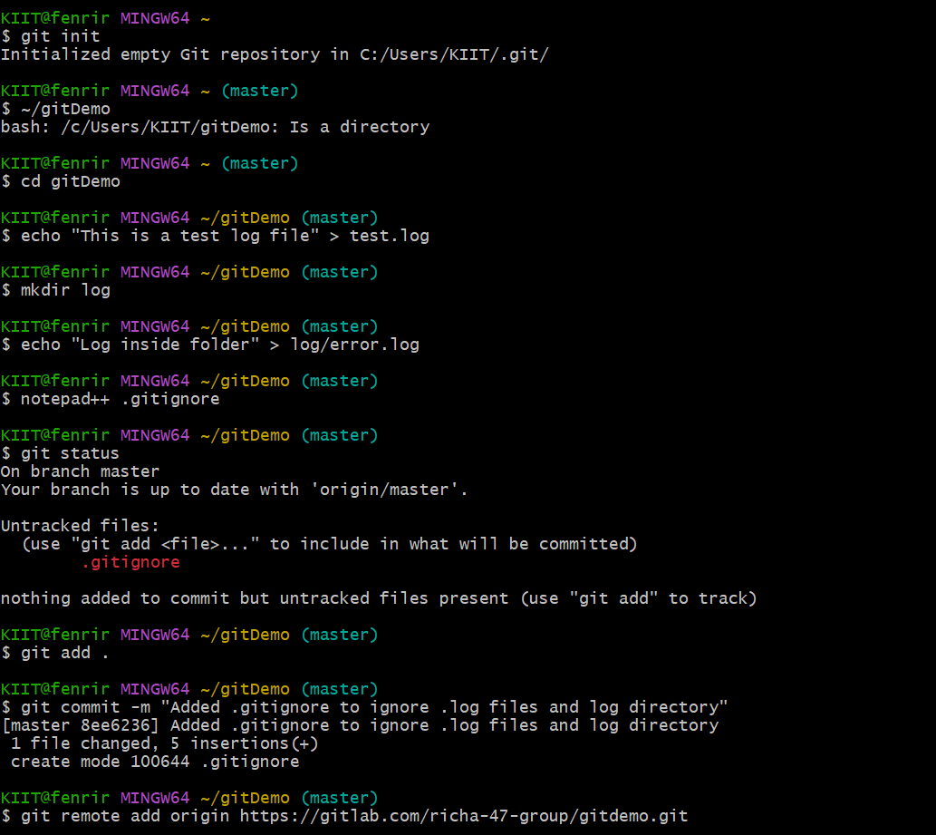

Branching:
- Create a new branch “GitNewBranch”.
- List all the local and remote branches available in the current trunk. Observe the “*” mark which denote the current pointing branch.
- Switch to the newly created branch. Add some files to it with some contents.
- Commit the changes to the branch.
- Check the status with “git status” command.

Merging:
- Switch to the master
- List out all the differences between trunk and branch. These provide the differences in command line interface.
- List out all the visual differences between master and branch using P4Merge tool.
- Merge the source branch to the trunk.
- Observe the logging after merging using “git log –oneline –graph –decorate”
- Delete the branch after merging with the trunk and observe the git status.
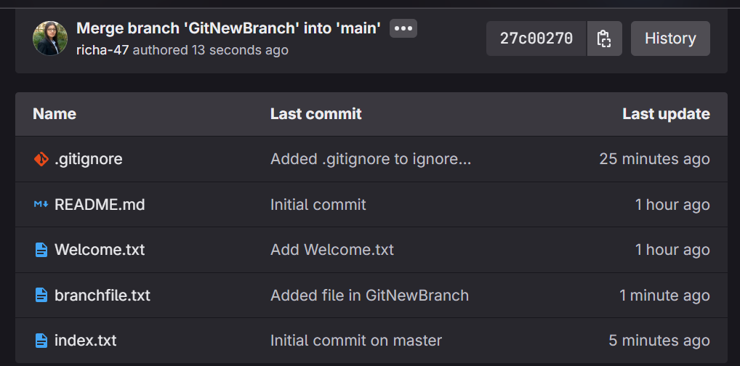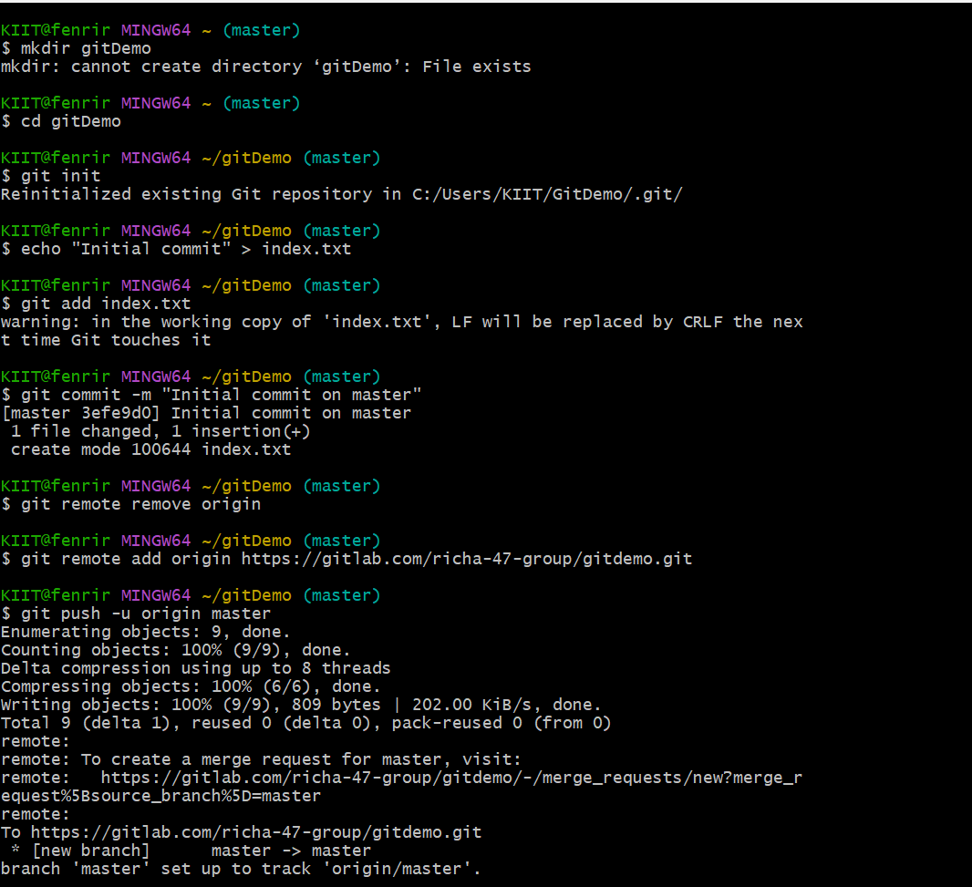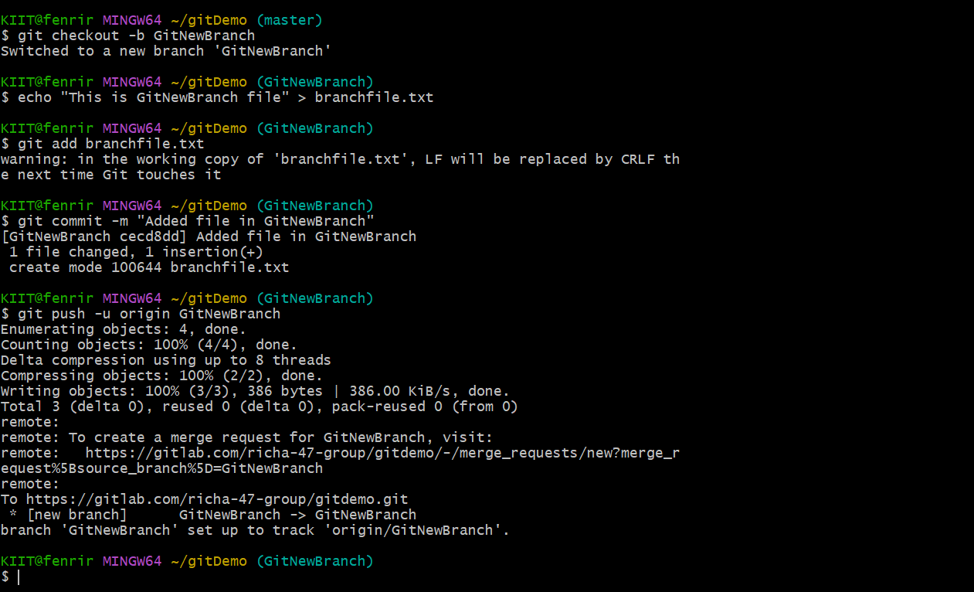

- Verify if master is in clean state.
- Create a branch “GitWork”. Add a file “hello.xml”.
- Update the content of “hello.xml” and observe the status
- Commit the changes to reflect in the branch
- Switch to master.
- Add a file “hello.xml” to the master and add some different content than previous.
- Commit the changes to the master
- Observe the log by executing “git log –oneline –graph –decorate –all”
- Check the differences with Git diff tool
- For better visualization, use P4Merge tool to list out all the differences between master and branch
- Merge the bran to the master
- Observe the git mark up.
- Use 3-way merge tool to resolve the conflict
- Commit the changes to the master, once done with conflict
- Observe the git status and add backup file to the .gitignore file.
- Commit the changes to the .gitignore
- List out all the available branches
- Delete the branch, which merge to master.
- Observe the log by executing “git log –oneline –graph –decorate”
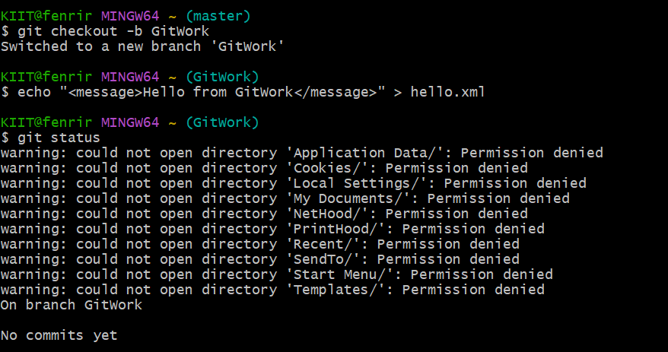
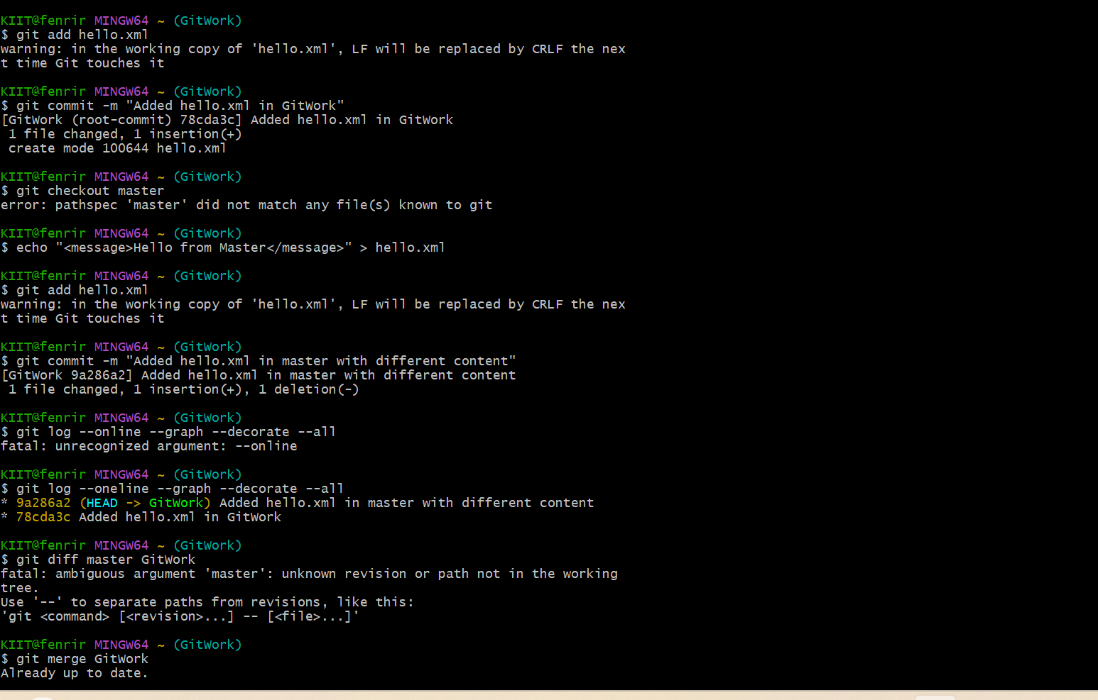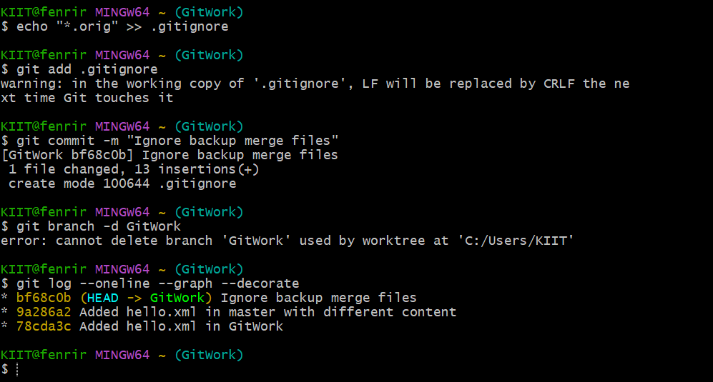

Please follow the instructions to complete the hands-on. Each instruction expects a command for the Git Bash.
- Verify if master is in clean state.
- List out all the available branches.
- Pull the remote git repository to the master
- Push the changes, which are pending from “Git-T03-HOL_002” to the remote repository.
- Observe if the changes are reflected in the remote repository.
