APMS: ActiPoints Management System
A Mini Project Report
Submitted
In Partial Fulfillment of the Requirements
for the award of the Degree of

Bachelor of Technology
In
Computer Science and Engineering
APJ Abdul Kalam Technological University
Thiruvananthapuram-Kerala
By
RICHA ANNA ALEX (AIK22CS051)
HIBA SHAJAHAN (AIK22CS032)
SREDHA RAMESHAN (AIK22CS058)
ALWIN SABU (AIK22CS009)


COMPUTER SCIENCE AND ENGINEERING
Albertian Institute of Science and Technology-AISAT
Kalamassery–Kochi 682022
2022-2026

Vision
To be a Centre of excellence for professional education and related services creating technically competent and ethically strong innovative minds committed to the growth of the nation and beyond.
Mission
- We are committed to provide value-based education with ample opportunities for research and industry institution interaction.
- We take very possible step to enhance the skills and bring out quality professionals, providing a friendly and growth-oriented ambience with appropriate resources.
- We improve ourselves through continuous evaluation and updation to meet the challenges and requirements of the modern society.
Motto
We make Engineers, not just Engineering Graduates

Program Outcomes (PO)
At the end of the program, graduate engineers will be able to
PO1-Engineering Knowledge: Apply the knowledge of mathematics, science, engineering fundamentals and an engineering specialization for the solution of complex engineering problems.
PO2-Problem Analysis: Identify, review research literature, formulate and analyze complex engineering problems, thereby arrive at substantiated conclusions using first principles of mathematics, natural sciences and engineering.
PO3-Design/Development of Solutions: Design solutions for complex engineering problems and design system components or processes that meet the specified needs with appropriate consideration for public health and safety, and cultural, societal, and environment considerations.
PO4-Conduct investigations of complex problems: User research based knowledge and research methods including design of experiments, analysis and interpretation of data, and synthesis of the information to provide valid conclusions.
PO5-Modern tool usage: Create, select and apply appropriate techniques, resources, and modern engineering and IT tools, including prediction and modelling to complex engineering activities with an understanding of the limitations.
PO6-The Engineer and Society: Apply reasoning informed by contextual knowledge to assess societal health, safety, legal and cultural issues and the consequent responsibilities relevant to the professional engineering practice.
PO7-Environment and sustainability: Understand the impact of the professional engineering solutions in societal and environmental contexts, and demonstrate the knowledge of, and need for sustainable development.
PO8 – Ethics: Apply ethical principles and commit to professional ethics and responsibilities and norms of the engineering practice.
PO9-Individual and teamwork: Function effectively as an individual, and a member in diverse teams and in multi-disciplinary settings.
PO 10- Communication: Communicate effectively on complex engineering activities with the engineering community and with the society at large, such as, being able to comprehend and write effective reports and design documentation, make effective presentations, and give and receive clear instructions.
PO11-Project management and finance: Demonstrate knowledge and understanding of the engineering and management principles and apply these to one’s own work, as a member or leader in a team, to manage projects, and in multidisciplinary environments.
PO12-Lifelong learning: Recognize the need for, and have the preparation and ability to engage in independent and lifelong learning in the broadest context of technological knowledge.

Program Specific Outcomes (PSOs)

Graduates of Computer Science and Engineering will be able to
PS01: Design and develop computer programs and computer-based systems of moderate complexity in the areas relevant to the current computational demands of the global society.
PSO2: Gather knowledge in the various domains of Computer Science and identify suitable career paths to succeed in life.
PSO3: Apply the fundamentals of computer science in order to evaluate potential risks and provide creative solutions to meet the needs of society.

COURSE OUTCOMES (COs)
CO1: Identify technically and economically feasible problems
CO2: Identify and survey the relevant literature for getting exposed to related solutions and get familiarized with software development processes
CO3: Perform requirement analysis, identify design methodologies and develop adaptable & reusable solutions of minimal complexity by using modern tools & advanced programming techniques
CO4: Prepare technical report and deliver presentation
CO5: Apply engineering and management principles to achieve the goal of the project

CO-PO-PSO Mapping Matrix
PO/ CO | PO1 | PO2 | PO3 | PO4 | PO5 | PO6 | PO7 | PO8 | PO9 | PO  10 | PO  11 | PO  12 | PSO1 | PSO2 | PSO3
CO1 | H | H | H | H |  | H | M | H | H | H | H | H | H | H | M
CO2 | H | H | H | H | H | H |  | H | H | H | H | H | H | H | H
CO3 | H | H | H | H | H | H | H | H | H | H | H | H | H | H | H
CO4 | H | M | M | M | H |  |  | H | H | H | H | M | M
CO5 | H | H | H | H | H | H | H | H | H |  | H | H | H | M

UNDERTAKING

We declare that the work presented in this project titled “APMS: ActiPoints Management System”, submitted to the Computer Science and Engineering Department, Albertian Institute of Science and Technology, AISAT, Kalamassery, Kochi for the award of the Bachelor of Technology degree in Computer Science and Engineering, is our research work. We have not plagiarized or submitted the same work for the award of any other degree. In case this undertaking is found incorrect, we accept that our degree may be unconditionally withdrawn.

Date: 03.04.2025
Place: Kochi
RICHA ANNA ALEX (AIK22CS051)
HIBA SHAJAHAN (AIK22CS032)
SREDHA REMESHAN (AIK22CS058)
ALWIN SABU (AIK22CS009)

CERTIFICATE

Certified that the work contained in the project titled “APMS: ActiPoints Management System”, by Richa Anna Alex (AIK22CS051), Hiba Shajahan (AIK22CS032), Alwin Sasbu (AIK22CS009), Sredha Remeshan (AIK22CS058) has been carried out under my supervision and that this work has not been submitted elsewhere for a degree.

Name & Signature of Guide Name & Signature of HOD
Asst. Prof. Nisy John, Assoc. Prof. Dr. Jeswin Roy
Dept. of CSE Dcouth,
AISAT HOD Dept. of CSE
AISAT

College /Department Seal

Approval & Evaluation
Presented for the B.Tech Semester VI Mini Project Evaluation held on

….............

Evaluation Committee

1. ……………………………………….

2. …………………………………………

3. …………………………………………

Acknowledgement

We would like to express our gratitude and appreciation to Dr. Veena V, Principal, Albertian Institute of Science and Technology. Heartfelt gratitude to our guide Asst. Prof. Nisy John (Dept. of CSE) for his valuable suggestions and encouragement. A special thanks to Assoc. Prof. Dr. Jeswin Roy Dcouth, HOD, Department of CSE. We also thank AISAT Prof. Ms. Divya Mohan (Dept. of CSE), our project coordinator, for her encouragement and support.

Date: 03-04-2025
Place: Kochi

RICHA ANNA ALEX (AIK22CS051)
HIBA SHAJAHAN (AIK22CS032)
SREDHA REMESHAN (AIK22CS058)
ALWIN SABU (AIK22CS009)

ABSTRACT

In colleges, tracking KTU activity points manually is time-consuming, prone to errors, and lacks transparency. Students often struggle to meet the mandatory 100-point requirement due to inefficient record-keeping and unclear tracking methods. To address this issue, we are creating ActiPoints, an automated system for tracking and managing KTU activity points.
With ActiPoints, students can register activities, upload proof documents, and monitor their category-wise progress. The system automatically calculates points based on activity type and level, ensuring compliance with KTU guidelines. Administrators will have a dedicated panel to verify submissions, manage activities, and keep track of students’ progress.
The platform organizes activities into various categories such as National Initiatives, Sports, Cultural, Professional Self-Initiatives, Entrepreneurship, and Leadership. It also provides visual progress tracking through progress bars, along with notifications about upcoming activities.
Administrators can approve or reject activity submissions, and view each student’s progress. This system ensures accuracy, efficiency, and transparency in managing KTU activity points.

TABLE OF CONTENTS

Chapter | Contents | Page No.
 | Undertaking | 7
 | Certification | 8
 | Approval and evaluation | 9
 | Acknowledgement | 10
 | Abstract | 11
 | Table of Contents | 12
 | List of Figures | 13
1. | Introduction | 14
2. | Literature Survey | 17
3. | Existing System | 22
4. | Proposed System | 23
5. | System Architecture | 25
6. | Design – UML Diagram | 27
7. | Implementation and Methodology | 30
8. | System Testing | 38
9. | Result and Analysis | 40
10. | Conclusion | 43
11. | Future Scope | 44
 | References | 45
LIST OF FIGURES

Figure No. | Figure Name | Page No.
2.1 | Context flow of Actipoints | 20
2.2 | Stakeholders involved in Actipoints | 21
5.1 | Architecture | 25
6.1 | Use Case Diagram | 27
6.2 | Class Diagram | 28
6.3 | Activity Diagram | 29

CHAPTER: 1
INTRODUCTION

Tracking activity points is an essential requirement for students under APJ Abdul Kalam Technological University (KTU), as they must accumulate at least 100 activity points to be eligible for graduation. However, the current process of manual tracking is inefficient, time-consuming, and error-prone. Students struggle to track their progress effectively due to the lack of automation and transparency in the system.
To address these challenges, we introduce ActiPoints, a comprehensive Activity Point Management System (APMS) tailored to meet KTU’s requirements. ActiPoints automates activity tracking, verification, and point calculation, enabling students to register activities, upload proof documents, and monitor their category-wise progress in real time. Faculty members and administrators can verify student submissions, manage activities, and evaluate progress of each student, ensuring an organized and streamlined evaluation process.
By implementing ActiPoints, students will have an interactive platform for managing their extracurricular achievements, while faculty will experience reduced workload and improved efficiency in tracking student activity points.
For ActiPoints, we have employed HTML, CSS, and JavaScript for frontend development, ensuring a seamless and user-friendly interface. The backend is powered by Python’s Django framework, which enables secure authentication, efficient data processing, and seamless integration with the database. SQLite serves as the database for storing student activity records, document uploads, and progress reports. Server-side scripting is used to create dynamic web pages, automate point calculations, and facilitate verification processes while maintaining data confidentiality and integrity.
ActiPoints guarantees confidentiality, security, and accessibility, ensuring a stress-free experience for students and faculty. With just a simple login, students can manage their activity records, and the verification process is streamlined for faculty members, allowing for faster approvals and real-time updates. This system will significantly improve the efficiency of KTU’s activity point tracking process, making it more structured, user-friendly, and effective.
CHAPTER: 2
LITERATURE SURVEY

[1] Challenges in Manual Activity Tracking
Manual tracking of student activities and achievements has long been a standard practice in educational institutions. However, studies by Yadav et al. (2020) and Sharma & Gupta (2019) highlight significant drawbacks, such as human errors, data loss, and inefficiency in updating student records. The process often involves paper-based logs or spreadsheet-based documentation, which can lead to miscalculations and delayed updates. These inefficiencies create frustration among students who are unable to track their progress in real time. Additionally, the burden on faculty members to manually verify certificates and update points further slows down the system. These challenges indicate a strong need for an automated activity tracking system that ensures accuracy, transparency, and efficiency.
[2] Existing Digital Solutions for Student Activity Tracking
Several universities have adopted digital solutions to automate the tracking of student achievements. Research by Kumar & Rao (2022) and Singh et al. (2020) shows that automated systems reduce processing time by more than 60%. These systems utilize AI-driven dashboards, real-time progress tracking, and smart verification methods to streamline student engagement. The implementation of cloud-based solutions and interactive portals allows students to monitor their achievements, receive recommendations for participation, and even track university-level activity rankings. Furthermore, these solutions foster data-driven decision-making for institutions, enabling them to enhance extracurricular engagement strategies.
[3] Data Security and Compliance in Student Management Systems
One of the most critical aspects of digital student activity tracking is data security and privacy compliance. Desai & Mehta (2021) discuss the risks associated with storing student records on external cloud storage platforms such as Google Drive, which may not always comply with educational data protection laws. Institutions must ensure that personal student data is safeguarded through encryption, access controls, and compliance with regulations such as GDPR. The absence of a secure framework can lead to unauthorized access, data breaches, and potential misuse of student records. This highlights the necessity for integrating robust security measures in any automated tracking system.
[4] Key Takeaways from Literature
Based on a thorough review of existing research, it is evident that an efficient student activity tracking system must incorporate several essential features to address the challenges faced by manual tracking methods. Automation of point allocation and verification is crucial to eliminate human errors and inconsistencies in data entry. By integrating an automated system, institutions can ensure that student achievements are recorded accurately and efficiently, without the delays and inaccuracies associated with manual processes.
Additionally, the system must provide real-time progress tracking through an interactive dashboard. This feature allows students to monitor their activity points, view their progress, and identify areas for improvement instantly. Faculty members and administrators can also use this functionality to keep track of student engagement levels and make informed decisions to encourage participation in extracurricular activities.
Another critical aspect is data security and compliance. Given the sensitive nature of student records, it is imperative to implement secure data storage with encryption and role-based access controls. This ensures that only authorized users, such as students and designated faculty members, can access the information while preventing unauthorized data breaches. A secure infrastructure also ensures compliance with educational data protection laws and university policies.
To further enhance student engagement, AI-driven recommendations can be integrated into the system. These recommendations can analyze student participation trends, suggest relevant activities, and provide personalized insights to encourage further involvement. Such intelligent features help students stay engaged and motivated by aligning suggested activities with their interests and academic goals.
Lastly, seamless communication between students and faculty is a vital component of an effective tracking system. A well-structured feedback and query resolution mechanism allows students to raise concerns, seek clarifications, and receive timely responses from faculty members. This fosters a transparent and efficient system where students feel supported and encouraged to participate in extracurricular activities without facing administrative hurdles.
By incorporating these best practices, ActiPoints aims to create a robust, secure, and user-friendly platform that simplifies activity tracking while enhancing student engagement and faculty efficiency.
ActiPoints incorporates these best practices, providing a secure, scalable, and efficient solution for automated student activity tracking at KTU. By reducing faculty workload and enhancing transparency, the system empowers students to actively engage in extracurricular activities while ensuring that their efforts are accurately recorded and rewarded.

Context flow of Activity Points Management system
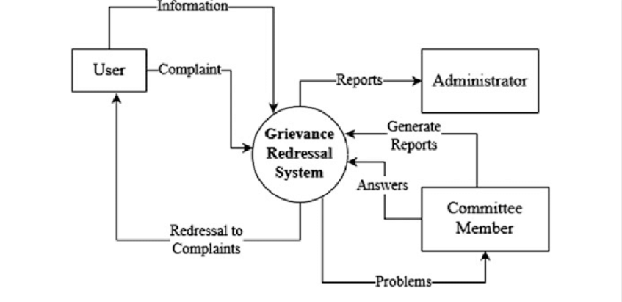
Fig:2.1: Context flow of Actipoints

Stakeholders involved in APMS

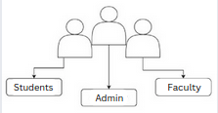
Fig:2.2: Stakeholders involved in Actipoints

CHAPTER: 3
EXISTING SYSTEM

The existing system for tracking KTU activity points relies on a faculty-managed Google Drive where students upload their activity certificates, which are then manually reviewed and verified by teachers before entering the corresponding points into the university’s website, allowing students to check their updated scores only through their KTU profile; however, this process is highly inefficient due to its dependence on manual verification, lack of real-time tracking, delays in point updates, potential errors in data entry, and the absence of automated notifications, making it difficult for students to monitor their progress and ensure they meet the mandatory 100-point requirement before graduation.

Disadvantages
- Unstructured Data Storage: Google Drive lacks a structured framework for organizing certificates, making data retrieval slow and inefficient.
- Manual Certificate Verification: Time-consuming and prone to human error, leading to delays and inconsistencies in point allocation.
- Delayed Data Entry into University Website: Manual entry prolongs the update process, causing delays for students to view their progress.
- Lack of Real-Time Progress Tracking: Students have no way to track the status of their submissions until the university profile is updated.
- Limited Automation & Efficiency: The system relies entirely on manual intervention, increasing errors and inefficiencies.
- Security & Privacy Concerns: Google Drive is not optimized for handling sensitive academic records, raising concerns about data security.
- Scalability Issues: As student numbers grow, the current system will struggle to manage a larger volume of submissions.

CHAPTER: 4
PROPOSED SYSTEM

Here, the ActiPoints platform addresses the inefficiencies of manual document storage, point calculation, and delayed updates by centralizing activity tracking, automating point allocation, and providing real-time progress updates, ensuring students instantly see their earned points. With a user-friendly interface, clear role-based access, and compliance with KTU guidelines, ActiPoints streamlines activity management while eliminating confusion. Enhanced data security measures safeguard sensitive information, and the platform’s scalability ensures smooth performance as student numbers grow. By offering transparency, instant updates, and an intuitive experience, ActiPoints enhances student engagement, reduces dissatisfaction, and ensures a seamless, efficient, and error-free activity point management system.

Advantages
- Centralized Activity Points Management eliminates manual document storage and data entry inefficiencies by integrating all processes into a single platform.
- Automated Point Calculation reduces human errors by automatically assigning points based on predefined KTU guidelines.
- Real-time Data and Point Updates provides instant updates on activity points, eliminating delays and confusion among students.
- User-friendly Interface offers an intuitive and easy-to-navigate system for students, faculty, and administrators.
- Clear Role-based Access ensures security and clarity by defining specific permissions for students, teachers, and admins.
- Compliance with KTU Guidelines ensures accuracy by aligning point calculation with university regulations.
- Scalability adapts to growing student populations without performance issues.

Product Function
The ActiPoints system is a streamlined platform for managing student activity points efficiently. Students can securely register and login to access a personalized dashboard where they submit extracurricular activity details with proof. Faculty members review and verify submissions before approval, ensuring accuracy. The system automatically calculates points based on KTU guidelines, eliminating manual errors. Real-time tracking prevents delays and confusion, while notifications alert users about deadlines, approvals, and pending verifications. Role-based access ensures security, with specific permissions for students, faculty, and administrators. The platform supports reporting and analytics for tracking student participation. Designed for scalability, it efficiently handles large student populations. Data security measures, including encryption and restricted access, safeguard sensitive information. By automating the process, ACTIPoints enhances transparency, reduces manual workload, and improves student satisfaction. Compliant with KTU regulations, it simplifies extracurricular tracking, making activity management seamless and efficient for both students and faculty.

CHAPTER: 5
SYSTEM ARCHITECTURE

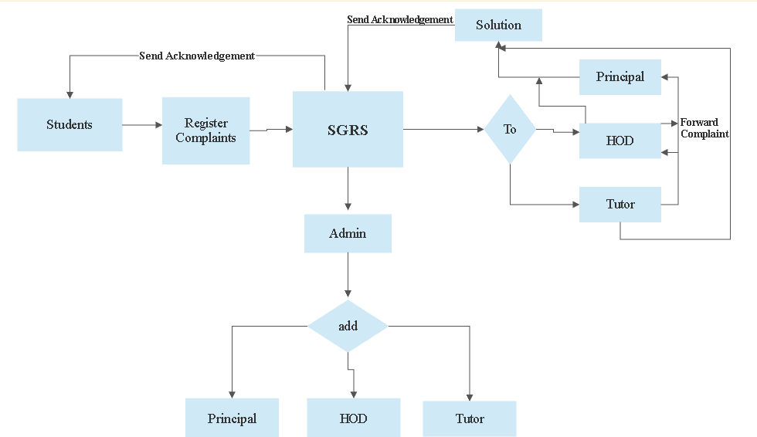

Fig:5.1: Architecture

Input Data:
The system comprises 3 major Entity as follows:

1. Students:
Students are the main users of the system, with access to a personalized dashboard displaying their profile, total accumulated activity points, and past activity history. They can submit activity details by selecting a category (e.g., National Initiatives, Sports, Cultural, Professional Self-Initiatives, Entrepreneurship, Leadership) and uploading supporting documents such as participation certificates. Once submitted, these activities are forwarded to the faculty for verification.

2. Faculty:
Faculty members are responsible for reviewing student-submitted activities, verifying supporting documents, and determining whether the activity meets KTU eligibility criteria. They can approve or reject submissions, providing necessary feedback (e.g., “Certificate not valid” or “Activity does not qualify for points”). Faculty members can also track the progress of each student, ensuring they meet the required extracurricular points.

3. Admin:
Admins can add, edit, or remove student and faculty profiles, granting appropriate permissions based on their roles. Additionally, admins can upload official events and activities, making them available for students to participate in and earn points.

CHAPTER: 6
DESIGN - UML DIAGRAMS

  - Use Case Diagram
The use case graph is for demonstrating the direction of the structure. This chart contains the course of action of use cases, performing pros, and their relationship. This chart might be utilized to address the static perspective of the structure

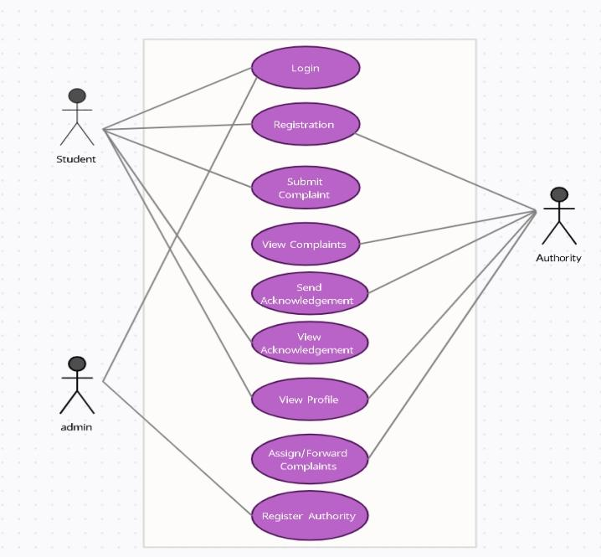 Fig:6.1: Use Case Diagram

6.2 Class Diagram:
The class graph is the most normally pulled in layout UML. It addresses the static course of action perspective of the structure. It solidifies the strategy of classes, interfaces, joint attempts, and affiliations.

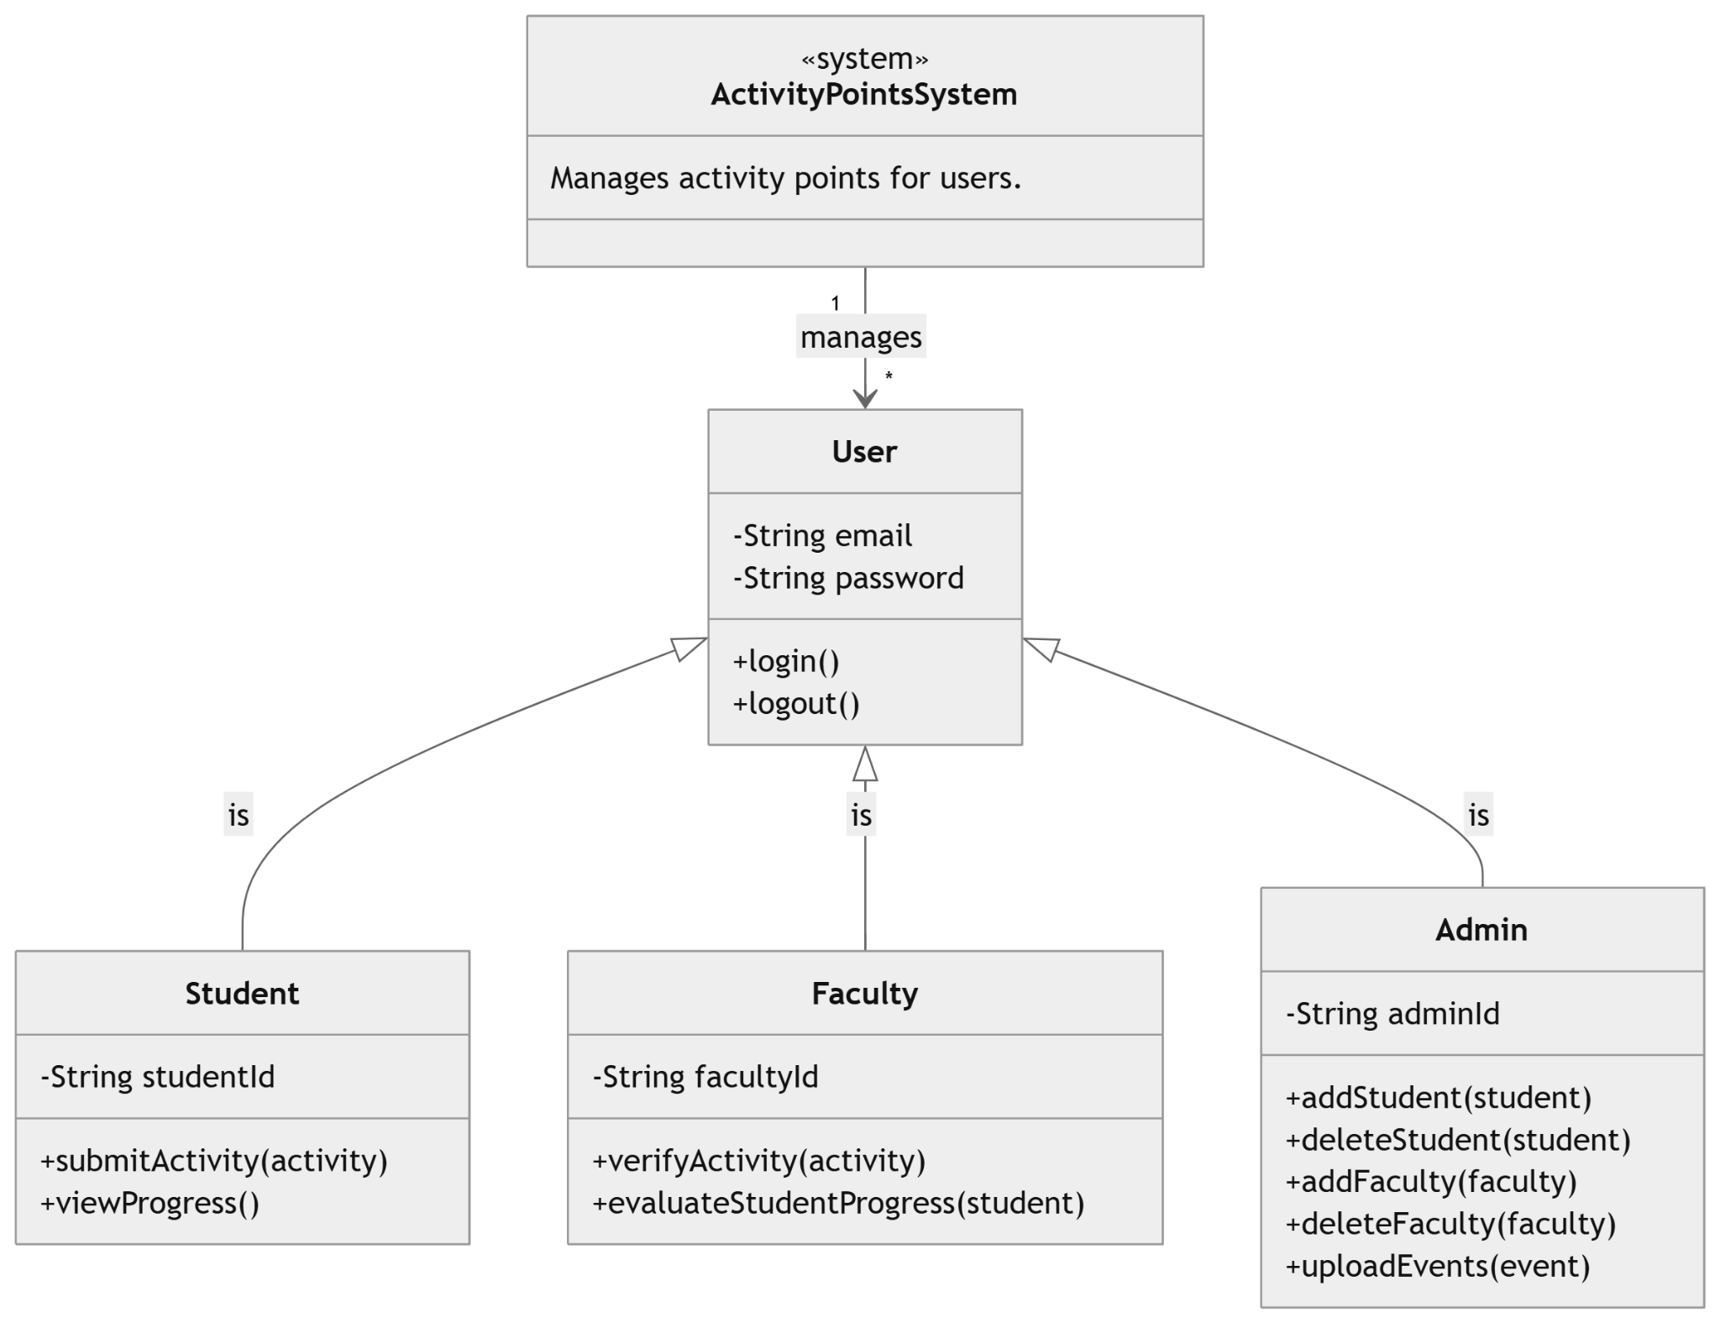
Fig:6.2: Class Diagram

In the above class diagram, the relationship that is the dependence between each one of the classes is sketched out. Additionally, even the operations performed in each and every class is similarly appeared.

6.3 Activity Diagram
An activity diagram visually presents a series of actions or flow of control in a system similar to a flowchart or a data flow diagram. Activity diagrams are often used in business process modeling. They can also describe the steps in a use case diagram. Activities modeled can be sequential and concurrent. In both cases, an activity diagram will have a beginning (an initial state) and an end (a final state).

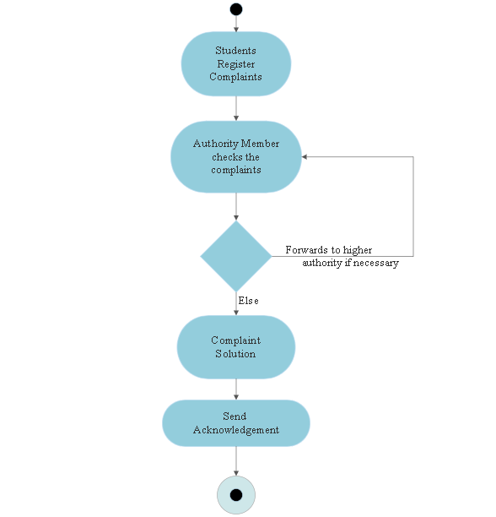
Fig:6.3: Activity Diagram

CHAPTER: 7
IMPLEMENTATION AND METHODOLOGY

APMS: ActiPoints Management System
The primary objective of this study is to manage and keep track of activity points of students. Student engagement and co-curricular participation are crucial aspects of a well-rounded educational experience. However, students often face difficulties in tracking their activity points, ensuring compliance with university guidelines, and maintaining transparency in their progress. The lack of a streamlined system for managing activity points can lead to confusion, delays, and errors in point allocation. To address this issue, we have developed ACTIPoints, a centralized platform that automates activity tracking, ensures accurate point calculations, and provides real-time updates. With ACTIPoints, students can easily register their activities, upload proof documents, and monitor their progress, while administrators can efficiently verify submissions and manage reports.

Now we can get into the various tools and frameworks that we used for the implementation of our project.
- Language: Python
- Frontend: HTML, CSS, JS
- Framework: Django
- Database: MySQL

● Python
Python is a powerful, high-level, interpreted programming language created by Guido van Rossum and first released in 1991. It is widely used for web development, system scripting, data science, automation, and more. One of the key reasons for choosing Python is its simple and readable syntax, which is similar to the English language, making it easier to learn and use. Additionally, Python is platform-independent, meaning it can run seamlessly across different operating systems.
Python supports multiple programming paradigms, including procedural, object-oriented, and functional programming, allowing for flexibility in development. It is known for its quick prototyping capabilities and enables developers to write efficient code with fewer lines compared to other programming languages. Being an open-source language, Python significantly reduces software development costs while offering a vast ecosystem of libraries and frameworks.
Python’s high-level built-in data structures, dynamic typing, and dynamic binding make it ideal for rapid application development. Its extensive standard library supports modules and packages, promoting modularity and code reuse. Furthermore, Python’s interpreter and libraries are available in both source and binary forms for all major platforms, and they can be freely distributed.
One of Python’s standout features is its efficiency in debugging and development. Unlike compiled languages, Python eliminates the need for a compilation step, resulting in a fast edit-test-debug cycle. When an error occurs, Python raises an exception rather than causing a segmentation fault, making debugging more manageable. The built-in debugger allows for inspection of variables, evaluation of expressions, and step-by-step execution of code. Additionally, Python’s introspective capabilities enable developers to analyze and modify the behavior of programs dynamically.
Due to these advantages, Python has gained immense popularity among developers, providing increased productivity, enhanced code maintainability, and a seamless development experience.

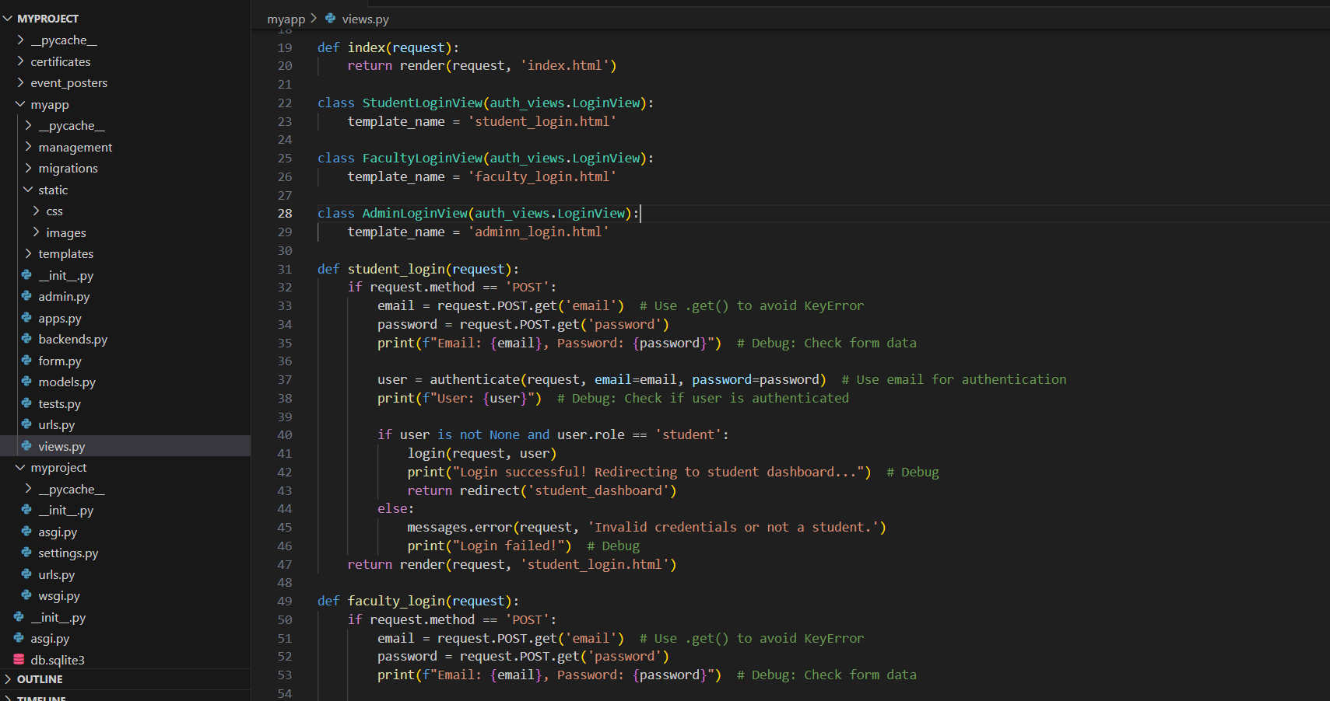

● HTML
HTML, or HyperText Markup Language, is the standard language used to create and structure web content. It defines elements such as headings, paragraphs, images, and links, giving web pages their fundamental structure and meaning. HTML consists of markup symbols or tags enclosed within angle brackets (< >), which instruct web browsers on how to display the content.
Each HTML element serves a specific purpose in formatting and structuring content. Some elements come in pairs—an opening tag to indicate the start of an effect and a closing tag to signify its end. HTML is primarily used to build web pages and web applications, providing the foundation for displaying content on the internet.

Understanding HTML Components
- HyperText: HyperText refers to text that contains links (hyperlinks) to other web pages or resources. When users click on a hypertext link, they are redirected to a different web page or section within the same page. This linking capability enables seamless navigation across the web.
- Markup Language: A markup language is a computer language used to format and structure text in a document. It defines how content is displayed, making it interactive and dynamic. Markup languages allow text to be transformed into images, tables, links, and multimedia elements, enhancing the user experience.
- Web Page: A web page is a digital document created using HTML, which a web browser translates and displays. Each web page has a unique URL (Uniform Resource Locator) that allows users to access it. Web pages can be static (fixed content) or dynamic (interactive and data-driven). Static pages are built using HTML alone, while dynamic pages require additional technologies such as JavaScript, CSS, and server-side scripting languages.

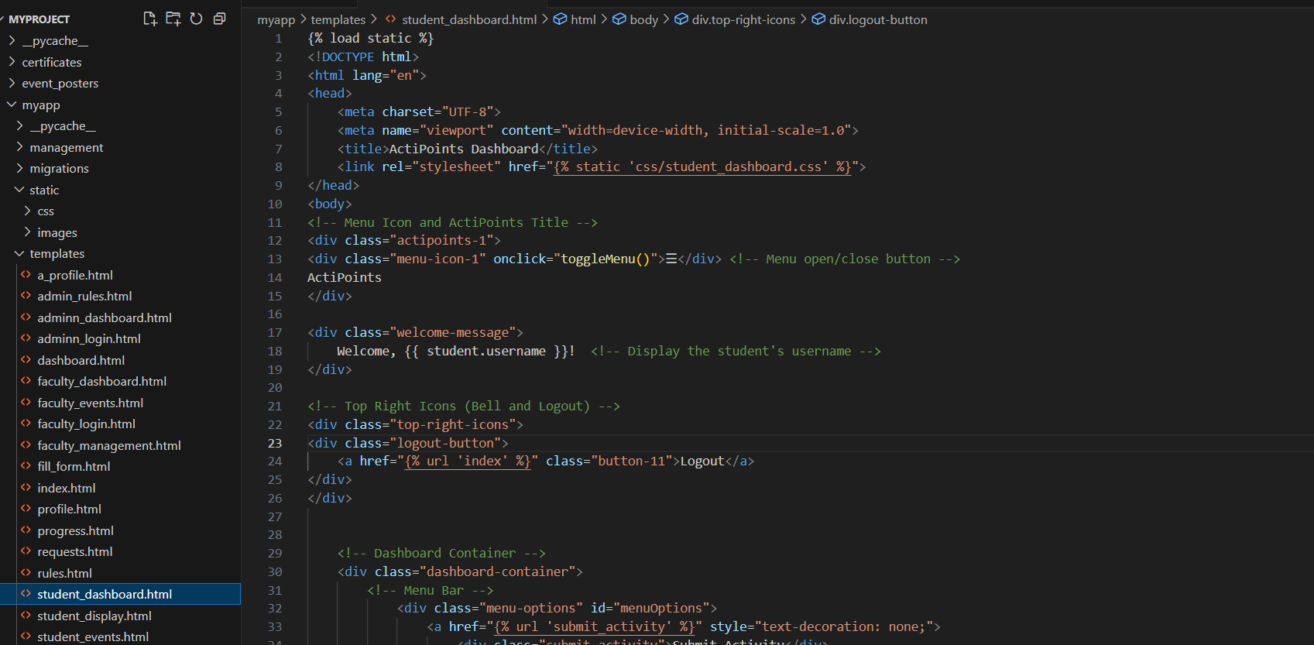

● CSS
CSS, or Cascading Style Sheets, is a styling language used to define the visual presentation of web content. While HTML structures a webpage, CSS enhances its appearance by applying styles such as fonts, colors, layouts, and spacing. It allows web developers to control the look and formatting of documents written in markup languages like HTML.
CSS works alongside HTML and JavaScript to create modern, visually appealing, and interactive web applications. It can also be applied to various XML-based documents, including plain XML, SVG (Scalable Vector Graphics), and XUL (XML User Interface Language).

Key Benefits of Using CSS
- Solves a Major Problem
Before CSS, formatting elements such as fonts, colors, backgrounds, and borders had to be manually coded into every individual webpage, making website development time-consuming and inefficient. CSS eliminates redundancy by allowing global styling rules, ensuring consistency across all pages. It was introduced as a W3C (World Wide Web Consortium) recommendation to solve these challenges.
- Saves Time and Improves Efficiency
CSS enables developers to store style definitions in external stylesheets, meaning changes can be applied across an entire website by modifying just one CSS file. This significantly reduces development time and maintenance efforts.
- Provides Extensive Styling Capabilities
CSS offers more styling attributes than plain HTML, allowing for precise control over webpage elements. Developers can create responsive designs, animations, transitions, and dynamic layouts, enhancing the overall user experience.
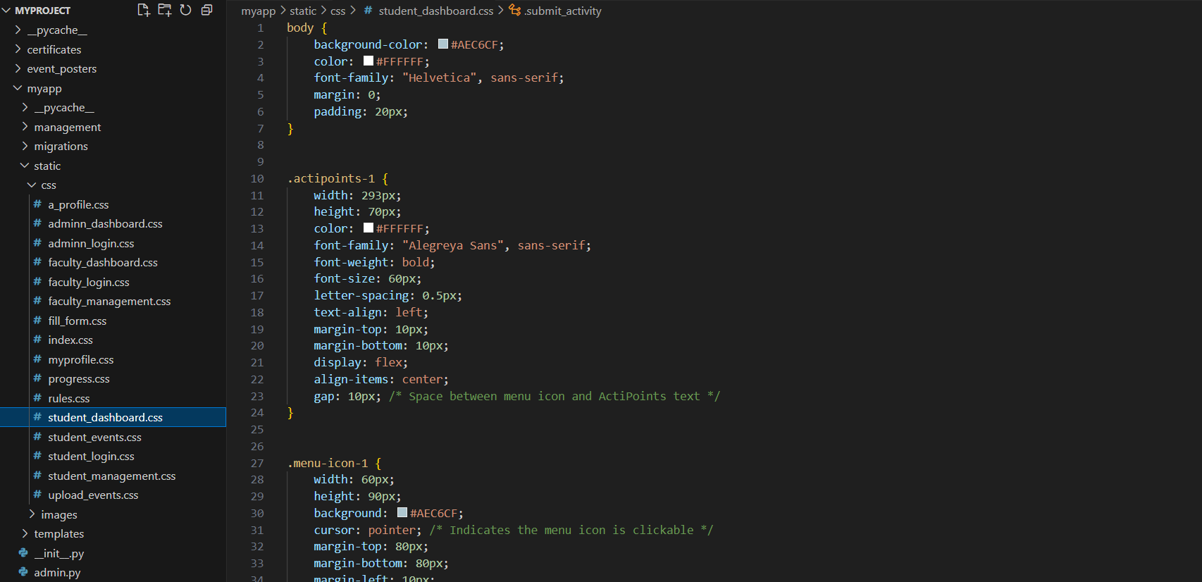

JavaScript
JavaScript (JS) is a dynamic, high-level programming language widely used for creating interactive and dynamic web applications. It runs in the browser and enables client-side functionality, making web pages responsive and user-friendly.

Key Features of JavaScript
- Client-Side Execution
JavaScript runs directly in the user's web browser, reducing server load and improving application responsiveness.
- Interactivity and Dynamic Content
JavaScript enables interactive elements such as form validation, animations, dropdowns, and real-time updates, enhancing the user experience.
- Cross-Browser Compatibility
JavaScript works across all major browsers (Chrome, Firefox, Safari, Edge), ensuring seamless functionality without additional installations.
- Event-Driven Programming
JavaScript responds to user actions (clicks, keystrokes, mouse movements) through event-driven programming, allowing dynamic page updates without reloading.
- Asynchronous Processing
Using AJAX (Asynchronous JavaScript and XML) and Promises, JavaScript can fetch data from servers in the background, enabling smooth, non-blocking experiences.
- Versatility and Integration
JavaScript is used for both frontend and backend development (via frameworks like Node.js), making it highly versatile for full-stack applications.
- Rich Ecosystem and Libraries
JavaScript has an extensive ecosystem, including React, Angular, Vue.js, and thousands of open-source libraries that simplify web development.
- Open Source and Community Support
As an open-source language, JavaScript has one of the largest developer communities, ensuring continuous updates, improvements, and extensive learning resources.
● Django
Django is a high-level Python web framework designed for fast and efficient web application development. It follows a set of standardized paradigms that simplify the creation of complex, database-driven websites. Many well-known platforms, including PBS, Instagram, Disqus, The Washington Times, Bitbucket, and Mozilla, use Django for their web applications.

Key Features of Django
- Rapid Development
Django is built to minimize development time, enabling developers to create web applications quickly and efficiently. It streamlines the implementation phase, reducing time-to-market.
- Security
Django prioritizes security and helps developers avoid common vulnerabilities such as SQL injection, cross-site scripting (XSS), and cross-site request forgery (CSRF). Its built-in user authentication system ensures secure account management.
- Scalability
Django's scalable architecture allows applications to adapt seamlessly from small projects to large-scale enterprise solutions.
- Comprehensive Feature Set
Django includes numerous built-in libraries and modules for handling essential web development tasks, such as user authentication, content management, site maps, and RSS feeds, reducing the need for third-party integrations.
- Versatility
Django is used across various domains, enabling the development of content management systems (CMS), social networking sites, and scientific computing platforms.
- Open Source
As an open-source framework, Django is free to use and can be downloaded from a public repository, reducing development costs.
- Strong Community Support
Django has a large and active community, providing extensive documentation, forums, and channels for collaboration and troubleshooting.

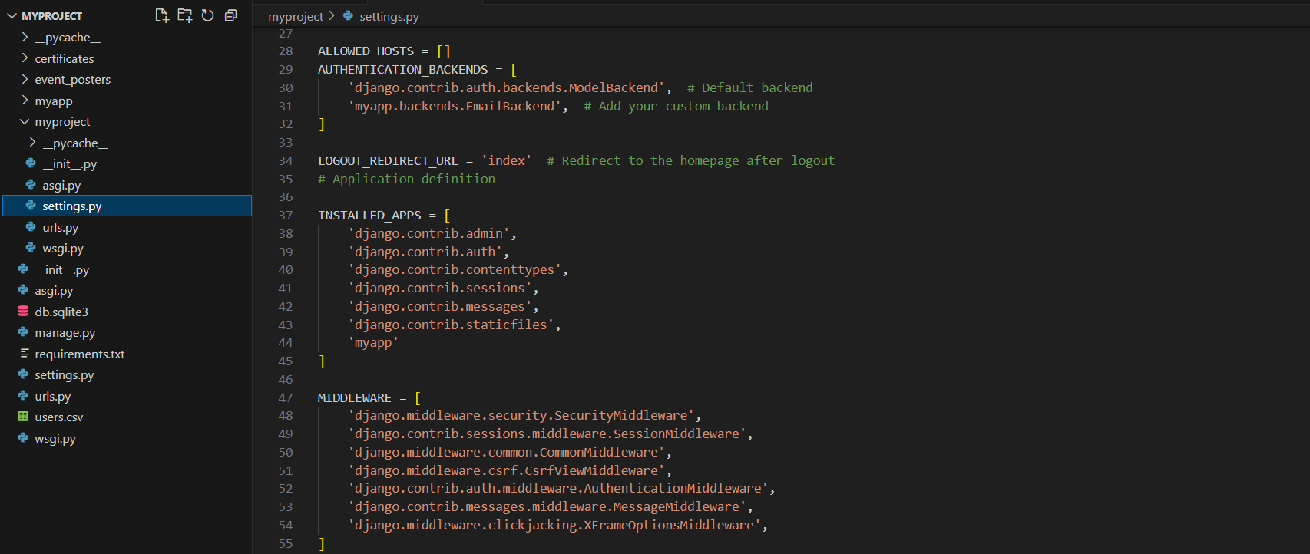

SQLite
SQLite is a self-contained, serverless, and lightweight relational database management system (RDBMS). Unlike traditional databases, it operates without a separate server process, making it ideal for embedded systems, mobile applications, and small to medium-sized web applications.

Key Features of SQLite
- Lightweight and Efficient
SQLite has a small footprint (less than 1MB in size) and requires minimal system resources, making it highly efficient for applications with limited storage and processing power.
- Serverless Architecture
Unlike traditional databases, SQLite does not require a separate server process, as it reads and writes data directly from a file, simplifying deployment and reducing maintenance costs.
- Zero Configuration
SQLite requires no installation or setup, making it easy to use and integrate into various applications without additional configuration.
- Cross-Platform Compatibility
SQLite works seamlessly across different operating systems, including Windows, macOS, Linux, Android, and iOS, ensuring broad application compatibility.
- Atomic Transactions
SQLite supports ACID (Atomicity, Consistency, Isolation, Durability) transactions, ensuring reliable and secure data management.
- Scalability
While primarily designed for lightweight applications, SQLite can handle moderate traffic loads efficiently, making it suitable for mobile apps, IoT devices, and embedded systems.
- Open Source and Free
SQLite is an open-source database, allowing developers to use, modify, and distribute it freely, reducing project costs.

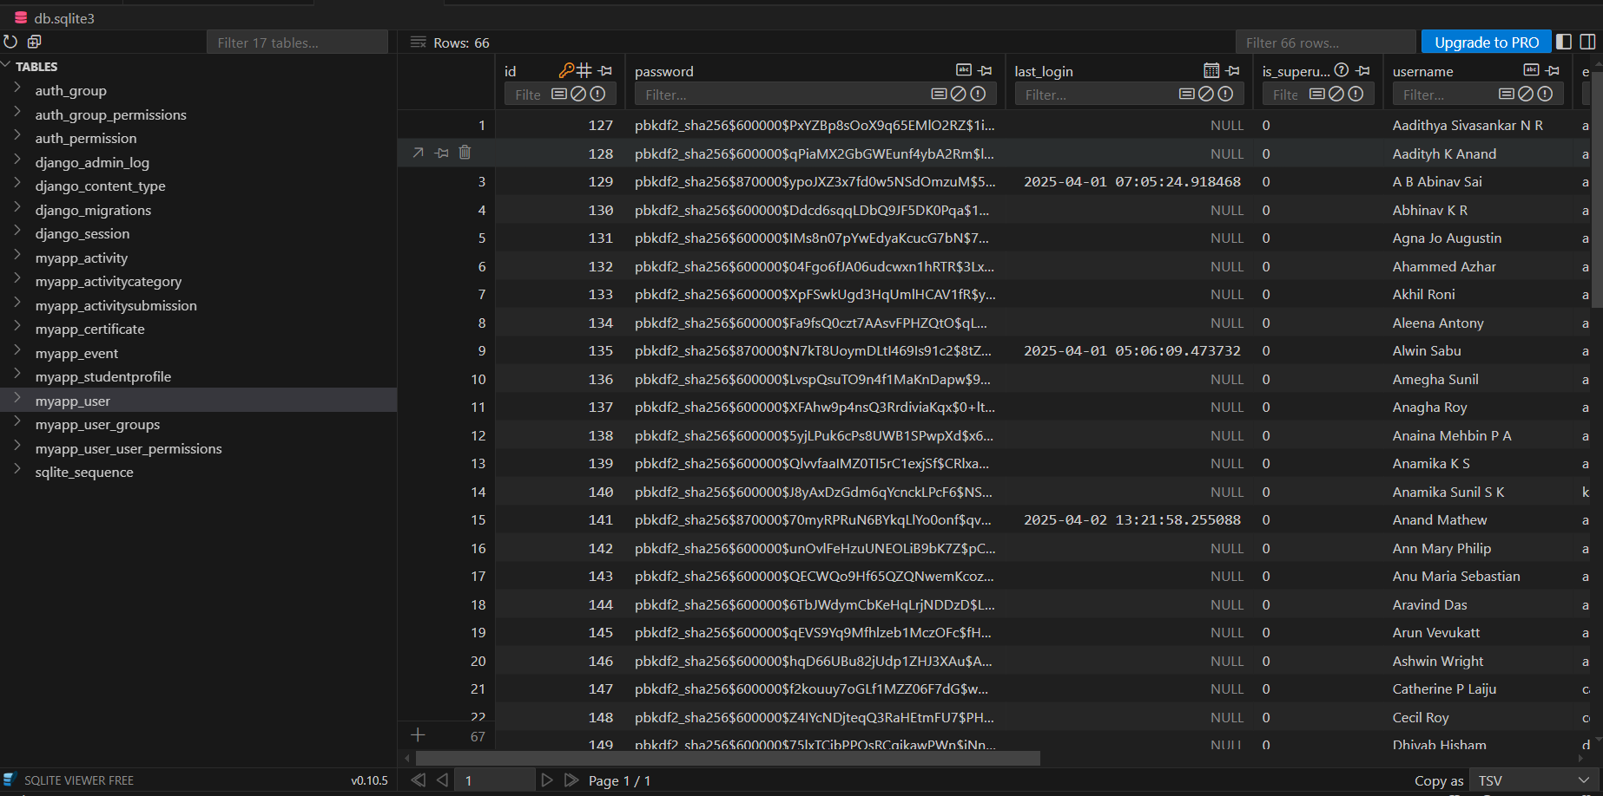

CHAPTER: 8
SYSTEM TESTING

The aim of the system testing process was to identify any defects in the ActiPoints platform. The system was tested with a range of inputs, and various observations were made to ensure that it behaved as expected. ActiPoints underwent two levels of testing:
- Unit Testing
- Integration Testing

UNIT TESTING
Unit testing was conducted for each module separately to verify the correctness of individual components. The testing environment was set up to include all required dependencies, such as necessary database connections and backend logic.

Test for Admin Module
- Testing Admin Login: The admin login form was tested by entering an email and password. If both credentials were correct, the admin dashboard was accessed. If incorrect, the system redirected back to the login page.

- Adding/Deleting Faculty or Student: The admin can add or remove faculty and student accounts. The system was tested to ensure that newly added users could log in and deleted users could no longer access the system.

- Event Management: The admin can upload and manage events. The test ensured that new events appeared in the student dashboard and that modified or deleted events reflected accordingly.
- Profile Management: The admin can update their profile details. The test verified that changes were correctly saved and displayed.

Test for Faculty Module
- Testing Faculty Login: Faculty members must enter valid credentials to access their dashboard. If incorrect, they were redirected back to the login page.
- Viewing Student Progress: Faculty members can track the progress of each student. The test confirmed that student records were correctly retrieved and displayed.
- Approving/Rejecting Activities: Faculty members can approve or reject activity submissions from students. The system was tested to ensure that approvals reflected in the student’s progress and rejections were notified to the student.
- Profile Management: Faculty members can update their profiles. The test checked that modifications were correctly saved and displayed.

Test for Student Module
- Testing Student Login: Students must enter correct credentials to access their dashboard. If incorrect, they were redirected back to the login page.
- Activity Submission: Students can submit activities for approval. The test ensured that submissions were correctly recorded in the database and reflected in the faculty approval queue.
- Viewing Progress: Students can track their progress based on approved activities. The test verified that approved activities correctly contributed to the total points.
- Event Notifications: Students should be able to view upcoming events. The test ensured that all uploaded events were correctly displayed on the student dashboard.
- Profile Management: Students can edit and update their profiles. The test checked that changes were successfully saved.

INTEGRATION TESTING
Integration testing was conducted to verify interactions between different modules. The primary objective was to ensure that no errors occurred when one module interacted with another.
- Admin-Faculty Interaction: Ensured that when the admin added or deleted faculty, the faculty list updated accordingly.
- Faculty-Student Interaction: Verified that when a student submitted an activity, it was correctly received by faculty for approval.
- Admin-Student Interaction: Ensured that when the admin added or deleted a student, the student list reflected the changes.
- Student-Event Management: Checked that when the admin uploaded an event, it was visible to students in real time.
- Database Integrity: Ensured that all user actions (profile updates, submissions, approvals, deletions) correctly reflected in the database without data corruption.
The system testing process confirmed that ActiPoints was functioning as expected, with modules interacting seamlessly and delivering the required functionalities.

CHAPTER: 9
RESULT

Screenshots

- A student has submitted an activity to their respective faculty.
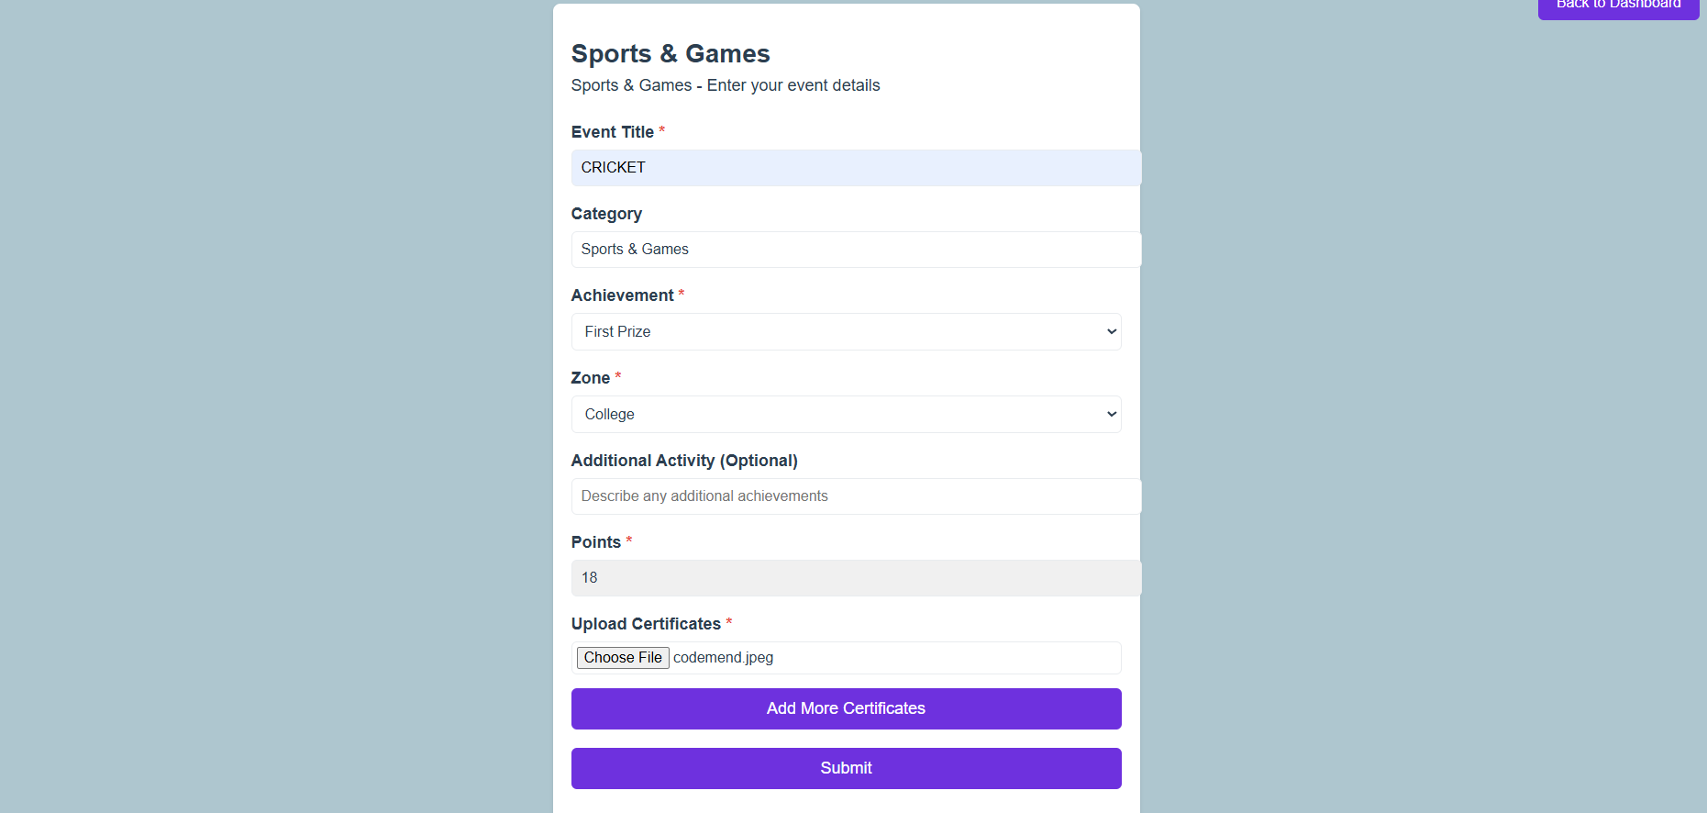
- The faculty will receive the submitted activity in their requests and can verify the activity.
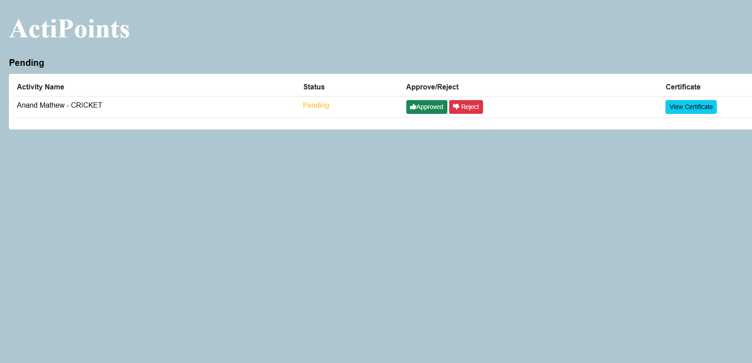
- The submitted activity status and points will be updated in the student’s progress page
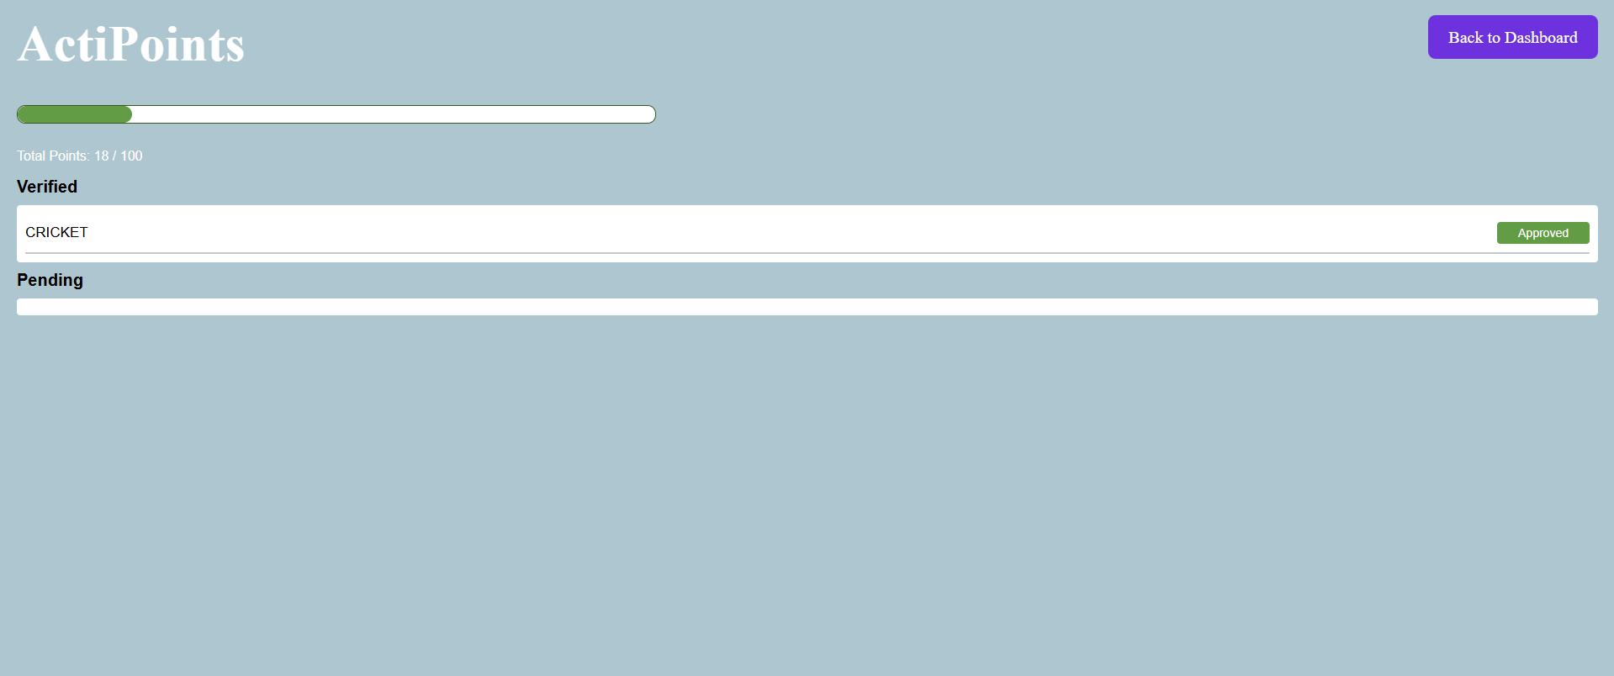

- The faculty can evaluate and view each student’s progress page.
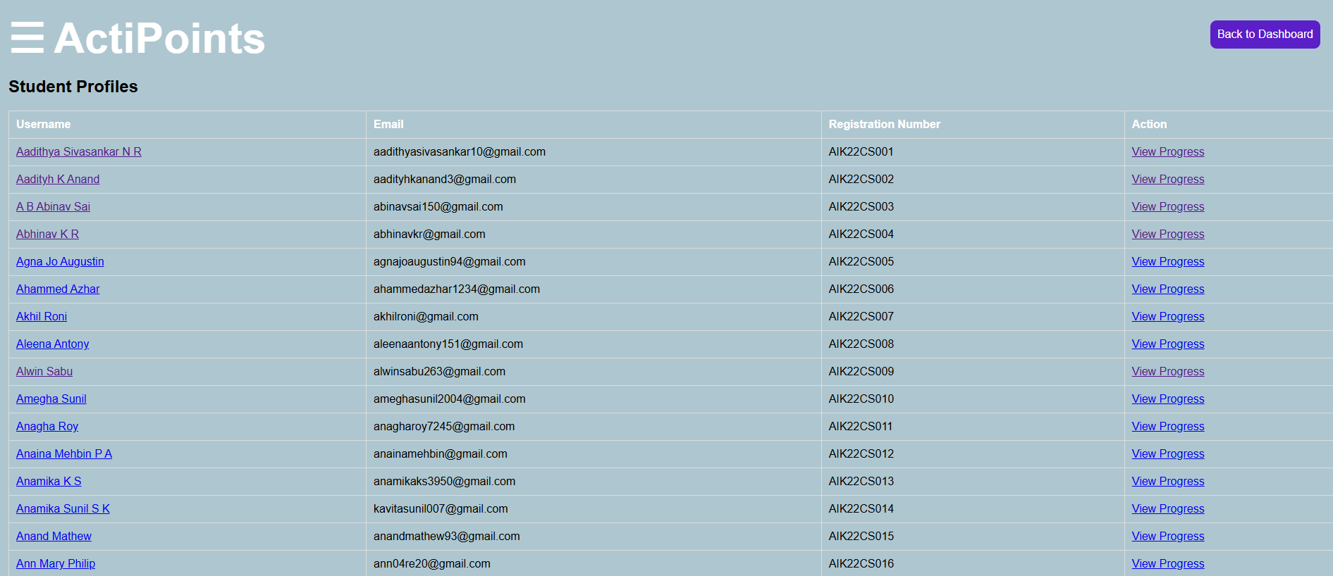

- Admins can add/delete students and faculty.
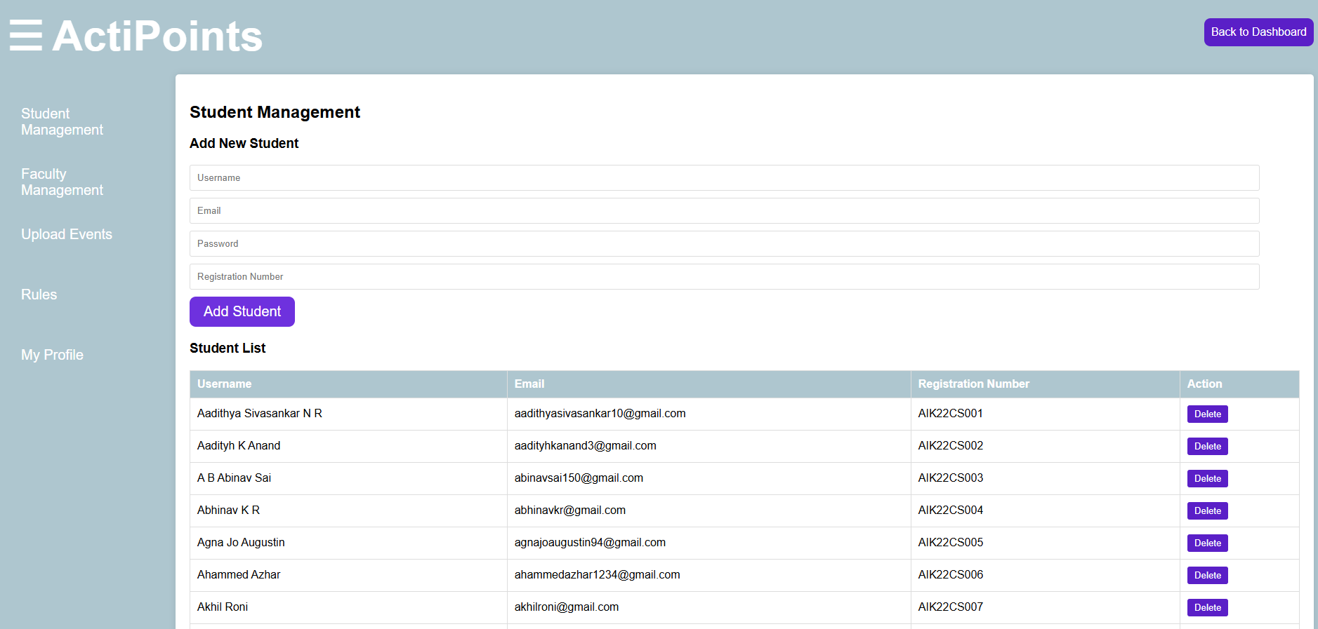

- Students can stay updated about upcoming events.


CHAPTER: 10
CONCLUSION

The project “ActiPoints” is designed to streamline the process of tracking and managing student activities, ensuring a structured and efficient system for maintaining records. By automating the submission, verification, and tracking of student activities, the platform eliminates the challenges of manual record-keeping while providing a transparent and accessible system for students, faculty, and administrators. The centralized database ensures secure data management, making it easy to update and retrieve records as needed.
With features like real-time progress tracking, faculty approvals, and event notifications, ActiPoints enhances student engagement and encourages active participation in extracurricular activities. The integration of a user-friendly interface ensures seamless interaction for students, faculty, and administrators alike.
"Ultimately, ActiPoints emerges as an effective, efficient, and reliable platform for managing student activity points, fostering a more organized and engaging academic environment."

CHAPTER: 11
FUTURE SCOPE

ActiPoints system currently functions as a web-based platform for tracking and managing student activity points efficiently. To enhance its capabilities and cater to broader requirements, the following future improvements are suggested:
- A mobile application can be developed to increase accessibility and convenience, allowing students to submit activity details, upload supporting documents, and track their points on the go. The mobile app could also include features like push notifications for reminders and real-time updates.
- Integration with other university systems, such as student portals or attendance tracking, can further streamline the verification process and reduce faculty workload.
- An AI-driven verification system can be introduced to automate certificate validation, improving accuracy and reducing manual intervention.
- The platform can be extended beyond students to include faculty and non-teaching staff, enabling a university-wide activity tracking and reward system.
- With sufficient enhancements, ActiPoints can be adapted for other institutions, providing a scalable solution for managing extracurricular achievements across multiple universities

REFERENCES

[1] Automated Student Activity Point Management System (2022): Rajesh Kumar, Sneha Verma, and Arjun Iyer.
[2] Web-Based Extracurricular Activity Tracking System (2021): Priya Sharma, Vikram Nair, and Rohan Desai.
[3]https://www.researchgate.net/publication/350987654_Student_Activity_Tracking_and_Point_Management_System
[4] Python Django 2023 - Full-Stack Web Development by Udemy.
[5] Django 4 By Example: Build Robust and Scalable Web Applications (Antonio Melé).

