RAG-Augmented Multi-Agent LLM Framework for Explainable Software Vulnerability Detection Using CWE Knowledge Bases
Richa Verma (25MCSS02) Advisor: Dr. Akshay Pandey
A small book of CWE facts
Where this fits
We already have 12 short Java files and a pattern checker that matches them. That checker can raise an alarm. It cannot yet say the official name of the weakness or how to fix it.
This note describes the book we store those facts in. It does not change the detection score.
What we did
CWE pages are published by MITRE. We do not copy the whole catalog. We keep the pages we need for the six weaknesses, plus some close neighbors, so a near miss can still be named.
Each stored page has an id, a name, a short description, a longer description when MITRE provides one, links to parent and child weaknesses, and suggested fixes.
The tool can look up one id, search by words such as "cross site scripting", and list neighbors. The pattern checker is not allowed to invent this text. If the answer names a CWE, that name has to come from this book.
Take CWE-89 as the example in the picture. The page says SQL injection. It says what goes wrong when user text is joined into a query. It also points at related pages and at a safer style of query.
A parent weakness is a broader group. A child weakness is a more specific case. We keep both so the explanation can stay honest when the code is close but not exact.
Picture
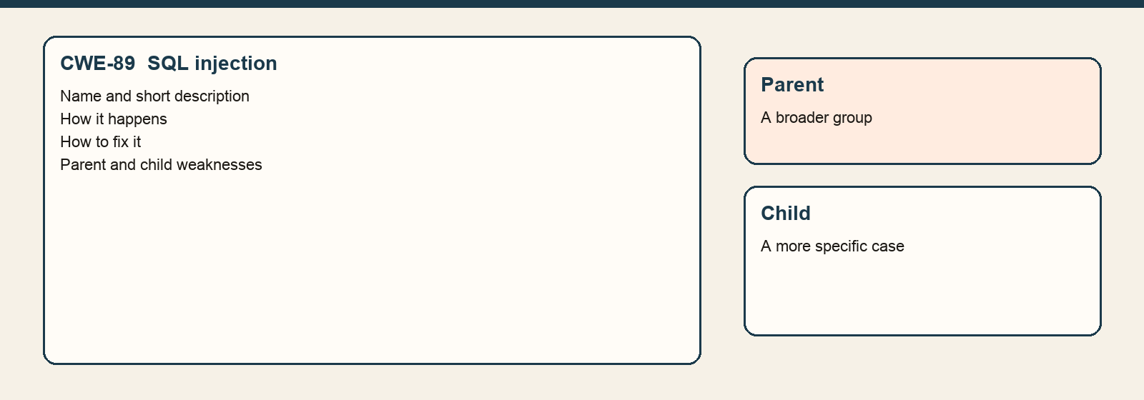
One stored page, CWE-89, and the kind of related pages we keep beside it.
The numbers
On each page | Why we keep it
Id and name | So the answer uses the official name.
Description | So the note can say what the weakness is.
Parents and children | So a close match can still be explained.
Fixes | So the answer can suggest a repair, not an attack.
This book is a subset. The full CWE list is much larger. We record that limit instead of pretending the book is complete.
Closing
The book can be queried by a person. The Java file does not search it by itself yet.
The next piece of work is to turn the risky part of a Java file into a question and find the best CWE pages for that question.
What we are not saying
Storing the book does not make detection better. The score on the 12 practice files is unchanged.

