RAG-Augmented Multi-Agent LLM Framework for Explainable Software Vulnerability Detection Using CWE Knowledge Bases
Richa Verma (25MCSS02) Advisor: Dr. Akshay Pandey
One shape for every answer
Where this fits
We can mark risky lines, and we can search the CWE book. What was missing was a single shape for the written answer. Without that, two runs cannot be compared.
This note describes that form. It does not add a new detection score.
What we did
Every answer must fill the same fields. If a required field is missing, or if the text is not valid JSON, the answer is rejected.
The decision is one of three words: unsafe, safe, or not sure. Not sure is allowed. We would rather see an honest abstention than a guessed yes.
The CWE field must be an id and a name. The lines field must name the file and the line numbers, counted from 1, the same way an editor counts. The other fields are a short cause, a plain explanation, and a fix.
There is no field for attack steps. The tool is not asked to write an exploit or a payload.
We store two sample answers, one unsafe and one safe, and one broken sample. A small check accepts the good samples and rejects the broken one. That check does not need a live model.
The pattern checker still only marks lines. The form is the contract for whoever writes the final note, whether that writer is a template or a model.
Picture
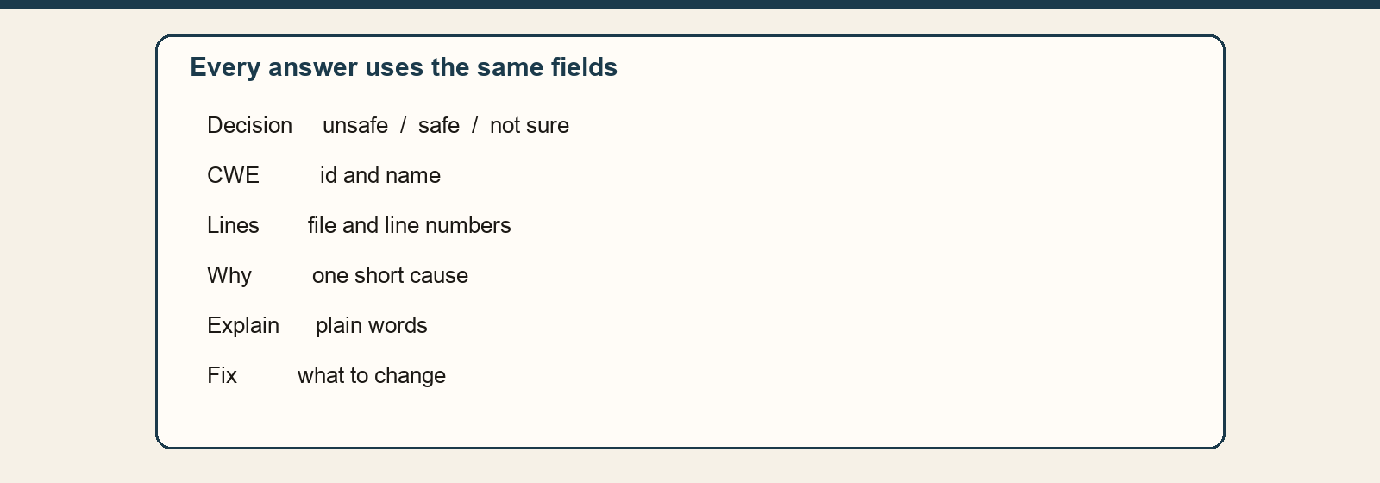
Every run has to fill these fields. A missing field makes the answer invalid.
The numbers
Field | What it means
Decision | Unsafe, safe, or not sure.
CWE | Id and name from the book.
Lines | File and line numbers, starting at 1.
Cause and explanation | Why the lines are risky, in plain words.
Fix | What a programmer should change.
The form is strict on purpose. Extra fields are not allowed, so the answer cannot hide an exploit in an extra box.
Closing
The pieces now exist separately: files, a checker, a book, search, and a form.
The next piece of work is to run them in one order, still without calling a paid model.
What we are not saying
A valid form is not a correct decision. The checker can still be wrong about whether the code is unsafe.

