RAG-Augmented Multi-Agent LLM Framework for Explainable Software Vulnerability Detection Using CWE Knowledge Bases
Richa Verma (25MCSS02) Advisor: Dr. Akshay Pandey
Six public Java test sets
Where this fits
Our own 24 hard files showed that a live model can recover cases the pattern checker misses. Those files were written by us, so they are not enough.
This note reports the same simple checker on six public Java sets that other people published. The live-model numbers on these sets are not in the table, and the reason is below.
What we did
Juliet is a large teaching suite from NIST. OWASP Benchmark is a scored Java suite. Securibench Micro is a small set of servlet examples. Find Security Bugs contributes detector test code. Vul4J and the CVEfixes slice are closer to real project bugs, but we only keep the Java files that match the weaknesses we study.
We ran the pattern checker on every file we ingested. F1 is again the combined score of false alarms and missed bugs. The best F1 here is 0.435, on 79 Find Security Bugs files. The lowest is 0.072, on 119 Securibench files. Juliet is the largest set, 20,728 files, and its F1 is 0.316.
A larger set is not an easier set. The checker is a list of text patterns. It is not CodeQL, and it is not a commercial scanner that follows data through the program.
We did run the live model earlier on small samples of these sets. Those scores are withdrawn. The questions still contained giveaway words, such as a method named bad or a comment that said the code was flawed. A fair test must not show the answer inside the question.
The public sets also do not all contain every weakness we study. When a set has no files for a weakness, we say "not present". We do not rename a nearby weakness to fill the gap.
Picture
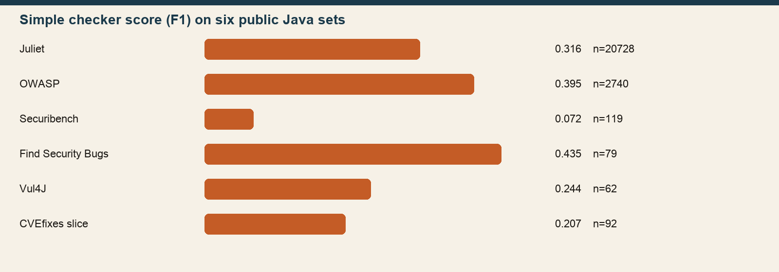
Each bar is the simple checker's F1. Longer is better. None of these bars is a model score.
The numbers
Test set | Files | Simple checker F1
Juliet Java | 20728 | 0.316
OWASP Benchmark | 2740 | 0.395
Securibench Micro | 119 | 0.072
Find Security Bugs | 79 | 0.435
Vul4J | 62 | 0.244
CVEfixes Java slice | 92 | 0.207
Read each row on its own. Do not average them into one project score. Do not mix them with the 0.923 score on our 24 files.
Closing
The pattern checker is weak on public code. That is a real result, and it is the fair baseline.
The next measurement is a live-model score on Juliet after the giveaway words are hidden. We will use matched unsafe and safe files, not a single mixed file.
What we are not saying
Do not quote the withdrawn model scores. The simple checker is not CodeQL and not a commercial product.

