Progress report 1 of 10
RAG-Augmented Multi-Agent LLM Framework for Explainable Software Vulnerability Detection Using CWE Knowledge Bases
Richa Verma (25MCSS02) Advisor: Dr. Akshay Pandey
The question
This is the first report. It only says what we want to build.
What we did
We want a tool that reads a small piece of Java and explains the risk in plain words.
The explanation should name a weakness from CWE. CWE is a public list of common software mistakes.
A useful answer says four things: unsafe or safe, which weakness, which lines, and how to fix it.
We are not trying to beat every scanner. We want an answer a person can check.
Picture
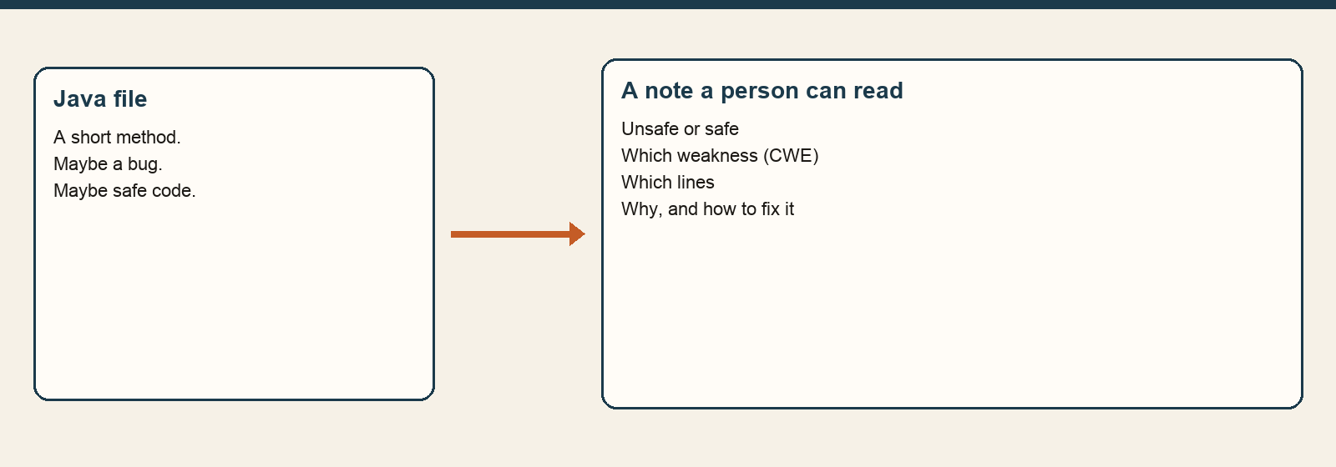
Numbers for this step only
Weakness | Plain meaning
CWE-89 | SQL injection. User text is stuck into a database query.
CWE-79 | Cross-site scripting. User text is shown as part of a web page.
CWE-22 | A file path can be steered outside the intended folder.
CWE-502 | Loading a saved object can run attacker-controlled data.
CWE-798 | A password is written directly in the code.
CWE-327 | The code uses weak encryption or a weak hash.
What is next
Next we will make a tiny set of Java examples, half unsafe and half safe.
What this report does not claim
This report has no test scores. We have not measured anything yet.

