RAG-Augmented Multi-Agent LLM Framework for Explainable Software Vulnerability Detection Using CWE Knowledge Bases
Richa Verma (25MCSS02) Advisor: Dr. Akshay Pandey
Finding the right CWE page
Where this fits
We have short Java examples, a pattern checker, and a small book of CWE facts. This note is about search: given some Java, which book page should we show.
Search is not the same as detection. A good search finds the right weakness page. It does not, by itself, decide that the code is unsafe.
What we did
We wrote 18 labeled questions from the practice files. Each question has a known right CWE. We then ask three searches to rank the book.
Word match (TF-IDF) looks for the same words in the question and on the page. It does not know that "query built by joining strings" means SQL injection unless those words overlap.
Meaning match uses a small model called MiniLM. It can rank a page higher when the idea is similar, even if the words are not identical. If that model cannot be loaded, we fall back to word match and we write that down.
The mix uses both rankings, plus two extra hints: the CWE id suggested by the pattern checker, and the parent or child pages of a hit. The mix is called hybrid search.
R@1 means the right page was the first result. MiniLM was first on 17 of the 18 questions, which is 0.944. Word match was first on about 14 of 18, which is 0.778. On this small set the mix matched MiniLM. It did not beat it.
A concrete example
The question is the idea "a SQL string is built by sticking text together". Word match may miss this if the CWE page says "injection" and the question says "sticking text". The meaning model can still rank CWE-89 first.
If the pattern checker has already hinted CWE-89, the mix gives that hint a vote as well. Related pages, such as a child of CWE-89, can appear just below the best hit. They are context, not a second decision.
If MiniLM cannot be downloaded, the same question is answered by word match only, and the result file says so. We do not quietly pretend the meaning model ran.
Picture
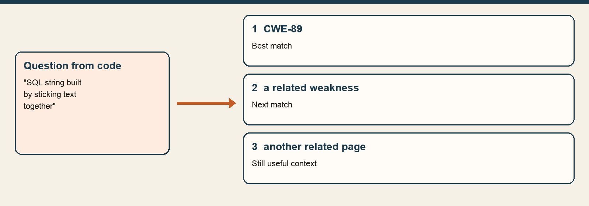
A short question from the code is ranked against the book. The first hit is the page we would show.
The numbers
Search | Right page first (R@1) | Questions
Word match (TF-IDF) | 0.778 | 18
Meaning match (MiniLM) | 0.944 | 18
Mix of both | 0.944 | 18
R@1 is not a detection score. It only says whether the correct CWE page was ranked first. These 18 questions come from our own files.
Closing
We can now retrieve a page. We still do not have one fixed shape for the written answer, so two runs could look different.
The next piece of work is a single answer form: decision, CWE, lines, cause, explanation, and fix.
What we are not saying
This is not a public benchmark. A high R@1 here does not mean the tool finds bugs in Juliet or in real projects.

