RAG-Augmented Multi-Agent LLM Framework for Explainable Software Vulnerability Detection Using CWE Knowledge Bases
Richa Verma (25MCSS02) Advisor: Dr. Akshay Pandey
How to run the tool, and what is still open
Where this fits
The tool can explain a Java method with a CWE page, and we have scores: a perfect score only on 12 practice files, a 0.923 score on 24 hard files we wrote, modest pattern-checker scores on six public sets, and a Juliet pair score of 9 out of 17.
This note is about using that tool without memorizing commands, and about the tests that are still not done. It does not add a new score.
What we did
A web page on this computer lists the test sets, the settings, and a token budget. Starting a job runs the same code as the command line. The page shows the exact command before the job starts, so the run can be repeated later.
The page listens only on this machine, at 127.0.0.1. It has no accounts, because it is not open to a network. A missing model key stops a live run and says which setting is missing. It does not invent a score. An offline setting still runs, using the template instead of the live model.
The six public Java sets are stored in the project, with a note of where they came from and which license applies. A fresh copy of the project can score the simple checker without downloading them again.
When code is pushed, GitHub runs the unit tests. Those tests do not call Groq. They check the form, the book, the sanitizer, and the scoring math.
One job runs at a time. The free model key has a daily token cap, and two big runs would spend it twice.
A concrete example
Open the page on this computer. Choose the seed pipeline, the test split, and the offline setting. The page prints the command it will run. The result is four practice files, scored by the template, with no call to Groq.
Choose a live Juliet run without a key and the page stops with the same message as the command line. It does not fill in a score.
The unfinished Juliet file, the search-off Juliet run, the live Vul4J slices, a second model, and the human explanation labels are still open. They need a key, tokens, or a person. This note does not close them.
Picture
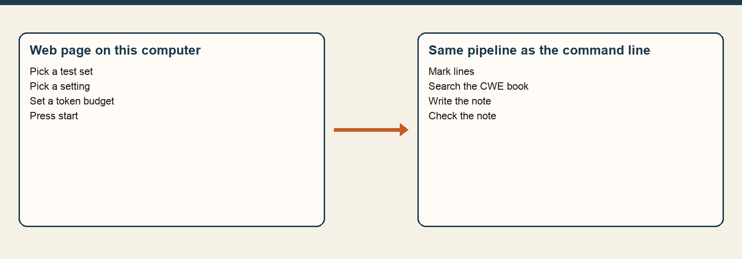
The page is only a front door. The steps behind it are the same pipeline: mark lines, search, write, check.
The numbers
Still open | Why it matters | Status
Finish the Juliet file cut off by the token limit | The pair score is missing one file. | Not finished
Same Juliet pairs with search turned off | We cannot yet say whether the book helps. | Not run
Sliced real bugs from Vul4J with the live model | Public pattern-checker scores are not a model result. | Not run
A second model | We only have one live model so far. | Not run
A person marking explanations | Detection scores do not say the explanation was good. | Labels empty
Empty explanation labels stay empty. We will not fill them in to make the table look finished, and we have no agreement score between two people.
Closing
Anyone with the project can open the page, pick an offline run, and see a note. A live run still needs a Groq key and the daily token budget.
The honest summary is unchanged by this screen: the model helps on our hard examples, the pattern checker is weak on public code, and the Juliet pair score is 9 of 17 with a wide range.
What we are not saying
A screen is not a new scientific result. We still do not say that CWE search improves Juliet detection.

