Chapter 1: Survey of WICED Bluetooth

Time 1 Hour

After completing Chapter 1 (this chapter) you will understand a top-level view of all of the components of the WICED ecosystem including the chips, modules, software, documentation, support infrastructure and development kits. You will have WICED Studio installed and working on your computer and will understand how to program an existing project into a kit.

1.1 Survey of WICED Studio SDK 2

1.1.1 First Look 2

1.1.2 Project Explorer 4

1.2 Tour of Documentation 7

1.1.3 In the SDK Workspace 7

1.1.4 On the Web 7

1.3 Reporting Issues 9

1.4 Tour of WICED SDK Structure 9

1.5 Tour of Bluetooth 10

1.6 Tour of Chips 10

1.7 Tour of Partners 11

1.8 Tour of Development Kits 12

1.1.5 Cypress CYW920719Q40EVB-01 12

1.1.6 Cypress CYW920706WCDEVAL 12

1.9 Exercise(s) 13

Exercise - 1.1 Create a forum account 13

Exercise - 1.2 Open the documentation 13

# Survey of WICED Studio SDK

## First Look

The WICED software tool is called “WICED Studio” and it is based on Eclipse.

WICED Studio is installed, by default, in *C:/Users/<UserName>/AppData/Local/WICED.* As a part of installing WICED Studio, an SDK Workspace is created, by default, in *C:/Users/<UserName>/My Documents/WICED-Studio-<version>/20719-B1_Bluetooth*. The SDK Workspace is where you will create your projects. Note that a new set of SDK Workspace files is created for each version of WICED Studio that you install. If you install a newer version of WICED Studio, your projects from the previous version will still be available in the SDK Workspace location associated with that previous version of WICED Studio. You must copy them over manually if you want to access them in the new version.

Once installed, WICED Studio will show up in Windows under Start > All Programs > Cypress > WICED-Studio. The first time you open WICED Studio, you will be asked for which platform you want to use. We will use *20719-B1_Bluetooth* for this class, but if you used a different selection don’t worry – you can change it easily from inside the tool using the dropdown menu.

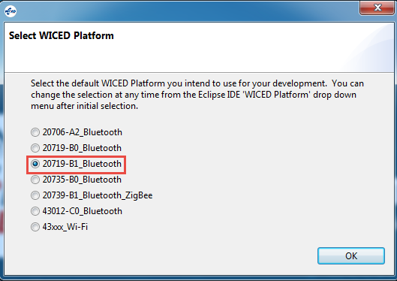

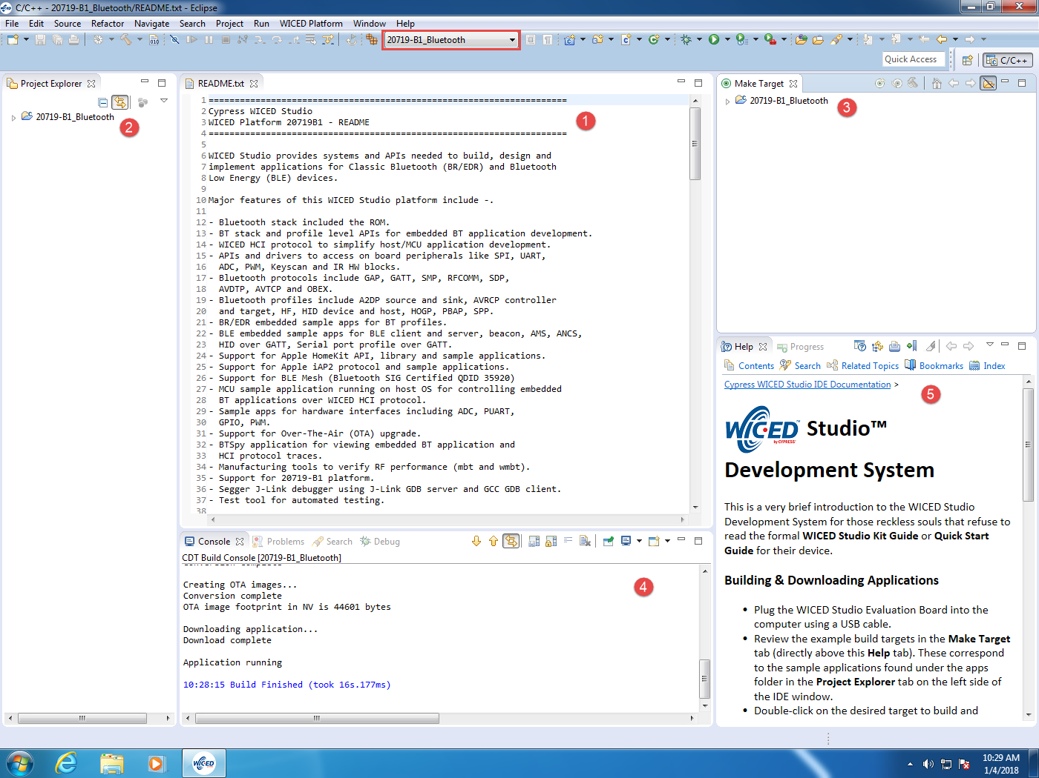

The major windows are:

1. File Editor
2. Project Explorer
3. Make Target
4. Console
5. Help

If you close a window unintentionally, you can restore the original set of windows using the following procedure:

1. Select Window > Reset Perspective
   1. Note: the perspective shown is *C/C++.* You can open other perspectives by clicking the icon near the top right corner of the screen or by using Window > Open perspective.
2. Select Window > Show View > Make Target
3. Select Window > Show View > Other… > Help > Help
4. Drag window edges or window tabs around as desired.

## Project Explorer

If you expand 20719-B1_Bluetooth from the Project Explorer window you will see the following:

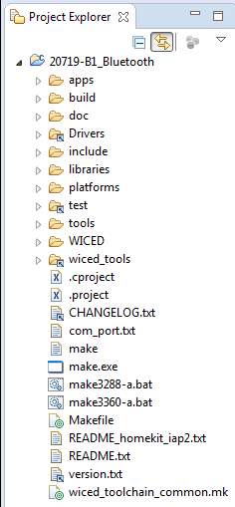

The README.txt file provides basic information about the SDK. This file is open by default in the editor window when the SDK is first opened. The file version.txt contains details of the version of WICED Studio that you have open. Other folders of interest in the Project Explorer are:

### Apps

The *apps* folder is where all the example projects reside as well as where you will put your own projects. The SDK Workspace includes a wealth of example projects. These are broken into categories by folder name. A few of the useful ones are:

1. *snip*: Short examples that typically demonstrate one feature. For example:
   1. *snip/hal/gpio* demonstrates GPIO use by reading buttons and blinking LEDs.
   2. *snip/ble/mybeacon* demonstrates a beacon that sends vendor specific advertising data.
2. *demo*: More complex and complete demonstrations. For example:
   1. *demo/hello_sensor* demonstrates a BLE application with custom profiles implemented. A client peer application for Android, iOS, and Windows is also provided in the project.

### Doc

The doc folder contains the documentation for the SDK Workspace. Of particular interest is the API.html file which documents all of the WICED API functions. It is usually easier to use that file if you open it in a web browser of your choice rather than from inside WICED Studio. You can do this from WICED Studio by right clicking on API.html and choosing “Open With > System Editor”. Depending on your web browser and settings, you may have to tell it to allow ActiveX controls to see the menus.

The first window you will see when you open the API.html file is shown below. You can enter search strings in the box in the upper-right corner. The list will filter dynamically as you type. For example, if you enter “wiced_hal_gpio” you will see a list of all WICED APIs that are used for controlling IOs.

Note: sometimes the search feature stops working. If this happens, close the browser page and reopen it.

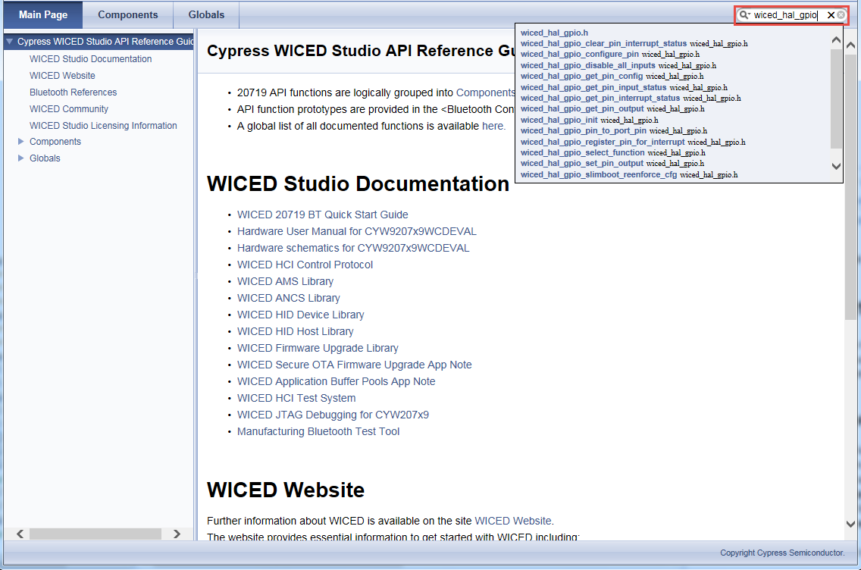

### Platforms

The platforms folder contains information on different kits (i.e. hardware platforms). These files are necessary in order to program a given project into specific hardware. In our case, the kit we are using is called CYW920719Q40EVB_01. That kit has a platform folder, but since we are also using a shield attached to it, we will use a custom set of platform files that also includes the peripherals on the shield. You will have to copy over the custom platform files before using the shield and kit (this will be the first exercise in Chapter 2). You can even create platform files for your own custom hardware that you design. We’ll discuss the platforms folder in more detail in Chapter 2.

### Libraries

The libraries folder contains various sets of library function files. For example, there are libraries for working with file systems (in the filesystems folder), for using U8G graphics displays (in the graphics folder), and for reading JSON (in the utilities folder). We will discuss the libraries folder in more detail in Chapter 4.

### Include

TBD

### Tools

TBD

### WICED

TBD

### Wiced_tools

TBD

# Tour of Documentation

## In the SDK Workspace

As discussed previously, the doc folder in the SDK Workspace contains various documents. The most important of these is the API guide but the folder also contains other useful documents such as debugging information, test system information, OTA update procedures, etc. The list of files in the doc directory looks like this:

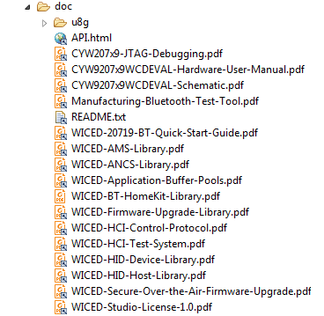

Each of the files in the doc folder can be accessed either from within the WICED Studio (the Project Explorer pane) or from Windows Explorer.

## On the Web

Navigating to “[www.cypress.com](http://www.cypress.com) > Design Support > Community” will take you to the following site (the direct link is <https://community.cypress.com/welcome>):

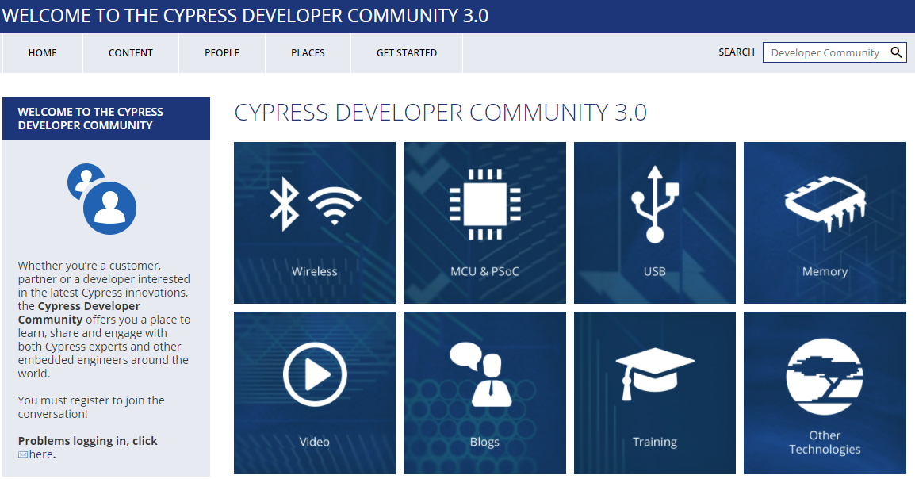

Clicking on the Wireless icon and then the WICED Studio Bluetooth icon will take you to the community page as shown below. From this page, you can download WICED Studio, purchase kits, search for answers, ask questions, etc.

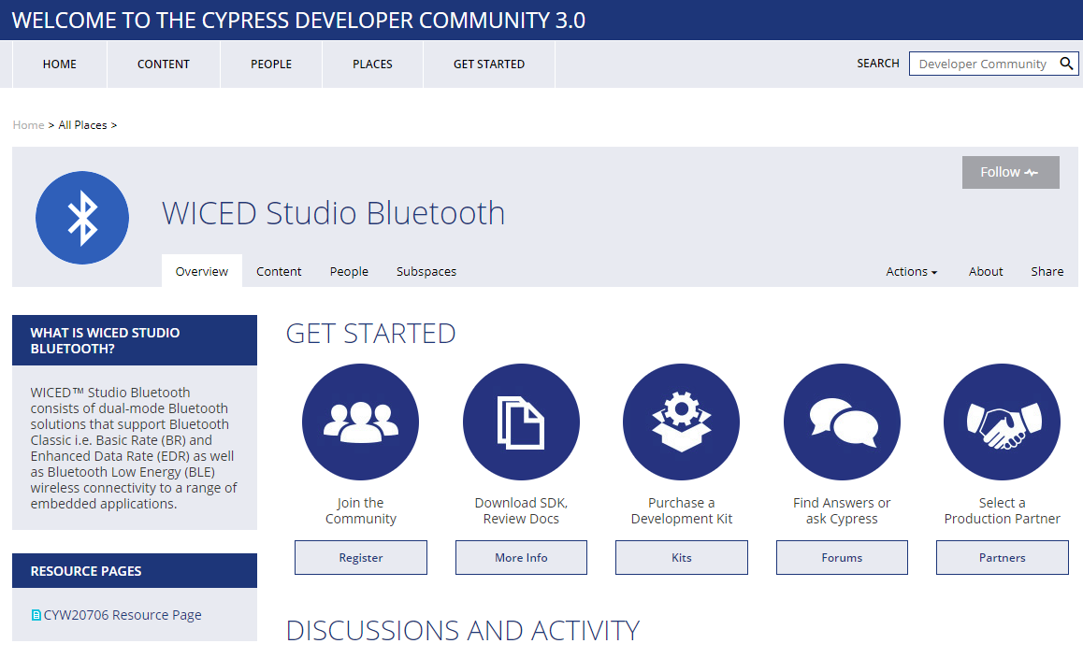

# Reporting Issues

If you find an issue in WICED Studio (bug, missing or confusing documentation, enhancement request), please use a “JIRA” to report it:

[jira.cypress.com](http://jira.cypress.com/)

Click on Create to start submitting a JIRA. Use the project type of SW-WICED and fill in as many details as you can to report the issue. If you are reporting an issue with a kit, use “KITS:” as a prefix to the summary.

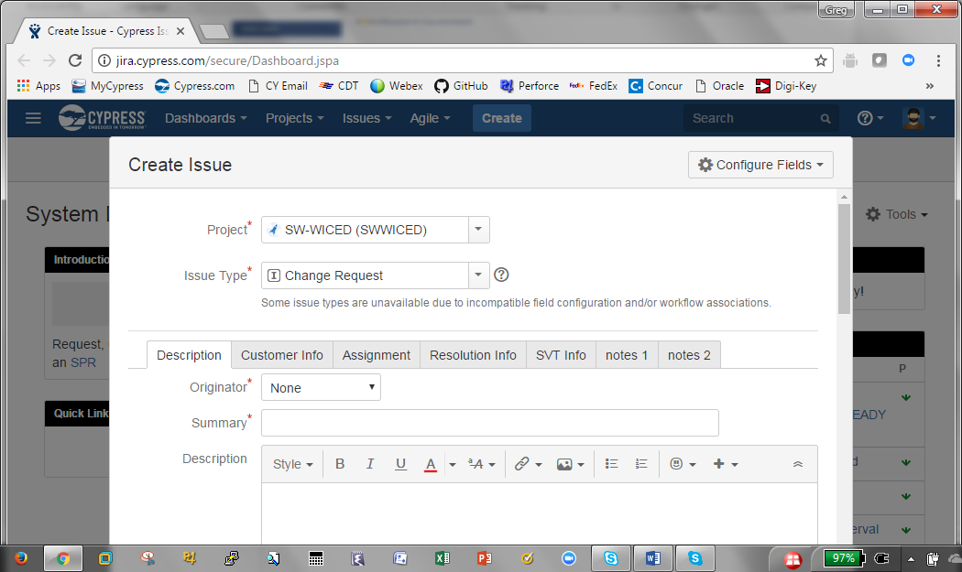

# Tour of WICED SDK Structure



# Tour of Bluetooth

|  |  |  |  |  |  |  |
| --- | --- | --- | --- | --- | --- | --- |
| **IEEE**  **Standard** | **Mbits/s** | **Freq**  **GHz** | **#**  **Chan** | **Chan Width**  **MHz** | **MIMO** | **Comment** |
| 802.11 | 2 | 2.4 | 14 | 22 | - |  |
| [802.11b](https://en.wikipedia.org/wiki/IEEE_802.11b-1999) | 11 | 2.4 | 14 | 22 | - | Same as 802.11 with new coding scheme |
| [802.11a](https://en.wikipedia.org/wiki/IEEE_802.11a-1999) | 54 | 5 | 22 | 20 | - | New coding scheme OFDM + 5GHz |
| [802.11g](https://en.wikipedia.org/wiki/IEEE_802.11g-2003) | 54 | 2.4 | 14 | 22 | - | New coding scheme OFDM |
| [802.11n](https://en.wikipedia.org/wiki/IEEE_802.11n-2009) | 600 | 2.4  5 | 14  22 | 20/40 | 4 | MIMO=Multiple Antennas  4 streams of 150Mbits/s |
| [802.11ac](https://en.wikipedia.org/wiki/IEEE_802.11ac) | 3600 | 2.4  5 | 22  10  5  1 | 20  40  80  160 | 8 | 433Mbits/s per stream  Beam forming directional |
| 802.11ax | 10,000 | 2.4  5 |  | 20  40  80  160 | 4x4 |  |

# Tour of Chips

|  |  |  |
| --- | --- | --- |
| **Device** | **Key Features** | **Notes** |
| CYW20706 | * Bluetooth 4.2 + HS * ARM Cortex-M3 |  |
| CYW20719 | * Bluetooth BR, EDR and LE v4.2 * 2 Mbps LE v5.0 * 96 MHz ARM Cortex-M4 * Single Precision FPU * 2 MB ROM * 1 MB On-Chip Flash * 512 kB RAM |  |

# Tour of Partners

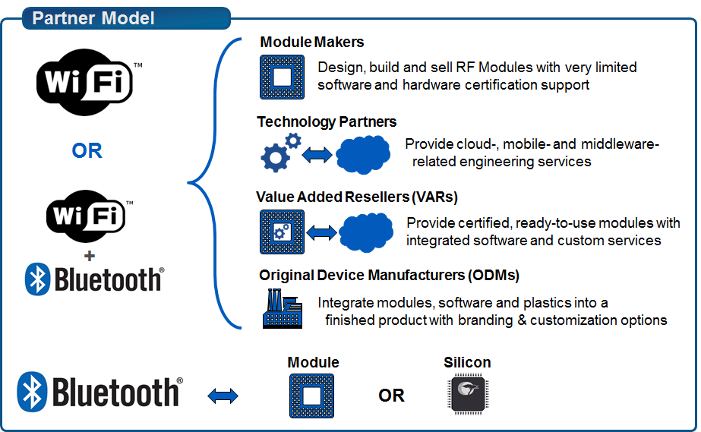

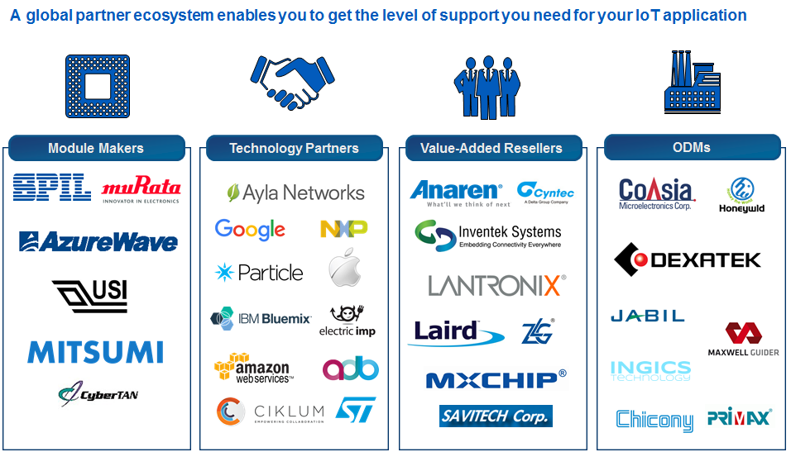

An IoT Selector Guide including partner modules available can be found in the Community at:

<https://community.cypress.com/docs/DOC-3021>

# Tour of Development Kits

## [Cypress CYW920719Q40EVB-01](http://www.cypress.com/documentation/development-kitsboards/cyw943907aeval1f-evaluation-kit)

* xxxkB Flash, xxxkB SRAM
* 1 User Button, 2 User LEDs
* USB JTAG Programmer/Debugger

## [Cypress CYW920706WCDEVAL](http://www.cypress.com/documentation/development-kitsboards/bcm94343wwcd1evb-evaluation-and-development-kit)

* Monlithic, Single-chip, Bluetooth 4.2
* ARM Cortex-M3 processor
* Integrated transceiver
* xxxkB Flash, xxxkB SRAM
* 1 User Button, 2 User LEDs
* USB JTAG Programmer/Debugger

# Exercise(s)

* 1. Create a forum account

1. Go to <https://community.cypress.com/welcome>
2. Click “Log in” from the top right corner of the page and login to your Cypress account. If you do not have an account, you will need to create one first first.
3. Once you are logged in, click the “Wireless” icon and then the “WICED Studio Bluetooth” icon.
4. Click on the “Forums” button.
5. Browse the existing forum articles or search for a particular topic that interests you.
   1. Open the documentation
6. Open the API.html document from the WICED Studio Project Explorer or using Windows Explorer in the SDK Workspace *doc* directory.

Depending on your browser and security settings, you may need to allow ActiveX controls to get the page to display correctly.