Chapter 1: Tour of WICED Bluetooth

Time ½ Hour

After completing Chapter 1 (this chapter) you will understand a top-level view of the components of the WICED ecosystem including the chips, modules, software, documentation, support infrastructure and development kits. You will have WICED Studio installed and working on your computer and will understand how to program an existing project into a kit.

1.1 Tour of WICED Studio SDK 2

1.1.1 First Look 2

1.1.2 Project Explorer 4

1.2 Tour of Documentation 7

1.1.3 In the SDK Workspace 7

1.1.4 On the Web 7

1.3 Reporting Issues 9

1.4 Tour of Bluetooth 10

1.1.5 The Bluetooth Special Interest Group (SIG) 10

1.1.6 Classic Bluetooth 11

1.1.7 Bluetooth Low Energy 12

1.1.8 Bluetooth History 12

1.5 Tour of Chips 12

1.6 Tour of Partners 13

1.7 Tour of Development Kits 15

1.1.9 Cypress CYW920706WCDEVAL 15

1.1.10 Cypress CYW920719Q40EVB-01 15

1.8 Exercise(s) 16

Exercise - 1.1 Create a forum account 16

Exercise - 1.2 Open the documentation 16

Exercise - 1.3 Download the Bluetooth Spec Version 5.0 16

# Tour of WICED Studio SDK

## First Look

The WICED software tool is called "WICED Studio" and it is based on Eclipse.

WICED Studio is installed, by default, in *C:/Users/<UserName>/AppData/Local/WICED.* As a part of installing WICED Studio, an SDK Workspace is created, by default, in *C:/Users/<UserName>/My Documents/WICED-Studio-<version>/20719-B1_Bluetooth*. The SDK Workspace is where you will create your projects. Note that a new set of SDK Workspace files is created for each version of WICED Studio that you install. If you install a newer version of WICED Studio, your projects from the previous version will still be available in the SDK Workspace location associated with that previous version of WICED Studio. You must copy them over manually if you want to access them in the new version.

Once installed, WICED Studio will show up in Windows under Start > All Programs > Cypress > WICED-Studio. The first time you open WICED Studio, you will be asked for which platform you want to use. We will use *20719-B1_Bluetooth* for this class, but if you used a different selection don't worry – you can change it easily from inside the tool using the dropdown menu.

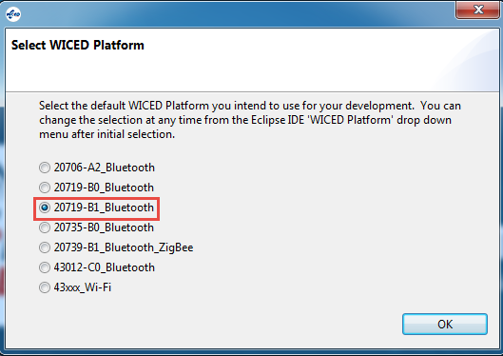

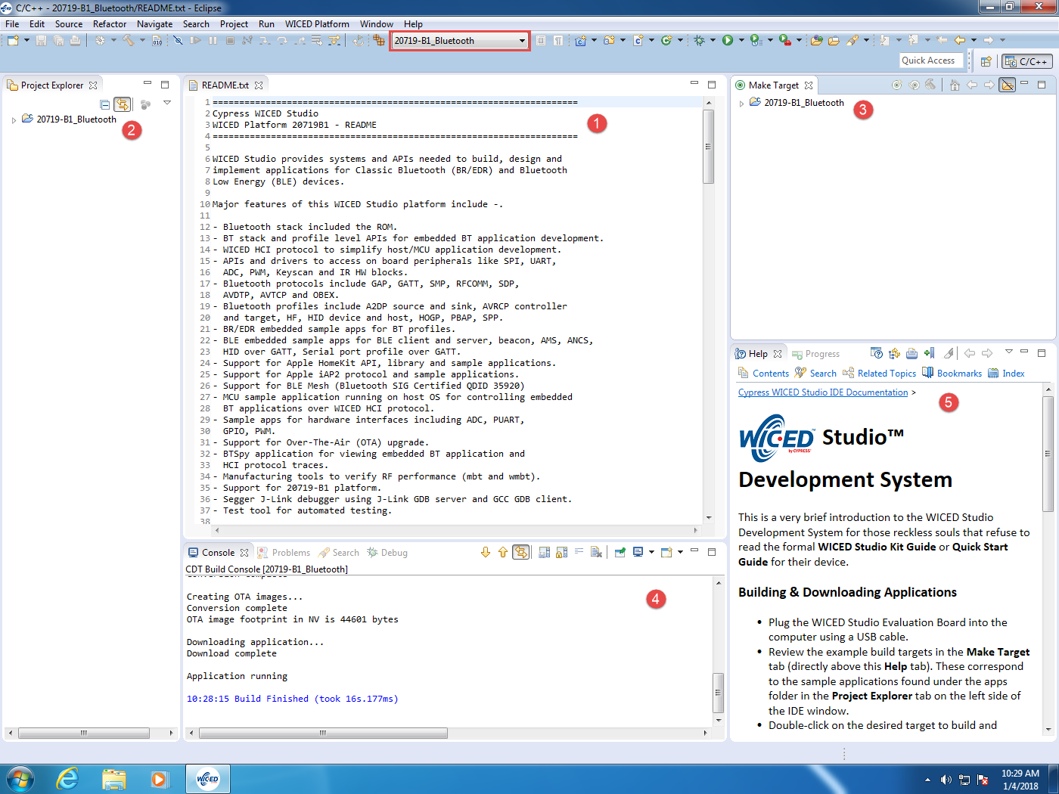

The major views are:

1. File Editor
2. Project Explorer
3. Make Target
4. Console
5. Help

If you close a view unintentionally, you can reopen it from the menu Window > Show View. Some of the views are under Window > Show View > Other… You can drag and drop windows and resize them as you desire.

## Project Explorer

If you expand 20719-B1_Bluetooth from the Project Explorer window you will see the following:

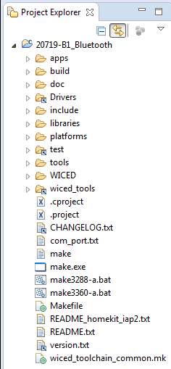

The README.txt file provides basic information about the SDK. This file is open by default in the editor window when the SDK is first opened. The file version.txt contains details of the version of WICED Studio that you have open. Other folders of interest in the Project Explorer are:

### Apps

The *apps* folder is where all the example projects reside as well as where you will put your own projects. The SDK Workspace includes a wealth of example projects. These are broken into categories by folder name. A few of the useful ones are:

1. *snip*: Short examples that typically demonstrate one feature. For example:
   1. *snip/hal/gpio* demonstrates GPIO use by reading buttons and blinking LEDs.
   2. *snip/ble/mybeacon* demonstrates a beacon that sends vendor specific advertising data.
2. *demo*: More complex and complete demonstrations. For example:
   1. *demo/hello_sensor* demonstrates a BLE application with custom profiles implemented. A client peer application for Android, iOS, and Windows is also provided in the project.

### Doc

The doc folder contains the documentation for the SDK Workspace. Of particular interest is the API.html file which documents all of the WICED API functions. It is usually easier to use that file if you open it in a web browser of your choice rather than from inside WICED Studio. You can do this from WICED Studio by right clicking on API.html and choosing "Open With > System Editor". Depending on your web browser and settings, you may have to tell it to allow ActiveX controls to see the menus.

The first window you will see when you open the API.html file is shown below. You can enter search strings in the box in the upper-right corner. The list will filter dynamically as you type. For example, if you enter "wiced_hal_gpio" you will see a list of all WICED APIs that are used for controlling IOs.

Note: sometimes the search feature stops working. If this happens, close the browser page and reopen it.

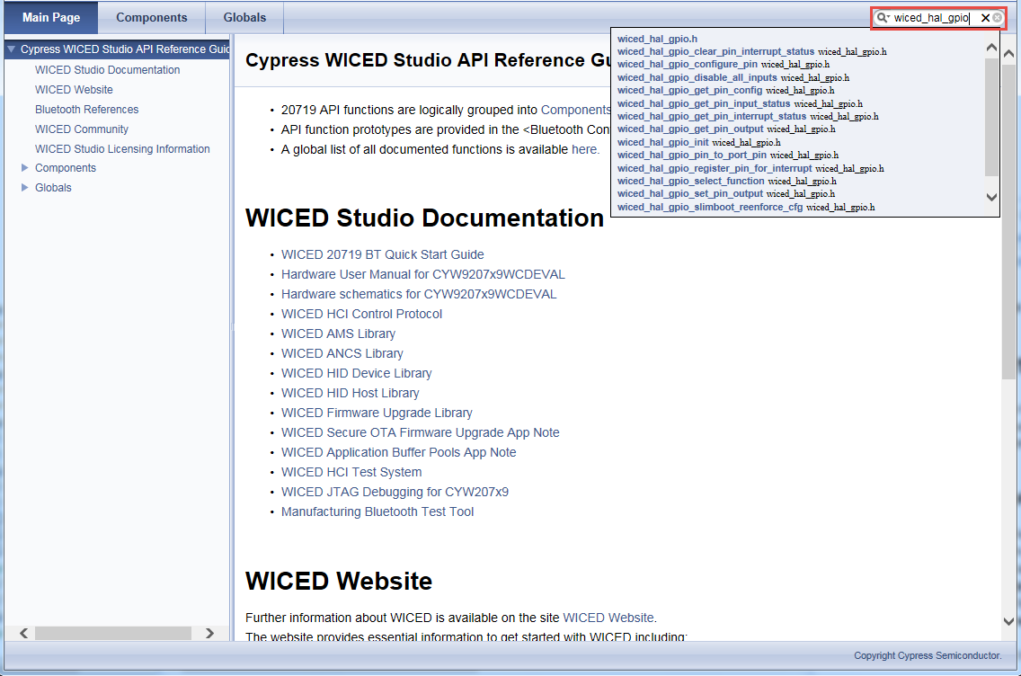

### Platforms

The platforms folder contains information on different kits (i.e. hardware platforms). These files are necessary to program a given project into specific hardware. In our case, the kit we are using is called CYW920719Q40EVB_01. That kit has a platform folder, but since we are also using a shield attached to it, we will use a custom set of platform files that also includes the peripherals on the shield. You will have to copy over the custom platform files before using the shield and kit (this will be the first exercise in Chapter 2). You can even create platform files for your own custom hardware that you design. We'll discuss the platforms folder in more detail in Chapter 2.

### Libraries

The libraries folder contains various sets of library function files. For example, there are libraries for working with different Bluetooth profiles such as A2DP (Advanced Audio Distribution Profile), HFP (Hands Free Profile), SPP (Serial Port Profile), etc. Many of the projects you look at and create later will use library functions.

### Include

The include folder contains header files that allow you to APIs for the different functions that your application requires. Many of these files and functions will be discussed in the next few chapters.

### WICED

The WICED folder contains the "guts" of the SDK such as global make files, linker scripts, etc.

# Tour of Documentation

## In the SDK Workspace

As discussed previously, the doc folder in the SDK Workspace contains various documents. The most important of these is the API guide but the folder also contains other useful documents such as debugging information, test system information, OTA update procedures, etc. The list of files in the doc directory looks like this:

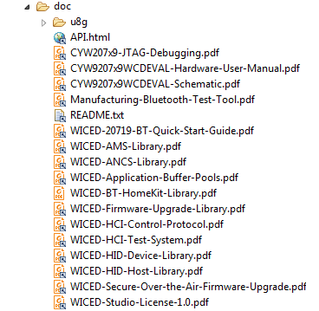

Each of the files in the doc folder can be accessed either from within the WICED Studio (the Project Explorer pane) or from Windows Explorer.

## On the Web

Navigating to "[www.cypress.com](http://www.cypress.com) > Design Support > Community" will take you to the following site (the direct link is <https://community.cypress.com/welcome>):

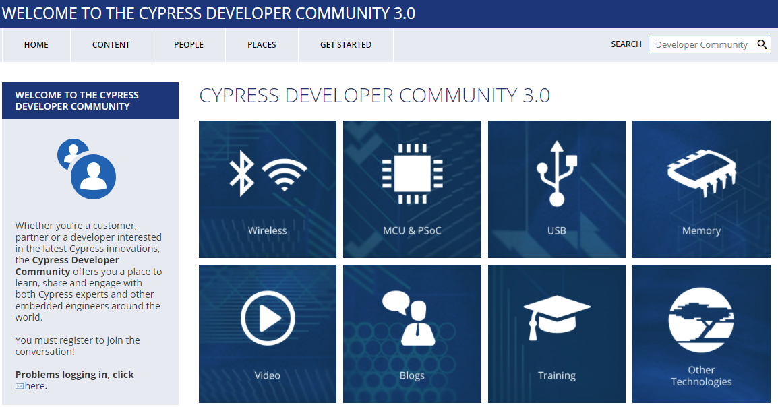

Clicking on the Wireless icon and then the WICED Studio Bluetooth icon will take you to the community page as shown below. From this page, you can download WICED Studio, purchase kits, search for answers, ask questions, etc.

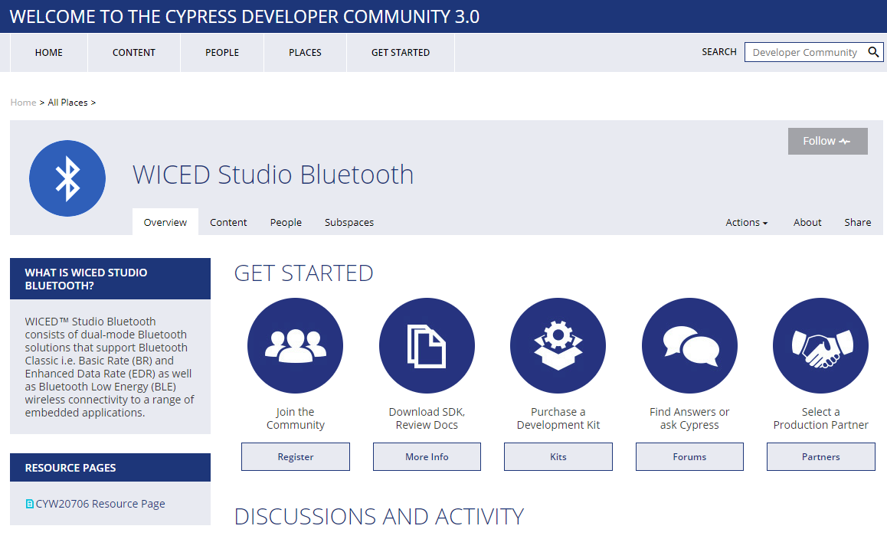

# Reporting Issues

If you find an issue in WICED Studio (bug, missing or confusing documentation, enhancement request), please use a "JIRA" to report it:

[jira.cypress.com](http://jira.cypress.com/)

Click on Create to start submitting a JIRA. Use the project type of SW-WICED and fill in as many details as you can to report the issue. If you are reporting an issue with a kit, use "KITS:" as a prefix to the summary.

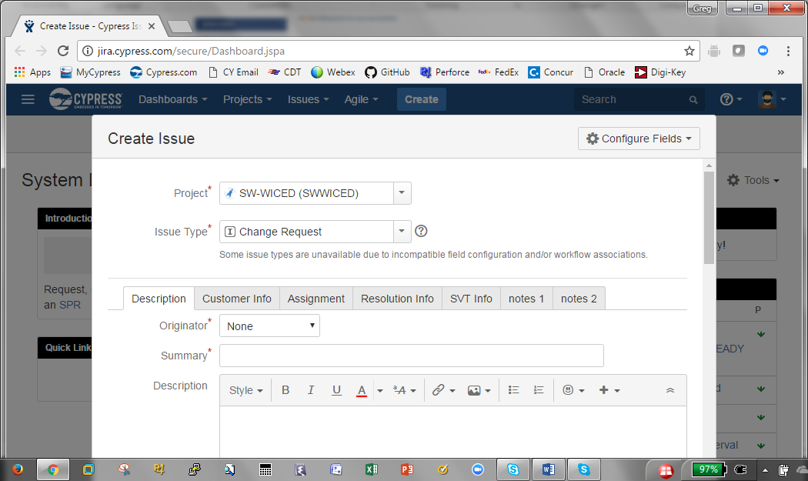

# Tour of Bluetooth

Bluetooth is a short-range wireless standard that runs on the 2.4 GHz ISM (Industrial, Scientific, and Medical) band modulation. It is controlled by the Bluetooth Special Interest Group (SIG).

The range is dependent on the transmission power which is divided into four classes:

|  |  |  |  |
| --- | --- | --- | --- |
| **Class** | **Max Permitted Power** | | **Typical Range**  **(m)** |
| (mW) | (dBm) |
| 1 | 100 | 20 | 100 |
| 2 | 2.5 | 4 | 10 |
| 3 | 1 | 0 | 1 |
| 4 | 0.5 | -3 | 0.5 |

Discussions about Bluetooth are typically divided into *Classic* *Bluetooth* and *Bluetooth Low Energy*.

## The Bluetooth Special Interest Group (SIG)

The Bluetooth Special Interest Group is an industry consortium that owns the specifications for Bluetooth. All the Bluetooth documentation is available at [www.bluetooth.org](http://www.bluetooth.org). You can register for an account on that website.

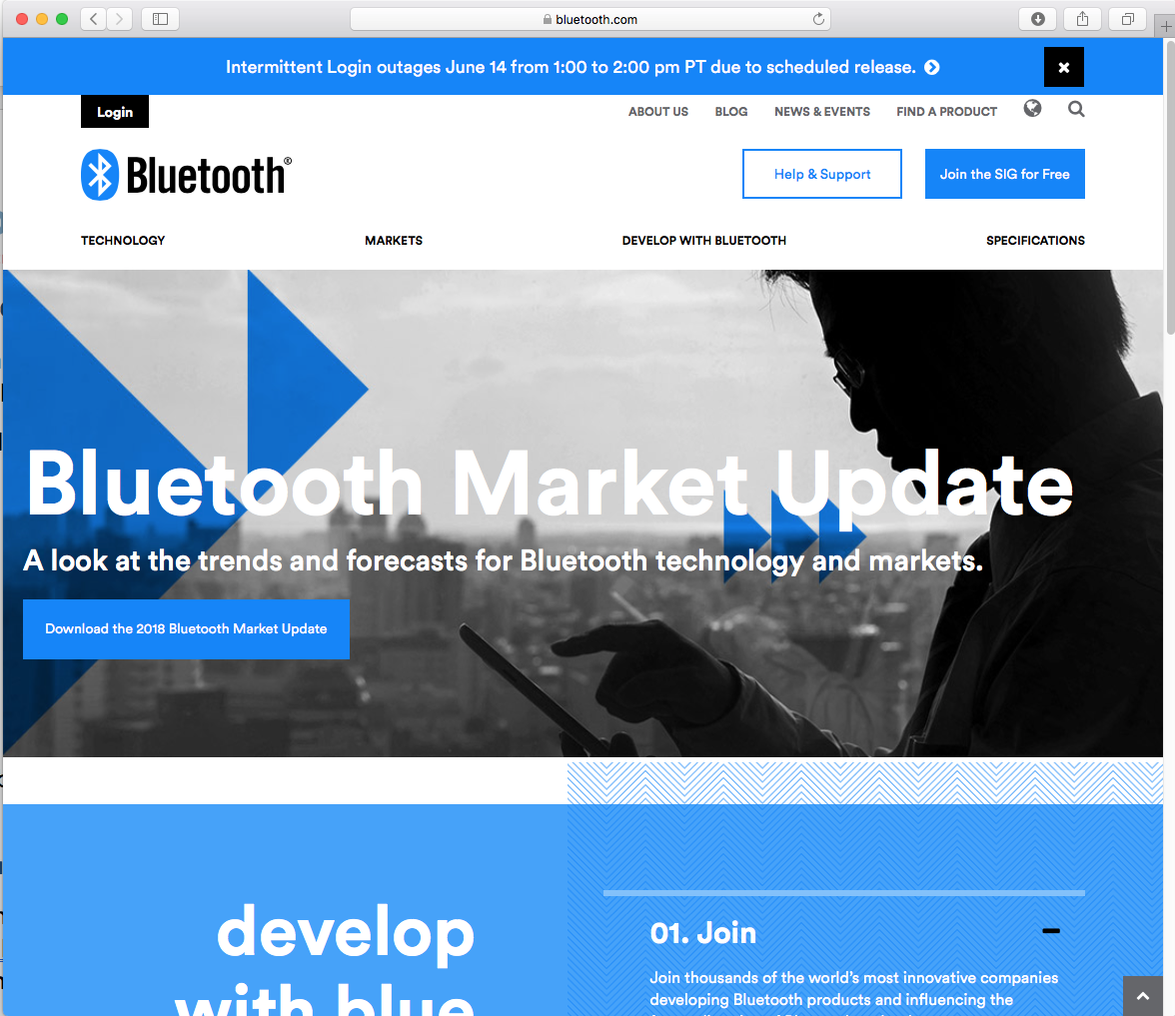

The current Bluetooth Specification is Version 5.0 is a 2822 page long document that can be downloaded from the Bluetooth SIG website at <https://www.bluetooth.com/specifications/bluetooth-core-specification>

## Classic Bluetooth

Classic Bluetooth uses 79 channels with a channel spacing of 1 MHz. It has three main speeds – Basic Rate (BR) and two Extended Data Rates (EDR). Each of these uses a different modulation scheme.

|  |  |  |
| --- | --- | --- |
| **Mode** | **Speed** | **Modulation** |
| Basic Rate | 1 Mbps | GFSK (Gaussian Frequency Shift Keying) |
| Extended Data Rate | 2 Mbps | π/4 DQPSK (Differential Quadrature Phase Shift Keying) |
| Extended Data Rate | 3 Mbps | 8DPSK (Octal Differential Phase Shift Keying) |

## Bluetooth Low Energy

Bluetooth Low Energy (BLE) uses 40 channels with a channel spacing of 2 MHz (and so it shares the same range of frequencies with Bluetooth Classic). It provides much lower power consumption than Classic Bluetooth. Lower power is not achieved by reducing range (i.e. transmission power) but rather by staying actively connected for short bursts and being idle most of the time. This requires devices to agree on a connection interval. This connection interval can be varied to trade off the frequency of data transmitted vs. power. Therefore, BLE is excellent for data that can be sent in occasional bursts such as sensor states (i.e. temperature, state of a door, state of a light, etc.) but is not good for continuous streaming of data such as audio. BLE typically transmits data up to 1 Mbps, but 2 Mbps can be achieved in Bluetooth version 5 with shorter range.

Another name for Bluetooth Low Energy is "Bluetooth Smart". Devices that support both Classic Bluetooth and BLE are sometimes called "Bluetooth Smart Ready".

## Bluetooth History

| **Bluetooth**  **Spec** | **Year** | **Major Features** |
| --- | --- | --- |
| 1.0 | 1999 | Initial standard. |
| 1.1 | 2002 | Many bug fixes.  Addition of RSSI and non-encrypted channels. |
| 1.2 | 2003 | Faster connection and discovery.  Adaptive Frequency Hopping (AFH)  Host Control Interface (HCI)  Addition of flow control and retransmission. |
| 2.0 + EDR | 2004 | Addition of EDR (up to 3 Mbps). |
| 2.1 + EDR | 2007 | Addition of Secure Simple Pairing (SPP) and enhanced security.  Extended Inquiry Response (EIR). |
| 3.0 + HS | 2009 | Addition of HS which uses Bluetooth for negotiation and establishment, then uses an 802.11 link for up to 24 Mbps. This is called Alternative MAC/PHY (AMP).  Addition of Enhanced Retransmission Mode (ERTM) and Streaming Mode (SM) for reliable and unreliable channels. |
| 4.0 + LE | 2010 | Addition of BLE.  Addition of Generic Attribute Profile (GATT).  Addition of Security Manager (SM) with AES encryption. |
| 4.1 | 2013 | Incremental software update. |
| 4.2 | 2014 | LE secure connections with data packet length extension.  Link Layer privacy.  Internet Protocol Support Profile (SPP) version 6. |
| 5 | 2016 | LE up to 2 Mbps for shorter range, or 4x range with lower data rate.  LE increased packet lengths to achieve 8x data broadcasting capacity. |

# Tour of Chips

|  |  |  |
| --- | --- | --- |
| **Device** | **Key Features** | **Notes** |
| CYW20706 | * Bluetooth 4.2 + HS * ARM Cortex-M3 * 848 kB ROM * 352 kB RAM (data and patches) * 2 kB NVRAM |  |
| CYW20719 | * Bluetooth BR, EDR and LE v4.2 * 2 Mbps LE v5 * 96 MHz ARM Cortex-M4 * Single Precision FPU * 2 MB ROM * 1 MB On-Chip Flash * 512 kB RAM |  |

# Tour of Partners

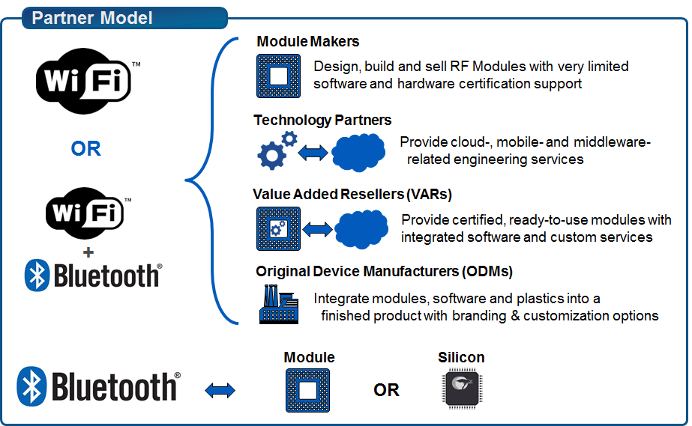

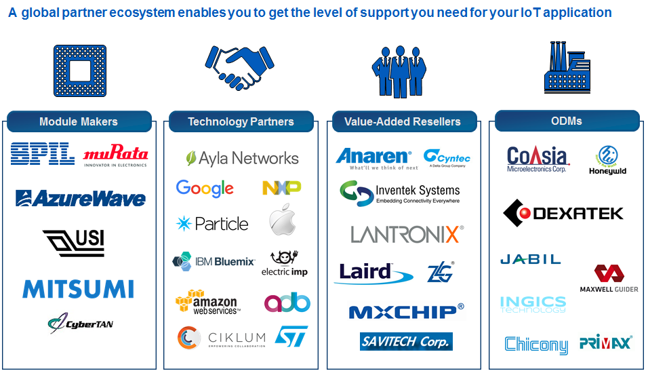

An IoT Selector Guide including partner modules available can be found in the Community at:

<https://community.cypress.com/docs/DOC-3021>

# Tour of Development Kits

## [Cypress CYW920706WCDEVAL](http://www.cypress.com/documentation/development-kitsboards/bcm94343wwcd1evb-evaluation-and-development-kit)

* Monolithic, Single-chip, Bluetooth 4.2 + HS
* ARM Cortex-M3 processor
* Integrated transceiver
* 848 kB ROM, 352 kB SRAM (data and patches), 2 kB NVRAM, 512 kB External Serial Flash
* 1 User Button, 2 User LEDs
* USB JTAG Programmer/Debugger

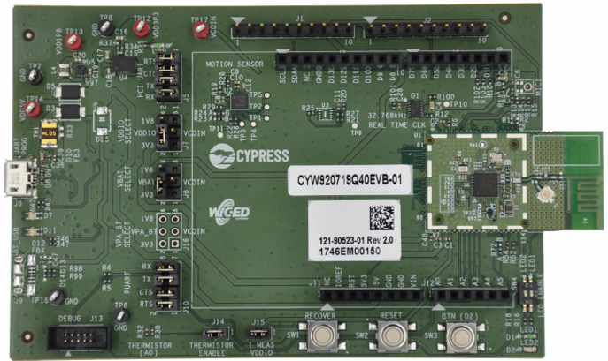

## [Cypress CYW920719Q40EVB-01](http://www.cypress.com/documentation/development-kitsboards/cyw943907aeval1f-evaluation-kit)

* Bluetooth v4.2 plus 2 Mbps LE from v5
* 96 MHz ARM Cortex-M4
* Integrated transceiver
* 2 MB ROM, 1 MB On-ChipFlash, 512 kB SRAM
* 1 User Button, 2 User LEDs
* USB JTAG Programmer/Debugger

# Exercise(s)

* 1. Create a forum account

1. Go to <https://community.cypress.com/welcome>
2. Click "Log in" from the top right corner of the page and login to your Cypress account. If you do not have an account, you will need to create one first first.
3. Once you are logged in, click the "Wireless" icon and then the "WICED Studio Bluetooth" icon.
4. Click on the "Forums" button.
5. Browse the existing forum articles or search for a particular topic that interests you.
   1. Open the documentation
6. Open the API.html document from the WICED Studio Project Explorer or using Windows Explorer in the SDK Workspace *doc* directory.

Depending on your browser and security settings, you may need to allow ActiveX controls to get the page to display correctly.

* 1. Download the Bluetooth Spec Version 5.0

The spec can be found at: [www.bluetooth.org](http://www.bluetooth.org)

Questions to Answer:

What is the organization scheme used in the spec?

On what page does the Attribute protocol specification start?