Chapter 3: Using the WICED Real Time Operating System (RTOS)

Time 1 ½ Hours

After completing chapter 3 you will have a fundamental understanding of the role of the WICED RTOS in building WICED projects. You will be able to use the WICED RTOS abstraction layer to create and use threads, semaphores, mutexes, queues, and timers.

3.1 An Introduction to RTOS 2

3.2 WICED RTOS Abstraction Layer 3

3.3 Problems with RTOSs 4

3.4 Threads 5

3.5 Semaphore 7

3.6 Mutex 8

3.7 Queue 9

3.8 Timer 10

3.9 Exercise(s) 12

Exercise - 3.1 Semaphore 12

Exercise - 3.2 (Advanced) Mutex 12

Exercise - 3.3 (Advanced) Queues 13

Exercise - 3.4 (Advanced) Timers 13

3.10 Related Example "Apps" 15

3.11 Known Errata + Enhancements + Comments 15

# An Introduction to RTOS

The [purpose of an RTOS](http://rtos.com/PDFs/What_Is_An_RTOS_and_Why_Use_One_Embedded.com_.pdf) is to reduce the complexity of writing embedded firmware that has multiple asynchronous, response-time-critical tasks that have overlapping resource requirements. For example, you might have a device that is reading and writing data to a connected network, reading and writing data to an external filesystem, and reading and writing data from peripherals. Making sure that you deal with the timing requirement of responding to network requests while continuing to support the peripherals can be complex and therefore error prone. By using an RTOS you can separate the system functions into separate tasks (called **threads**) and develop them in a somewhat independent fashion.

The RTOS maintains a list of threads that are idle, halted or running and which task needs to run next (based on priority) and at what time. This function in the RTOS is called the scheduler. There are two major schemes for managing which threads/tasks/processes are active in operating systems: preemptive and co-operative.

In preemptive multitasking the CPU completely controls which task is running and has the ability to stop and start them as required. In this scheme the scheduler uses CPU protected modes to wrest control from active tasks, halt them, and move onto the next task. Preemptive multitasking is the scheme that is used in Windows, Linux etc.

In co-operative multitasking each process has to be a good citizen and yield control back to the RTOS. There are a number of mechanisms for yielding control such as rtos_delay, semaphores, mutexes, and queues (which we will discuss later in this document).

The WICED RTOSs are preemptive. However, higher priority tasks will always run at the expense of lower priority tasks so it is still important to yield control to give lower priority tasks a turn. If not, tasks that don't yield control will prevent lower or equal priority tasks from running at all. It is good practice to have some form of yield control mechanism in every thread to prevent such situations.

# WICED RTOS Abstraction Layer

Currently WICED Studio supports multiple RTOSs, but [ThreadX](http://rtos.com/products/threadx/) by [Express Logic](http://rtos.com/) is built into the device ROM and the license is included for anyone using WICED chips so that is by far the best choice.

In order to simplify using multiple RTOSs, the WICED SDK has a built-in abstraction layer that provides a unified interface to the fundamental RTOS functions. You can find the documentation for the WICED RTOS APIs under the API Guide🡪Components🡪RTOS.

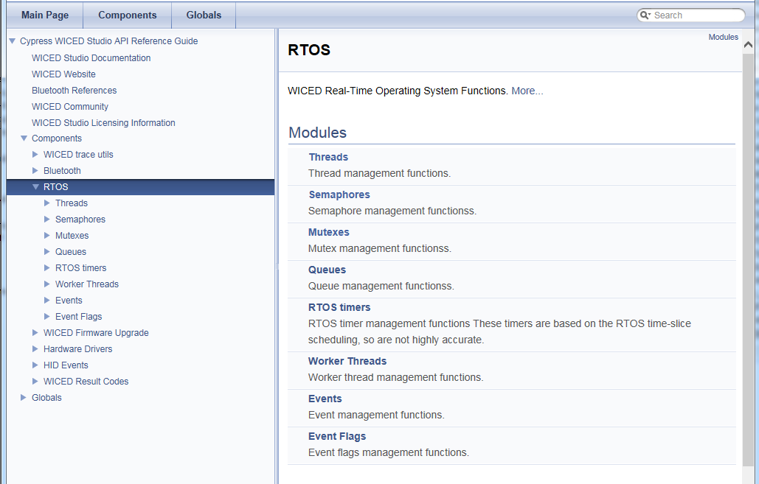

# Problems with RTOSs

All of this sounds great, but everything is not peaches and cream (or whatever your favorite metaphor for a perfect situation might be). There are three serious bugs which can easily be created in these types of systems and these bugs can be very hard to find. These bugs are all caused by side effects of interactions between the threads. The big three are:

* Cyclic dependencies which can cause deadlocks
* Resource conflicts when sharing memory and sharing peripherals which can cause erratic non-deterministic behavior
* Difficulties in executing inter-process communication.

But all hope is not lost. The WICED RTOSs give you mechanisms to deal with these problems, specifically semaphores, mutexes, queues and timers. These functions generally all work the same way. The basic process is:

1. Include the wiced_rtos.h header file so that you have access to the RTOS functions.
2. Declare a pointer of the right type (e.g. *wiced_mutex_t\**)
3. Call the appropriate create function to allocate memory and return the pointer.
4. Call the appropriate RTOS initialize function (e.g. *wiced_rtos_init_mutex()*). Provide it with the pointer that was created in the first step.
5. Access the pointer using one of the access functions (e.g. *wiced_rtos_lock_mutex()*).
6. If you don't need it anymore, free up the pointer with the appropriate de-init function (e.g. *wiced_rtos_deinit_mutex()*).

All these functions need to have access to the pointer, so I generally declare these "shared" resources as static global variables within the file that they are used.

# Threads

As we discussed earlier, threads are at the heart of an RTOS. It is easy to create a new thread by calling the function *wiced_rtos_create_thread()* and then *wiced_rtos_init_thread()* with the following arguments:

* *wiced_thread_t* thread* – A pointer to a thread handle data structure returned by the *wiced_rtos_create_thread()* function. This handle is used to identify the thread for other thread functions.
* *uint8_t priority* – This is the priority of the thread.
  + Priorities can be from 0 to 7 where 0 is the highest priority. User applications should typically use priorities from 1 to 5.
  + If the scheduler knows that two threads are eligible to run, it will run the thread with the higher priority.
* *char *name* – A name for the thread. This name is only used by the debugger. You can give it any name or just use NULL if you don't want a specific name.
* *wiced_thread_function_t *thread* – A function pointer to the function that is the thread.
* *uint32_t stack size* – How many bytes should be in the thread's stack (you should be careful here as running out of stack can cause erratic, difficult to debug behavior. Using 10000 is overkill but will work for any of the exercises we do in this class).
* *void *arg* – A generic argument which will be passed to the thread.
  + If you don't need to pass an argument to the thread, just use NULL.

As an example, if you want to create a thread that runs the function "mySpecialThread", the initialization might look something like this:

**#define** THREAD_PRIORITY (10)

**#define** THREAD_STACK_SIZE (10000)

.

.

wiced_thread_t* mySpecialThreadHandle;

.

.

mySpecialThreadHandle = wiced_rtos_create_thread();

wiced_rtos_init_thread(mySpecialThreadHandle, THREAD_PRIORITY, "mySpecialThreadName", mySpecialThread, THREAD_STACK_SIZE, NULL);

The thread function must match type *wiced_thread_function_t*. It must take a single argument of type *uint32_t* and must have a *void* return.

The body of a thread looks just like the "main" function of a typical C application. Often a thread will run forever so it will have an initialization section and a while(1) loop that repeats forever. For example:

**void** mySpecialThread(uint32_t arg)

{

while(1)

{

processData();

wiced_rtos_delay_milliseconds(100, ALLOW_THREAD_TO_SLEEP);

}

}

Note: you should usually put a *wiced_rtos_delay_milliseconds()* of some amount in every thread with the delay type of *ALLOW_THREAD_TO_SLEEP* so that other threads get a chance to run. The exception is if you have some other thread control function such as a semaphore or queue that is guaranteed to cause the thread to periodically pause.

The functions available to manipulate a thread are in the "Component🡪RTOS🡪Threads" section of the API guide.

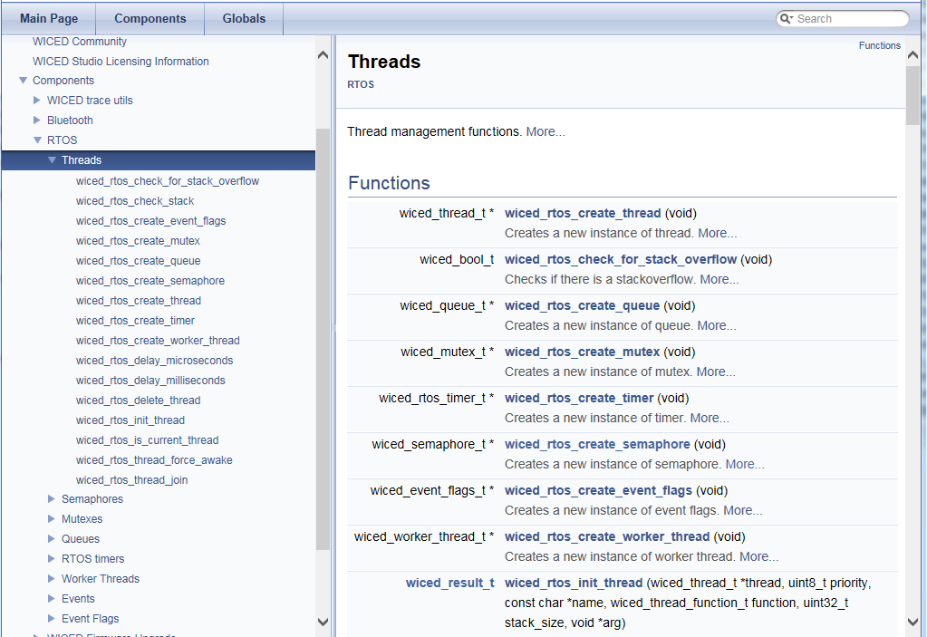

# Semaphore

A [semaphore](https://en.wikipedia.org/wiki/Semaphore_(programming)) is a signaling mechanism between threads. The name semaphore (originally sailing ship signal flags) was applied to computers by Dijkstra in a paper about synchronizing sequential processes. In the WICED SDK, semaphores are implemented as a simple unsigned integer. When you "set" a semaphore it increments the value of the semaphore. When you "get" a semaphore it decrements the value, but if the value is 0 the thread will SUSPEND itself until the semaphore is set. So, you can use a semaphore to signal between threads that something is ready. For instance, you could have a "sendData" thread and a "collectDataThread". The sendData thread will "get" the semaphore which will suspend the thread UNTIL the collectDataThread "sets" the semaphore when it has new data available that needs to be sent.

The get function requires a timeout parameter. This allows the thread to continue after a specified amount of time even if the semaphore doesn't get set. This can be useful in some cases to prevent a thread from stalling permanently if the semaphore is never set due to an error condition. The timeout is specified in milliseconds. If you want the thread to wait indefinitely for the semaphore to be set rather than timing out after a specific delay, use WICED_WAIT_FOREVER for the timeout.

The semaphore functions are available in the documentation under Components🡪RTOS🡪Semaphores. Note that the create function is documented under "Threads" rather than under "Semaphores".

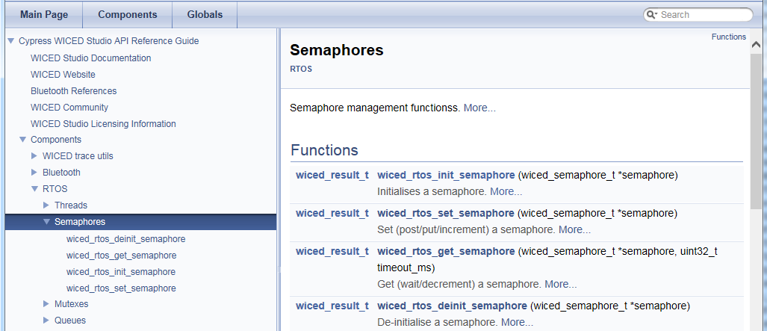

You should always create and initialize a semaphore before starting any threads that use it. Otherwise, you may see unpredictable behavior.

It is generally not a good idea to use a semaphore get inside an interrupt callback or a timer callback with a non-zero timeout since it may lock up your program waiting for a set that never occurs.

# Mutex

Mutex is an abbreviation for "Mutual Exclusion". A mutex is a lock on a specific resource - if you request a mutex on a resource that is already locked by another thread, then your thread will go to sleep until the lock is released. In the exercises for this chapter you will create two different threads that blink the same LED at different rates. Without a mutex, you will see strange behavior. With a mutex, the threads are each given exclusive access to the LED.

The mutex functions are available in the documentation under Components🡪RTOS🡪Mutex. Note that the create function is documented under "Threads" rather than under "Mutexes".

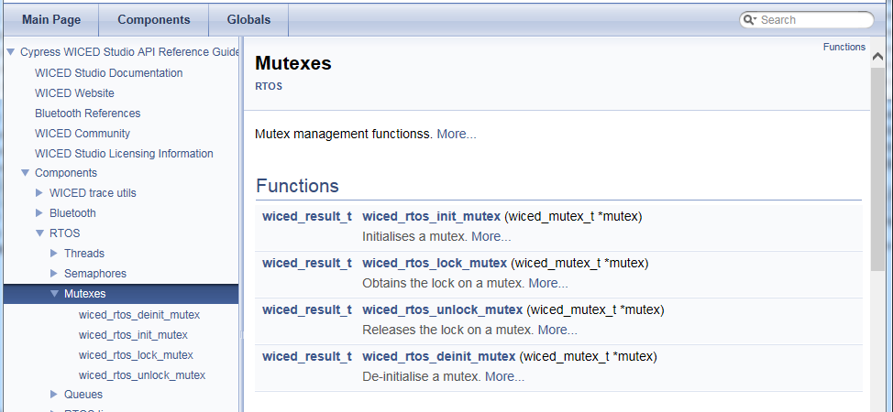

You should always create and initialize a mutex before starting any threads that use it. Otherwise, you may see unpredictable behavior.

Note that a mutex can only be unlocked by the same thread that locked it.

# Queue

A queue is a thread-safe mechanism to send data to another thread. The queue is a FIFO - you read from the front and you write to the back. If you try to read a queue that is empty your thread will suspend until something is written into it. The payload in a queue (size of each entry) and the size of the queue (number of entries) is user configurable at queue creation time.

The *wiced_rtos_push_to_queue()* requires a timeout parameter. This comes into play if the queue is full when you try to push into it. The timeout allows the thread to continue after a specified amount of time even if the queue stays full. This can be useful in some cases to prevent a thread from stalling permanently if the queue stays full due to an error condition. The timeout is specified in milliseconds. If you want the thread to wait indefinitely for room in the queue rather than timing out after a specific delay, use WICED_WAIT_FOREVER for the timeout. If you want the thread to continue immediately if there isn't room in the queue, then use WICED_NO_WAIT. Note that if the function times out, then the value is not added to the queue.

Likewise, the *wiced_rtos_pop_from_queue()* function requires a timeout parameter to specify how long the thread should wait if the queue is empty. If you want the thread to wait indefinitely for a value in the queue rather than continuing execution after a specific delay then use WICED_WAIT_FOREVER. If you want the project to continue immediately if there isn't anything in the queue then use WICED_NO_WAIT.

There are also functions to check to see if the queue is full or empty and to determine the number of entries in the queue.

The queue functions are available in the documentation under Components🡪RTOS🡪Queues. Note that the create function is documented under "Threads" rather than under "Queues".

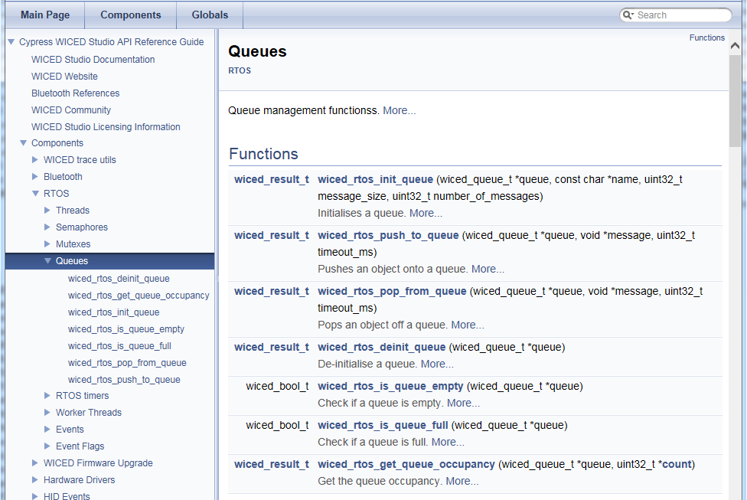

You should always create and initialize a queue before starting any threads that use it. Otherwise, you may see unpredictable behavior.

# Timer

A timer allows you to schedule a function to run at a specified interval - e.g. send data every 10 seconds. The RTOS has timers, but in WICED it is recommended to use the built-in SysTick based timers instead. So, this is not strictly an RTOS topic.

First you initialize the timer using wiced_init_timer, you give it a pointer to a timer structure, specify the function want run, provide an argument to the function (or NULL if you don't need it), and the timer type. There are four types of timer. The first two are one-shot timers while the last two will repeat:

*WICED_SECONDS_TIMER*

*WICED_MILLI_SECONDS_TIMER*

*WICED_SECONDS_PERIODIC_TIMER*

*WICED_MILLI_SECONDS_PERIODIC_TIMER*

The function that you specify takes a single argument of u*int32_t arg*. If the function doesn't require any arguments you can specify 0 in the timer initialization function, but the function itself must still have the *int32_t arg* argument in its definition.

Once you initialize the timer, you then start it using wiced_start_timer. This function takes a pointer to the timer structure and the actual time interval for the timer (either in seconds or milliseconds depending on the timer chosen).

Note that there is a single execution of the function every time the timer expires rather than a continually executing thread so the function should NOT have a while(1) loop – it should just run and exit each time the timer calls it.

The timer functions are available in the documentation under Components🡪Hardware Drivers🡪Timer Management Services.

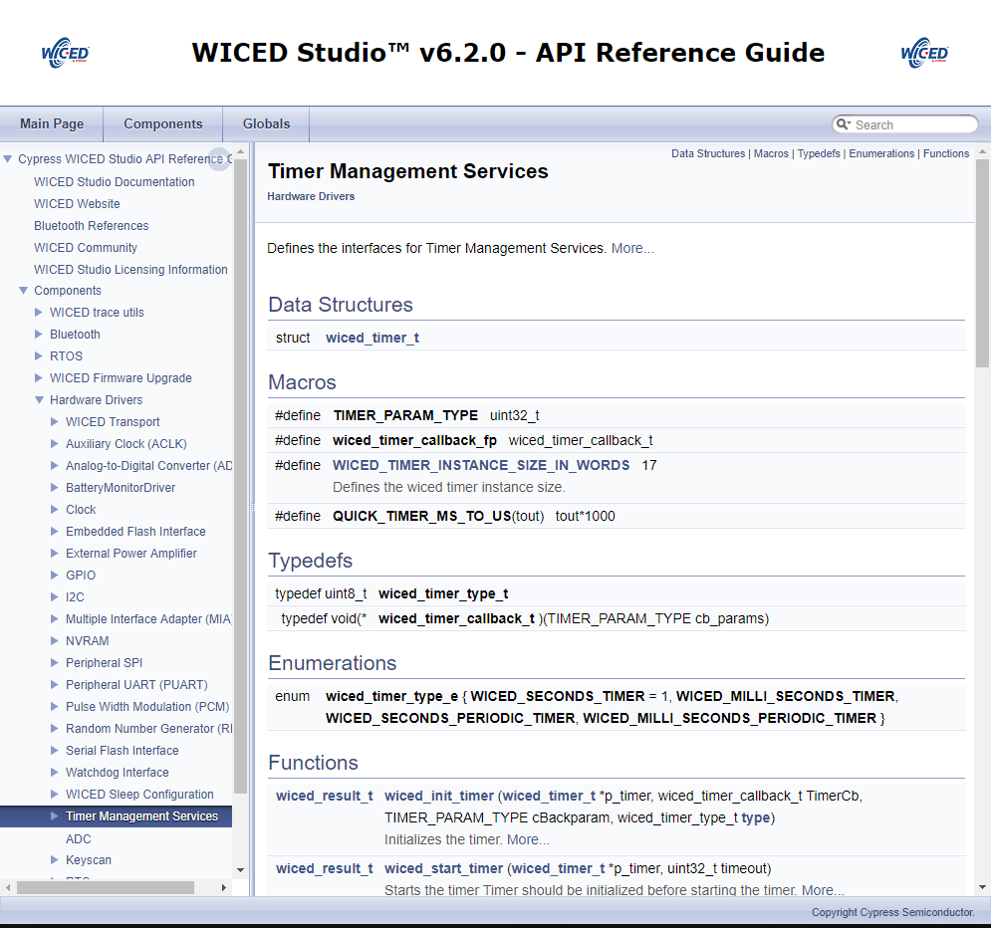

# Exercise(s)

* 1. Semaphore

Create a program where an interrupt looks for a button press then sets a semaphore to communicate to the toggle LED thread.

1. Copy ch02/ex02_blinkled to ch03/ex01_semaphore. Rename the C file, modify the makefile as needed and create a make target.
2. Create a new semaphore pointer as a global variable, then create and initialize the semaphore when the Bluetooth stack is enabled.
   1. Hint: the create functions are all documented in API.html under Components -> RTOS -> Threads.
   2. Hint: be sure to create and initialize the semaphore before starting the LED thread or the interrupt (added in the next step) since they use the semaphore.
3. Add an interrupt to look for a button press and set the semaphore inside the interrupt handler.
   1. Hint: refer to the interrupt exercise from the peripherals chapter.
4. Get the semaphore inside the LED thread so that it waits for the semaphore forever and then toggles the LED rather than blinking constantly.
   1. Hint: If the thread has "blink" in its name you should rename it to be consistent with what it now does.
   2. Hint: Use WICED_WAIT_FOREVER so that the thread will wait until the button is pressed. The definition for this can be found at the top of wiced_rtos.h.

Questions to answer:

Do you need *wiced_rtos_delay_millisecon*ds() in the LED thread? Why or why not?

What happens if you use a value of 100 for the semaphore timeout? Why?

* 1. (Advanced) Mutex

An LED may behave strangely if two threads try to blink it at the same time. In this exercise we will use a mutex to lock access.

1. Copy ch02/ex02_blinkled to ch03/ex02_mutex. Rename the C file, modify the makefile as needed and create a make target.
2. Modify the thread so that instead of toggling the LED every 250ms, it will toggle every 250ms only when Button 1 is being pressed.
   1. Make sure you yield control in the thread when the button is not being pressed.

As an example, Thread 1 should look like this:

**void** **led_control**( uint32_t arg )

{

uint32_t led;

**for**(;;)

{

/* Loop while button is pressed */

**while**(0 == wiced_hal_gpio_get_pin_input_status( WICED_GPIO_PIN_BUTTON_1 ))

{

led = wiced_hal_gpio_get_pin_output( WICED_GPIO_PIN_LED_1 );

wiced_hal_gpio_set_pin_output( WICED_GPIO_PIN_LED_1, ! led );

/* Send the thread to sleep for a period of time */

wiced_rtos_delay_milliseconds( THREAD_DELAY_IN_MS, *ALLOW_THREAD_TO_SLEEP* );

}

/* Yield control when button is not pressed */

wiced_rtos_delay_milliseconds( 1, *ALLOW_THREAD_TO_SLEEP* );

}

}

1. Create a second thread that blinks the same LED with a delay of 200ms only when Button 2 is being pressed.
2. Declare a mutex structure as a global.
3. In the initialization, just setup the two threads and get them running (i.e. create the mutex and initialize it).
4. Program the project to the kit.

Press button 1 and button 2 separately to observe the blink rates. Then press both buttons simultaneously. Do you see issues with the blinking?

1. Add a mutex to the project so that when you press button 1 it will ignore button 2 and vice versa. That is, the LED blink rate will follow the first button that was pressed.
   1. Hint, don't forget to create the mutex before initializing it.

Questions to answer:

What happens if you forget to unlock the mutex in one of the threads? Why?

* 1. (Advanced) Queues

Use a queue to send a message to indicate the number of times to blink an LED.

1. Copy ex01_semaphore to ex01_queue. Rename the C file, modify the makefile as needed and create a make target.
2. Remove the semaphore from the project and instead create and initialize a queue.
3. Add a static variable to the interrupt callback that increments each time the button is pressed. Push the value onto the queue to give the LED thread access to it.
4. In the LED thread, pop the value from the queue to determine how many times to blink the LED.
5. Program your project to the board. Press the button a few times to see how the number of blinks is increased with each press. Note that you can press the button while it is currently blinking and the new press will be added to the queue (provided that the queue is large enough).
   1. (Advanced) Timers

Make an LED blink using a timer.

1. Copy ch02/ex02_blinkled to ch03/ex04_timer. Rename the C file, modify the makefile as needed and create a make target.
2. Add an include for wiced_timer.h.
3. Update the LED thread function so that it is just a simple function to toggle the LED with no *while(1)* loop and no *wiced_rtos_delay_milliseconds()*.
4. Remove the thread creation function call and instead initialize and start a timer that will call the LED function every 250ms.
   1. Hint: Don't forget to declare a timer structure of type wiced_timer_t to use in the wiced_init_timer and wiced_start_timer functions.
5. Program your project to the board.

Questions to answer:

What happens if you don't remove the *while(1)* loop from the function that blinks the LED? Why?

# Related Example "Apps"

|  |  |
| --- | --- |
| **App Name** | **Function** |
| snip.thraed_monitor | Demonstrates using the system monitor API to monitor operation of an application thread. |
| snip.stack_overflow | Demonstrates a stack overflow condition. |

# Known Errata + Enhancements + Comments

How do you know what size stack is required for a given thread?