Chapter 4B: More Advanced BLE Peripherals

Time: 3 Hours

This chapter expands your basic knowledge of BLE Peripherals by introducing more Attribute Procedures, GATT Database Features, Security, WICED Configuration Files, HCI, etc.

4B.1 Notify & Indicate 2

4B.2 Other Characteristic Descriptors 4

4B.3 Security 6

4B.3.1 Pairing 6

4B.3.2 Bonding 9

4B.3.3 Pairing & Bonding Process Summary 9

4B.3.4 Authentication, Authorization and the GATT DB 9

4B.3.5 Link Layer Privacy 9

4B.4 WICED Configuration: wiced_bt_cfg.c 11

4B.5 WICED Configuration: Buffer Pools 12

4B.6 WICED Bluetooth Designer 13

4B.6.1 Running the Tool 13

4B.6.2 Editing the Firmware 16

4B.6.3 Testing the Project 18

4B.7 WICED Bluetooth Firmware Architecture 21

4B.8 Exercises 27

Exercise 4B.1 Simple BLE Project with Notifications using WICED BT Designer 27

Exercise 4B.2 BLE Notifications for Wiced101 Button 28

Exercise 4B.3 BLE Pairing and Security 31

Exercise 4B.4 (Advanced) Save BLE Pairing Information (i.e. Bonding) and Enable Privacy 34

Exercise 4B.5 (Advanced) Add a Pairing Passkey 39

Exercise 4B.6 (Advanced) Add Numeric Comparison 41

Exercise 4B.7 (Advanced) Add Multiple Bonding Capability 43

# Notify & Indicate

In the previous chapter, we talked about how the GATT Client can Read and Write the GATT Database running on the GATT Server. But, there are cases where you might want the Server to initiate communication. For example, if your Server is a Peripheral device, you might want to send the Client an update each time a button value changes. That leaves us with the obvious questions of how does the Server initiate communication to the Client, and when is it allowed to do so?

The answer to the first question is, the Server can notify the Client that one of the values in the GATT Database has changed by sending a Notification message. That message has the Handle of the Characteristic that has changed and a new value for that Characteristic. Notification messages are not responded to by the Client, and as such are not reliable. If you need a reliable message, you can instead send an Indication which the Client must respond to.

To send a Notification or Indication use the APIs:

* wiced_bt_gatt_send_notification (conn_id, handle, length, value)
* wiced_bt_gatt_send_indication (conn_id, handle, length, value)

By convention, the GATT Server will not send Notification or Indication messages unless they are turned on by the Client.

How do you turn on Notifications or Indications? In the last chapter, we talked about the GATT Attribute Database, specifically, the Characteristic. If you recall, a Characteristic is composed of a minimum of two Attributes:

* Characteristic Declaration
* Characteristic Value

However, information about the Characteristic can be extended by adding more Attributes, which go by the name of Characteristic Descriptors.

For the Client to tell the Server that it wants to have Indications or Notifications, four things need to happen.

First, the Server must add a new Characteristic Descriptor Attribute called the Client Characteristic Configuration Descriptor, often called the CCCD. This Attribute is simply a 16-bit mask field, where bit 0 represents the Notification flag, and bit 1 represents the Indication flag. In other words, the Client can Write a 1 to bit 0 of the CCCD to tell the Server that it wants Notifications.

To add the CCCD to your GATT DB use the following Macro:

* CHAR_DESCRIPTOR_UUID16_WRITABLE (
  + <HANDLE>,
  + UUID_DESCRIPTOR_CLIENT_CHARACTERISTIC_CONFIGURATION,
  + LEGATTDB_PERM_READABLE | LEGATTDB_PERM_WRITE_REQ | LEGATTDB_PERM_AUTH_WRITABLE ),

The permissions above indicate that the CCCD value is readable whenever connected but will only be writable if the connection is authenticated (more on that later). To see the other possible choices, right click on one of them from inside WICED Studio and select "Open Declaration".

Second, you must change the Properties for the Characteristic to specify that the characteristic allows notifications. That is done by adding LEGATTDB_CHAR_PROP_NOTIFY to the Characteristic's Properties. To see all the available choices, right-click on one of the existing Properties in WICED Studio and select "Open Declaration".

Third, in your GATT Attribute Write Callback you need to save the CCCD value that was written to you.

Finally, when a value that has Notify and/or Indicate enabled changes in your system, you must send out a new value using the appropriate API.

# Other Characteristic Descriptors

There are several other interesting Characteristic Descriptors that are defined by the Bluetooth SIG including:

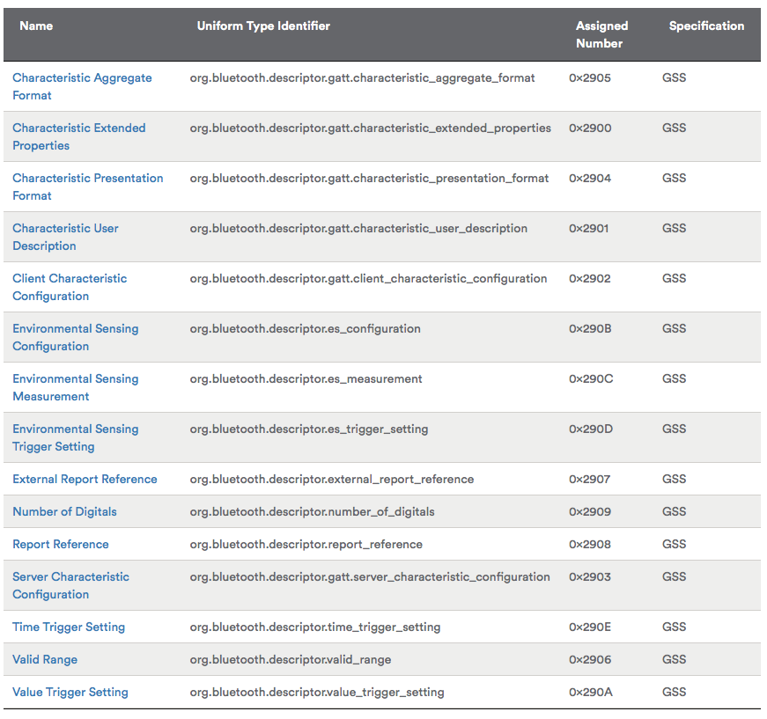

A commonly used Characteristic Descriptor is the Characteristic User Description which is just a text string that describes in human format the Characteristic Type. Many GATT Database Browsers (e.g. Light Blue) will display this information when you are looking at the GATT Database. To add the Characteristic User Description to your Characteristic just add:

* CHAR_DESCRIPTOR_UUID16 (
  + <Handle>,
  + UUID_DESCRIPTOR_CHARACTERISTIC_USER_DESCRIPTION,
  + LEGATTDB_PERM_READABLE ),

WICED Bluetooth has defines for the rest of the Descriptors which you can find in wiced_bt_uuid.h

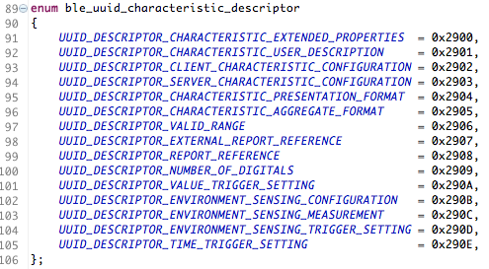

# Security

To securely communicate between two devices, you want to: (1) Authenticate that both sides know who they are talking to; (2) ensure that all access to data is Authorized, (3) Encrypt all message that are transmitted; (4) verify the Integrity of those messages; and (5) ensure that the Identity of each side is hidden from eavesdroppers.

In BLE, this entire security framework is built around AES-128 symmetric key encryption. This type of encryption works by combining a Shared Secret code and the unencrypted data (typically called plain text) to create an encrypted message (typically called cypher text).

* CypherText = F(SharedSecret,PlainText)

There is a bunch of math that goes into AES-128, but for all practical purposes if the Shared Secret code is kept secret, you can assume that it is very unlikely that someone can read the original message.

If this scheme depends on a Shared Secret, the next question is how do two devices that have never been connected get a Shared Secret that no one else can see? In BLE, the process for achieving this state is called Pairing. A device that is Paired is said to be Authenticated.

## Pairing

Pairing is the process of arriving at the Shared Secret. The basic problem continues to be how do you send a Shared Secret over the air, unencrypted and still have your Shared Secret be Secret. The answer is that you use public key encryption. Both sides have a public/private key pair that is either embedded in the device or calculated at startup. When you want to authenticate, both sides of the connection exchange public keys. Then both sides exchange encrypted random numbers that form the basis of the shared secret.



But how do you protect against Man-In-The-Middle (MIM)? There are four possible methods.

Method 1 is called "Just works". In this mode you have no protection against MIM.

Method 2 is called "Out of Band". Both sides of the connection need to be able to share the PIN via some other connection that is not Bluetooth such as NFC.

Method 3 is called "Numeric Comparison" (V2.PH.7.2.1). In this method, both sides display a 6-digit number that is calculated with a nasty cryptographic function based on the random numbers used to generate the shared key and the public keys of each side. The user observes both devices. If the number is the same on both, then the user confirms on both sides. If there is a MITM, then the random numbers on both sides would be different so the 6-digit codes would not match.

Method 4 is called "Passkey Entry" (V2.PH.7.2.3). For this method to work, at least one side needs to be able to enter a 6-digit Passkey. The other side must be able to display the Passkey. Once the side with numeric entry capability enters the Passkey, an exchange and comparison process starts with the Passkeys being divided up, encrypted, exchanged and compared with the other side.

Pictorially, the process with no MIM and with MIM is shown below. Note that if there is a man in the middle, the two sides will calculate different numbers because the number is a function of the public keys used to encrypt the random numbers. If both sides used the same two public keys, then there can't be a man in the middle.





## Bonding

The whole process of Pairing is a bit painful and time consuming. It is also the most vulnerable part of establishing security, so it is beneficial to do it only once. Certainly, you don't want to have to repeat it every time two devices connect. This problem is solved by Bonding, which just saves all the relevant information into a non-volatile memory. The allows the next connection to launch without repeating the pairing process.

## Pairing & Bonding Process Summary

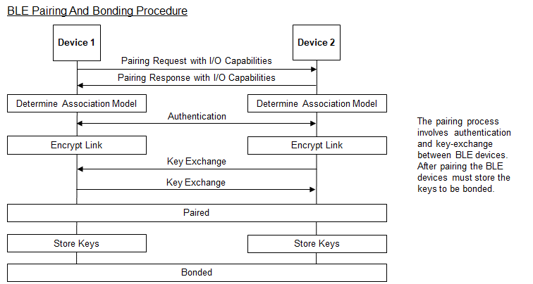

## Authentication, Authorization and the GATT DB

In Chapter 4A3.1 we talked about the Attributes and the GATT Database. Each Attribute has a permissions bit field that includes bits for Encryption, Authentication, and Authorization. The WICED Bluetooth Stack will guarantee that you will not be able to access an Attribute that is marked Encryption or Authentication unless the connection is Authenticated and/or Encrypted.

The Authorization flag is not enforced by the WICED Bluetooth Stack. Your Application is responsible for implementing the Authorization semantics. For example, you might not allow someone to turn off/on a switch without entering a password.

## Link Layer Privacy

BLE devices are identified using a 48-bit device address. This device address is part of all the packets sent by the device in the advertising channels. A third device which listens on all three advertising channels can easily track the activities of a device by using its device address. Privacy is a feature that reduces the ability to track a BLE device by using a private address that is generated and changed at regular intervals. Note that this is different than security (i.e. encrypting of messages).

There are a few different types of address types possible for BLE devices; these are shown in the following table:

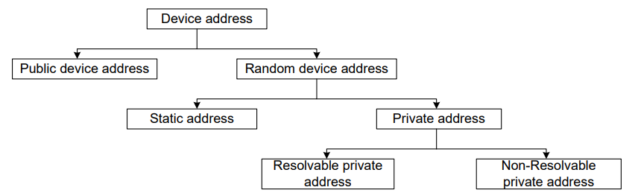

The device address can be a Public Device Address or a Random Device Address. The Public Device Addresses are comprised of a 24-bit company ID (an Organizationally Unique Identifier or OUI based on an IEEE standard) and a 24-bit company-assigned number (unique for each device); these addresses do not change over time.

There are two types of Random Addresses: Static Address and Private Address. The Static Address is a 48-bit randomly generated address with the two most significant bits set to 1. Static Addresses are generated on first power up or during manufacturing. A device using a Public Device Address or Static Address can be easily discovered and connected to by a peer device. Private Addresses change at some interval to ensure that the BLE device cannot be tracked. A Non-Resolvable Private Address cannot be resolved by any device so the peer cannot identify who it is connecting to. Resolvable Private Addresses (RPA) can be resolved and are used by Privacy-enabled devices.

Every Privacy-enabled BLE device has a unique address called the Identity Address and an Identity Resolving Key (IRK). The Identity Address is the Public Address or Static Address of the BLE device. The IRK is used by the BLE device to generate its RPA and is used by peer devices to resolve the RPA of the BLE device. Both the Identity Address and the IRK are exchanged during the third stage of the pairing process. Privacy-enabled BLE devices maintain a list that consists of the peer device’s Identity Address, the local IRK used by the BLE device to generate its RPA, and the peer device’s IRK used to resolve the peer device’s RPA. This is called the Resolving List. Only peer devices that have the 128-bit identity resolving key (IRK) of a BLE device can connect to it.

A Privacy-enabled BLE device periodically changes its RPA to avoid tracking. The BLE Stack configures the Link Layer with a value called RPA Timeout that specifies the time after which the Link Layer must generate a new RPA. In WICED Studio, this value is set in wiced_bt_cfg.c and is called rpa_refresh_timeout. If the rpa_refresh_timeout is set to 0 (i.e. *WICED_BT_CFG_DEFAULT_RANDOM_ADDRESS_NEVER_CHANGE*), privacy is disabled, and a public device address will be used.

# WICED Configuration: wiced_bt_cfg.c

When you initialize the BLE Stack one of the arguments you pass is a pointer to a structure of type wiced_bt_cfg_settings_t. This structure contains initialization information for both the BLE and Classic Bluetooth configuration. This structure is built for you by WICED Bluetooth Designer and typically resides in the file wiced_bt_cfg.c

The structure definition is shown below. Note that many of the entries are themselves structures with multiple entries of their own.

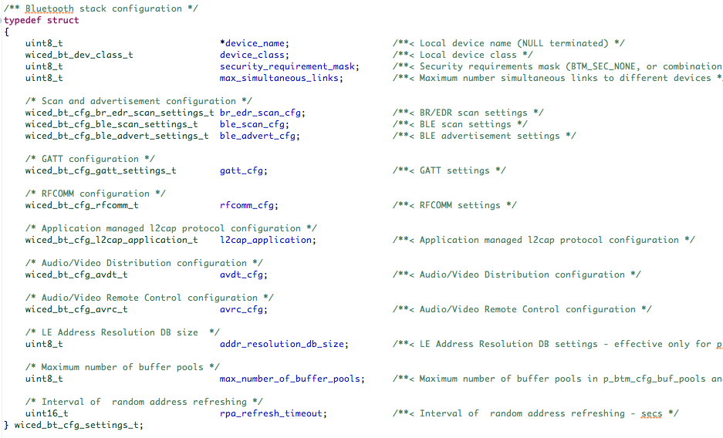

# WICED Configuration: Buffer Pools

Rather than use the C typical memory allocation scheme, malloc, the WICED team has built a scheme optimized for Bluetooth. One of the arguments that you need to pass to the Stack initialization function is a pointer to the pools. This array is typically created for you by the WICED Bluetooth Designer.

There are four different size buffer pools. The configuration settings for them can be found in wiced_bt_cfg.c. The default settings are:

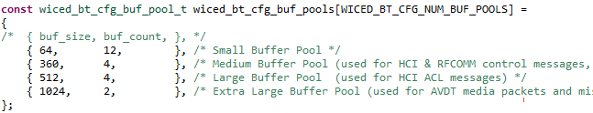

There is a file in the doc folder inside WICED Studio called WICED-Application-Buffer-Pools.pdf that contains some additional information on the use of buffer pools. For example, the large buffer pool should be set to at least as large as the MTU value plus 12.

You can read the amount of free memory in the device at initialization and after starting the stack by using the function wiced_memory_get_free_bytes.

# WICED Bluetooth Designer

WICED Bluetooth Designer can be used to setup Characteristics for Notify and Indicate. It can also be used to create Characteristic User Descriptions.

For this example, I'm going to build a BLE project that has a custom Service called WicedButton containing one Characteristic called MB1. The Characteristic will count the number of times the mechanical user button on the kit has been pressed. It will be Readable by the Client and it will send Notifications if the Client enables them.

## Running the Tool

Start the tool from *File->New->WICED Bluetooth Designer*.I'll use a Device name of key_Button. **When you do this yourself, use a unique name such as *<inits>_Button* where <*inits>* is your initials**. Otherwise you will have trouble finding your specific device among all the ones that are advertising. Click on Finish to launch the configuration window.

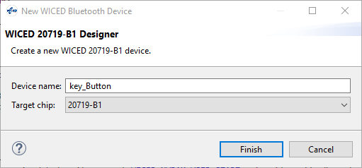

We will keep all the defaults on the Device Settings tab.

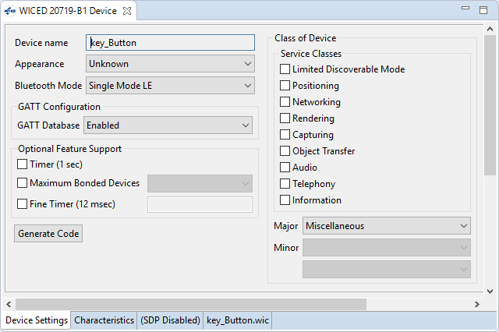

On the Characteristics tab, add a new Vendor Specific Service and change its name to WicedButton.

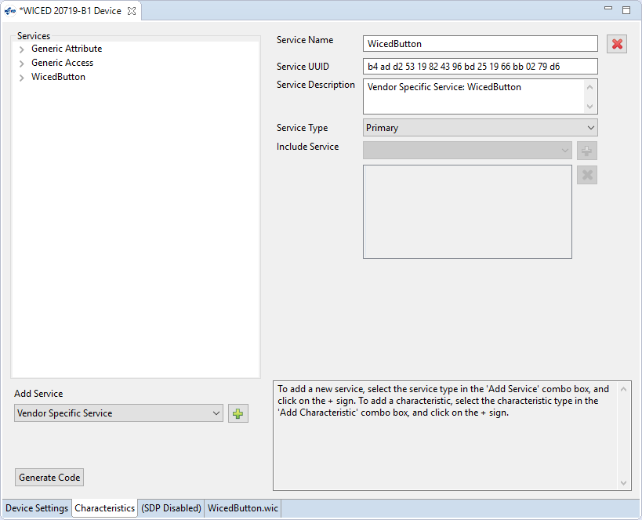

Next, add a Vendor Specific Characteristic and change its name and description to MB1. It has a size of 1.

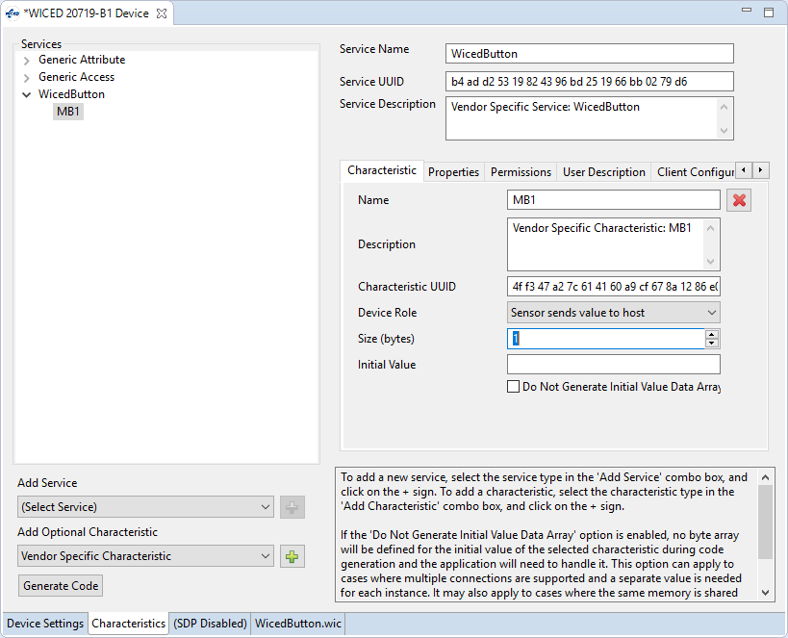

On the Properties tab, we want this Characteristic to have Read and Notify selected.

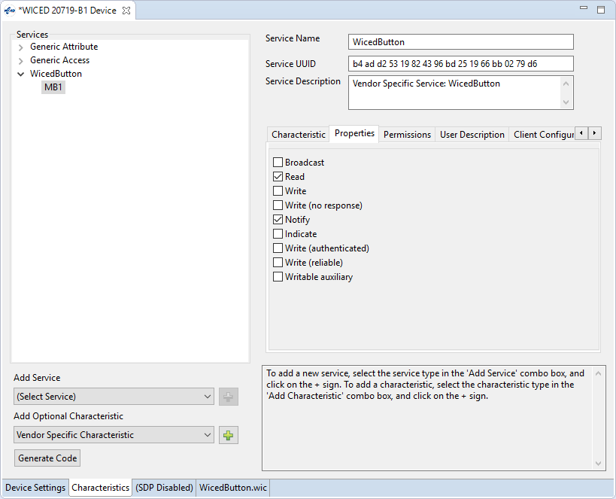

Now check the Permissions tab. It was set by the tool to Read based on our Properties selections. This means that we will be able to Read the Characteristic value without Pairing first. Let's also turn on Read (authenticated) so that Read will require an Authenticated (i.e. Paired) link.

(Note, you must also leave on Read although that does NOT mean that it will be Readable with a non-Authenticated link anymore.)

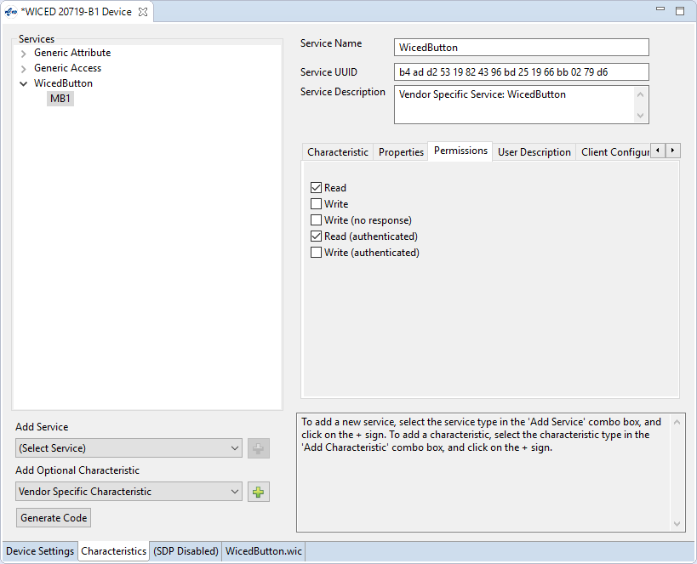

Enabling/disabling Notifications requires a Paired connection by default – it can't be changed in WICED Bluetooth Designer, but you'll see how that can be done in the exercises.

Next, let's go to the User Description tab and include a User Description with the value of "Mechanical Button 1 Count". We will allow this to be read without an Authenticated link.

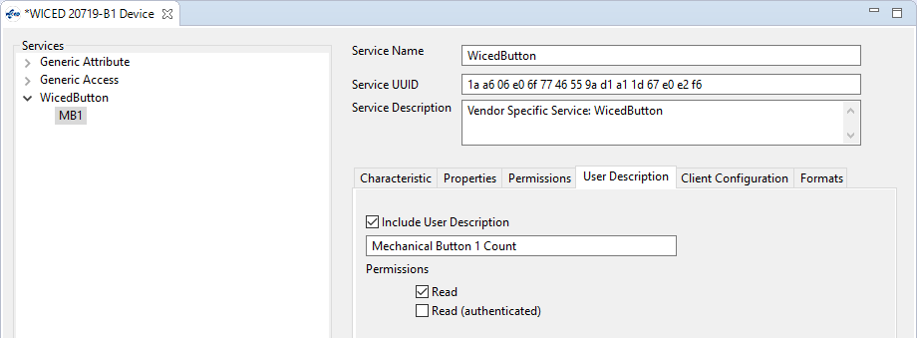

Now, click the Generate Code button.

## Editing the Firmware

In <inits>_Button.c, we need to:

1. Switch the debug messages to the PUART.

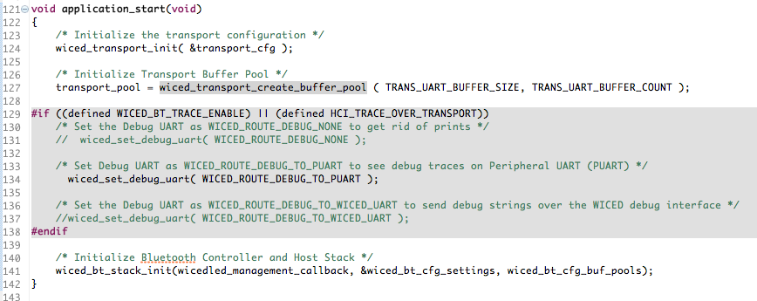

1. Declare a global variable called connection_id. Upon a GATT connection (i.e. in <inits>_button_connect_callback), save the connection ID. Upon a GATT disconnection, reset the connection ID. The ID is needed to send a notification – you need to tell it which connected device to send the notification to. In our case we only allow one connection at a time but there are devices that allow multiple connections.

Global Variable:

uint16_t connection_id = 0;

GATT Connection:

/* **TODO**: Handle the connection */

connection_id = p_conn_status->conn_id;

GATT Disconnection:

/* **TODO**: Handle the disconnection */

connection_id = 0;

1. Configure MB1 as a falling edge interrupt.

**void** **key_button_app_init**(**void**)

{

/* Initialize Application */

wiced_bt_app_init();

/* Configure the Button GPIO as an input with a resistive pull up and falling edge interrupt */

wiced_hal_gpio_register_pin_for_interrupt( WICED_GPIO_PIN_BUTTON_1, button_cback, NULL );

wiced_hal_gpio_configure_pin( WICED_GPIO_PIN_BUTTON_1,

( *GPIO_INPUT_ENABLE* | *GPIO_PULL_UP* | *GPIO_EN_INT_FALLING_EDGE* ),

*GPIO_PIN_OUTPUT_HIGH* );

1. Create the button callback function. In the callback we will increment the Characteristic value, and then send a notification if we have a connection and the notification is enabled.

/* Interrupt callback function for BUTTON_1 */

**void** **button_cback**( **void** *data, uint8_t port_pin )

{

/* Increment the button value */

key_button_wicedbutton_mb1 [0] ++;

/* If the connection is up and if the client wants notifications, send it */

**if** ( connection_id != 0)

{

**if**(key_button_wicedbutton_mb1_client_configuration[0] & *GATT_CLIENT_CONFIG_NOTIFICATION*)

{

wiced_bt_gatt_send_notification(connection_id, HDLC_WICEDBUTTON_MB1_VALUE,

**sizeof**(key_button_wicedbutton_mb1), key_button_wicedbutton_mb1);

WICED_BT_TRACE( "\tSend Notification: sending Button value\r\n");

}

}

/* Clear the GPIO interrupt */

wiced_hal_gpio_clear_pin_interrupt_status( WICED_GPIO_PIN_BUTTON_1 );

}

1. In wiced_bt_cfg.c, change the rpa_refresh_timeout to *WICED_BT_CFG_DEFAULT_RANDOM_ADDRESS_NEVER_CHANGE* so that privacy is disabled.
2. Update the Make Target to add the option BT_DEVICE_ADDRESS=random.

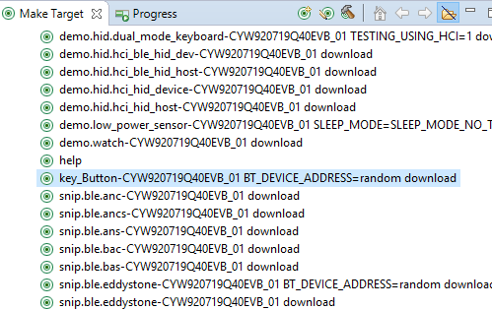

## Testing the Project

Start up a UART terminal and then run the Make Target to program the kit. When the firmware starts up you will see some messages.

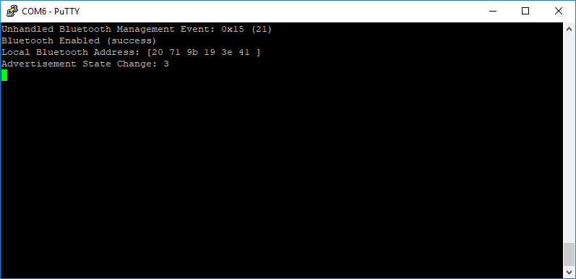

Run CySmart on your phone. When you see the "<inits>_Button" device, tap on it. CySmart will connect to the device and will show the GATT browser widget.

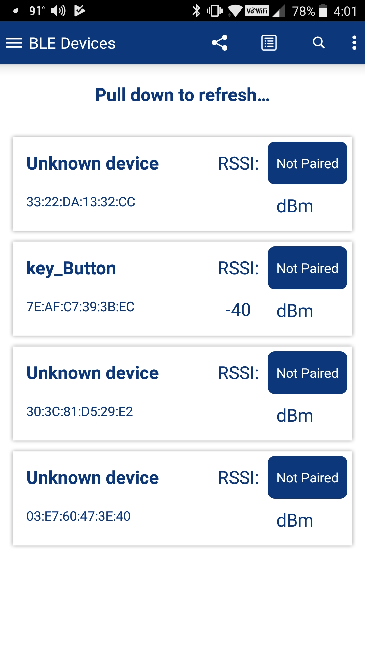 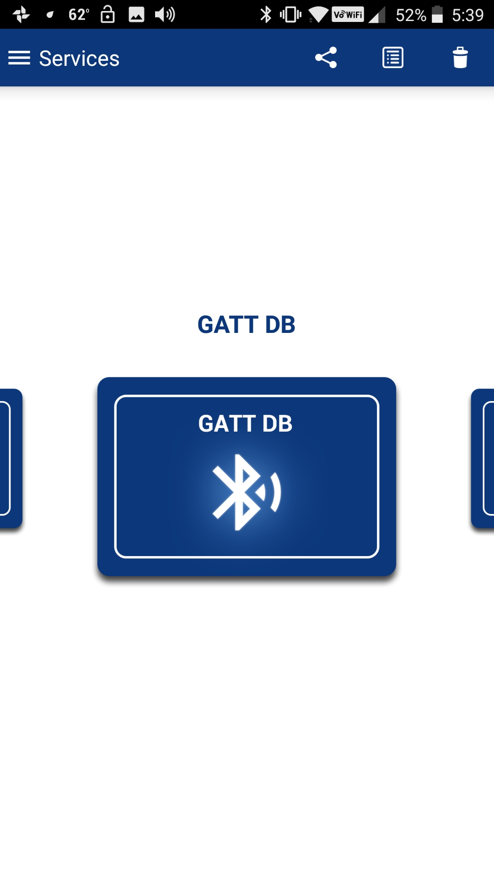

Tap on the GATT DB widget to open the browser. Then tap on the Unknown Service (which we know is WicedButton) and then on the Characteristic (which we know is MB1).

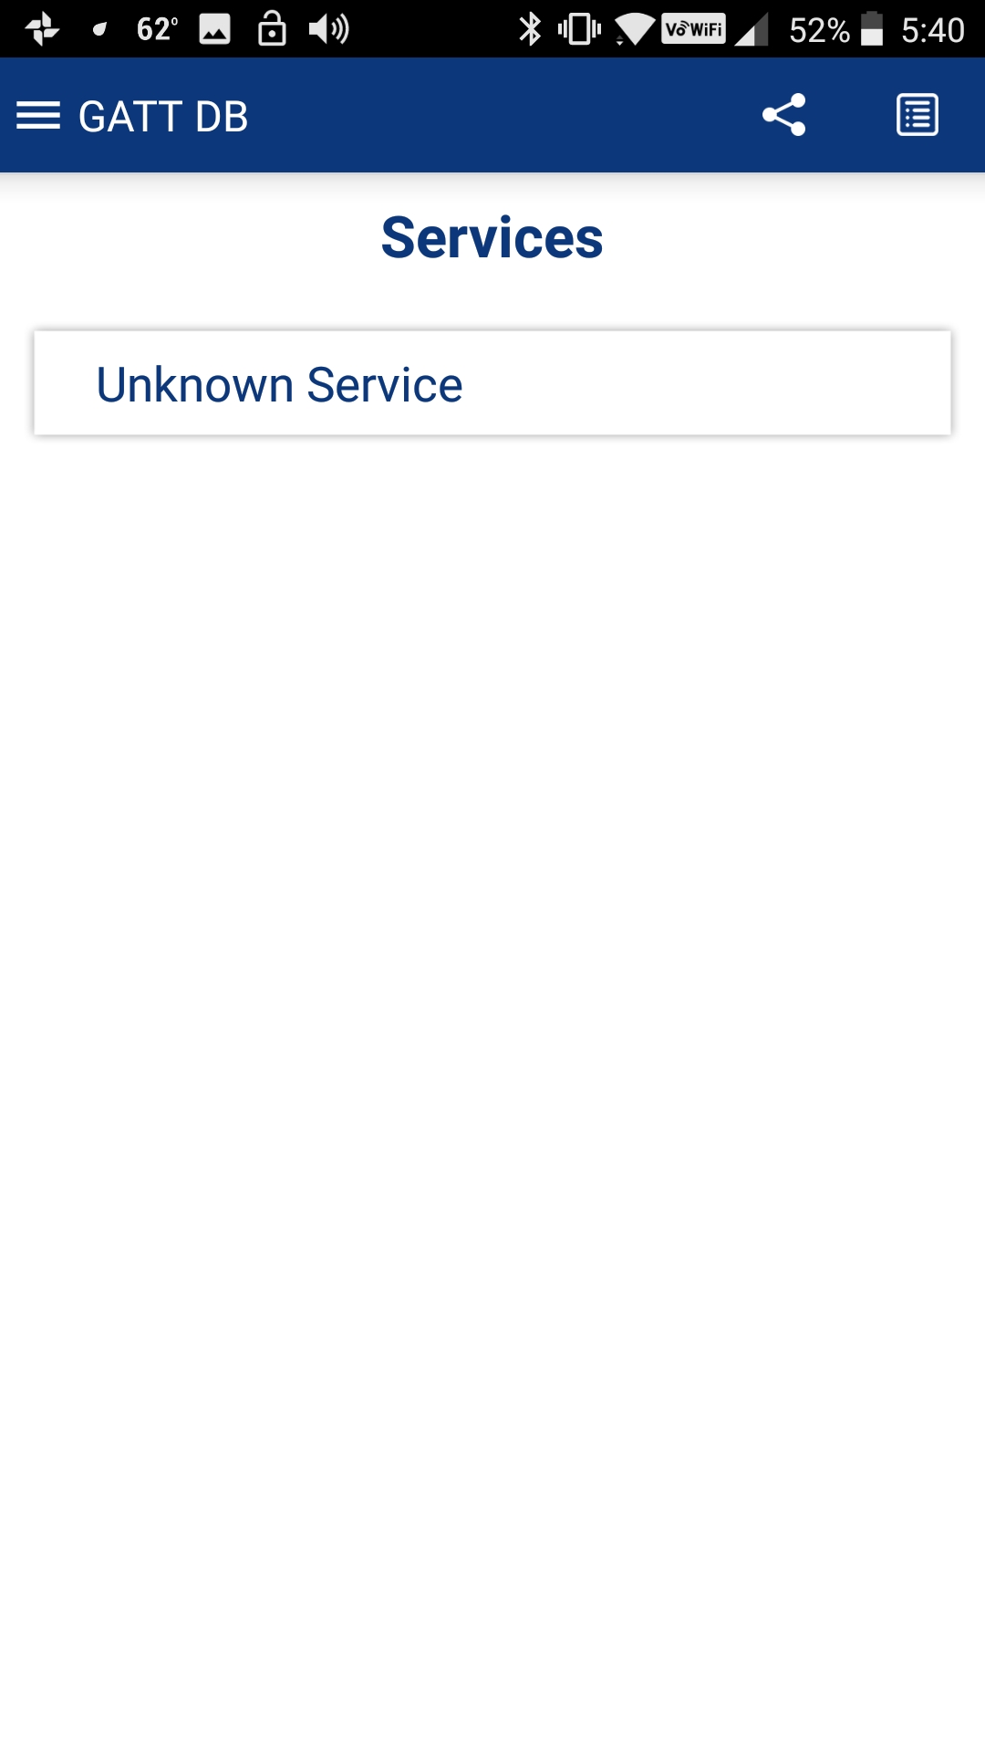 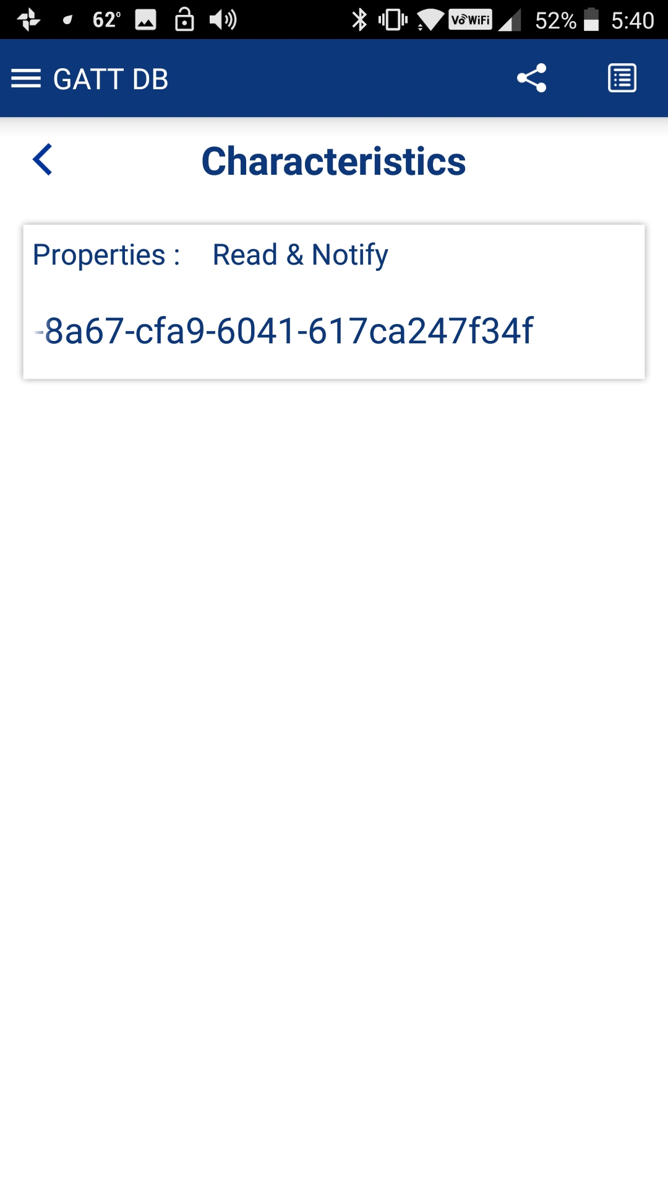

Tap the Read button to read the value. Press the button on the kit a few times and then Read again to see the incremented value. Then tap the Notify button to enable notifications. Now each time you press the button the value is shown automatically.

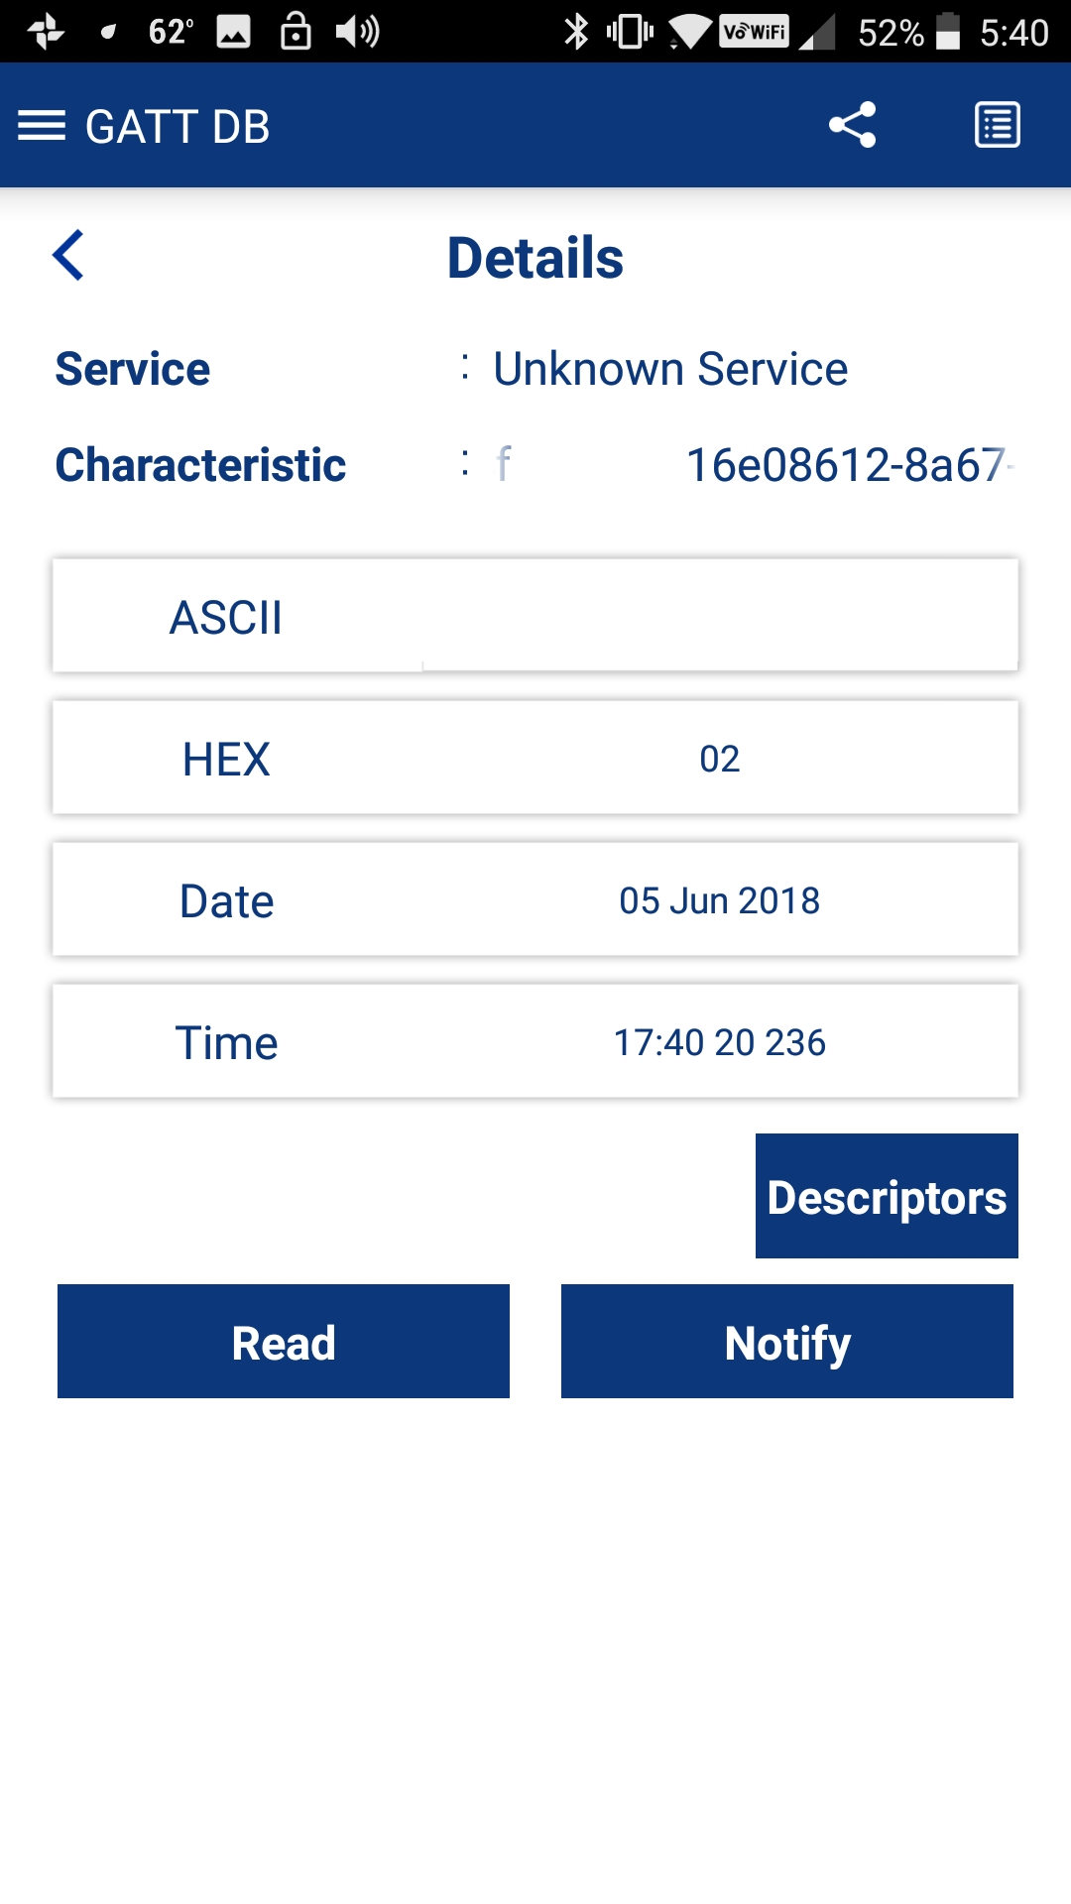 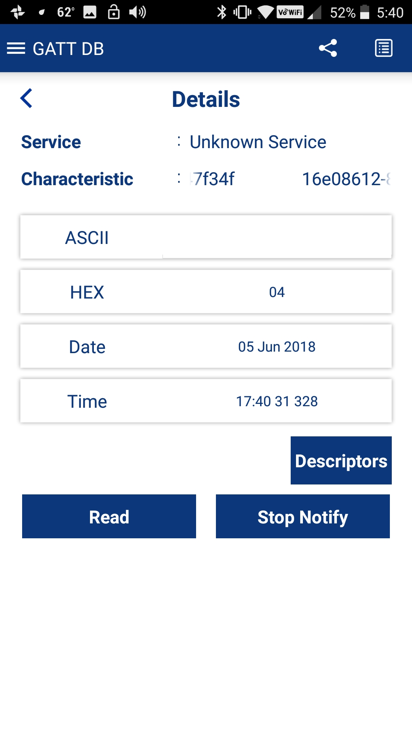

When you are done, press back until CySmart disconnects. Then go to your phone's Bluetooth settings and remove the device from the list of paired devices. If you don't do this, you will have trouble connecting again once you re-program your kit since it will no longer match the information stored on the phone.

# WICED Bluetooth Firmware Architecture

The firmware architecture is the same as was described in the previous chapter. The only difference is that there are additional Stack Management events and GATT Database events that occur.

For a typical BLE application that connects using a Paired link but does NOT use privacy, does NOT store bonding information in NVRAM and does NOT require a passkey, the order of callback events will look like this:

|  |  |  |
| --- | --- | --- |
| **Activity** | **Callback Event Name (both Stack and GATT)** | **Reason** |
| Powerup | BTM_LOCAL_IDENTITY_KEYS_REQUEST_EVT | At initialization, the BLE stack looks to see if the privacy keys are available. If privacy is not enabled, then this state does not need to be implemented. |
| BTM_ENABLED_EVT | This occurs once the BLE stack has completed initialization. Typically, you will start up the rest of your application here. |
| BTM_BLE_ADVERT_STATE_CHANGED_EVT | This occurs when you enable advertisements. You will see a return value of 3 for fast advertisements. After a timeout, you may see this again with a return value of 4 for slow advertisements. Eventually the state changes to 0 (off) if there have been no connections, giving you a chance to save power. |
| Connect | GATT_CONNECTION_STATUS_EVT | The callback needs to determine if the event is a connection or a disconnection. For a connection, the connection ID is saved, and pairing is enabled (if a secure link is required). |
| BTM_BLE_ADVERT_STATE_CHANGED_EVT | Once the connection happens, the stack stops advertisements which will result in this event. You will see a return value of 0 which means advertisements have stopped. |
| Pair  (if secure link is required) | BTM_SECURITY_REQUEST_EVT | The occurs when the client requests a secure connection. When this event happens, you need to call wiced_bt_ble_security_grant() to allow a secure connection to be established. |
| BTM_PAIRING_IO_CAPABILITIES_BLE_REQUEST_EVT | This occurs when the client asks what type of capability your device has that will allow validation of the connection (e.g. screen, keyboard, etc.). You need to set the appropriate values when this event happens. |
| BTM_ENCRYPTION_STATUS_EVT | This occurs when the secure link has been established. |
| BTM_PAIRED_DEVICE_LINK_KEYS_UPDATE_EVT | This event is used so that you can store the paired devices keys if you are storing bonding information. If not, then this state does not need to be implemented. |
| BTM_PAIRING_COMPLETE_EVT | This event indicates that pairing has been completed successfully. |
| Read Values | GATT_ATTRIBUTE_REQUEST_EVT 🡪 GATTS_REQ_TYPE_READ | The firmware must get the value from the correct location in the GATT database. |
| Write Values | GATT_ATTRIBUTE_REQUEST_EVT 🡪 GATTS_REQ_TYPE_WRITE | The firmware must store the provided value in the correct location in the GATT database. |
| Notifications | N/A | Notifications must be sent whenever an attribute that has notifications set is updated by the firmware. Since the change comes from the local firmware, there is no stack or GATT event that initiates this process. |
| Disconnect | GATT_CONNECTION_STATUS_EVT | For a disconnection, the connection ID is reset, all CCCD settings are cleared, and advertisements are restarted. |
| BTM_BLE_ADVERT_STATE_CHANGED_EVT | Upon a disconnect, the firmware will get a GATT event handler callback for the GATT_CONNECTION_STATUS_EVENT (more on this later). At that time, it is the user's responsibility to determine if advertising should be re-started. If it is restarted, then you will get a BLE stack callback once advertisements have restarted with a return value of 3 (fast advertising) or 4 (slow advertising). |

If bonding information is stored to NVRAM, the event sequence will look like the following. The sequence is shown for three cases (each shaded differently):

1. First-time connection before bonding information is saved
2. Connection after bonding information has been saved for disconnect/re-connect without resetting the kit between connections.
3. Connection after bonding information has been saved for disconnect/reset/re-connect.

In the reconnect cases, you can see that the pairing sequence is greatly reduced since keys are already available.

| **Activity** | **Callback Event Name** | **Reason** |
| --- | --- | --- |
| 1st Powerup | BTM_LOCAL_IDENTITY_KEYS_REQUEST_EVT | When this event occurs, the firmware needs to load the privacy keys from NVRAM. If keys have not been previously saved for the device, then this state must return a value other than WICED_BT_SUCESS such as WICED_BT_ERROR. The non-success return value causes the stack to generate new privacy keys. |
| BTM_ENABLED_EVT | This occurs once the BLE stack has completed initialization. Typically, you will start up the rest of your application here.  During this event, the firmware needs to load keys (which also includes the BD_ADDR) for a previously bonded device from NVRAM and then call *wiced_bt_dev_add_device_to_address_resolution_db*() to allow connecting to an bonded device. If a device has not been previously bonded, this will return values of all 0. |
| BTM_BLE_ADVERT_STATE_CHANGED_EVT | This occurs when you enable advertisements. You will see a return value of 3 for fast advertisements. After a timeout, you may see this again with a return value of 4 for slow advertisements. Eventually the state changes to 0 (off) if there have been no connections, giving you a chance to save power. |
| BTM_LOCAL_IDENTITY_KEYS_UPDATE_EVT | This event is called if reading of the privacy keys from NVRAM failed (i.e. the return value from BTM_LOCAL_IDENTITY_KEYS_REQUEST_EVT was not 0). During this event, the privacy keys must be saved to NVRAM. |
| BTM_LOCAL_IDENTITY_KEYS_UPDATE_EVT | This is called twice to update both the IRK and the ER in two steps. |
| 1st Connect | GATT_CONNECTION_STATUS_EVT | The callback needs to determine if the event is a connection or a disconnection. For a connection, the connection ID is saved, and pairing is enabled (if a secure link is required). |
| BTM_BLE_ADVERT_STATE_CHANGED_EVT | Once the connection happens, the stack stops advertisements which will result in this event. You will see a return value of 0 which means advertisements have stopped. |
| 1st Pair | BTM_SECURITY_REQUEST_EVT | The occurs when the client requests a secure connection. When this event happens, you need to call wiced_bt_ble_security_grant() to allow a secure connection to be established. |
| BTM_PAIRING_IO_CAPABILITIES_BLE_REQUEST_EVT | This occurs when the client asks what type of capability your device has that will allow validation of the connection (e.g. screen, keyboard, etc.). You need to set the appropriate values when this event happens. |
| BTM_PASSKEY_NOTIFICATION_EVT | This event only occurs if the IO capabilities are set such that your device has the capability to display a value, such as BTM_IO_CAPABILITIES_DISPLAY_ONLY. In this event, the firmware should display the passkey so that it can be entered on the client to validate the connection. |
| BTM_USER_CONFIRMATION_REQUEST_EVT | This event only occurs if the IO capabilities are set such that your device has the capability to display a value and accept Yes/No input, such as BTM_IO_CAPABILITIES_DISPLAY_ANT_YES_NO_INPUT. In this event, the firmware should display the passkey so that it can be compared with the value displayed on the Client. This state should also provide confirmation to the Stack (either with or without user input first). |
| BTM_ENCRYPTION_STATUS_EVT | This occurs when the secure link has been established. Previously saved information such as paired device BD_ADDR and notify settings is read. If no device has been previously bonded, this will return all 0's. |
| BTM_PAIRED_DEVICE_LINK_KEYS_UPDATE_EVT | During this event, the firmware needs to store the keys of the paired device (including the BD_ADDR) into NVRAM so that they are available for the next time the devices connect. |
| BTM_PAIRING_COMPLETE_EVT | This event indicates that pairing has been completed successfully.  Information about the paired device such as its BT_ADDR should be saved in NVRAM at this point. You may also initialize other state information to be saved such as notify settings. |
| Read Values | GATT_ATTRIBUTE_REQUEST_EVT 🡪 GATTS_REQ_TYPE_READ | The firmware must get the value from the correct location in the GATT database. |
| Write Values | GATT_ATTRIBUTE_REQUEST_EVT 🡪 GATTS_REQ_TYPE_WRITE | The firmware must store the provided value in the correct location in the GATT database. |
| Notifications | N/A | Notifications must be sent whenever an attribute that has notifications set is updated by the firmware. Since the change comes from the local firmware, there is no stack or GATT event that initiates this process. |
| Disconnect | BTM_BLE_ADVERT_STATE_CHANGED_EVT | Upon a disconnect, the firmware will get a GATT event handler callback for the GATT_CONNECTION_STATUS_EVENT (more on this later). At that time, it is the user's responsibility to determine if advertising should be re-started. If it is restarted, then you will get a BLE stack callback once advertisements have restarted with a return value of 3 (fast advertising) or 4 (slow advertising). |
| Re-Connect | GATT_CONNECTION_STATUS_EVT | The callback needs to determine if the event is a connection or a disconnection. For a connection, the connection ID is saved, and pairing is enabled (if a secure link is required). |
| BTM_BLE_ADVERT_STATE_CHANGED_EVT | Advertising off. |
| Re-Pair | BTM_ENCRYPTION_STATUS_EVT | In this state, the firmware reads the state of the server from NVRAM. For example, the BD_ADDR of the paired device and the saved state of any notify settings may be read.  Since the paired device BD_ADDR and keys were already available, no other steps are needed to complete pairing. |
| Read Values | GATT_ATTRIBUTE_REQUEST_EVT 🡪 GATTS_REQ_TYPE_READ | The firmware must get the value from the correct location in the GATT database. |
| Write Values | GATT_ATTRIBUTE_REQUEST_EVT 🡪 GATTS_REQ_TYPE_WRITE | The firmware must store the provided value in the correct location in the GATT database. |
| Notifications | N/A | Notifications must be sent whenever an attribute that has notifications set is updated by the firmware. Since the change comes from the local firmware, there is no stack or GATT event that initiates this process. |
| Disconnect | BTM_BLE_ADVERT_STATE_CHANGED_EVT | Advertising on. |
| Reset | BTM_LOCAL_IDENTITY_KEYS_REQUEST_EVT | Local keys are loaded from NVRAM. |
| BTM_ENABLED_EVT | Stack is enabled. Paired device keys (including the BD_ADDR) are loaded from NVRAM and the device is added to the address resolution database. |
| BTM_BLE_ADVERT_STATE_CHANGED_EVT | Advertising on. |
| Re-Connect | GATT_CONNECTION_STATUS_EVT | The callback needs to determine if the event is a connection or a disconnection. For a connection, the connection ID is saved, and pairing is enabled (if a secure link is required). |
| BTM_BLE_ADVERT_STATE_CHANGED_EVT | Advertising off. |
| Re-Pair | BTM_PAIRED_DEVICE_LINK_KEYS_REQUEST_EVT | Since we are connecting to a known device (because it is in the address resolution database), this event is called by the stack so that the firmware can load the paired device's keys from NVRAM. If keys are not available, this state must return WICED_BT_ERROR. That return value causes the stack to generate keys and then it will call the corresponding update event so that the new keys can be saved in NVRAM. |
| BTM_ENCRYPTION_STATUS_EVT | In this state, the firmware reads the state of the server from NVRAM. For example, the BD_ADDR of the paired device and the saved state of any notify settings may be read.  Since the paired device BD_ADDR and keys were already available in NVRAM, no other steps are needed to complete pairing. |
| Read Values | GATT_ATTRIBUTE_REQUEST_EVT 🡪 GATTS_REQ_TYPE_READ | The firmware must get the value from the correct location in the GATT database. |
| Write Values | GATT_ATTRIBUTE_REQUEST_EVT 🡪 GATTS_REQ_TYPE_WRITE | The firmware must store the provided value in the correct location in the GATT database. |
| Notifications | N/A | Notifications must be sent whenever an attribute that has notifications set is updated by the firmware. Since the change comes from the local firmware, there is no stack or GATT event that initiates this process. |
| Disconnect | BTM_BLE_ADVERT_STATE_CHANGED_EVT | Advertising on. |

# Exercises

* 1. Simple BLE Project with Notifications using WICED BT Designer

Follow the instructions in section 4B.6 to use WICED BT Designer to create a project with a Service called WicedButton and a Characteristic called MB1 that will keep track of how many times mechanical button 1 has been pressed and will send a notification if it is enabled by the client.

Hint: Remember to use your initials in the project name (i.e. device name) so that you can find it in the list of devices that will be advertising.

Hint: Remember to add the option BT_DEVICE_ADDRESS=random to the make target so that your device's address will not conflict with another kit in the class.

Hint: You may want to move the project from apps into the folder for ch04b and rename the project folder to ex01_<inits>_Button to keep the projects organized. If you do, remember to update the make target.

* 1. BLE Notifications for Wiced101 Button

### Introduction

In this exercise, you will add notifications manually to the LED and Button BLE project from the previous chapter. This will allow you to become more familiar with the GATT permissions in the firmware and will also allow you to re-use the custom code created for handling the LED and Button in the Wiced101 Service.

Below is a table showing the events that occur during this exercise. Arrows indicate the cause/effect of the stack events. New events introduced in this exercise are highlighted.

|  |  |  |
| --- | --- | --- |
| **External Event** | **BLE Stack Event** | **Action** |
| Board reset 🡪 | BTM_LOCAL_IDENTITY_KEYS_REQUEST_EVT 🡪 | Not used yet |
| BTM_ENABLED_EVT 🡪 | Initialize application. |
|  | BTM_BLE_ADVERT_STATE_CHANGED_EVT (BTM_BLE_ADVERT_ UNDIRECTED _HIGH) | 🡨 Start advertising |
| CySmart will now see advertising packets |  |  |
| Connect to device from CySmart 🡪 | GATT_CONNECTION_STATUS_EVT 🡪 | Set the connection ID and enable pairing |
| BTM_BLE_ADVERT_STATE_CHANGED_EVT (BTM_BLE_ADVERT_OFF) |  |
| Read button characteristic while pressing button 🡪 | GATT_ATTRIBUTE_REQUEST_EVT, GATTS_REQ_TYPE_READ 🡪 | Returns button state |
| Read Button CCCD 🡪 | GATT_ATTRIBUTE_REQUEST_EVT, GATTS_REQ_TYPE_READ 🡪 | Returns button notification setting |
| Write 01:00 to Button CCCD 🡪 | GATT_ATTRIBUTE_REQUEST_EVT, GATTS_REQ_TYPE_WRITE 🡪 | Enables notifications |
| Press or release button 🡪 |  | Send notifications |
| Disconnect 🡪 | GATT_CONNECTION_STATUS_EVT 🡪 | Clear the connection ID and re-start advertising |
| BTM_BLE_ADVERT_STATE_CHANGED_EVT (BTM_BLE_ADVERT_UNDIRECTED_HIGH) |  |
| Wait for timeout. 🡪 | BTM_BLE_ADVERT_STATE_CHANGED_EVT  (BTM_BLE_ADVERT_ UNDIRECTED _LOW) | Stack switches to lower advertising rate to save power |
| Wait for timeout. 🡪 | BTM_BLE_ADVERT_STATE_CHANGED_EVT  (BTM_BLE_ADVERT_OFF) | Stack stops advertising. |

### Project Creation

1. Copy the folder from the class files at WBT101_Files/Templates/ch04b/ex02_ble_ntfy into the ch04b folder for your workspace.
   1. Hint: The template is just the solution from exercise ch04a/ex04_ble_con so if you prefer, you can instead copy your answer to that exercise and rename things as necessary.
   2. Hint: Change the name from *key_ntfy to use your initials instead of "key"* in the wiced_bt_cfg.c file and the ex02_ble_ntfy.c file.
   3. Hint: If your initials are more than 3 letters, make sure you also update the maxlen and curlen in the GATT database lookup table (gatt_db_lookup_table).
2. In the GATT database header file, add a new handle for a Client Characteristic Configuration Descriptor (CCCD) for the Wiced101 Service, Button Characteristic.
   1. Hint: the format is: HDLD_<service>_<characteristic>_CLIENT_CONFIGURATION <value>.
   2. Hint: use the next free handle value.
   3. Note: This could have been done in WICED Bluetooth Designer when the Characteristic was setup in the starting exercise, but we wanted you to practice reading and modifying the GATT permissions on your own.
3. In the GATT database C file, add the Client Characteristic Configuration Descriptor to the GATT database for the Button Characteristic.
   1. Hint: We are not adding in pairing yet so make sure the CCCD value has the Read and Write Permissions set. That is, don't include *LEGATTDB_PERM_AUTH_WRITABLE* in the permissions.
4. In the GATT database C file, update the Properties for the Button Characteristic to enable Notifications.
5. In the main C file, add the CCCD initial value array
   1. Hint: The CCCD is an array of 2 uint8_t values.
   2. Hint: Initialize the CCCD value array to {0x00, 0x00}.
6. Add the CCCD handle and array name to the GATT attribute lookup table.
7. In the GATT connect handler function for a disconnection add code to turn off the CCCD notifications.
8. In the button callback, check to see if there is a connection (i.e. connection_id is not 0) and if notifications are enabled. If both are true, send the notification.
   1. Hint: There is a bitmask defined called *GATT_CLIENT_CONFIG_NOTIFICATION* which can be used to mask out the bit for notifications.
   2. Hint: the API to send the notification is *wiced_bt_gatt_send_notification*.

### Testing

1. Create a Make Target and run it to program the project to the board. Make sure you include the option for BT_DEVICE_ADDRESS=random.
2. Open the mobile CySmart app.
3. Connect to the device.
4. Open the GATT browser. Traverse down to the Button Characteristic and notice that there are now selections for Read and Notify. Turn on Notify and then press the button to observe that changes are reported real-time.
5. Disconnect from the mobile CySmart app and start the PC CySmart app.
6. Start scanning. When you see your device show up, stop scanning and then connect to your device.
7. Notice that the address that appears in the scan results is the "Public Address". This is because we have disabled privacy.
8. Click on "Discover all Attributes" and then on "Enable All Notifications".
   1. Hint: you can also turn on/off notifications individually by selecting the Client Characteristic Configuration Description attribute and writing a 1 (to enable) or a 0 (to disable) to the LSB.
      1. Hint: Remember that BLE is little-endian so the left-most byte is the LSB.
9. Press the button and observe that the value updates real-time due to the notifications.
10. Click on "Disable All Notifications"
11. Press the button again and observe that the values are no longer updated.
12. Click "Disconnect".
    1. BLE Pairing and Security

### Introduction

In this exercise, you will add Pairing and Security (Encryption) to the previous project.

Below is a table showing the events that occur during this exercise. Arrows indicate the cause/effect of the stack events. New events introduced in this exercise are highlighted.

|  |  |  |
| --- | --- | --- |
| **External Event** | **BLE Stack Event** | **Action** |
| Board reset 🡪 | BTM_LOCAL_IDENTITY_KEYS_REQUEST_EVT 🡪 | Not used yet. |
| BTM_ENABLED_EVT 🡪 | Initialize application. |
|  | BTM_BLE_ADVERT_STATE_CHANGED_EVT (BTM_BLE_ADVERT_ UNDIRECTED _HIGH) | 🡨 Start advertising |
| CySmart will now see advertising packets |  |  |
| Connect to device from CySmart 🡪 | GATT_CONNECTION_STATUS_EVT 🡪 | Set the connection ID and enable pairing |
| BTM_BLE_ADVERT_STATE_CHANGED_EVT (BTM_BLE_ADVERT_OFF) |  |
| Pair 🡪 | BTM_SECURITY_REQUEST_EVT 🡪 | Grant security |
| BTM_PAIRING_IO_CAPABILITIES_BLE_REQUEST_EVT🡪 | Capabilities are set |
| BTM_ENCRYPTION_STATUS_EVT | Not used yet |
| BTM_PAIRED_DEVICE_LINK_KEYS_UPDATE_EVT | Not used yet |
| BTM_PAIRING_COMPLETE_EVT | Not used yet |
| Read Button characteristic while pressing button 🡪 | GATT_ATTRIBUTE_REQUEST_EVT, GATTS_REQ_TYPE_READ 🡪 | Returns button state |
| Read Button CCCD 🡪 | GATT_ATTRIBUTE_REQUEST_EVT, GATTS_REQ_TYPE_READ 🡪 | Returns button notification setting |
| Write 01:00 to Button CCCD 🡪 | GATT_ATTRIBUTE_REQUEST_EVT, GATTS_REQ_TYPE_WRITE 🡪 | Enables notifications |
| Press button 🡪 |  | Send notifications |
| Disconnect 🡪 | GATT_CONNECTION_STATUS_EVT 🡪 | Clear the connection ID |
| BTM_BLE_ADVERT_STATE_CHANGED_EVT (BTM_BLE_ADVERT_UNDIRECTED_HIGH) | Re-start advertising |
| Wait for timeout 🡪 | BTM_BLE_ADVERT_STATE_CHANGED_EVT  (BTM_BLE_ADVERT_ UNDIRECTED _LOW) | Stack switches to lower advertising rate to save power |
| Wait for timeout 🡪 | BTM_BLE_ADVERT_STATE_CHANGED_EVT  (BTM_BLE_ADVERT_OFF) | Stack stops advertising |

### Project Creation

1. Copy the folder from the class files at WBT101_Files/Templates/ch04b/ex03_ble_pair into the ch04b folder for your workspace.
   1. Hint: The template is just the solution from exercise ex02_ble_ntfy so if you prefer, you can instead copy your answer to that exercise and rename things as necessary.
   2. Hint: Change the name from *key_pair to use your initials instead of "key"* in the wiced_bt_cfg.c file and the ex03_ble_pair.c file.
   3. Hint: If your initials are more than 3 letters, make sure you also update the maxlen and curlen in the GATT database lookup table (gatt_db_lookup_table).
2. Find the call to *wiced_bt_set_pairable_mode* mode that was changed earlier and set it to WICED_TRUE to allow pairing.
3. In the BTM_PAIRING_IO_CAPABILITIES_BLE_REQUEST_EVT event, change the following two settings:
   1. p_event_data->pairing_io_capabilities_ble_request.auth_req = BTM_LE_AUTH_REQ_SC_MITM_BOND;
   2. p_event_data->pairing_io_capabilities_ble_request.init_keys = BTM_LE_KEY_PENC|BTM_LE_KEY_PID;

These settings are used to determine the type of security used during pairing. The new settings specify to use a secure connection. The authorization request and init_keys each have many options which can be explored in wiced_bt_dev.h. The values we selected determine that the link must use an LE secure connection with MITM and bonding, and that the encryption information and identity keys of the peer device are distributed.

1. In the GATT database C file, update the Button Characteristic Permissions so that Reads require an authenticated link. Update the CCCD Permissions so that both Reads and Writes require an authenticated link. We will leave the LED Characteristic as-is so that will be Readable and Writable with either an authenticated or an unauthenticated link.
   1. Hint: You need both "LEGATTDB_PERM_READABLE" and " LEGATTDB_PERM_AUTH_READABLE" to make a Characteristic readable only in an authenticated link. The same goes for " LEGATTDB_PERM_WRITE_REQ" and LEGATTDB_PERM_AUTH_WRITABLE". That is, you will ORing in new permissions but not removing any existing ones.

### Testing

1. Create a Make Target and run it to program the project to the board. Be sure to include the option for BT_DEVICE_ADDRESS=random.
2. Open the mobile CySmart app.
3. Connect to the device.
4. Open the GATT browser, navigate to the Button characteristic, enable notifications and observe the button value while pressing and releasing the button on the kit.
5. Disconnect from the mobile CySmart app.
6. Go to the phone's Bluetooth settings and remove the <inits>_pair device from the paired devices list. This is necessary so that when you re-program the kit the phone won't have stale bonding information stored which could prevent you from re-connecting. In the next exercise we'll store bonding information on the device so that you will be able to leave the devices paired.
7. Start the PC CySmart app. Scan for your device and connect to it.
8. Click on "Discover all Attributes" and then on "Enable Notifications". Notice that you will get an authentication error. Click "OK" to close the error window.
9. Try reading the Button Characteristic Value manually. Notice that you again get an authentication error. Click "OK" to close the error window.
10. Try reading and writing the LED Characteristic and notice that it works even though pairing has not been done.
11. Click on "Pair" and click "No" when asked if you want to add the device to the resolving list since we haven't yet enabled privacy.
12. Click on "Enable All Notifications" again. Now when you press the button you will see the characteristic value change.
13. Click on "Disable All Notifications" and then read the Button Characteristic Value manually. It should now work.
14. Try reading and writing the LED Characteristic again to see that it is still accessible.
15. Click "Disconnect".
16. From the Device List, select a Device Address and select "Clear -> All" since we have not stored bonding information in the device yet.

### Questions

1. How long does the device stay in high duty cycle advertising mode? How long does it stay in low duty cycle advertising mode? Where are these values set?
   1. (Advanced) Save BLE Pairing Information (i.e. Bonding) and Enable Privacy

### Introduction

The prior exercise has been modified for you to save and restore bonding information to NVRAM. You will copy over the code, program it to your kit, experiment with it, and then answer questions about the stack events that occur.

By saving Bonding information on both sides (i.e. the client and the server) future connections between the devices can be established more quickly with fewer steps. This is particularly useful for devices that require a pairing passkey (which will be added in the next exercise) since saving the bonding information means the passkey doesn't have to be entered every time the device connects.

Moreover, since the keys are saved on both devices, they don't need to be exchanged again. This means that after the first connection, there is no possibility of a MITM attack since the keys are not sent out over the air.

The firmware has two "modes": *bonding mode* and *bonded mode*. After programming, the kit will start out in bonding mode. LED1 will blink slowly (1 sec duty cycle) to indicate that the kit is waiting to be Paired/Bonded. Once a Client connects to the kit and pairs with it, the Bonding information will be saved in non-volatile memory. The LED will be ON since the kit is connected. The only Client that will be allowed to pair with the kit is the one that is bonded (the firmware only allows 1 bonded device at a time for now). If the Bonding information is removed from the Client, it will no longer be able to Pair/Bond with the kit without going through the Paring/Bonding process again.

When you disconnect, LED1 will flash rapidly (200ms duty cycle) to indicate that it is bonded. To remove Bonding information from the kit and return bonding mode, press 'e' in the UART terminal window. This will erase the stored bonding information and put the kit back into Bonding mode. LED1 will now go back to a slow flashing rate. When you reconnect, the key must be entered again to connect. This allows you to Pair/Bond from a Client that has "lost" the bonding information or to Pair/Bond with a new device without having to reprogram the kit.

### Project Creation

1. Copy Templates/ch04b/ex04_ble_bond from the electronic class material folder. All of the code for this exercise has already been implemented for you.
   1. Create a new make target. Don't forget the BT_DEVICE_ADDRESS option.
   2. Update the device name in *wiced_bt_cfg.c* and *ex04_ble_bond.c* to *<inits>_bond* where *<inits>* is your initials instead of *"key"*.

### Testing

1. Open a UART terminal window to the PUART.
2. Build the project and program it to the board.
3. Open the CySmart PC application and connect to the dongle.
4. Click ‘Configure Master Settings’ and, under ‘Privacy 1.2’, change the Address Generation Interval to match the *rpa_refresh_timeout* in *wiced_bt_cfg*.
5. If there is anything listed in the "Device List" near the bottom of the screen, click on any device from the list and choose "Clear > All". This will remove any stored bonding information from CySmart so that it will not conflict with your new firmware. It is necessary to do this each time you re-program the kit so that the old information is not used.
6. Start scanning. Once you see your device in the list stop scanning. Note that your device shows up with a Random Bluetooth address now since privacy is enabled.
7. Connect to your device.
8. Click on "Discover all Attributes".
9. Click on "Pair" and click "Yes" when asked if you want to add the device to the resolving list so that the privacy keys will be remembered by CySmart.
   1. Note down the Bluetooth Stack events that occur during pairing. This information is displayed in the UART.
10. Click on "Enable All Notifications". Press the button and observe the characteristic value changes.
11. Click "Disconnect". Do NOT remove the device from the Device List this time – we want bonding information retained.
12. Start a new scan and stop when your device appears in the list.
13. Notice how the Address is now listed as a Public Identity Address rather than Random in the table of discovered devices. Look at the Resolving List; both the Random Device Address and the Public Identity Address are listed. If you click on ‘View …’, some Details concerning the device appear. Multiple things, including the Identity Resolving Key, are listed. The IRK is used to map the Private Random Address to the Public Identity Address.
14. Re-connect to your device.
15. Click on "Discover all Attributes" and "Pair".
    1. Once again note down the Bluetooth Stack events that occur during pairing. You will notice that fewer steps are required this time.
16. Press the button and observe that notifications are already enabled since they were enabled when you disconnected. This information was retained in NVRAM.
17. Disconnect again.
18. Reset or power cycle the board.
    1. Hint: If you power cycle the board, you will need to either reset or re-open the UART terminal window.
19. Start scanning, stop when your device appears, and then connect to your device for a third time.
20. Click on "Discover all Attributes" and "Pair".
    1. Note down the Bluetooth Stack events that occur this time during pairing. Compare to the previous two connections.
21. Note that notifications are still enabled.
22. Disconnect again.
23. Clear the Device List.
24. Start scanning and stop when your device appears. Notice that it again has a Random address type.
25. Connect to your device, "Discover all Attributes" and then try to "Pair". Note that paring will not complete because CySmart no longer has the required keys to use.
    1. Hint: If you look in the UART window you will see a message about the security request being denied.
26. Click on Disconnect and close the Authentication failed message window.
27. Press "e" in the UART window and note that LED1 begins flashing slowly. This indicates that the bonding information has been cleared from the device and it will now allow a new connection.
28. Connect, Discover Attributes, and Pair again. This time it should work.
29. Note the steps that the firmware goes through this time.
30. Disconnect a final time and clear the Device List so that the saved boding information won't interfere with the next exercise.
    1. Hint: You should clear the bonding information from CySmart anytime you are going to reprogram the kit since it will no longer have the bonding information on its side.

### Overview of Changes

1. A structure called "hostinfo" is created which holds the BD_ADDR of the bonded device and the value of the Button CCCD. The BD_ADDR is used to determine when we have reconnected to the same device while the CCCD value is saved so that the state of notifications can be retained across connections for bonded devices.
2. Before initializing the GATT database, existing keys (if any) are loaded from NVRAM. If no keys are available this step will fail so it is necessary to look at the result of the NVRAM read. If the read was successful, then the keys are copied to the address resolution database and the variable called "bond_mode" is set as FALSE. Otherwise, it stays TRUE, which means the device can accept new pairing requests.
3. In the BTM_SECURITY_REQUEST_EVENT look to see if bond_mode is TRUE. Security is only granted if the device is in bond_mode.
4. In the Bluetooth stack event *BTM_PAIRING_COMPLETE_EVT* if bonding was successful write the information from the hostinfo structure into the NVRAM and set bond_mode to FALSE.
   1. This saves hostinfo upon initial pairing. This event is not called when bonded devices reconnect.
5. In the Bluetooth stack event *BTM_ENCRYPTION_STATUS_EVT*, if the device is bonded (i.e. bond_mode is FALSE), read bonding information from the NVRAM into the hostinfo structure.
   1. This reads hostinfo upon a subsequent connection when devices were previously bonded.
6. In the Bluetooth stack event BTM_PAIRED_DEVICE_LINK_KEYS_UPDATE_EVT, save the keys for the peer device to NVRAM.
7. In the Bluetooth stack event BTM_PAIRED_DEVICE_LINK_KEYS_REQUEST_EVT, read the keys for the peer device from NVRAM.
8. In the Bluetooth stack event BTM_LOCAL_IDENTITY_KEYS_UPDATE_EVT, save the keys for the local device to NVRAM.
9. In the Bluetooth stack event BTM_LOCAL_IDENTITY_KEYS_REQUEST_EVT, read the keys for the local device from NVRAM.
10. In the GATT connect callback:
    1. For a connection, save the BD_ADDR of the remote device into the hostinfo structure. This will be written to NVRAM in the BTM_PAIRING_COMPLETE_EVT.
    2. For a disconnection, clear out the BD_ADDR from the hostinfo structure and reset the CCCD to 0.
11. In the GATT set value function, save the Button CCCD value to the hostinfo structure whenever it is updated and write the value into NVRAM.
12. The UART is configured to accept input. The rx_cback function looks for the key "e". If it has been sent, the sets bond_mode to TRUE, removes the bonded device from the list of bonded devices, removes the device from the address resolution database, and clears out the bonding information stored in NVRAM.
13. The timer that blinks the LED during advertising has two different rates. The timer is started during initialization, and then stopped/restarted when a disconnect happens or when bonding information is removed. The timeout is set depending on the value of bond_mode.
14. Finally, privacy is enabled in wiced_bt_cfg.c by updating the rpa_refresh_timeout to *WICED_BT_CFG_DEFAULT_RANDOM_ADDRESS_CHANGE_TIMEOUT*.

### Questions

1. What items are stored in NVRAM?
2. Which event stores each piece of information?
3. Which event retrieves each piece of information?
4. In what event is the privacy info read from NVRAM?
5. Which event is called if privacy information is not retrieved after new keys have been generated by the stack?
   1. (Advanced) Add a Pairing Passkey

### Introduction

In this exercise, you will modify the previous exercise to require a Passkey to be entered to pair the device the first time. The Passkey will be randomly generated by the device and will be sent to the UART. The Passkey will need to be entered in CySmart on the PC or in your Phone's Bluetooth connection settings before Pairing/Bonding will be allowed.

### Project Creation

1. Copy the folder from the class files at WBT101_Files/Templates/ch04b/ex05_ble_pass into the ch04b folder for your workspace.
   1. Hint: The template is just the solution from exercise ex04_ble_bond so if you prefer, you can instead copy your answer to that exercise and rename things as necessary.
   2. Hint: Change the name from *key_pass to use your initials instead of "key"* in the wiced_bt_cfg.c file and the ex05_ble_pass.c file.
   3. Hint: If your initials are more than 3 letters, make sure you also update the maxlen and curlen in the GATT database lookup table (gatt_db_lookup_table).
2. In the Bluetooth Stack event BTM_PAIRING_IO_CAPABILITIES_BLE_REQUEST_EVT:
   1. Change the value for pairing_io_capabilities_ble_request.local_iop_cap from BTM_IO_CAPABILITIES_NONE to BTM_IO_CAPABILITIES_DISPLAY_ONLY.
      1. This indicates that the device can display a key value.
3. Add a Bluetooth stack callback event for BTM_PASSKEY_NOTIFICATION_EVT to send the value of the Passkey to the UART.
   1. Hint: Make sure you print something around the value so that it is easy to find in the terminal window.
   2. Hint: The Passkey must be 6 digits so print leading 0's if the value is less than 6 digits. (i.e. use %06d).
   3. Hint: The key is passed to the callback event as:
      1. p_event_data->user_passkey_notification.passkey

### Testing

1. Create a Make Target and run it to program the project to the board. As usual, don't forget the BT_DEVICE_ADDRESS=random option.
2. Open a UART terminal window.
3. Open the mobile CySmart app.
4. Attempt to Connect to the device and then navigate down to the button characteristic in the GATT browser. You will see a notification from the Bluetooth system asking for the Passkey to be entered. Find the Passkey on the UART terminal window and enter it into the device.
5. Once Pairing and Bonding completes, verify that the application still works.
6. Disconnect and reconnect. Observe that the key does not need to be entered to Pair this time.
7. Disconnect, then manually remove the bonding information from the phone's Bluetooth settings.
8. Press 'e' in the UART terminal to put the kit into Bonding mode (i.e. erase the stored bonding information) and then reconnect. Observe that the key must be entered again to connect.
9. Disconnect again and remove the bonding information from the phone's Bluetooth settings.
10. Now try the same thing using the PC version of CySmart. It will pop up a window when the Passkey is needed.
    1. Hint: Remember to put the kit into Bonding mode first to remove the phone's Bonding information from the kit. This is necessary since we only allow bonding information from one device to be stored in our firmware. The next exercise will fix that.

### Questions

1. Other than BTM_IO_CAPABILITIES_NONE and BTM_IO_CAPABILITIES_DISPLAY_ONLY, what other choices are available? What do they mean?
2. What additional stack callback event occurs compared to the previous exercise? At what point does it get called?
   1. (Advanced) Add Numeric Comparison

### Introduction

In this exercise, you will modify the previous exercise to require the user to compare a 6-digit number on both devices to pair the first time. After comparing that both numbers are the same, the user needs to click "Yes" in CySmart on the PC or in your Phone's Bluetooth connection settings before Pairing/Bonding will be allowed.

### Project Creation

1. Copy the folder from the class files at WBT101_Files/Templates/ch04b/ex06_ble_num into the ch04b folder for your workspace.
   1. Hint: The template is just the solution from exercise ex05_ble_pass so if you prefer, you can instead copy your answer to that exercise and rename things as necessary.
   2. Hint: Change the name from *key_num to use your initials instead of "key"* in the wiced_bt_cfg.c file and the ex05_ble_pass.c file.
   3. Hint: If your initials are more than 3 letters, make sure you also update the maxlen and curlen in the GATT database lookup table (gatt_db_lookup_table).
2. In the Bluetooth Stack event BTM_PAIRING_IO_CAPABILITIES_BLE_REQUEST_EVT:
   1. Change the value for pairing_io_capabilities_ble_request.local_iop_cap to BTM_IO_CAPABILITIES_DISPLAY_AND_YES_NO_INPUT.
      1. This indicates that the device can display a numeric value and can accept a Yes/No response.
3. The BTM_PASSKEY_NOTIFICATION_EVT Stack event won't be called anymore. You can remove it or leave it in if you want to support both connection types depending on the Central's capabilities.
4. WICED Bluetooth Designer already includes the stack event called BTM_USER_CONFIRMATION_REQUEST_EVT so you don't need to implement it. It is setup to automatically send confirmation so that you don't have to enter "Yes" on both the Central device and the Peripheral, but you could add code to read an input before providing the confirmation if you wanted to verify on both devices.
   1. Hint: You may want to change how the value is displayed so that it is more prominent on the UART terminal.

### Testing

1. Create a Make Target and run it to program the project to the board. As usual, don't forget the BT_DEVICE_ADDRESS=random option.
2. Open a UART terminal window.
3. Open the PC CySmart app.
4. Attempt to Connect and then Pair to the device. You will see a notification from CySmart asking for you to verify the number printed by both devices is the same. Find the number on the UART terminal window and click "Yes" if it matches.
5. Once Pairing and Bonding completes, verify that the application still works.
6. Disconnect and reconnect. Observe that the number does not need to be verified to Pair this time.
7. Disconnect, then clear the Device List in CySmart.
8. Enter "e" in the UART window to put the kit into Bonding mode and then reconnect. Observe that the comparison must be done again to connect.
9. Disconnect again and clear the Device List in CySmart.
   1. (Advanced) Add Multiple Bonding Capability

### Introduction

In this exercise, you will copy the multiple bonding project from the templates folder and use it to bond to up to 4 different devices at one time. Note that this application stores bonding information for multiple devices, it does NOT allow multiple simultaneous BLE connections. That is also possible but it is not demonstrated by this example.

### Project Creation

1. Copy templates/ch04b/ex07_ble_multi from the folder provided in the electronic class material, create the Make Target, and make the necessary updates.
   1. Hint: Make sure you change "key" to your initials in both the ex07_ble_multi.c file and wiced_bt_cfg.c file to so that you will be able to find your device.

### Testing

1. Download the project onto the kit.
2. Open a UART terminal window.
3. The device starts out in bonding mode (LED_1 should be flashing slowly – once per second).
4. Open the mobile CySmart app.
5. Discover all attributes in the GATT database, and attempt to Pair with the device.
6. Once Pairing completes, verify that the application still works. The device will now be in “normal mode”.
7. Disconnect from the device. The LED will be flashing rapidly – once every 200ms. Keep the bonding information on the phone.
8. To put the device back in bonding mode, press "e" in the UART terminal. The LED will begin flashing slowly.
   1. Note: If you already have the max number of devices bonded and enter "e" in the UART, it will remove the oldest bonded device before going back into bonding mode.
9. Connect to the device using the PC version of CySmart and Pair with the device.
10. Verify that the application still works.
11. Enter "l" (lower-case letter L) in the UART terminal. You should see a list of the bonded devices on the terminal window.
12. Disconnect from the PC CySmart app, connect again from the phone, and verify that the application still works. It should connect and pair without requiring the passkey.
13. Disconnect from the device, re-connect from the PC, Pair, and verify that the application still works. Again, a passkey should not be required to Pair with the device.
14. Disconnect from the device.
15. Clear the bonding information from the phone and CySmart on the PC.
16. Note: you may not be able to bond to multiple computers running CySmart, but you can connect to a PC and a phone or multiple phones.

### Overview of Changes

1. A #define for BOND_MAX which is the maximum number of devices that can be bonded at a time (default is set to 4).
2. NVSRAM is organized so that we have:
   1. 1 VSID for the local keys (i.e. privacy keys).
   2. 1 VSID to keep track of how many bonded devices we have and the next one to be over-written.
   3. VSIDs to hold host information (i.e. BD_ADDR and CCCD values). There is one VSID for each bonded device so this is BOND_MAX VSIDs.
   4. VSIDs to hold encryption keys for each bonded host. There is one VSID for each bonded device so this is BOND_MAX VSIDs.
3. Update UART receive callback function so that it just toggles whether we are in bonding mode or not when "e" is pressed. Upon entering bonding mode, if the max number of devices is already bonded, it will remove the oldest information from the bonded device list, address resolution database, and NVRAM (hostinfo and paired device keys).
4. Update UART receive callback function that prints bonding information when "l" is pressed.
5. Update BTM_PAIRING_COMPLETE_EVT so that it stores the newly bonded device's host information into the correct VSID slot in NVRAM. That is, it needs to store the information in the first free location. This case also increments the number of bonded devices and increments the next free slot location since a new device has just completed bonding.
6. Update BTM_ENCRYPTION_STATUS_EVT so that it searches for the BD_ADDR of the device that was just paired. If it is found, then the device was previously bonded, so its host information can be read from NVRAM.
7. Update BTM_PAIRED_DEVICE_LINK_KEYS_UPDATE_EVT so that it stores the newly bonded device's encryption key information into the correct VSID slot in NVSRAM. That is, it needs to store the information in the first free location.
8. Update BTM_PAIRED_DEVICE_LINK_KEYS_REQUEST_EVT so that it searches through all bonded devices to determine if the device that is currently trying to pair already has bonding information. If the information is found, it is loaded from NVRAM. If the information is not found, this case returns WICED_BT_ERROR which causes the stack to generate new keys and then call BTM_PAIRED_DEVICE_LINK_KEYS_UPDATE_EVT.
9. Update the GATT set_value function so that it stores any changes to the CCCD value to the proper NVRAM location. That is, the value must be stored in the location that is assigned to the currently connected host.