Graph of Total Seconds of Crying per Each Recording for All Subjects

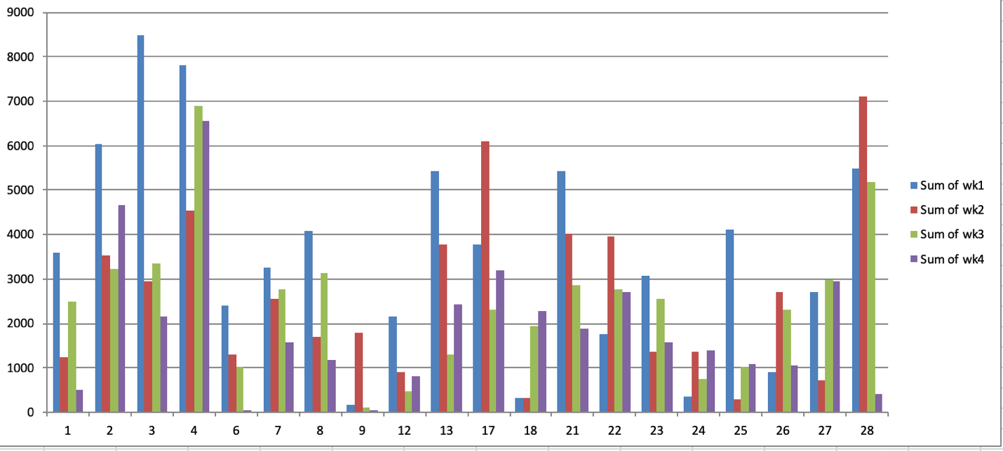

Graph for Total Seconds of Crying/Recording for Infants with First Time Parents

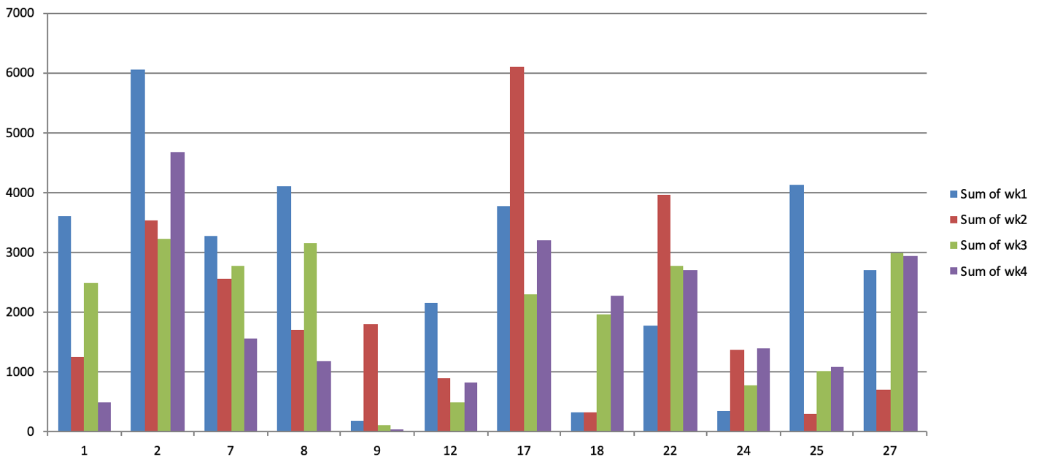

Graph of Total Seconds/Recording for Infants with Experienced Parents

