Richa Bhattacharya

Dr. Cabana

UCSF CHIPPER CRI

January 20 2018

Demographics and Data Analysis

Before analyzing the data provided by the families, we must understand the demographics of our data sample and look for possible features in terms of demographics that may serve as confounding variables.

All participant families in the study were selected based off a uniform criterion. Infants born with were enrolled into the study under the presumptions that they were not premature (born after 38 weeks of gestation) and was the product of a singleton delivery at the UCSF Benioff Children’s Hospital unless we had access to their gestation age and birth weight. All subjects that were entered into study fit into these criteria.

Gestational Age

The typical gestational time for a newborn is around 40 weeks. In our data set, all of our newborns are around 38-41 weeks old. This is important as it eliminates the need for taking into account other variables that could be affecting the crying time of the children including being born prematurely or later than expected.

Age at Enrollment

The first several weeks of life for a newborn are some of the most crucial and drastically different weeks as they are learning about their surroundings at an exponential rate and also acclimating to their new environment more. Consequently, it was important that this study was properly blocking our analyses into analyzing crying time within groups of children who were the same age. This study began with a range of children with around 13 being in their first week of life and one in his fourth week of life. This study was conducted over the course of 3 weeks which means that the data collected has some information regarding crying times for children from their first week of life up until their seventh.

Gender Distribution

The gender distribution of the subjects is also crucial to analyze any possible trends that exist in terms of crying times amongst boys and girls.

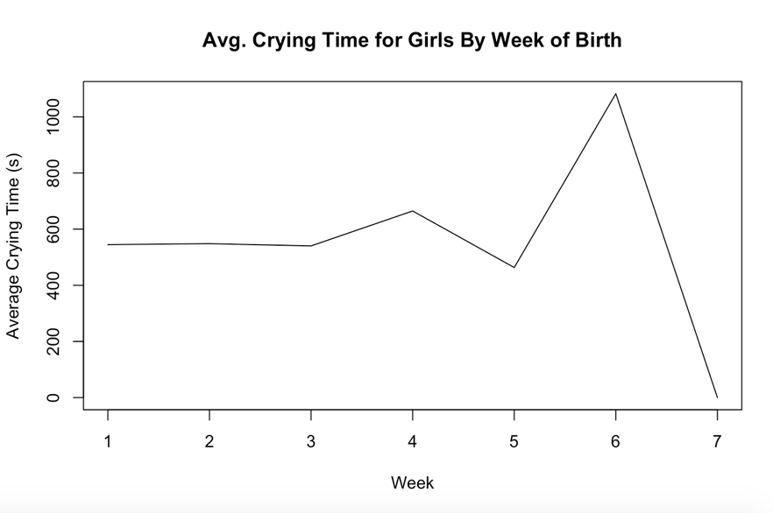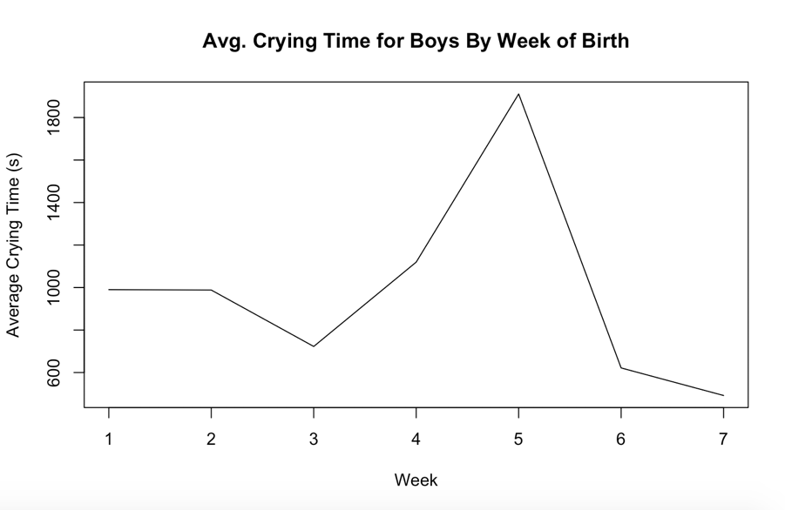

These graphs show us that on average the female children cried less on average than the male children. Interestingly, both groups of children did experience a peak in their average crying time which was not near the beginning or end of the study but rather somewhere in the middle. The average crying time for girls per week typically fluctuated around 600 seconds except for the girls in their sixth week of life, who had an average of over 1000 seconds. Similarly, for the boys, the average crying time fluctuated around 1000 seconds except during week 5 when it peaked to a high of 1800 seconds.

For the purposes of this study, it is also very important to analyze our data under different features of the mother’s information (ie. Mother’s Age, Mother’s Experience, etc). The mother’s background, along with other information about the household in which a child is being brought up can dramatically affect the average crying time of the children within these households.

Mother’s History

A mother’s age and experience with handling children are major confounding variables that can affect the crying time of children. For instance, it is possible that significantly younger mothers would be more quick and more able to stay up and comfort their child into the night to comfort their child. On the other hand, mothers with other children in the household may know how to comfort the child better, but they may also not be able to attend to the child with as much focus because of other younger children in the household who need attention.

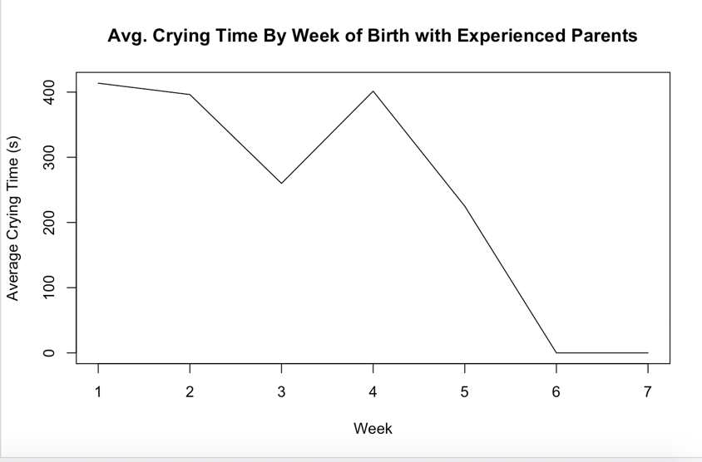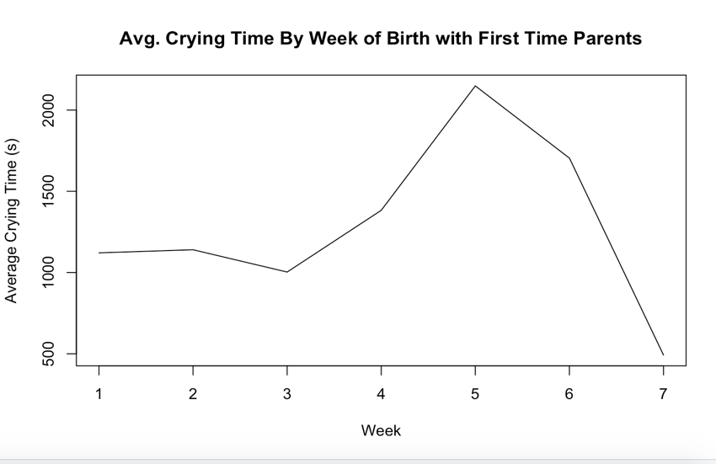

The data shows that children with experienced parents, or in other words, parents who’ve already had more than one child, had a significantly smaller crying time than the children of first time parents. The average crying time with experienced parents had a maximum crying time during the first week which was around 400 seconds, whereas for first time parents in general the crying time was around 1000 seconds or higher and peaked at around 2000 seconds. From the data, we can clearly see that children with first time parents cried significantly more than children with experienced parents did.

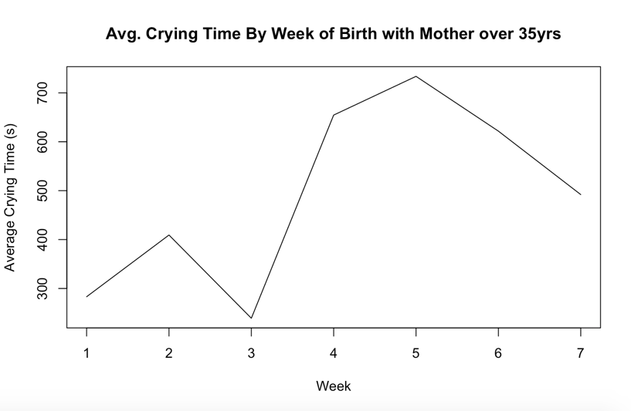

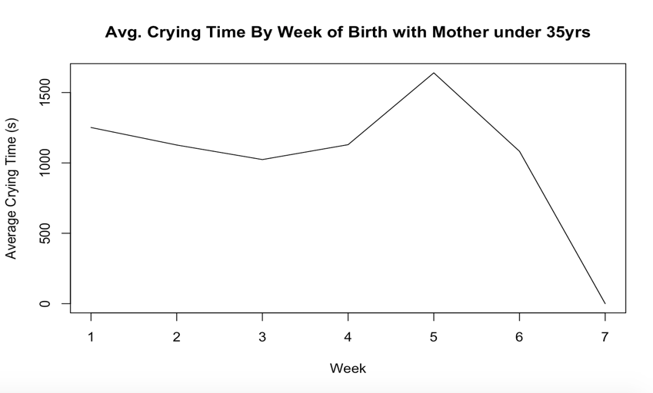

It is interesting to note that the children with mothers under 35 years old had average crying times that ranged within 1750 to 1000 seconds typically compared to children with mothers over the age of 35 had crying times that ranged from 200 to 700 seconds, a significantly lower range.

The table below displays the distribution of children divided under both of the following features, the mother’s age and experience –

|  |  |  |  |  |
| --- | --- | --- | --- | --- |
|  | Above 35, Experienced | Above 35,  First Time | Under 35,  Experienced | Under 35,  First Time |
| Total Subjects | 5 | 0 | 9 | 6 |

From the table, it is evident that all of the women above 35 years of age were experienced, whereas there were both experienced and first-time mother under the age of 35. In order to see if experience seems to be correlated with the lower average crying times, we can graph the two divisions of under 35 against each other and compare them.

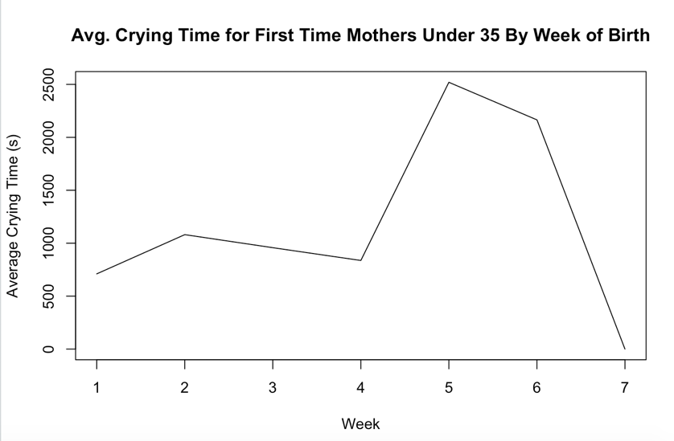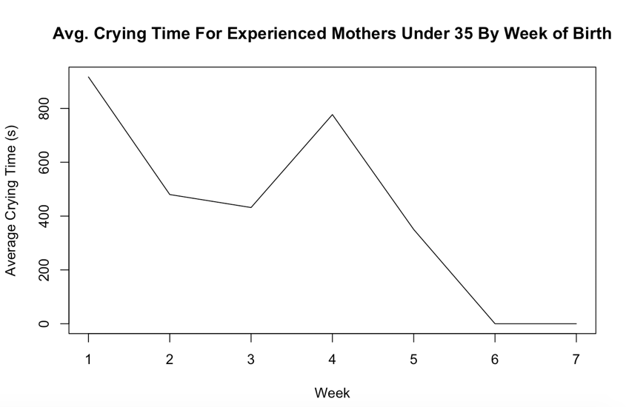

After dividing the data for the average crying time for children with mothers under the age of 35, it is evident that the average crying time with first time mothers under the age of 35 fluctuates from around 800 to as high as 2500 seconds whereas for children with experienced mothers, the average crying times are within 200 to around 800 seconds, significantly lower. This shows that it is possible that children with experienced mothers tends to cry less on average than children with first time mothers.

Another interesting division of our data set to examine would be comparing the average crying times of children who had normal deliveries versus children who were delivered via C-section. In this study, there were 6 children born via C-section, while the rest of the children were born via normal vaginal delivery. Thus, although our sample size for the children born under C-section is extremely small and subject to influences by several other variables, it could be interesting to look at differences among the two groups.

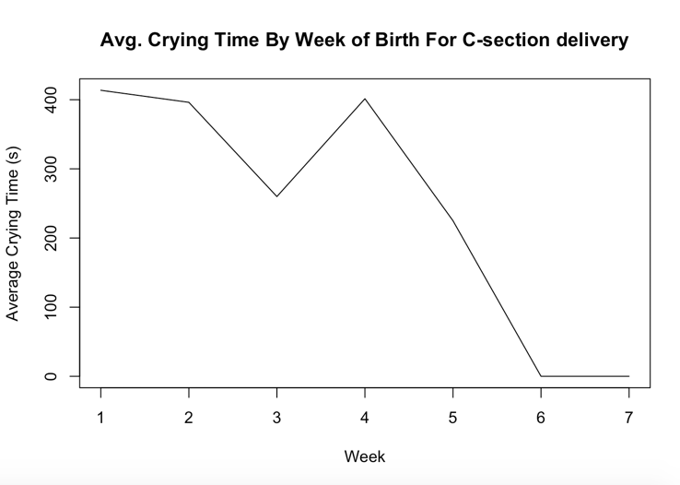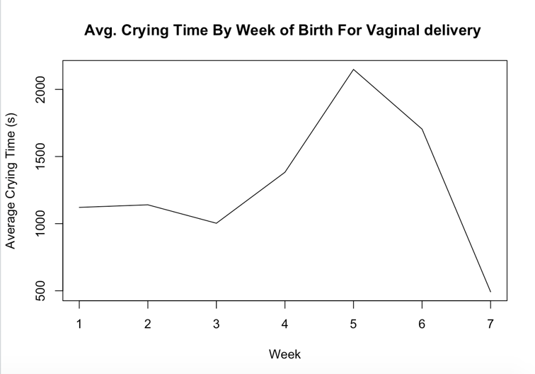

This data division appears to show that the average crying time for children born normally experienced crying times that ranged from 1000 seconds to as high as around 2100 seconds whereas children born under C-section experienced crying times that changed from 400 second to as low as 100.