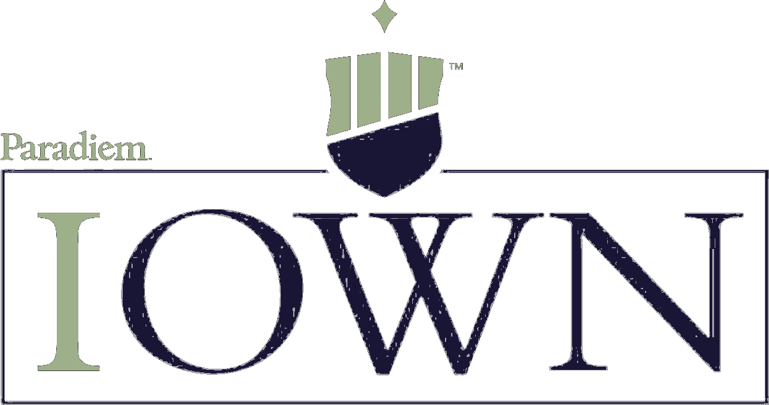
HWKN Hawkins, Inc.
GROWTH SLEEVE · 2026-10-12 · Inspire: 41 · MIXED
WATCH
59 / 100
COMPANY PROFILE
Basic Materials · Specialty Chemicals · NASDAQ · United States
Hawkins, Inc. is a specialty chemical distribution and blending company headquartered in Minneapolis, Minnesota, operating through three segments: Water Treatment (largest and fastest-growing), Industrial, and Health & Nutrition. FY2026 (ended March 2026) revenue reached a record ~$1.08B across four quarters of year-over-year growth, with the Water Treatment segment leading at 16-21% YoY sales growth driven by six acquisitions completed during the fiscal year. Net income was $81.5M ($3.91/share) vs $84.3M ($4.03/share) in FY2025, with EPS pressure from ~$5M in incremental amortization and interest costs related to the acquisition program. CEO Patrick H. Hawkins has led the company since March 2011.
https://www.hawkinsinc.com
EXCELLENCE EVALUATION — THINK LIKE AN OWNER (50%)
Innovation WEAK
3 /10
Track Record (2/3): Hawkins completed six acquisitions in the first nine months of FY2026, transforming from a regional specialty chemical distributor into an increasingly national platform [1][2]. Q2 FY2026 hit a record $280.4M in quarterly revenue (+14% YoY), and Q1 FY2026 reached $293M. The Water Treatment segment grew 16-21% annually through both organic growth and bolt-on acquisitions, fundamentally expanding the company's geographic footprint and customer base. This represents a meaningful strategic evolution through serial M&A execution. AI Deployment (0/2): No evidence of AI-powered products, AI-enhanced logistics, or quantified AI-driven operational efficiencies. Chemical distribution operations appear to run on traditional systems. Market Share (1/2): Hawkins is a meaningful regional-to-national specialty chemical distributor with growing scale through acquisitions, particularly in water treatment where the six FY2026 acquisitions expanded geographic coverage [2]. The company is not a category-defining leader but is an actively consolidating player gaining share through M&A. Product Pipeline (0/2): Growth is acquisition-driven rather than product-innovation-driven. No next-generation chemical products or technology platforms announced with specific timelines. R&D Intensity (0/1): Specialty chemical distribution has minimal traditional R&D. No evidence of above-peer technology investment.
Inspiration DEVELOPING
4 /10
Mission Floor (2/4): Hawkins' purpose centers on providing essential water treatment and industrial chemicals that enable safe drinking water, food production, and manufacturing processes. This is clear and identifies what the company does and for whom, but is not deeply distinctive — many chemical distributors could make a similar claim. The 15-year CEO tenure under Patrick Hawkins suggests leadership stability aligned with long-term purpose. Community Impact (1/2): Hawkins was named to Newsweek's 'America's Most Responsible Companies' list in 2020 and 2021, and Forbes named it one of 'America's Most Trustworthy 100 Companies' [4]. The company published a comprehensive ESG report in 2023 covering environmental, social, and governance metrics. These recognitions suggest above-average corporate responsibility for a mid-cap industrial company, though specific charitable programs with dollar amounts were not identified. Employee Retention (1/2): Glassdoor shows 3.8/5 from 84 reviews with 81% CEO approval for Patrick Hawkins, above the manufacturing industry average of 3.5 [3]. Reviews cite good pay and helpful colleagues, with criticisms of long hours and being stretched thin with many roles to fill. Average-to-good for the specialty chemical industry. Insider Buying (0/2): No evidence of meaningful net insider buying by CEO or executives in the last 12 months.
Infrastructure STRONG
9 /10
Growth stock scored on available metrics. D/E of 47.01% scores 1.0 (1x weight) — strong balance sheet with conservative leverage despite the six-acquisition FY2026 program [1][2]. ROE of 15.6% scores 1.0 (2x weight) — right at the 15% target, reflecting efficient capital deployment. Revenue Growth YoY of 7.6% scores 0.92 (1x weight) — near the 10% target, driven by acquisition-fueled growth in Water Treatment. Forward P/E of 27.10 scores 0.82 (1x weight) — somewhat premium but reflecting the acquisition-driven growth profile. Profit Margin of 7.3% scores 0.37 (1x weight) — below the 20% target, typical of distribution businesses with thin margins offset by volume. Revenue Growth 5yr CAGR and Forward PEG are unavailable and excluded, reducing the denominator from 10 to 6 weight units. Weighted sum 5.11 / max 6.0 = 8.51, rounded to 9. Note: the missing metrics (4/10 weight units) may inflate the score; a fully-evaluated Growth stock with comparable fundamentals would likely score 7-8. Daily dollar volume of $21.5M provides strong institutional-grade liquidity.
FINITE VS INFINITE GAME — SINEK (25%)
Mindset: MIXED Overall: 5 /10
Hawkins shows meaningful elements of infinite game thinking, particularly in its long-term acquisition strategy and leadership continuity. CEO Patrick Hawkins has led the company for 15 years, providing the kind of consistent stewardship that Sinek values [3]. The six-acquisition FY2026 program, despite near-term EPS dilution from amortization and interest costs, represents a deliberate investment in long-term scale over short-term earnings optimization [1][2]. Newsweek and Forbes recognition for corporate responsibility suggests institutional values beyond quarterly performance [4]. However, the company's competitive language focuses on growth metrics and market expansion rather than on a deeply articulated Just Cause, and the acquisition strategy is more about building scale than advancing a transformative purpose.
Just Cause
7 /10
Just Cause (2/3): Hawkins' focus on water treatment chemicals connects the company's work to a genuinely important societal function — enabling safe drinking water for communities across the United States. The acquisition strategy (six deals in FY2026, with Water Treatment leading at 16-21% growth) can be traced back to this purpose of expanding the company's capacity to serve water infrastructure needs [1][2]. CEO Patrick Hawkins' 15-year tenure suggests leadership alignment with long-term purpose. However, the company has not articulated this purpose as a transformative Just Cause in Sinek's framework — it functions more as a business strategy than an idealistic vision of a future state.
Trusting Teams
6 /10
Trusting Teams (1/2): Glassdoor shows 3.8/5 from 84 reviews with 81% CEO approval for Patrick Hawkins, above the manufacturing industry average of 3.5 [3]. The 15-year CEO tenure provides organizational stability and leadership continuity. Reviews describe 'great career opportunities' and helpful colleagues. Criticisms include long hours, being stretched thin with many roles to fill (likely acquisition-related growing pains), and inconsistent regional management. Adequate trust environment for a growing mid-cap industrial company, but not exceptional.
Worthy Rivals
3 /10
Worthy Rivals (0/1): No evidence of an infinite competitive mindset in management commentary. The company's acquisition-driven growth strategy focuses on geographic expansion and scale building rather than learning from competitors' strengths. No public statements from leadership reference worthy rivals or competitive dynamics as motivation for self-improvement.
Existential Flexibility
6 /10
Existential Flexibility (1/2): Hawkins has evolved from a regional chemical distributor into an increasingly national platform through serial M&A, completing six acquisitions in FY2026 alone [1][2]. The Water Treatment segment has become the growth engine (16-21% annual growth), shifting the company's center of gravity toward water infrastructure. This represents meaningful strategic evolution, though the changes are incremental (same industry, adjacent geographies, bolt-on acquisitions) rather than transformative pivots that redefine the company.
Courage To Lead
6 /10
Courage to Lead (1/2): Hawkins accepted a $5M increase in amortization and interest expense in FY2026 from its six-acquisition program, resulting in a 3% EPS decline ($3.91 vs $4.03) despite record revenue growth [1][2]. Management prioritized long-term platform building over short-term earnings optimization, which Sinek would recognize as choosing long-term capability over current performance. The 15-year CEO tenure through multiple economic cycles also demonstrates commitment to the long game. However, chemical distribution acquisitions are relatively low-risk strategic moves — they expand an existing business model rather than represent bold, costly bets on an uncertain future.
INVESTMENT THESIS
Hawkins at $130 with a $2.7B market cap is a well-managed specialty chemical distribution platform executing an aggressive but disciplined acquisition strategy that is building national scale, particularly in the essential water treatment segment [1][2]. FY2026 revenue hit a record ~$1.08B with all three segments growing, led by Water Treatment at 16-21% YoY. CEO Patrick Hawkins' 15-year tenure provides leadership continuity, and the company's ROE of 15.6% with D/E of just 47% demonstrates efficient capital deployment and balance sheet discipline even while funding six acquisitions in a single fiscal year. The business is structurally protected from AI disruption — you cannot replace physical chemicals with software — and the water treatment end market benefits from secular tailwinds around aging U.S. water infrastructure, EPA regulatory tightening, and growing municipal water treatment spending.
The WATCH recommendation reflects the stock's premium valuation (33.7x trailing P/E, 27.1x forward P/E) against thin profit margins (7.3%) and a near-term EPS decline (-3.6%) driven by acquisition-related amortization and interest costs [1][2]. While the acquisition strategy is building long-term value, the current earnings profile doesn't yet reflect the full benefit of the platform buildout, and any execution misstep in integrating six acquisitions could pressure margins further. The forward PEG ratio is unavailable due to negative near-term earnings growth, making it difficult to assess whether the premium multiple is justified by future growth acceleration. Revenue Growth 5yr CAGR data is also unavailable, and these two missing metrics (4/10 weight units) may inflate the calculated Infrastructure score of 9. An upgrade to HOLD would require demonstrated margin expansion as acquisition synergies materialize and clear evidence that the platform investment is translating into accelerating EPS growth rather than just top-line scale.
KEY CATALYSTS
1. Water Treatment segment growing 16-21% annually through organic and acquisitive growth — aging U.S. water infrastructure and EPA regulatory tightening provide secular demand tailwinds for this essential service [1][2]
2. Six FY2026 acquisitions building a national specialty chemical platform — as integration matures and amortization rolls off, EPS accretion should accelerate beyond the current $5M annual drag from acquisition-related costs [2]
3. FY2027 Q1 consensus expected ~$313M revenue (+13% YoY), indicating analysts project continued strong growth as the acquisition program scales
KEY RISKS
1. Forward P/E of 27.1x and trailing P/E of 33.7x price the stock for significant growth — any slowdown in acquisition pace, integration difficulties, or margin compression would make the valuation difficult to sustain
2. FY2026 EPS declined 3% to $3.91 despite record revenue growth — the $5M increase in amortization and interest from six acquisitions pressured profitability, and continued aggressive M&A could further weigh on near-term earnings [1][2]
3. Profit margin of 7.3% reflects the structurally thin margins of chemical distribution — limited pricing power and commodity-adjacent economics leave little cushion for input cost inflation, competitive pressure, or economic slowdown
AI RESILIENCE (25%)
AI Resilience LOW RISK
8 /10
AI Risk Protection (8/9): Hawkins' core business — manufacturing, blending, storing, and physically distributing specialty chemicals for water treatment, industrial processes, and health/nutrition applications — is structurally immune to AI disruption [1]. AI cannot replace the physical delivery of water treatment chemicals that enable safe drinking water, the handling and blending of hazardous industrial chemicals, or the regulatory compliance (EPA, OSHA, DOT) required for chemical storage and transportation. The company's distribution infrastructure — warehouses, tank trucks, blending facilities, and regional distribution centers — represents physical-world operations that AI enhances (route optimization, demand forecasting) rather than displaces. Water treatment chemicals are essential infrastructure: municipalities and industrial facilities cannot substitute AI for the physical chemicals needed to treat water. AI Opportunity (0/1): No AI-related revenue streams. Chemical distribution is not an AI-enabled business model, though operational efficiencies from AI-powered logistics optimization are possible future cost savings.
FAITH ALIGNMENT — INSPIRE INSIGHT
Inspire Impact Score: 41 ALIGNED
Positive: Business Resilience · Customer Welfare · Employee Wellbeing · Energy Management · Ethical Labor Practices · Ethical Supply Chain Management · Hiring Ethics · Materials Efficiency · Product Sustainability
Source: Inspire Insight
RESOURCES
1. Hawkins Inc FY2026 Q4 Earnings — Sales $265.9M (+8% YoY), Water Treatment +16%, Full Year Net Income $81.5M ($3.91 EPS) vs $84.3M ($4.03 EPS) — SEC 8-K Filing, 2026
2. Hawkins Inc FY2026 Q2-Q3 Earnings — Q2 Record Revenue $280.4M (+14%), Q3 Revenue $244.1M (+8%), Six Acquisitions in First 9 Months, $5M Incremental Amortization/Interest — SEC 8-K Filing, 2026
3. Hawkins Inc Leadership and Culture — CEO Patrick Hawkins (Since 2011), Glassdoor 3.8/5 (84 Reviews), 81% CEO Approval, Above Manufacturing Average — Glassdoor, Hawkins Inc Website, 2026
4. Hawkins Inc ESG — Newsweek 'Most Responsible Companies' 2020-2021, Forbes 'Most Trustworthy 100', 2023 ESG Report, PitchBook ESG Risk 28.2 (Medium) — GlobeNewsWire, Hawkins Inc, CSRHub, 2020-2026
Paradiem, LLC dba Intentional Ownership (“IOWN”) is a registered investment advisor. The information provided is for educational and informational purposes only and does not constitute investment advice.

