**Setting up angular app using CLI:**

1. Verify npm and node version

Node -v

Npm -v

1. Install angular globally

npm install -g @angular/cli

1. Create new application

ng new <<app name>>

1. cd <<app name>>
2. ng serve

**Setting up angular app with routing and scss**

Use –-routing while creating np-app

Example – ng new ng-project --routing

Use --style=scss

Example – ng new ng-project --routing --style=scss

**Creating components using CLI:**

ng g c <component name>

**Setting up angular app manually:**

If you are setting up angular app by manually adding files

1. App.module.ts

This will contain import statements of modules.

import { NgModule } from '@angular/core';

import { BrowserModule } from '@angular/platform-browser';

@NgModule({

imports: [

BrowserModule

],

declarations: [

AppComponent

],

bootstrap: [

AppComponent

]

})

export class AppModule {}

1. Main.ts - for bootstrapping app module - root module

import { platformBrowserDynamic } from '@angular/platform-browser-dynamic';

import { AppModule } from './app.module';

platformBrowserDynamic().bootstrapModule(AppModule);

1. App.component.ts

import { Component } from '@angular/core';

@Component({

selector: 'mw-app',

templateUrl: 'app/app.component.html',

styleUrls: ['app/app.component.css']

})

export class AppComponent { }

**Routing**

1. Create router.module.ts in app folder
2. Content
3. import { Routes, RouterModule } from '@angular/router';
4. import { ContactComponent } from './homepage-nav-circle/contact/contact.component';
5. import { EducationComponent } from './homepage-nav-circle/education/education.component';
6. import { ExperienceComponent } from './homepage-nav-circle/experience/experience.component';
7. import { SummaryComponent } from './homepage-nav-circle/summary/summary.component';
8. const appRoutes: Routes = [
9. {path: 'summary', component: SummaryComponent},
10. {path: 'education', component: EducationComponent},
11. {path: 'experience', component: ExperienceComponent},
12. {path: 'contact', component: ContactComponent},
13. {path: '', pathMatch: 'full', redirectTo: '/'}
14. ];
15. export const routing = RouterModule.forRoot(appRoutes);
16. Include it in app.module.ts
17. import { routing } from './app.routing';
18. imports: [
19. BrowserModule,
20. routing
21. ],
22. Add <router-outlet> in app.component.html
23. Add routerLink accordingly in any component html

**Deployment**

1. Push code to git repo with same name is project name
2. npm i -g angular-cli-ghpages
3. ng build --prod --base-href "https://richadeshwal.github.io/<pro name>/
4. ngh –dir dist/<pro name>/

­­­[https://richadeshwal.github.io/ng-goals/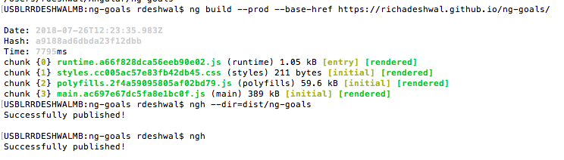](https://richadeshwal.github.io/ng-goals/)

1. Access site deployed at “https://richadeshwal.github.io/<proj name>/