SVM-Based Brain Tumor Classification – Individual Report

Team Member: Richa Patel

Model Type: Support Vector Machine (SVM)

Task: Brain tumor classification using contour-based features

# Introduction

In this project, I implemented a brain tumor classification model using Support Vector Machines (SVM). Unlike deep learning models, this approach relies on handcrafted features, making it lightweight and interpretable. This method is particularly useful in remote or low-resource settings where access to radiologists or high-end hardware is limited.

# Why SVM?

SVM is an effective model for small to medium-sized datasets with high-dimensional input features. It works well with handcrafted feature vectors and is ideal for fast training and prediction. It’s also easier to understand and control compared to complex neural networks.

# Methodology

Image Preprocessing:

- Converted MRI images to grayscale  
- Resized all images to 128×128 pixels  
- Loaded from Training/ and Testing/ folders (4 classes: glioma, meningioma, pituitary, notumor)

Feature Extraction:

- Histogram of Oriented Gradients (HOG) – to extract edge and shape patterns  
- Local Binary Patterns (LBP) – to extract texture patterns  
- Combined both features into one vector for each image using np.hstack

SVM Training:

- Tried Linear and RBF kernels  
- Trained on full dataset using scikit-learn’s SVC class  
- Compared models using accuracy, classification report, and confusion matrix

# Results

Accuracy Comparison:

|  |  |  |  |
| --- | --- | --- | --- |
| Model Type | Features Used | Kernel | Accuracy |
| SVM | HOG only | Linear | 94.74% |
| SVM | HOG + LBP | Linear | 94.81% |
| SVM | HOG + LBP | RBF | 93.06% |

Classification Report (Best Model - Linear SVM with HOG+LBP):

- Precision (average): 0.95  
- Recall (average): 0.95  
- F1 Score (average): 0.95

Confusion Matrix Highlights:

- Perfect classification on “no tumor” class (405/405)  
- Slight confusion between glioma and meningioma  
- Strong performance across all classes

# Discussion & Insights

HOG and LBP features together provided rich edge and texture information. Surprisingly, the linear kernel outperformed RBF, suggesting the features were already linearly separable. This model proves that feature-engineered models can achieve excellent results without deep learning. Suitable for clinical screening systems with limited computing power.

# Model Saving

Final model was saved using joblib:

/MyDrive/brain_tumor_project/models/svm_hog_lbp_linear.pkl

# Conclusion

This experiment showed that SVMs, when combined with carefully selected image features like HOG and LBP, can deliver high performance on complex tasks such as brain tumor classification. It provides a reliable, interpretable, and lightweight alternative to deep learning models.

# Confusion Matrices

Below are the confusion matrices for the linear and RBF SVM models:

Linear SVM (HOG + LBP):

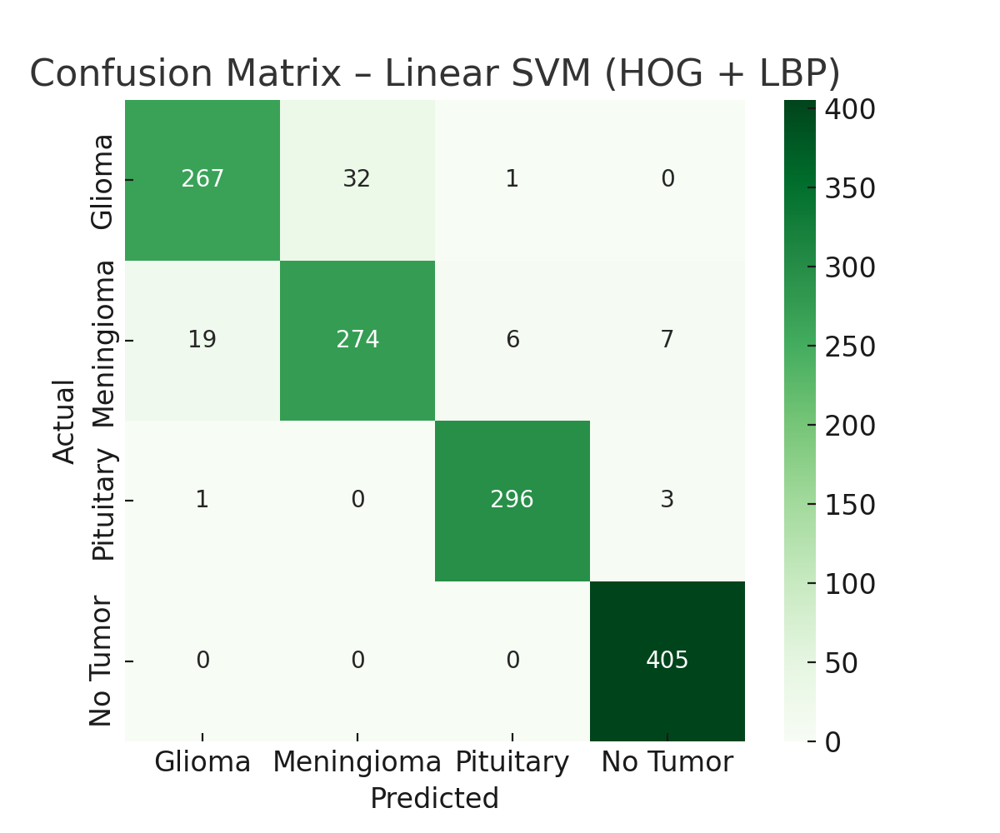

RBF SVM (HOG + LBP):

