Marathwada Shikshan Prasarak Mandal’s
Deogiri Institute of Engineering and Management Studies,
Aurangabad

Project Report
on
Prediction of COVID-19
Using Random Forest

Submitted By
Richa Vijay Patil (36035)
Riteeka Amol Purnekar (36041)
Saurabh Shivaji Pawar (36060)

for
Continuous Assessment of
Machine Learning (TY CSE)

Dr. Babasaheb Ambedkar Technological University
Lonere

Department of Computer Science and Engineering
Deogiri Institute of Engineering and Management Studies,
Aurangabad
(2020- 2021)

Project Report
on
Prediction of COVID-19 using Random Forest

Submitted By
Richa Vijay Patil (36035)
Riteeka Amol Purnekar (36041)
Saurabh Shivaji Pawar (36060)

In partial fulfillment of
Bachelor of Technology
(Computer Science & Engineering)

Guided By
Dr. Padmapani P. Tribhuvan

Department of Computer Science & Engineering
Deogiri Institute of Engineering and Management Studies,
Aurangabad (2020- 2021)
CERTIFICATE

This is to certify that, the Project entitled “Prediction of COVID-19” submitted by Richa Vijay Patil, Riteeka Amol Purnekar and Saurabh Shivaji Pawar is a bonafide work completed under my supervision and guidance in partial fulfillment for award of Bachelor of Technology (Computer Science and Engineering) Degree of Dr. Babasaheb Ambedkar Technological University, Lonere.

Place: Aurangabad
Date: 21.12.’20

Dr. Padmapani P. Tribhuvan Mr. Sanjay B. Kalyankar
Guide Head

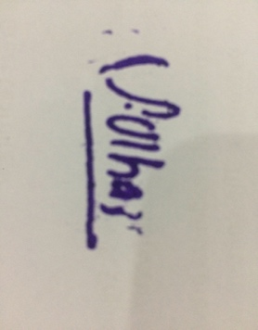
Dr. Ulhas D. Shiurkar
Director,
Deogiri Institute of Engineering and Management Studies,
Aurangabad
CONTENTS

List of tables i
List of figures ii
List of screenshots iii
- INTRODUCTION 1
  - Introduction 1
  - Problem Statement 1
  - Objectives 1
  - Application 2
- DATA COLLECTION AND ANALYSIS 3
- FINAL DESIGN AND IMPLEMENTATION 5
- PERFORMANCE ANALYSIS 6
- CONCLUSION AND FUTURE SCOPE 8
  - Conclusion 8
  - Future Scope 8

Project Code 9
List of Tables

Table Illustration Page

Table 4.1 Scores for Random Forest Model 7

List of Figures

Figure Illustration Page

Figure 2.2 | Various age groups and percentage of cases obtained | 4
Figure 4.1 | Comparison of various models’ performance | 6
Figure 4.2 | Evaluation Metrics for Boosted Random Forest | 7

List of Screen Shots

Screenshot Illustration Page

Screenshot 2.1 | Dataset used for building model | 3
Screenshot 2.2 | Dataset used for building model | 4
Screenshot 3.1 | Final Design | 5
Screenshot 4.1 | Evaluation metrics for test dataset | 7
Screenshot 6.1 | GitHub webpage | 13

  - INTRODUCTION

1.1 Introduction
Coronavirus disease 2019 (COVID-19) is a contagious disease caused by severe acute respiratory syndrome coronavirus 2 (SARS-CoV-2). COVID-19, belongs to genus of Corona viridae. A virus with no vaccine creating unpredictable havocs in the human lives and financial and economic systems in every country throughout the world. It is precariously halted everything in the society mercilessly. The first case was identified in Wuhan, China, in December 2019. It has since spread worldwide, leading to a pandemic. Symptoms are variable, but often include fever, cough, fatigue, breathing difficulties, and loss of smell and taste. Symptoms begin one to fourteen days after exposure to the virus. Around one in five infected individuals do not develop any symptoms. While most people have mild symptoms, some people develop acute respiratory distress syndrome (ARDS).

1.2 Problem Statement
The number of COVID-19 cases are Worldwide 4,180305 people and the total number of deaths caused by disease now are 283,865 by 11th MAY 2020. There are very a smaller number of COVID-19 test kits available in hospitals which are not at all sufficient for the increasing cases. Hence, it is required to implement an automatic detection system to prevent COVID-19 spreading among people.

1.3 Objectives
Implement an automatic detection system for prediction of COVID-19.

1.4 Applications
This model can be used in hospitals for predicting COVID-19, that can support the growth of health care. This can provide an autonomous diagnostic system that can provide rapid screening and detection for COVID-19 for affected regions and prepare us for future outbreaks.

- DATA COLLECTION AND ANALYSIS

2.1 Data Collection
The dataset consists of column such as location, country, gender, fever, dry cough, difficulty in breathing, tiredness, soar_throat, nasal_congestion. With 864 total entries.
The dataset consists of columns with the data being the String, and Numeric type. We also have categorical variables in the dataset. Since the ML model requires all the data that is passed as input to be in the numeric form, we performed label-encoding of the categorical variables. This assigns a number to every unique categorical value in the column.
Source of Data:
https://github.com/Atharva-Peshkar/Covid-19-Patient-Health-Analytics/blob/master/final.csv
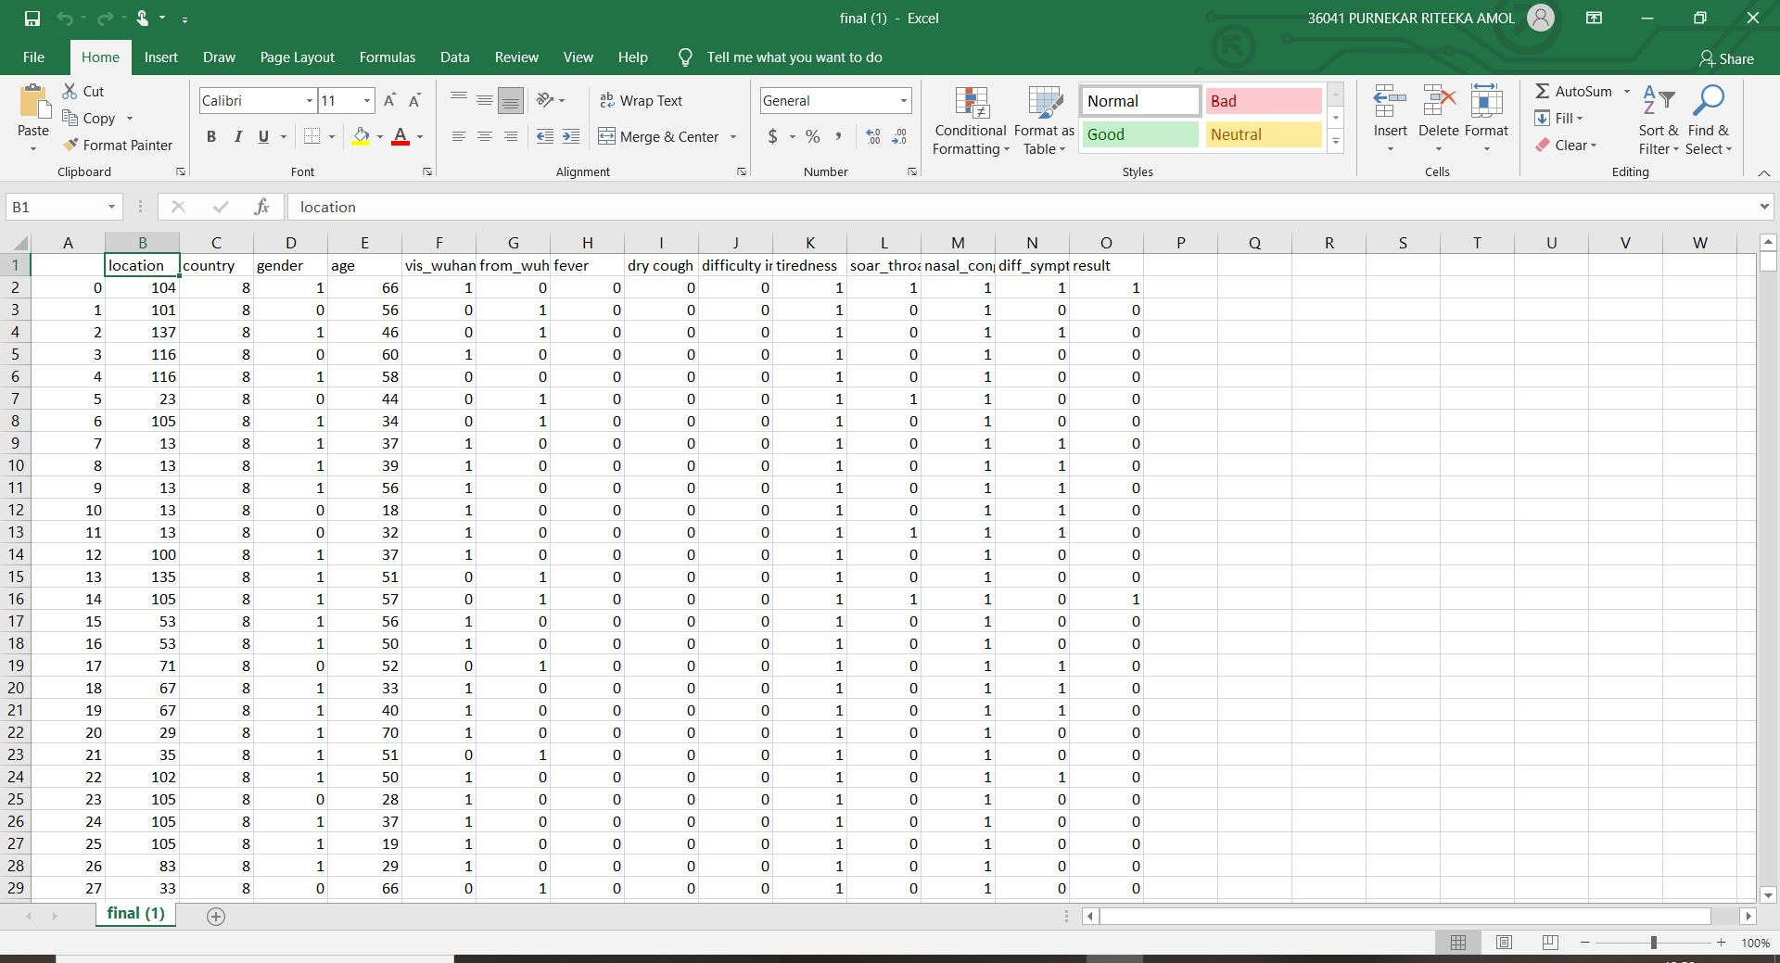
Screenshot 2.1: Dataset used for building model

2.2 Analysis
The various age groups and percentage of cases obtained. The age groups of 20-50 are highly probable of getting infected with COVID-19.
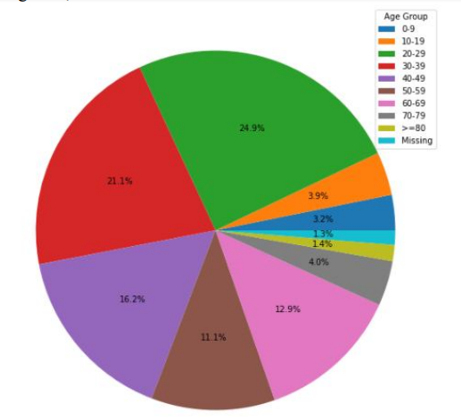
Fig 2.2: Various age groups and percentage of cases obtained.

FINAL DESIGN AND IMPLEMENTATION

  - Final Design
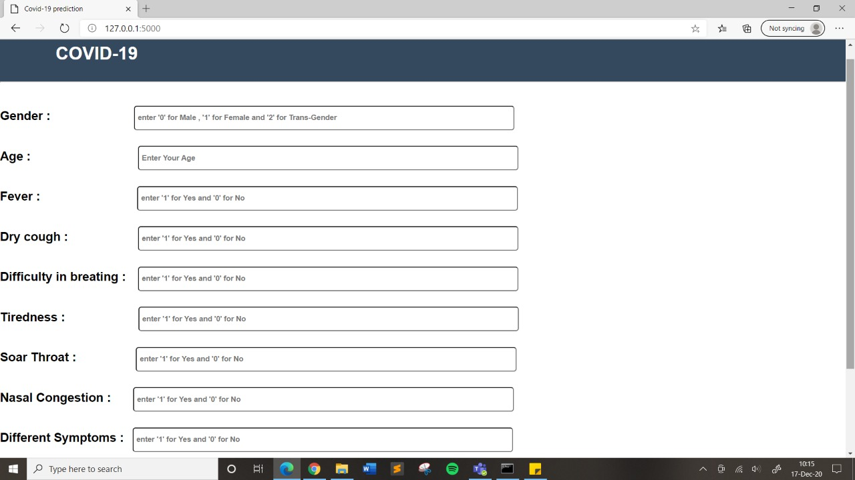
Screenshot 3.1: Final Design
  - Implementation
Code was implemented using Flask (Flux Advanced Security Kernel). And we used Jupiter notebook platform for data cleaning, data visualization and further process.
Flask is a web framework. This means flask provides you with tools, libraries and technologies that allow you to build a web application. This web application can be some web pages, a blog, a wiki or go as big as a web-based calendar application or a commercial website.
The Jupyter Notebook is an open-source web application that allows you to create and share documents that contain live code, equations, visualizations and narrative text. Uses include: data cleaning and transformation, numerical simulation, statistical modeling, data visualization, machine learning, and much more.
- PERFORMANCE ANALYSIS

We have used the pre-processed dataset to train multiple ML classification models. The models included in this study include: Support Vector Machine Classifier, Gaussian Naïve Bayes Classifier and Boosted Random Forest Classifier.
Since Boosted Random Forest algorithm is the best performing model because it gave us an accuracy of 96%, we finally tuned the model for better performance on the dataset.
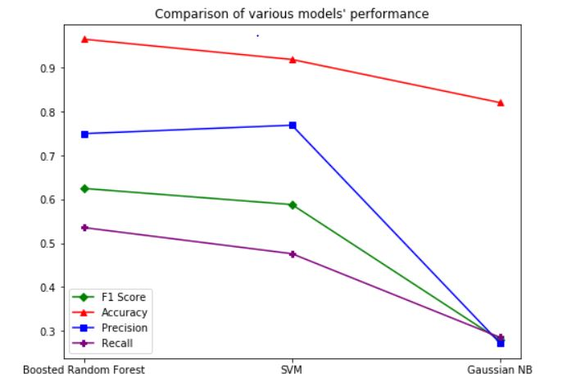
Fig 4.1: Comparison of various models’ performance

Parameters | Values
Recall Score | 0.8571
Precision Score | 0.9230
F1 Score | 0.8888
Accuracy | 0.9653
Table 4.1: Scores for Random Forest Model
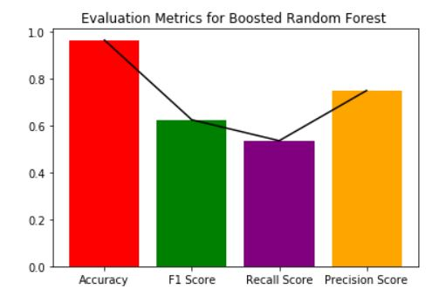
Fig 4.2: Evaluation Metrics for Boosted Random Forest

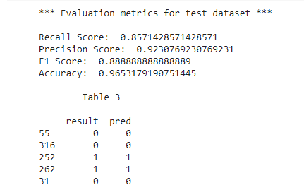
Screenshot 4.1: Evaluation metrics for test dataset

- CONCLUSION AND FUTURE SCOPE

5.1 Conclusion
In this we presented a model that implements the Random Forest algorithm, with a F1 Score of 0.89 on the COVID-19 patient dataset. We have discovered that Random Forest algorithm provides accurate predictions even on imbalanced datasets. The data analyzed in this study has revealed male patients had a greater death rate compared to female patients. The majority of affected patients are aged between of 20 and 70 years.

5.2 Future scope
Future work will focus on creating a pipeline that combines CXR scanning computer vision models with these types of healthcare data processing models. These models will then be integrated into applications that will support the growth of mobile healthcare. This can provide a step toward a semi-autonomous diagnostic system that can provide rapid screening and detection for COVID-19 affected regions and prepare us for future outbreaks.

Project Code

#importing library
import numpy as np
import pandas as pd
import sklearn
from sklearn import preprocessing
from sklearn.ensemble import RandomForestClassifier
from sklearn.model_selection import train_test_split
from sklearn.metrics import recall_score as rs
from sklearn.metrics import precision_score as ps
from sklearn.metrics import f1_score as fs
from sklearn.metrics import balanced_accuracy_score as bas
encoder = preprocessing.LabelEncoder()

Data Preprocessing

#importing dataset
data = pd.read_csv('final.csv')
data = data.fillna(np.nan,axis=0)

#encoding categorical values
data['location'] = encoder.fit_transform(data['location'].astype(str))
data['country'] = encoder.fit_transform(data['country'].astype(str))
data['gender'] = encoder.fit_transform(data['gender'].astype(str))
data[['fever']] = encoder.fit_transform(data['fever'].astype(str))
data[['dry cough']] = encoder.fit_transform(data['dry cough'].astype(str))
data[['difficulty in breathing']] = encoder.fit_transform(data['difficulty in breathing'].astype(str))
data[['tiredness']] = encoder.fit_transform(data['tiredness'].astype(str))
data[['soar_throat']] = encoder.fit_transform(data['soar_throat'].astype(str))
data[['nasal_congestion']] = encoder.fit_transform(data['nasal_congestion'].astype(str))

Training
print(data.head()) #printing first few entry

#Extracting the data set into X and Y values
X = data[['location','country','gender','age','vis_wuhan','from_wuhan','fever','dry cough','difficulty in breathing','tiredness','soar_throat','nasal_congestion','diff_symptoms']]
Y = data['result']

#Spliting data set into training and testing
X_train, X_test, Y_train, Y_test = train_test_split(X,Y,test_size=0.2,random_state=0)
classifier.fit(X_train,np.array(Y_train).reshape(Y_train.shape[0],1))
# Training the model
rf= RandomForestClassifier(n_estimators=50, random_state=1)
rf.fit(X,Y)

Evaluation of the model
pred = np.array(classifier.predict(X_test)) #predicting the values
recall = rs(Y_test,pred)
precision = ps(Y_test,pred)
f1 = fs(Y_test,pred)
ma = classifier.score(X_test,Y_test)

#Printing All score
print('*** Evaluation metrics for test dataset ***\n')
print('Recall Score: ',recall)
print('Precision Score: ',precision)
print('F1 Score: ',f1)
print('Accuracy: ',ma)
a = pd.DataFrame(Y_test)
a['pred']= classifier.predict(X_test)
print('\n\tTable 3\n')
print(a.head())

Flask
Initialize the flask app, and load our ML model

# Saving model to current directory
# Pickle serializes objects so they can be saved to a file, and loaded in a program again later on.
import pickle
pickle.dump(rf, open('model.pkl','wb'))

#Loading model to compare the results
model = pickle.load(open('model.pkl','rb'))
print(model.predict([[1,66,14,7,6,7,2,0,4]]))
from flask import Flask, render_template,request
import pickle #Initialize the flask App
app = Flask(__name__)
model = pickle.load(open('model.pkl', 'rb'))

#default page of our web-app
@app.route('/')
def home():
return render_template('index.html')

#To use the predict button in our web-app
@app.route('/predict',methods=['POST'])
def predict():
#For rendering results on HTML GUI
int_features = [float(x) for x in request.form.values()]
final_features = [np.array(int_features)]
prediction = model.predict(final_features)
output = round(prediction[0], 2)
return render_template('index.html', prediction_text='Given patient is tested :{}'.format(outp ut))

if __name__ == "__main__":
app.run(debug=True)

GitHub link:
https://github.com/riteekapurnekar/Covid-19-Prediction

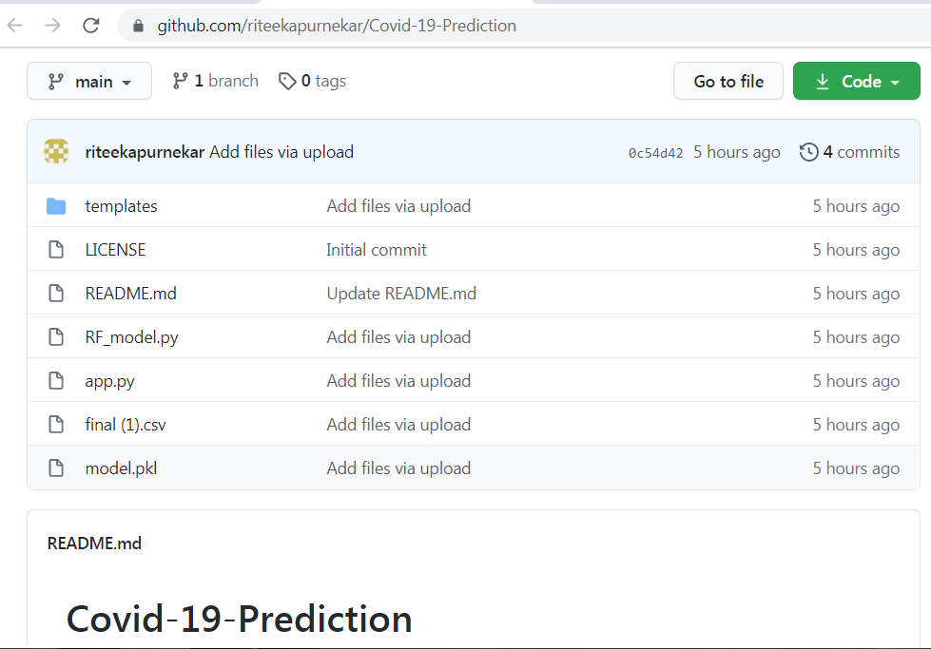
Screenshot 6.1: GitHub webpage

ACKNOWLEDGEMENT

We would like to place on record our deep sense of gratitude to Mr. Sanjay Kalyankar, Head of Department Computer Science and Engineering, Deogiri Institute of Engineering and management Studies Aurangabad, for his generous guidance, help and useful suggestions.

We express our sincere gratitude to Dr. Padmapani P. Tribhuvan, Dept. of Computer Science and Engineering, Deogiri Institute of Engineering and management Studies Aurangabad, for her stimulating guidance, continuous encouragement and supervision throughout the course of present work.

We are extremely thankful to Dr. Ulhas Shiurkar, Director, Deogiri Institute of Engineering and management Studies Aurangabad, for providing me infrastructural facilities to work in, without which this work would not have been possible.

Signature(s) of Students

Richa Vijay Patil 
Riteeka Amol Purnekar 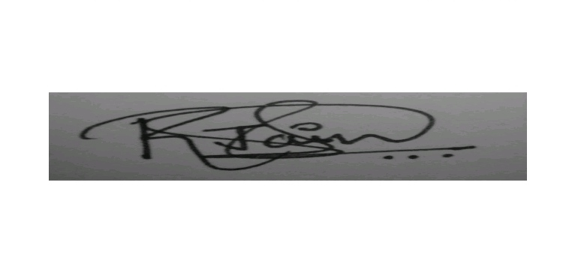
Saurabh Shivaji Pawar 