Pandoc check: title block, cross-references and captions
Ada Lovelace, University of London
Charles Babbage, University of Cambridge
Mary Somerville
27 October 2026
Abstract
This document checks what Word and LaTeX receive from Halmos. The abstract cites a source [1], has emphasis and an inline formula $E=mc^{2}$, and refers to fig:photo?.
Each section opens with a Check: line saying what the Word (.docx) and LaTeX (.tex) output should show. Export this file to PDF, Word and LaTeX, and compare. The style is IEEE, so citations are numbered in reading order.

1. Title block
Check: - Title: shown once, with its colon kept. - Authors: all three appear. In Word and LaTeX, the first two read “Ada Lovelace, University of London” and “Charles Babbage, University of Cambridge”, and the third reads “Mary Somerville”. - Date: “27 October 2026”, exactly as written. - Abstract: - It shows its italic word and its formula. - Its citation is [1], the first number in the document. - Its reference reads “Figure 1”. - PDF: no header on page 1. From page 2, the title is at the top of each page, and “Page N of M” is at the bottom of every page. - Word and LaTeX: no stray {title} or “Page {page}” text anywhere.

2. Text
Check: - Bold, italic, strike-through, inline code and the link all survive. - Both footnotes are numbered and listed at the end (Word) or at the foot of the page (LaTeX).
This line has bold, italic, struck and inline code, and a link to Pandoc. A first footnote and a second.
A block quotation, which should be indented in every format.

3. Lists
Check: - Nesting: both lists keep their nesting. - Numbering: the numbered list counts 1, 2, 3. - Task list: shows ticked and empty boxes, or plain bullets, but never [ ] as text.
- First point
  - Nested point
  - Another nested point
- Second point
- Step one
- Step two
  - Sub-step
- Step three
- A finished task
- An open task

4. Citations
Check: - Every form below formats in IEEE style. - Numbers continue from the abstract’s [1]. - The unknown key shows as “(nosuch2099?)” in Word and LaTeX, as Pandoc does. - Reference list: comes after the text under a “References” heading that Halmos adds, so the document doesn’t write one. It’s in IEEE order and leaves out the unknown key.
- One source [3].
- Two at once [4], [5].
- Narrative: [6] shows this.
- With a page: see [2, p. 3].
- Year only: [1].
- Unknown key: nosuch2099?.

5. Figures
Check: - Numbering: the figures are numbered 1, 2, 3, 4 in this order in every format, with captions such as “Figure 1: …”. - Images: the decorative image has no number and no caption. - Charts and diagrams: - Word: the chart and the diagram are pictures. - LaTeX: they stay as code, so they are not figures there. This is known.
A labelled image:
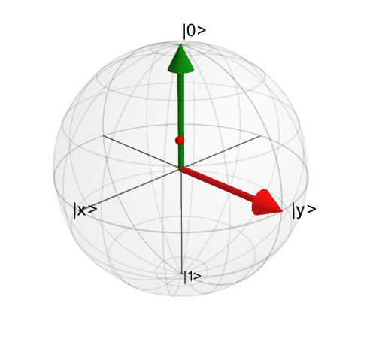
Figure 1: A labelled photograph
An unlabelled captioned image. Halmos gives it a hidden label for export, so it is still numbered:
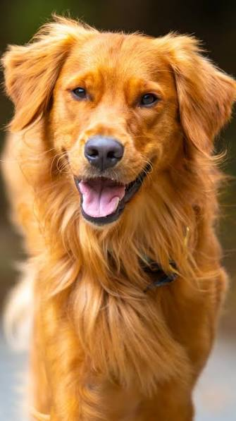
Figure 2: An unlabelled photograph
A decorative image, with no alt text:
A labelled chart:
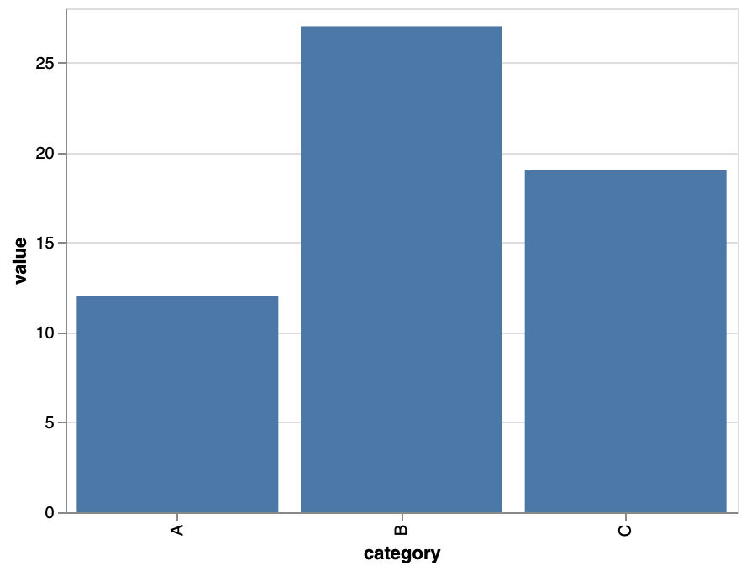
Figure 3: Recovered sources by category
A labelled diagram:
Figure 4: Conversion pipeline

6. Tables
Check: - Numbering: the two captioned tables are numbered 1 and 2, apart from the figures. - Captions: each caption reads “Table N: …”, above its table. - Uncaptioned table: it has no number. - Alignment: right-aligned columns stay right-aligned.
Table 1: Yield by treatment
Group | Yield (t/ha) | Change
Control | 6.12 | —
Late N | 6.61 | +8%
Split N | 6.48 | +6%

Table 2: Rainfall by season, with no label
Season | Rainfall (mm)
2024 | 512
2025 | 438

An | uncaptioned | table
1 | 2 | 3

7. Equations
Check: - Labelled equation: shows the number (1) at the right. - Unlabelled display equation: has no number. - Inline maths: stays in the line.
A labelled equation:
$$E=mc^{2} (1)$$
An unlabelled display equation, not numbered:
$$\int_{0}^{∞}{e^{−x^{2}}} dx=\frac{\sqrt{π}}{2}$$
Inline: the mean is x=1ni​xi.

8. Cross-references
Check: - Word: each reference is linked text, for example “Figure 1” or “Table 1”. - LaTeX: the references to the photograph, the table and the equation resolve. The ones to the chart and the diagram do not, which is known. - Missing label: the reference to it is visibly broken in every format.
- The labelled photograph: Figure 1.
- At the start of a sentence: Figure 3 shows the categories.
- Two at once: Figures 1, 4.
- The table: Table 1.
- The equation: Equation 1.
- A missing label: Figure ¿fig:nosuch?.

9. Code
Check: - The block keeps its line breaks and indentation, in a fixed-width font. - Word may colour the syntax; LaTeX may not.
def mean(xs):
"""The arithmetic mean."""
return sum(xs) / len(xs)

10. Alerts
Check: - GitHub-style alerts have no Pandoc equivalent. Expect a block quotation that starts with “[!NOTE]” or “Note”. Record which one you get.
[!NOTE] An alert, for comparison with the preview.

References
[1] Y. Y. Fein et al., “Quantum superposition of molecules beyond 25 kDa,” Nature Physics, vol. 15, no. 12, pp. 1242–1245, Dec. 2019, doi: 10.1038/s41567-019-0663-9.
[2] T. N. Bandi, “A Comprehensive Overview of Atomic Clocks and their Applications,” Biology, Engineering, Medicine and Science Reports, vol. 9, no. 1, pp. 01–10, Jan. 2023, doi: 10.5530/bems.9.1.1.
[3] A. S. Bracker, D. Gammon, and V. L. Korenev, “Fine structure and optical pumping of spins in individual semiconductor quantum dots,” Semiconductor Science and Technology, vol. 23, no. 11, p. 114004, Nov. 2008, doi: 10.1088/0268-1242/23/11/114004.
[4] A. M. Brańczyk, “Hong-Ou-Mandel Interference,” Canadian Journal of Physics, vol. 102, no. 8, pp. 411–421, Aug. 2024, doi: 10.1139/cjp-2023-0312.
[5] W. A. Coish and J. Baugh, “Nuclear spins in nanostructures,” physica status solidi (b), vol. 246, no. 10, pp. 2203–2215, Oct. 2009, doi: 10.1002/pssb.200945229.
[6] Decoherence and the Quantum-To-Classical Transition. in Frontiers Collection. Berlin, Heidelberg: Springer Berlin Heidelberg, 2007. doi: 10.1007/978-3-540-35775-9.

The first note, with a formula $a^{2}+b^{2}=c^{2}$.
The second note, citing [2].

