System design documentation
Introduction

Background
Zend framework is a simple and loosely-coupled component library which provides functionalities and APIs suitable for every php application.

Magento is well designed software that provides enterprise solution for eCommerce. However, as it’s an international version and designed for all. So there is some redundant code we don’t need, we have existing database that doesn’t have EAV database design. So it’s not suitable for us. Meanwhile, its whole template system is based on xml file, which cause huge performance problem.

The detailed information about mvc, module development and widget template engine, magento and Zend framework are not specified. Further readings can be found in reference.

Basic Theory
Base on zend framework and magento, the system is separated into different module, and template system is separated into widgets. The design goal is to make modules are loosely coupled and templates are customizable.

Dispatch loops
Zend Framework dispatch loop diagram:

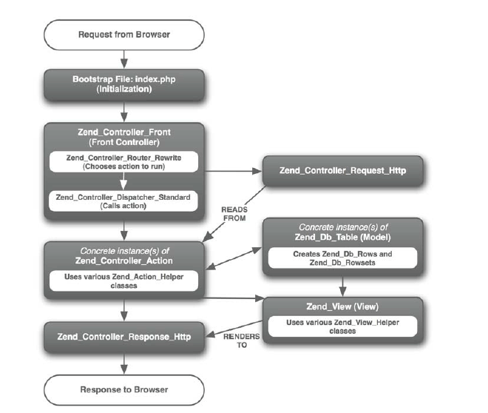

Detailed dispatch flow:
http://www.slideshare.net/polleywong/zend-framework-dispatch-workflow

The project folder structure is listed as following:

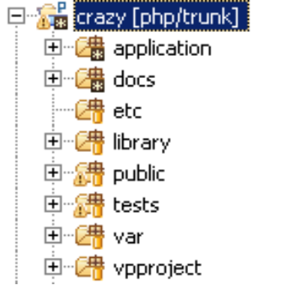

The application folder:
The main application source files resides
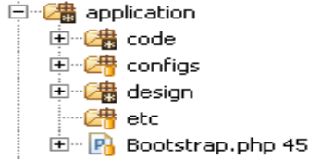
1. code: the application source code
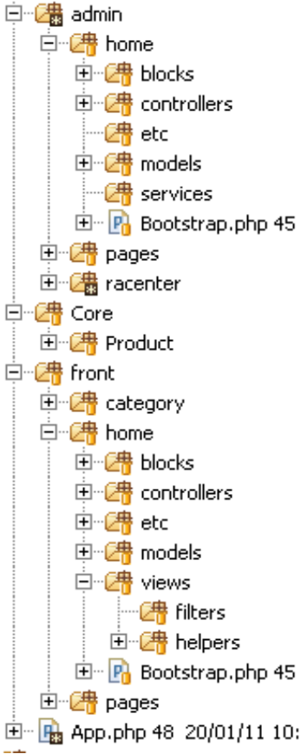

The admin folder
All source code for admin section, divided by modules, each modules has block, controller, etc (config file directory), models, services, bootstrap file, view folder with helpers and filters.

The Core folder
The share code between admin and front, all shared models files

The front folder
All source code for front section, the folder structure is same with admin section.

2. configs: the application.ini (Zend Framework)
3. design: all the template files
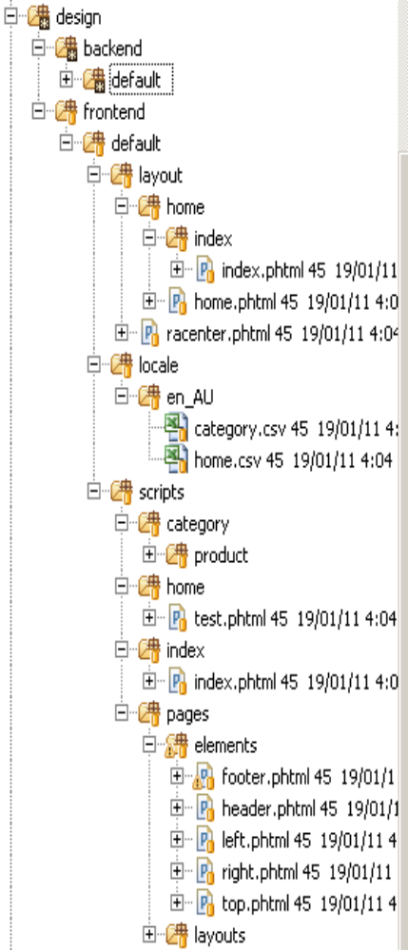
The template tree is divided into frontend and backend section. Each of them has a default theme. Each theme has layout, locale and scripts folder.
In layout folder, all the files are organized by the module name for clear purpose. Each file is corresponding to a module action.
In scripts folder, it has all the block template files, organized by module and type name.

*note: the folder structure within template scripts folder is not fixed. it can be named and structured in any order you want. The only thing you need to do is referencing them correctly in the layout script

In locale folder, it has all the translation files divided by language type. They are named according to module name.

4. etc: store configuration file
5. bootstrap.php (Zend Framework)

The docs folder:
All development and design documents

The library folder:
All the library code, including php, javascript etc

The public folder:
All the content that allow client browser to access
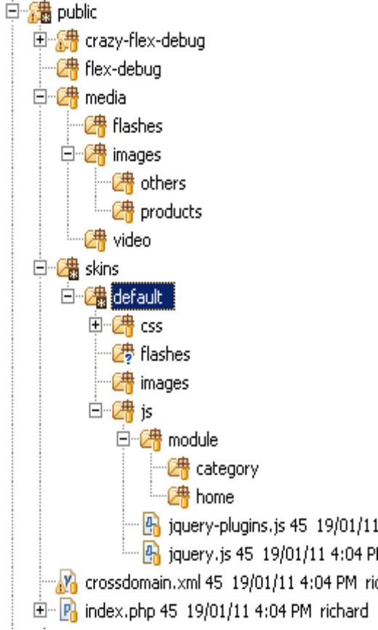

The media folder
It has all the images, flashes, video that upload by programs

The skins folder
It has all the skin files, it has a default skin folder, all the css, flashes, images and js, skin related file need to put it here. Within js folder, jquery-plugins.js is a yui minimized file which includes all the jquery plugins from library.

In js/module folder, all the inline javascript are located here.

The tests folder:
All unit test cases

The var folder:
All temporary data, incuding log, cache, session files

The vpproject folder:
All visual design files

Good points:
- Use block helper instead of action helper, which save huge resource on dispatching.

- Use php as template language, make it faster than magento.

- Template widgets make layout page very easy and flexible. For display logic only page, the page can be customized from the backend.

- Module development methodology makes maintain code much easier.

- The code is loose coupled and has high integrity.

- Enterprise solution, it is easy to change and extends by using OOP.

Drawbacks:
- Some original view helpers may not able to use, but they are not necessary

- Caching can be enhanced at some point

- Some functionality needs to be done and improved.

Resources
Why use Zend_Layout and Zend_View, rather than smarty?
Zend_Layout and Zend_View is pure php based, and helpers are simple but powerful. Smarty engine is implemented by wrap a stream wrap to interfere php parsing, and translate smarty syntax to php syntax.

Writing a filter, plugin and view helper is simple. But they can be fit into the whole system very easily.

Use Zend_Cache to implements cache mechanism is simple.

Why don’t use actionStack and action helper use Zend_View_Helper instead?
ActionStack and action helpers are too slow. Please read reference.

Why use inline javascript rather than put them in a single file and append on header?
Due to template widgets system, put javascript inline allow you move them around the whole system, without modified a single code.

It is easy to maintained inline javascript files, as they are organized by their module names, and inject them into template at runtime

Cheat Sheets
- how to add controller?
- how to use model?
- how to add action?
- how to use module option?
- how to use global options?
- how to get model/block/singleton in controller action or block action?
- how to add action corresponding template?
- how to change layout in a template?
- how to add block widgets into template ?
- how to add inline javascript?
- how to make css / javascript / flash auto versioned?
- how to cache template?
- how to clear cache?
- how to add customerize a new layout?
- how to add new helper and filter for current module?
- how to use global helper and filter?
- how to make ajax call and fetch the view script?
- how to do amf remote call?
- how to add new module?
- how to avoid file cache limitation?
- Other suggestion

Further development
- Caching
- Store config
- Security
- Code Performance
- Unit testing
- Cron job system
- Template hierarchy

Reference:

