So far
So far with our style sheets we have looked as style. What did you expect we are doing style sheets. However there is more that we can do with style sheets. We can also do layout.

Next Layout
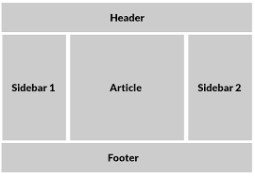
To day we will be learning how to layout a page. We will lay it out something like the image on the right. Your articles will go in the middle. In the left sidebar we will add navigation. The right sidebar, will have some other content (could be another way to navigate, some adverts, or in this case a quote). The header can be a title, or maybe other controls for your site. The footer may me some legal stuff such as copyright notice.

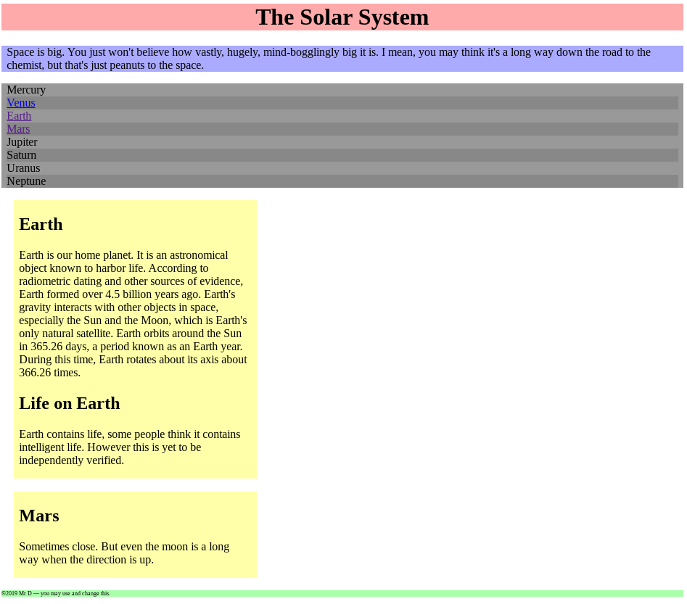
Here we have a page, but everything is laid out one after the other.
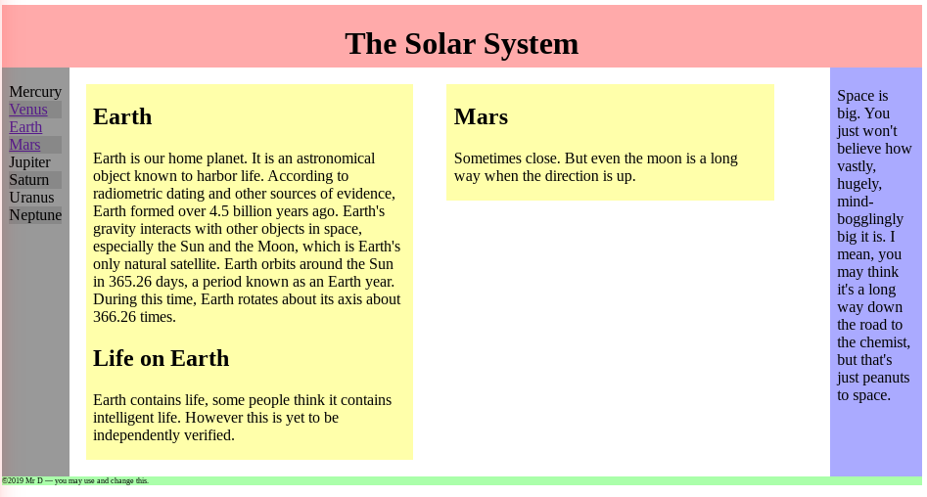
To day we will be adding layout to make it look like the next image.
Remember to add style between the style tags:
<style>
add style here
</style>

How to layout as a grid
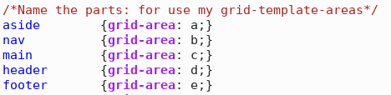
First you need to name the parts of the page. Name them a, b, c, ...
Then we define the layout:
We are applying it to the body (so to the whole page).
We want a grid of 3 rows, and 3 columns. We have different specifiers for the width height. Then we have a definition for the grid-template-area: This says what goes where (remember the section where we named things).
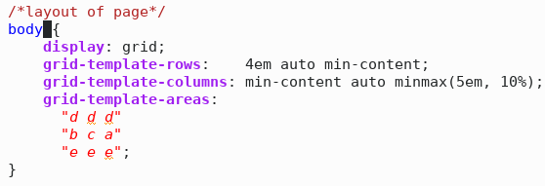
When you have it working, you can start to change bits (Experiment):
- What does 4em, auto, min-content, and minmax(5em, 10%) mean? Have a guess, change it, test it. (The best thing to change is the numbers). Some other units (as well as em and %) are px, ex, mm (see https://www.w3schools.com/cssref/css_units.asp for more )
- These letters in the grid area, what happens if you move them? Warning it will not work if a letter is not contiguous, or if it dose not form a rectangle (a square is a rectangle).

Laying out the articles
Now to layout the articles. We want them to not be to wide (as this is hard to read), or to narrow. We also don't want to wast too much screen space. Therefore we want one under another, if the browser is narrow, but next to each other if we have the space (browser is wide).
A grid is to ridged. We need something more flexible. We need a flex box.

Defining a flex box
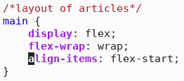
The articles are in main, so we can tell main to be a flex box. Add the formatting rules one at a time, and test them. To test these you will also have to adjust the width of the browser. Try it, see what happens.
That works, but the articles are still inflexible: we are still wasting space.

Make the articles flex
We want the articles to flex: to take up available space (but not too much).
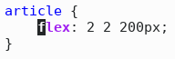
Add this test, tweak, test, ...

An article for each planet (extension)
Add an article for each planet. Ensure that you have this links to it in the <nav>. How does it look at different browser widths?

Can you add another (html) section? (challenge)
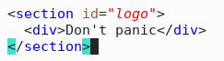
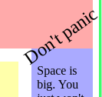
Add it to the grid. Talk to the person next to you, look it up on the web, try it, figure it out. How about rotating it? (search: css transform)

