**Magic**

Farrell Dillion - Remove

Brian Cook - Remove

Nick Paul - UPdate -

Nick Paul is renowned for his distinctive blend of physical comedy, magic tricks, and sharp humor.

With a track record spanning two decades, Nick has delighted audiences worldwide, including Fortune 500 juggernauts such as Google, Amazon, and Microsoft.

He has showcased his talents on esteemed television platforms such as CONAN, Netflix, and Penn & Teller Fool US. Additionally, he has lent his expertise as a consultant for popular shows like The Tonight Show with Jimmy Fallon and Magic for Humans with Justin Willman.

A regular and highly regarded performer at the renowned Magic Castle in Hollywood, Nick Paul also travels extensively to entertain audiences at Fortune 500 company corporate events, cruise ships, and theaters. His captivating performances have been enjoyed by audiences in over twenty countries, four continents across the globe for nearly three decades.

Video

[](https://www.youtube.com/watch?v=p8mpTEGjsRE)

Jon Armstrong - Add him. (Bio)

Winner of numerous awards, including Close Up Magician of the Year, Jon Armstrong is best known for his world-class magical talent and for being funny. Not just magician funny—actually funny.

Jon honed both skills beginning at age 20, when he became the resident magician at Disney World, and then a recurring headliner at Caesar's Magical Empire. Soon after, Jon started touring all over the world, performing in over 40 countries to date.

Jon stars in the NetFlix documentary Magicians: Life in the Impossible, about his life in magic. You also have seen him amaze Kathy Lee on “The Today Show”, cause Penn on CW’s “Penn and Teller’s Fool Us” to exclaim his act as “the most original I’ve ever seen!”, and have Jay Leno profess his love to him on “The Tonight Show”.

When you see him live, Jon hopes that you laugh loudly, are amazed by his skills, and most of all, feel like you made a new friend.

Video -[](https://vimeo.com/922776136)

Trevor and Lorenna - Change bio and add new promo link to:

A Classical Fusion of Comedy & Magic

“Prepare to embark on an enchanting journey with Trevor and Lorena Watters, a dynamic duo setting the comedy magic world ablaze! Picture this: the comedic charm of The Carol Burnett Show seamlessly intertwines with the magical mastery of Penn and Teller.   
  
Their performance, a harmonious fusion of classic humour and innovative magic, has garnered over 20 international awards, including the prestigious Siegfried and Roy “Golden Lions Head” from the World Magic Seminar in Las Vegas.   
  
Step into their world where laughter knows no bounds – their show is hailed as priceless and fun, leaving audiences spellbound with every effect. Trevor and Lorena, the coveted comedy magic duo of North America, effortlessly blend audience participation, spectacular illusions, and a sprinkle of magic dust to create an unforgettable roller coaster of[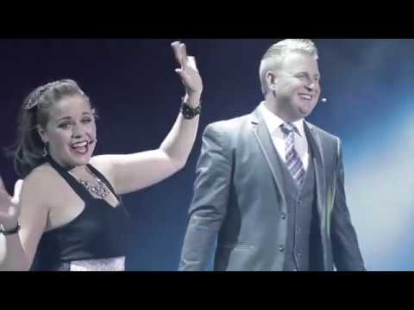](https://www.youtube.com/watch?v=uQdgEZ6Ri0A) entertainment.

Indulge in the magic that makes them the most sought-after duo, as Trevor and Lorena Watters weave a tapestry of laughter, astonishment, and pure entertainment. Get ready to witness the extraordinary – because with them, magic meets hilarity in a league of its own!”

Nate Jester - (change title to “Mentalist”) New promo - [https://youtu.be/rBYPwiybhjE](https://urldefense.proofpoint.com/v2/url?u=https-3A__youtu.be_rBYPwiybhjE&d=DwMFaQ&c=euGZstcaTDllvimEN8b7jXrwqOf-v5A_CdpgnVfiiMM&r=DcltmgDsXm9BGPK0YIFaLCWqdzRyD2OS6pAJvvbXvnw&m=7dEpVDIMeF-KScqIzBGAVWNPeMlQ7EMvnz4VXVik6v52nwJ1jMm1WhvVCYoKsQ_3&s=cxJlqEwIGP122E9f0Fw3NSGhNxKDFixr9ID53Up9ndA&e=)

Hart Keene change title to "Mentalist and Illusionist”

Puck - Add new promo video link: [](https://www.youtube.com/watch?v=dGAuHOwmpk4)

Bruce GOld - Add him:

Bio: Bruce Gold fills event stages and meeting rooms with gales of laughter and gasps of astonishment with his charismatic brand of wit and wizardry. His show features a masterful blend of good clean humor, delightful audience interactivity and genuine amazement!

Bruce has appeared on TV’s Master’s of Illusion, Penn & Teller’s Fool US and is a favorite performer at Hollywood’s famous Magic Castle where’s he’s known for crowd pleasing performances that are always clean, clever and connected!

Video: [https://vimeo.com/887455193?share=copy](https://urldefense.proofpoint.com/v2/url?u=https-3A__vimeo.com_887455193-3Fshare-3Dcopy&d=DwMFaQ&c=euGZstcaTDllvimEN8b7jXrwqOf-v5A_CdpgnVfiiMM&r=DcltmgDsXm9BGPK0YIFaLCWqdzRyD2OS6pAJvvbXvnw&m=lHuOxdnoz9pCIwku3IlwznxtPq8Hd1Igg0pw0plEBYiIcLr3Ry0WI1Zfwh5bEOmS&s=EJ44WsNWIgGNm83pwEuBo4bSZBic7hL50tmZl6PMa6o&e=)

**Comedians:**

Travis Nelson: Add new headshot

Heath Hyche - Add him - ONE MAN - HIGH ENERGY - SKETCH COMEDY SHOW

Bio: Acclaimed actor and comedian, Heath Hyche, uses stand-up comedy, quick-change costumes, original music, unique props and video to take the audience on a one-of-a-kind journey through his vivid imagination full of manic characters.

Heath's television credits include The Tonight Show, Jeff Foxworthy's hit sketch comedy show Blue Collar TV, CMT's Comedy Road Show, NBC's Late Night Stand-Up, Roseanne Barr's Saturday Night Special, Last Comic Standing, FOX's Jack's House, CBS' Drive and Style and Substance, and the lead in the ABC pilot Mark of Greatness.

[](https://www.youtube.com/watch?v=z6JhMtbJxZo)

Mary lou Gamba - Add her to roster

Bio: Mary Lou Gamba is an East Coast transplant living it up in the PNW.  A midde-aged teenager and delightfully dirty bird, Mary Lou will get you laughing til you snort with her charming wit and silly exaggerations of her wacky life.

As a regular opener and headliner, this pint-sized dynamite burns down comedy clubs, bars and locker rooms all over the country.  Mary Lou has been featured in HBO's Women in Comedy Festival, Bumbershoot Music and Arts Festival, and was a finalist in the Seattle International Comedy Competition. Watch out, she'll steal your chicken!

Video -

[](https://www.youtube.com/watch?v=MYKwBj0NQEY)

Tyler Boeh - Add him to roster

Bio: Tyler Boeh’s award winning “beat-boxing” talent and ability to shift seamlessly

from well-crafted material to improvised exchanges keep audiences in awe. He

established himself early in his career by placing in the finals of three of the most

prestigious comedy competitions in the country: The Seattle International, San

Francisco International, and the World Series of Comedy in Las Vegas. With past

appearances on “NESN Comedy All-Stars”, “Celebrity Name Game”, and two

seasons of “Laughs on Fox”, Tyler has laid the groundwork for his growing

success. In 2018 Tyler’s second album, “Full Circle” debuted at #2 on the

Billboard Comedy Charts and he was selected as the SiruisXM 98 Artist of the

Month. 2018 also brought the release of Tyler’s first Dry Bar Comedy special

“Wait for it” which garnered millions of views online. In 2023 Tyler returned to Dry

Bar to film his second special titled “Upgraded” which was released across

multiple platforms in February of 2024. You can find his comedy on Amazon

Prime, Spotify, Pandora, and SiriusXM, but don’t miss the chance to see Tyler

perform live!

Video:

[https://youtu.be/3DXoyWsdNHM?si=I4p_5odVPsuYXP0W](https://urldefense.proofpoint.com/v2/url?u=https-3A__youtu.be_3DXoyWsdNHM-3Fsi-3DI4p-5F5odVPsuYXP0W&d=DwMFaQ&c=euGZstcaTDllvimEN8b7jXrwqOf-v5A_CdpgnVfiiMM&r=DcltmgDsXm9BGPK0YIFaLCWqdzRyD2OS6pAJvvbXvnw&m=x_lRbWe1RJ38214U_7HOmAm0VkRzRJY1ChcZX-Xw1NA_NqpvqS7NVSywRtQkrpeH&s=PTGK-DnFztkNk3J5Hir9KyweT7vqzprQ2bFrL1FMLRE&e=)

**Jugglers**

[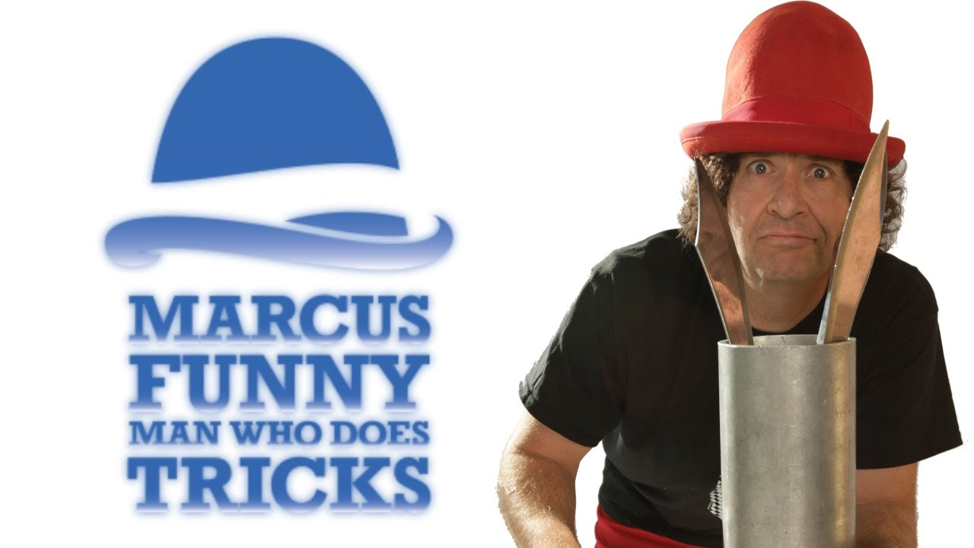](https://www.youtube.com/watch?v=yOfbIq1n_h4)

Marcus - Add New Promo (see above or below this document sucks)

**Variety**

Joe Stoddard: Add him Comedy and music

Joe Stoddard, the Comic Musician brings a blend of high energy, comedy and music that is guaranteed to give your guests the memorable experience of laughter and song!

In addition to his hilarious stage show, you may book his "Talking Animals". . . A unique Roving Ventriloquist show like no other!

Youtube Video - <https://www.youtube.com/watch?v=YnOAJhoa2_4&t=188s>

Supernova - Add her - Strong woman - Supernova the Strongwoman is your chance to experience the thrill of high-octane entertainment. This world-class athlete, daredevil, and steel-bender pushes her muscles to the limit to bring you a one-of-a-kind spectacle that is at once powerful, and playful. Members of the audience are invited to join Supernova on stage, and to become leading protagonists along the journey of insane stunts, comical shenanigans, and the wanton destruction of perfectly good metal! Trained by Cirque du Soleil coaches, Supernova delivers precision acrobatic skills coupled with the explosive force of a human recking ball. The whole family can join this cyclone of laughter, gasping, inspiration, and DEMOLITION!!! Video -

[](https://www.youtube.com/watch?v=2SHuhLgUruA)

Mark Hayward - Add new headshot

Hilia Hula - Add - Hula Hoop Extrardinaire- The Hula Hoop Extraordinaire's show is packed with jaw-dropping hula hoop tricks, comedy, and audience participation.

Watch Hillia hula hoop using only her feet while standing on her head, make a hoop float in mid-air, create beautiful geometric patterns with glowing LED hoops at night, and perform her grand finale using her human slinky composed of an astounding 40 hoops.

<https://drive.google.com/file/d/1h_pfy0r3mGPyX0uv8CUxZh08M7HET2bO/view>

Heather Pearl - Add her - Professional Funny Woman.

BioHeather Pearl has been entertaining small and large audiences at County Fairs, Festivals, corporate events, libraries, and even grandmother's birthday parties.  Pearl trained in physical theatre and clown at Dell'Arte International School of Physical Theatre and at the SF School of Circus Arts and has performed with Dell'Arte, Do Jump, SF Woman's Circus and the Nomadic Theatre Co.

What she brings to an event goes beyond talent--it's human magic

Radiance Work - Stiltwalker - Bio - A multi faceted muse, Jodie amazing stilt characters have been making events magical for over 15 years. With over 6 different stilt characters to choose from, create a memorable ambience for your event with Jodie.