Northern California Winery Sales: Analysis and Optimization

Richard J. Lusch II

Southern New Hampshire University

Executive Summary

Amid one of the largest, and most fruitful wine markets in the world, this Northern California winery is beginning to look into methods of analyzing and optimizing its sales mix and sales force. This paper looks through some of the basic summary statistics relevant to the sales of this Northern California winery, attempting to turn the data into actionable knowledge. Then, with some assumptions, models will be evaluated to try and determine how to optimize the winery’s future sales.

Keywords: Add keywords here. To replace this (or any) tip text with your own, just select it and then start typing. Don’t include space to the right or left of the characters in your selection.

Northern California Winery Sales: Analysis and Optimization

Globally, 25.7 million liters of wine was consumed in 2015, of which 3.3 million liters were consumed in the United States alone; which represents a 6.46% growth over 2013 (Trade Data and Analysis, 2017). This growing U.S. market is being served by 10,736 wineries, with 4,416 being in California, for the year of 2015 (The Wine Institute, 2017). The California wineries produce an average of about 85% of the U.S. wine production (The Wine Institute, 2017). Highly competitive markets, like this, have driven countless businesses to try to harness data analytics and optimization to increase their margins and profits. This paper conducts analytics and optimization on the sales of a Northern California winery, in an attempt to get a larger portion of this market.

# Analysis

The analysis will consist of 2 parts. First, an analysis of the data so that there is a clear understanding of the data that was provided. Second, an analysis of the information contained in the data, with which knowledge will be generated. This should all lead to insights that will inform the optimization task at hand.

## Data

The data provided by the business consist of a single flat file, .csv, containing 101 rows of data over 5 fields. The fields provided are ‘Sales’, ‘City’, ‘Date’, ‘Sales Rep’, and ‘Type Wine’. The ‘Sales’ field is captured in dollars. The ‘City’ field consists of ‘San Diego’, ‘San Francisco’, or ‘Los Angeles’. When questions or answers are given in terms of ‘California’, they will be referring to these three locations. Sales outside of this scope are either non-existent, or are so minimal that the business deemed them unimportant to the analysis. The ‘Date’ field consists of only the month that the sale occurred in with no year included, and spans from January through June. Without a year in place, this paper will assume that this time frame covers the most recent January through June time frame. The ‘Sales Rep’ field consists of three sales representatives that appear to have sales in all three cities, and have the ability to sell any of the types of wines that are included in the data. The ‘Type Wine’ field includes three types of wines, ‘Organic’, ‘Red’, and ‘White’.

This means that for each row, the business has provided the ability to know how much was sold, in dollars, by any of the three agents, in any of the three cities, for any of the three wines by month. Questions that try to drill down to a more specific time frame, to whom the wine was sold, how much was sold at one time, or specific wine type (such as Zinfandel, Riesling, etc.) are all outside of the scope of this paper and cannot be answered with the data provided.

## **Data Analysis**

Starting with the broadest questions, the information that can be gleaned from this data will continue to be narrowed down. Firstly, total sales by sales person should be reviewed. Figure 1 shows that the grand total sales was about $767,239, with Jane leading the trio with $269,805, Joe coming in second with $251,513, and Bill bringing up the rear with $245,921.

Interestingly, that ranking is not consistent when the sales per different kind of wine is reviewed. For example, figure 2 shows that Jane would still be ranked first but Joe and Bill change their rankings. Specifically, Jane had $111,937, Bill had $95,536, and Joe had $91,888.

Sales per type of wine are also a pertinent information point. Figure 3 shows that white wine has a slight edge over red wine, $301,704 to $299,361, and organic wine is not sold as much as its counter parts, pulling in only $166,174.

#### ***Heading 4.***

When using headings, don’t skip levels. If you need a heading 3, 4, or 5 with no text following it before the next heading, just add a period at the end of the heading and then start a new paragraph for the subheading and its text. (Last Name, Year)

##### *Heading 5.*

Like all sections of your paper, references start on their own page, as you see on the page that follows. Just type in-text citations as you do any text of your paper, as shown at the end of this paragraph and the preceding paragraph. (Last Name, Year)

To see this document with all layout and formatting, such as hanging indents, on the View tab of the ribbon, click Reading View.

# References

The Wine Institute. (2017, June 19). *Wine Institute Statistics*. Retrieved from Wine Institute: https://www.wineinstitute.org/resources/statistics/article124

The Wine Institute. (2017, July 12). *Wine Institute Statistics*. Retrieved from Wine Institute: https://www.wineinstitute.org/resources/statistics/article83

Trade Data and Analysis. (2017, 4 10). *files.* Retrieved from Wine Institute: http://www.wineinstitute.org/files/World_Wine_Consumption_by_Country_2015.pdf

Footnotes

1Add footnotes, if any, on their own page following references. The body of a footnote, such as this example, uses the Normal text style. (Note: If you delete this sample footnote, don’t forget to delete its in-text reference as well. That’s at the end of the sample Heading 2 paragraph on the first page of body content in this template.)

Tables

Table 1

Table Title

| Column Head | Column Head | Column Head | Column Head | Column Head |
| --- | --- | --- | --- | --- |
| Row Head | 123 | 123 | 123 | 123 |
| Row Head | 456 | 456 | 456 | 456 |
| Row Head | 789 | 789 | 789 | 789 |
| Row Head | 123 | 123 | 123 | 123 |
| Row Head | 456 | 456 | 456 | 456 |
| Row Head | 789 | 789 | 789 | 789 |

Note: Place all tables for your paper in a tables section, following references (and, if applicable, footnotes). Start a new page for each table, include a table number and table title for each, as shown on this page. All explanatory text appears in a table note that follows the table, such as this one. Use the Table/Figure style, available on the Home tab, in the Styles gallery, to get the spacing between table and note. Tables in APA format can use single or 1.5-line spacing. Include a heading for every row and column, even if the content seems obvious. A table style has been setup for this template that fits APA guidelines. To insert a table, on the Insert tab, click Table.

Figures

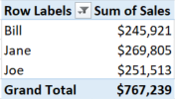

Figure 1. Total Sales per sales representative

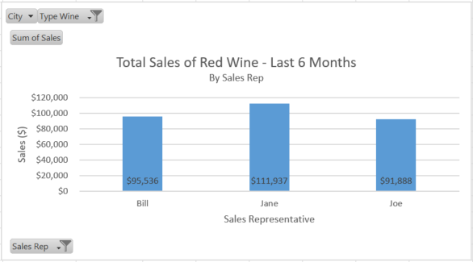

Figure 2. Total red wine Sales over the last 6 months

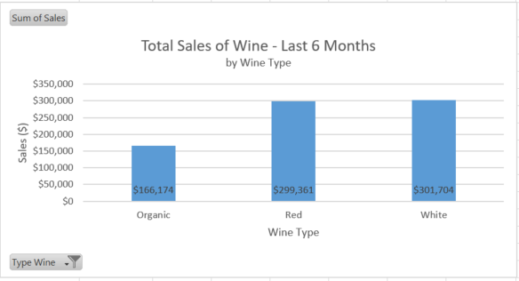

Figure 3. Total wine sales over the last 6 months.