**Using VS Code:**

I just have a folder sitting on my desktop with my files in it. To open up the HTML or JS, I right-click on the file and a few lines down, I have the option to “open with Code”. That opens it in VS Code. Try that and stay out of the double editing you are doing. To see the html actually working just a double click should open it in Chrome. Here is a screenshot so you can see what I am talking about when I right-click on my login.html file.

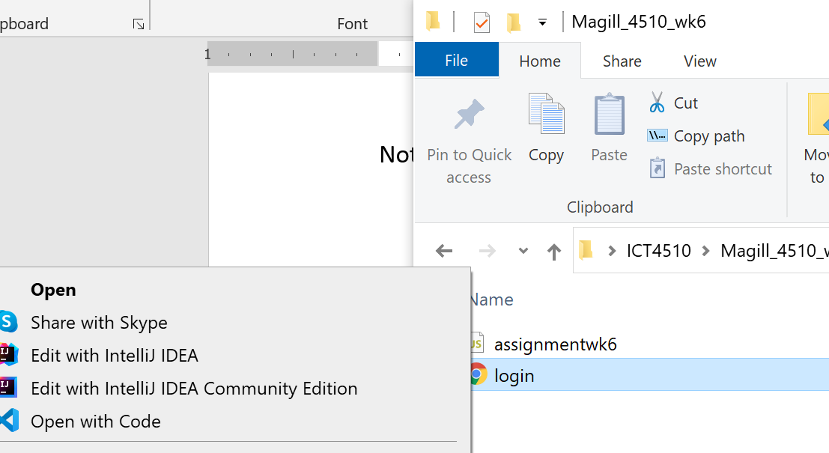

**Notes on final project:**

* You are going to make 4 web pages for a fake restaurant.
  + **Home page**: do this page first, no JavaScript required! Just make a responsive page with a header, footer, nav menu and some pictures in a carousel.
  + **About page**: all you have to do here is paste in your map stuff from the week 7 assignment.
  + **Menu page**: here is where you start doing JavaScript. You need to pull menu items from the Heroku api with Fetch. Best way to do this is:
    - First, go to the documentation and use Postman to learn how to put things in the Heroku api and pull them back out: <https://app.swaggerhub.com/apis-docs/ict4510-course/ict4510/1.0.0#/>
    - You can actually put menu items in with Postman (hotdog, hamburger, etc)
    - Then write a Fetch function that gets them back out to display on your page.
    - Note the GET doesn’t require a token so you don’t have to mess with that here.
    - I used this article to format my menu (look at the part with the table formatting), works great: <https://www.geeksforgeeks.org/how-to-use-the-javascript-fetch-api-to-get-data/>
  + **Admin page:** this is the page where you will need to have:
    - A “login” button/function – you will need to save the token from Heroku. This is basically just the week 6 assignment.
    - A “logout” button/function
    - An “addMenuItem” form/function – you will need to use the token for your POST

**Some Postman notes:**

I would set aside a couple hours to just mess around with Postman. Get it downloaded, then see if you can login with Postman. Should look like this when you are successful. Here on top you can see exactly what you have to provide, and on bottom is exactly what you get back:

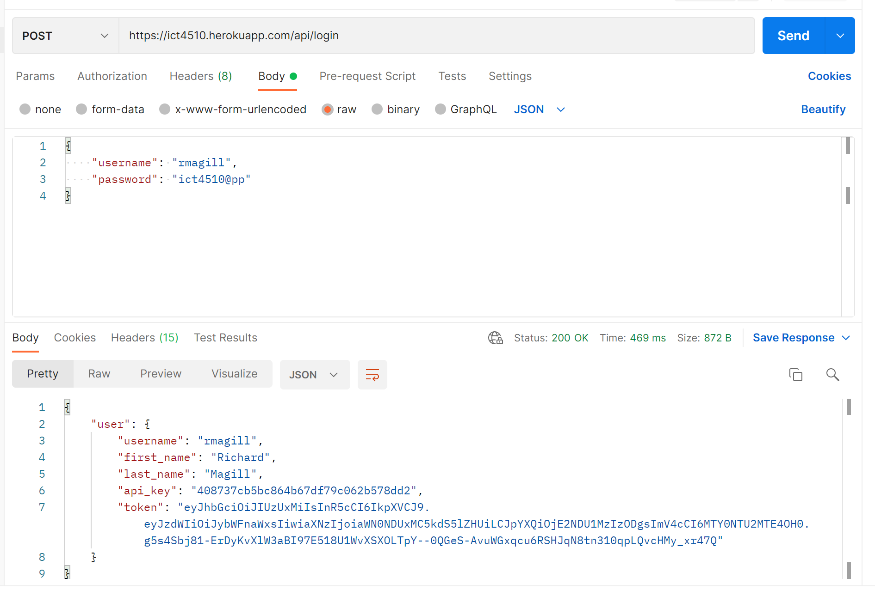

Then you can use Postman to add a menu item. Here is what the body and url looks like:

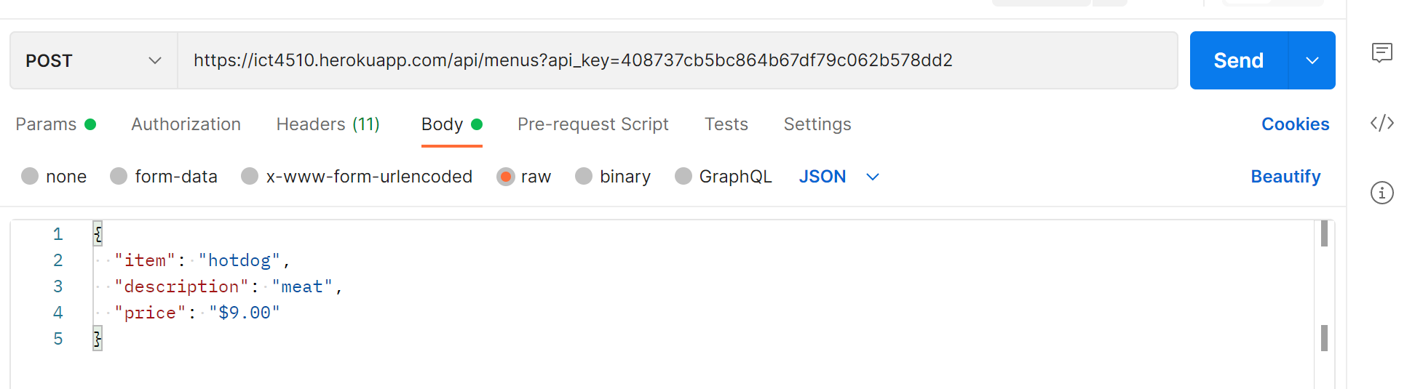

And here is what you have to put in the Headers area, note that now we are including the api_key in the url and the token you got in the headers:

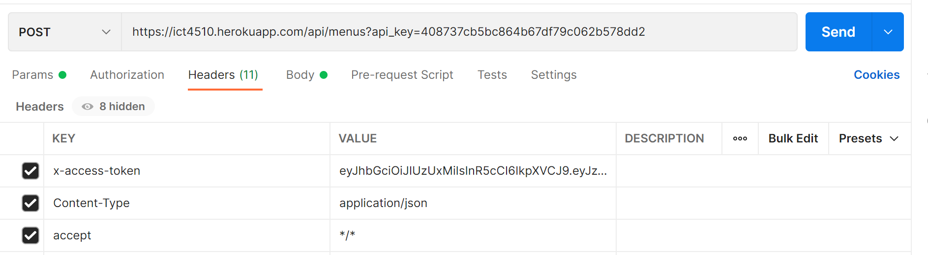

When that works, it will say “item saved”.

Now you can do a GET to see the list of menu items you added. The GET doesn’t need a token, so it is just like:

