Image understanding hw 1 Yu-Ting Liu, 20642518

1. (a) It will randomly select one number between 1 to 5 until all the numbers are selected.

(b) a = $[\begin{matrix}1 & 2 & 3 \\ 4 & 5 & 6 \\ 7 & 8 & 9\end{matrix}]$

b = [4, 5, 6], which is the second row of a.

(c) f = [1501, 1502, …, 2000]

g is the matrix that contains the positions of f which it’s value is bigger than 1850.

h = f(g), which means that h = those values that is bigger than 1850.

(d) x equals a 1 by 10 matrix that each element’s value = 22.

y is the total sum of x, which means that it is the sum of ten 22, 220.

(e) b is the reverse of a.

a = [1, 2, …, 100]

b = [100, 99, …, 1]

1. (a) reshape A (b) histogram of A’s intensities

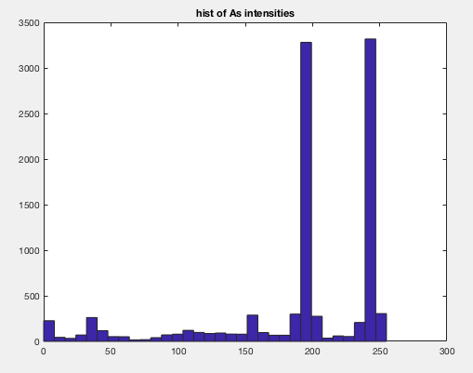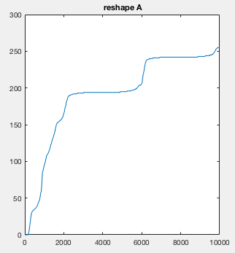

(c) new image with threshold t (d) the bottom right quadrant of A

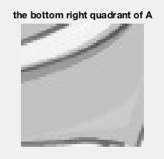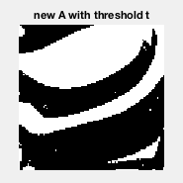

(e) mean intensity value subtracted from each pixel (f) mirror-flipped

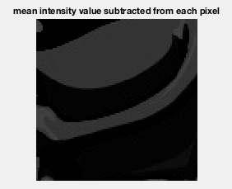

(g)

X = 0, r = 10, c = 1

(h)

Total unique numbers in v is 5.

B.

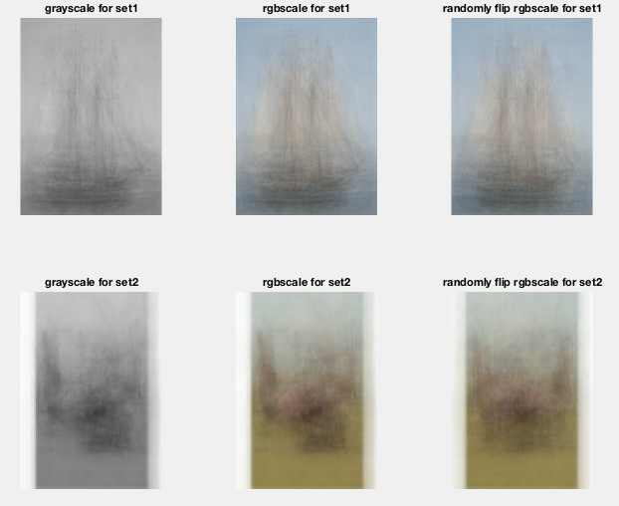

The reason why the results from step 2 and step 3 are different because the sources they use are different. In step 2, it only uses the average of each RPG channel. This makes it’s contour clearer. However, in step 3, the pictures it uses are randomly flipped over, which makes the contour blurry.

C.

1. the first airplane in the test set



2.

There is no writeup for this problem.

3.

Class-confusion matrix for K = 1

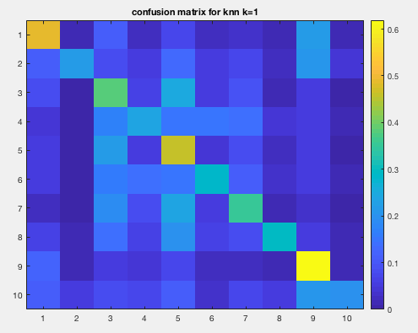

Average classification rate = 0.3539

4.

|  |  |  |
| --- | --- | --- |
|  | The most common label | Average misclassification rate |
| K = 1 | 4 | 1 - 0.3539 = 0.6461 |
| K = 3 | 2 | 1 - 0.3303 = 0.6697 |
| K = 5 | 4 | 1 - 0.3398 = 0.6602 |

We can see from the average misclassification rate that the best-performing K is 1 because its average misclassification rate is the smallest.

Class-confusion matrix for K = 1:



Average misclassification rate: 0.6461

5. NN-classifier that uses normalized correlation:

|  |  |  |
| --- | --- | --- |
|  | The most common label | Average misclassification rate |
| K = 1 | 8 | 1 - 0.4200 = 0.58 |
| K = 3 | 0 | 1 - 0.4163 = 0.5837 |
| K = 5 | 0 | 1 - 0.4358 = 0.5642 |

We can see from the table above that K = 5 has the best performance because its average misclassification is the smallest.

Class-confusion matrix for K = 5:

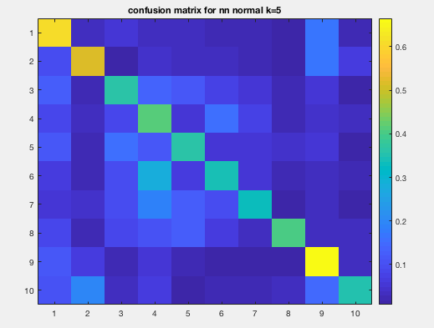

Average misclassification rate: 0.5642

6.

My best-performing system is K = 5 using NN-classifier with normalized correlation because its average misclassification rate is the smallest.

We can see from the confusion matrix that class 7, horse, is the class that most easily to be confused with class 4, deer.

The images showing above are horses but misclassifying as deer.

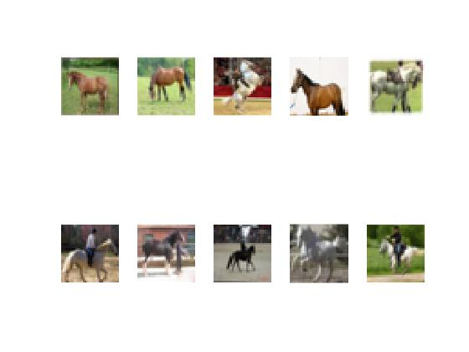

The reason why they are often misclassifying is that the shape of horses is very similar to the shape of deer.